Electronic supplementary data for a manuscript “Covariation in reproductive investment between sterile and fertile sex organs contributes to sterile stamens persistence in cryptically dioecious Actinidia” coauthored by Hua He, Hua Yan, Jie Zhang, Lijuan Zhang, Xiaochen Yang and Dunyan Tan
Six tables (Table S1-S6) and two figures (Fig. S1-S2).

Table S1: Samples sites in the Wuling area of China the nine studied Actinidia taxa.
Table S2: List of Actinidia examined in this study and GenBank accession numbers.
Table S3: Generalized linear models (GLMs) of floral traits between floral morphs within and between taxon. Significant differences are in bold.
Table S4: Factors loading value, eigenvalue, contribution, and the cumulative contribution of the principal components in principal component analysis in two floral morphs of nine Actinidia taxa.
Table S5: Pollen viability of nine Actinidia taxa was studied using Alexander staining.
Table S6: Generalized linear models (GLMs) of proportion of each part biomass and total biomass between functionally female and male flowers within taxon.

Fig. S1: Principal component analysis (PCA) of floral traits in two floral morphs of nine Actinidia taxa: (A) A. chinensis, (B) A. chinensis var. deliciosa, (C) A. eriantha, (D) A. fulvicoma var. hirsuta, (E) A. callosa var. henryi, (F) A. rubricaulis var. coriacea, (G) A. melanandra, (H) A. polygama, (I) A. valvata.
Fig. S2: Pollen morphology from two floral morphs of nine Actinidia taxa (stained by Alexander's stain). (A) A. chinensis, (B) A. chinensis var. deliciosa, (C) A. eriantha, (D) A. fulvicoma var. hirsuta, (E) A. callosa var. henryi, (F) A. rubricaulis var. coriacea, (G) A. melanandra, (H) A. polygama, (I) A. valvata. Pollen from functionally female and male flowers is shown above and below the dashed line, respectively.

Raw data for (1) Table 1: Floral traits (mean ± SE) and coefficient of variation (CV) across nine Actinidia taxa (main text, Table 1). (2) Fig. 2: Comparisons of biomass allocation to floral parts within and between floral morphs of eight Actinidia taxa (main text, Fig. 2). (3) Fig. 4: Phylogenetic relationships and floral traits of 28 Actinidia taxa with Saurauia tristyla as the outgroup inferred from maximum likelihood (ML) tree (main text, Fig. 4).
Table S1 Samples sites in the Wuling area of China the nine studied Actinidia taxa.
Sample site |  | Location | Taxon | Date | Voucher
Xiangxi Tujia and Miao  Autonomous  Prefecture | Jishou University Actinidia Germplasm Nursery | 28°17′12″N, 109°43′32″E | A. fulvicoma var. hirsuta | 2023.04-05, 2024.04-05 | XXJSU011 (JIU)
Xiangxi Tujia and Miao  Autonomous  Prefecture | Jishou University Actinidia Germplasm Nursery | 28°17′12″N, 109°43′32″E | A. callosa var. henryi | 2024.04-05 | XXJSU013 (JIU)
Xiangxi Tujia and Miao  Autonomous  Prefecture | Jishou University Actinidia Germplasm Nursery | 28°17′12″N, 109°43′32″E | A. rubricaulis var. coriacea | 2023.04-05, 2024.04-05 | XXJSU014 (JIU)
Xiangxi Tujia and Miao  Autonomous  Prefecture | Jishou University Actinidia Germplasm Nursery | 28°17′12″N, 109°43′32″E | A. valvata | 2023.04-05, 2024.04-05 | XXJSU015 (JIU)
Xiangxi Tujia and Miao  Autonomous  Prefecture | Zhenwuying Village | 28°21′41″N, 109°46′28″E | A. valvata | 2023.04-05, 2024.04-05 | XXZWY001 (JIU)
Xiangxi Tujia and Miao  Autonomous  Prefecture | Majing’ao Town | 28°23′19″N, 109°49′19″E | A. melanandra | 2024.05 | XXMJA003 (JIU)
Xiangxi Tujia and Miao  Autonomous  Prefecture | Research base of the  Academy of Agricultural Sciences | 28°21′22″N, 109°46′5″E | A. chinensis var. deliciosa | 2024.04 | XXNKY005 (JIU)
Xiangxi Tujia and Miao  Autonomous  Prefecture | Xiangxi Vocational and Technical College for  Nationalities | 28°13′26″N, 109°40′52″E | A. eriantha | 2023.04-05, 2024.04-05 | XXZY001 (JIU)
Xiangxi Tujia and Miao  Autonomous  Prefecture | Guyun Greenway | 28°18′40″N, 109°39′24″E | A. callosa var. henryi | 2024.04,  2025.04 | XXGY002 (JIU)
Zhangjiajie | Badagongshan National Nature Reserve | 29°46′59″N, 110°05′52″E | A. chinensis | 2022.06, 2024.06 | ZJEBDGS001 (JIU)
Zhangjiajie | Badagongshan National Nature Reserve | 29°46′59″N, 110°05′52″E | A. polygama | 2022.06, 2024.06 | ZJEBDGS002 (JIU)

Table S2 List of Actinidia examined in this study and GenBank accession numbers
Section | Series | Taxon | GenBank accession number
Section | Series | Taxon | ITS | matK | rbcL
Sect. Stellatae | Ser. Imperfectae | A. pilosula | KC519780.1 | KC519847.1 | KC519922.1
Sect. Stellatae | Ser. Perfectae | A. chinensis | KC832316.1 | KP314070.1 | KP314125.1
Sect. Stellatae | Ser. Perfectae | A. chinensis var. deliciosa | KC832314.1 | KP314077.1 | KP314127.1
Sect. Stellatae | Ser. Perfectae | A. eriantha | AF323800.1 | KP314097.1 | KP314147.1
Sect. Stellatae | Ser. Perfectae | A. farinosa | KC519744.1 | KC519835.1 | KC519910.1
Sect. Stellatae | Ser. Perfectae | A. fulvicoma | KC519745.1 | KC519797.1 | KC519867.1
Sect. Stellatae | Ser. Perfectae | A. fulvicoma var. hirsuta | AF323799.1 | KP314094.1 | KP314144.1
Sect. Stellatae | Ser. Perfectae | A. latifolia | KP314043.1 | KP314096.1 | KP314146.1
Sect. Stellatae | Ser. Perfectae | A. liangguangensis | KP314049.1 | KP314102.1 | KP314152.1
Sect. Maculatae |  | A. callosa | MH808395.1 | MN370061.1 | KR819564.1
Sect. Maculatae |  | A. callosa var. henryi | AF323803.1 | KC519821.1 | KC519896.1
Sect. Maculatae |  | A. cylindrica | KP314058.1 | KP314082.1 | KC519875.1
Sect. Maculatae |  | A. glaucocallosa | KC519779.1 | KC519845.1 | KC519920.1
Sect. Maculatae |  | A. indochinensis | KC519768.1 | KC519834.1 | KC519909.1
Sect. Maculatae |  | A. rubricaulis var. coriacea | KP314057.1 | KP314089.1 | KP314139.1
Sect. Maculatae |  | A. venosa | KR819515.1 | KP314080.1 | KP314130.1
Sect. Leiocarpae | Ser. Lamellatae | A. arguta | KP314062.1 | KP314088.1 | KP314138.1
Sect. Leiocarpae | Ser. Lamellatae | A. kolomikta | KP737353.1 | KP737308.1 | KP737323.1
Sect. Leiocarpae | Ser. Lamellatae | A. melanandra | MG714285.1 | KP737311.1 | KP737326.1
Sect. Leiocarpae | Ser. Lamellatae | A. tetramera | KP737358.1 | KP737316.1 | KP737330.1
Sect. Leiocarpae | Ser. Solidae | A. macrosperma | AF323834.1 | AF322599.1 | AJ549053.1
Sect. Leiocarpae | Ser. Solidae | A. macrosperma var. mumoides | AF323831.1 | - | AJ549042.1
Sect. Leiocarpae | Ser. Solidae | A. polygama | KC519766.1 | KP314112.1 | KP314162.1
Sect. Leiocarpae | Ser. Solidae | A. valvata | KC519764.1 | KP737317.1 | KP737332.1
Sect. Strigosae |  | A. fortunatii | KP314040.1 | KP314093.1 | KP314143.1
Sect. Strigosae |  | A. hemsleyana | KC519783.1 | MG714292.1 | KC519928.1
Sect. Strigosae |  | A. henryi | KP314059.1 | KP314083.1 | KP314133.1
Sect. Strigosae |  | A. rudis | KC519776.1 | KC519842.1 | KC519917.1
outgroup |  | Saurauia tristyla | KP092594.1 | EU310435.1 | KR529999.1

Table S3 Generalized linear models (GLMs) of floral traits between floral morphs within and between taxon. Significant differences are in bold.
Taxon | Corolla diameter/mm |  | No. of stamens |  | Stamen length/mm |  | Anther  length/mm |  | Anther width/mm |  | No. of pollen grains per flower |  | Pollen volume/μm³ |  | No. of styles |  | Style length/mm |  | Ovary length/mm |  | Ovary diameter/mm
Taxon | Wald χ² | P | Wald χ² | P | Wald χ² | P | Wald χ² | P | Wald χ² | P | Wald χ² | P | Wald χ² | P | Wald χ² | P | Wald χ² | P | Wald χ² | P | Wald χ² |  | P
A. chinensis | 4.314 | 0.038 | 0.463 | 0.496 | 23.633 | <0.001 | 9.063 | 0.003 | 8.736 | 0.003 | 0.113 | 0.736 | 3.742 | 0.053 | - |  | - |  | - |  | -
A. chinensis var. deliciosa | 269.304 | <0.001 | 2.055 | 0.152 | 0.819 | 0.366 | 19.252 | <0.001 | 0.061 | 0.805 | 8.147 | 0.004 | 0.030 | 0.863 | - |  | - |  | - |  | -
A. eriantha | 14.345 | <0.001 | 308.462 | <0.001 | 9.758 | 0.002 | 51.734 | <0.001 | 19.192 | <0.001 | 10.826 | 0.001 | 3.205 | 0.073 | - |  | - |  | - |  | -
A. fulvicoma var.  hirsuta | 0.005 | 0.944 | 43.381 | <0.001 | 16.755 | <0.001 | 116.063 | <0.001 | 29.246 | <0.001 | 17.634 | <0.001 | 94.442 | <0.001 | - |  | - |  | - |  | -
A. callosa var. henryi | 86.156 | <0.001 | 66.545 | <0.001 | 4.983 | 0.026 | 1.131 | 0.287 | 0.181 | 0.670 | 12.562 | <0.001 | 21.5578 | <0.001 | - |  | - |  | - |  | -
A. rubricaulis var.  coriacea | 3.534 | 0.060 | 17.417 | <0.001 | 128.070 | <0.001 | 3.460 | 0.063 | 0.425 | 0.514 | 0.799 | 0.371 | 128.249 | <0.001 | - |  | - |  | - |  | -
A. melanandra | 184.678 | <0.001 | 30.297 | <0.001 | 0.010 | 0.919 | 36.247 | <0.001 | 49.822 | <0.001 | 7.313 | 0.007 | 6.496 | 0.011 | - |  | - |  | - |  | -
A. polygama | 7.452 | 0.006 | 0.831 | 0.362 | 112.411 | <0.001 | 24.929 | <0.001 | 0.194 | 0.660 | 1.104 | 0.293 | 19.375 | <0.001 | - |  | - |  | - |  | -
A. valvata | 11.853 | <0.001 | 30.770 | <0.001 | 29.946 | <0.001 | 115.253 | <0.001 | 0.438 | 0.508 | 0.233 | 0.630 | 59.524 | <0.001 | - |  | - |  | - |  | -
Functionally female  flowers | 3645.970 | <0.001 | 2871.990 | <0.001 | 1775.545 | <0.001 | 1655.400 | <0.001 | 330.937 | <0.001 | 300.386 | <0.001 | 1300.919 | <0.001 | 1506.471 | <0.001 | 1989.838 | <0.001 | 1150.579 | <0.001 | 2313.349 |  | <0.001
Male flowers | 2785.511 | <0.001 | 3164.353 | <0.001 | 865.111 | <0.001 | 733.367 | <0.001 | 195.983 | <0.001 | 315.437 | <0.001 | 1665.951 | <0.001 | - |  | - |  | - |  | -

Table S4 Factors loading value, eigenvalue, contribution, and the cumulative contribution of the principal components in principal component analysis in two floral morphs of nine Actinidia taxa
Characters | Components
Characters | A. chinensis |  |  | A. chinensis var. deliciosa |  |  | A. eriantha |  |  | A. fulvicoma var. hirsuta |  | A. callosa var. henryi
Characters | 1 | 2 | 3 | 1 | 2 | 3 | 1 | 2 | 3 | 1 | 2 | 1 | 2 | 3
Corolla diameter (mm) | 0.120 | 0.571 | -0.216 | 0.760 | -0.150 | -0.246 | -0.133 | 0.628 | -0.245 | 0.348 | 0.813 | 0.796 | 0.321 | -0.132
No. of stamens | -0.339 | 0.675 | -0.114 | -0.008 | 0.650 | 0.518 | 0.772 | 0.157 | -0.252 | 0.636 | -0.231 | 0.852 | -0.014 | 0.003
Stamen length (mm) | -0.388 | 0.572 | 0.561 | 0.040 | 0.631 | -0.459 | 0.571 | 0.196 | 0.346 | 0.711 | 0.572 | -0.219 | 0.722 | -0.119
Anther length (mm) | 0.702 | -0.016 | 0.351 | 0.767 | -0.414 | 0.056 | 0.812 | -0.043 | -0.214 | 0.800 | -0.402 | 0.142 | 0.242 | 0.897
Anther width (mm) | 0.698 | 0.309 | 0.235 | 0.119 | -0.135 | 0.824 | 0.634 | -0.550 | -0.169 | 0.697 | -0.444 | -0.145 | 0.791 | 0.177
No. of pollen per flower | -0.579 | -0.315 | 0.550 | 0.662 | 0.419 | 0.050 | 0.332 | 0.713 | 0.048 | 0.548 | 0.421 | 0.572 | 0.328 | -0.429
Pollen grain volume (μm³) | 0.183 | -0.024 | 0.618 | -0.425 | -0.355 | -0.083 | 0.270 | -0.013 | 0.850 | 0.851 | -0.168 | 0.694 | -0.276 | 0.318
Eigenvalues | 1.628 | 1.304 | 1.238 | 1.801 | 1.334 | 1.231 | 2.185 | 1.270 | 1.042 | 3.181 | 1.606 | 2.258 | 1.492 | 1.152
Contribution (%) | 23.264 | 18.634 | 17.679 | 25.735 | 19.056 | 17.584 | 31.212 | 18.147 | 14.886 | 45.448 | 22.939 | 32.262 | 21.316 | 16.459
Cumulative contribution (%) | 23.264 | 41.898 | 59.577 | 25.735 | 44.790 | 62.375 | 31.212 | 49.360 | 64.246 | 45.448 | 68.387 | 32.262 | 53.578 | 70.036

Table S4 continue
Characters | Components
Characters | A. rubricaulis var. coriacea |  |  | A. melanandra |  |  | A. polygama |  | A. valvata
Characters | 1 | 2 | 3 | 1 | 2 | 3 | 1 | 2 | 1 | 2 | 3
Corolla diameter (mm) | -0.269 | 0.813 | 0.012 | 0.790 | -0.189 | 0.079 | 0.222 | 0.831 | -0.361 | -0.048 | 0.818
No. of stamens | 0.654 | 0.013 | -0.198 | 0.755 | 0.463 | -0.216 | -0.010 | 0.676 | 0.780 | -0.033 | 0.368
Stamen length (mm) | 0.827 | 0.126 | -0.209 | 0.038 | 0.913 | 0.041 | 0.673 | 0.561 | 0.729 | 0.098 | 0.498
Anther length (mm) | 0.451 | -0.292 | 0.665 | 0.665 | 0.132 | -0.190 | 0.848 | -0.249 | -0.893 | -0.028 | 0.176
Anther width (mm) | 0.318 | 0.348 | 0.738 | -0.792 | 0.031 | -0.249 | 0.221 | -0.370 | -0.303 | 0.710 | 0.207
No. of pollen per flower | 0.150 | 0.753 | -0.052 | 0.509 | -0.283 | 0.607 | -0.458 | 0.610 | 0.047 | 0.818 | -0.147
Pollen grain volume (μm³) | 0.844 | 0.018 | -0.261 | -0.391 | 0.393 | 0.719 | -0.792 | -0.020 | 0.768 | 0.116 | -0.167
Eigenvalues | 2.223 | 1.450 | 1.140 | 2.675 | 1.336 | 1.037 | 2.107 | 2.033 | 2.751 | 1.200 | 1.176
Contribution (%) | 31.752 | 20.718 | 16.289 | 38.220 | 19.085 | 14.815 | 30.097 | 29.048 | 39.303 | 17.142 | 16.793
Cumulative contribution (%) | 31.752 | 52.470 | 68.759 | 38.220 | 57.305 | 72.119 | 30.097 | 59.145 | 39.303 | 56.445 | 73.238

Table S5 Pollen viability of nine Actinidia taxa was studied using Alexander staining
Taxon | Pollen viability/%
Taxon | Functionally female flowers | Male flowers
A. chinensis | 0 | 95.17 ± 2.31
A. chinensis var. deliciosa | 0 | 99.50 ± 0.11
A. eriantha | 0 | 97.60 ± 0.30
A. fulvicoma var. hirsuta | 0 | 95.56 ± 1.32
A. callosa var. henryi | 0 | 98.31 ± 0.17
A. rubricaulis var. coriacea | 0 | 97.10 ± 0.66
A. melanandra | 0 | 87.66 ± 2.52
A. polygama | 0 | 98.20 ± 0.27
A. valvata | 0 | 97.20 ± 0.54

Table S6 Generalized linear models (GLMs) of proportion of each part biomass and total biomass between functionally female and male flowers within taxon.
Taxon |  | Actinidia chinensis | A. chinensis var. deliciosa | A. fulvicoma var. hirsuta | A. callosa var. henryi | A. rubricaulis var. coriacea | A. melanandra | A. polygama | A. valvata
Sepals (%) | Female | 14.34 | 13.37 | 23.72 | 12.60 | 16.26 | 9.05 | 12.87 | 10.67
Sepals (%) | Male | 13.49 | 13.86 | 23.11 | 16.47 | 16.94 | 10.02 | 12.66 | 11.10
 | Wald χ² | 5.956 | 1.441 | 1.930 | 22.257 | 0.926 | 2.876 | 0.193 | 3.069
 | P | 0.015 | 0.230 | 0.165 | <0.001 | 0.336 | 0.090 | 0.661 | 0.080
Petals (%) | Female | 32.86 | 32.11 | 22.43 | 37.18 | 32.08 | 34.19 | 32.80 | 42.30
Petals (%) | Male | 28.06 | 31.19 | 27.87 | 43.40 | 34.38 | 44.55 | 35.66 | 35.44
 | Wald χ² | 70.824 | 0.814 | 162.086 | 45.270 | 12.967 | 69.796 | 7.029 | 86.286
 | P | <0.001 | 0.367 | <0.001 | <0.001 | <0.001 | <0.001 | 0.008 | <0.001
Stamens (%) | Female | 17.83 | 20.66 | 16.54 | 17.06 | 22.10 | 19.88 | 27.63 | 20.86
Stamens (%) | Male | 43.57 | 37.87 | 40.31 | 29.32 | 38.40 | 36.92 | 40.42 | 41.29
 | Wald χ² | 2615.426 | 392.945 | 1906.120 | 22.257 | 386.602 | 273.797 | 125.731 | 709.939
 | P | <0.001 | <0.001 | <0.001 | <0.001 | <0.001 | <0.001 | <0.001 | <0.001
Pistil (%) | Female | 22.67 | 20.93 | 30.02 | 24.37 | 19.37 | 31.30 | 17.05 | 19.26
Pistil (%) | Male | - | - | - | - | - | - | - | -
 | Wald χ² | - | - | - | - | - | - | - | -
 | P | - | - | - | - | - | - | - | -
Receptacle (%) | Female | 12.31 | 12.93 | 7.28 | 8.79 | 10.20 | 5.58 | 9.65 | 6.90
Receptacle (%) | Male | 14.88 | 17.08 | 8.70 | 10.80 | 10.28 | 8.51 | 11.26 | 12.17
 | Wald χ² | 52.790 | 47.592 | 20.635 | 9.306 | 0.016 | 22.610 | 12.282 | 169.208
 | P | <0.001 | <0.001 | <0.001 | 0.002 | 0.898 | <0.001 | <0.001 | <0.001
Total biomass (mg) | Female | 169.72 | 163.06 | 30.36 | 17.99 | 13.15 | 28.35 | 25.05 | 87.45
Total biomass (mg) | Male | 96.24 | 101.50 | 24.73 | 10.82 | 7.68 | 8.39 | 19.42 | 36.38
 | Wald χ² | 310.339 | 162.489 | 54.930 | 305.338 | 257.861 | 522.731 | 36.090 | 1029.846
 | P | <0.001 | <0.001 | <0.001 | <0.001 | <0.001 | <0.001 | <0.001 | <0.001

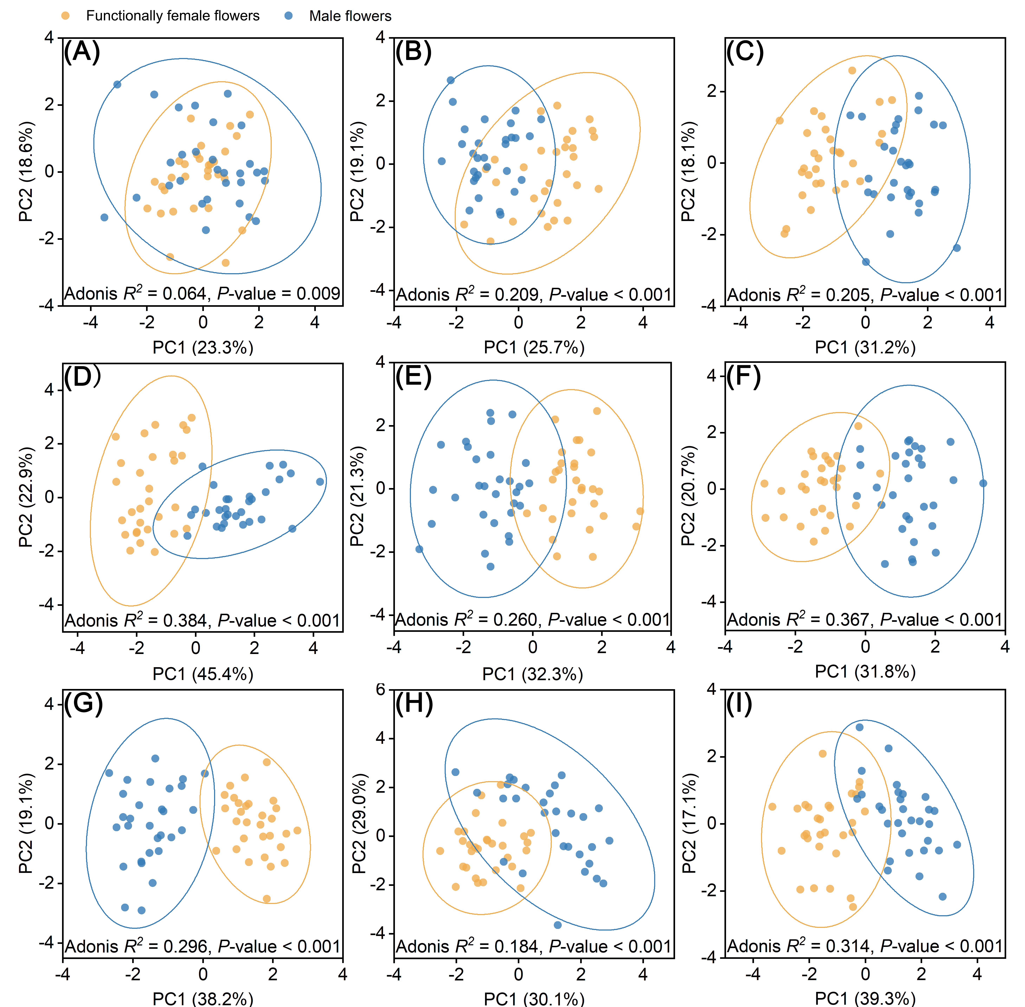
Fig. S1 Principal component analysis (PCA) of floral traits in two floral morphs of nine Actinidia taxa: (A) A. chinensis, (B) A. chinensis var. deliciosa, (C) A. eriantha, (D) A. fulvicoma var. hirsuta, (E) A. callosa var. henryi, (F) A. rubricaulis var. coriacea, (G) A. melanandra, (H) A. polygama, (I) A. valvata.
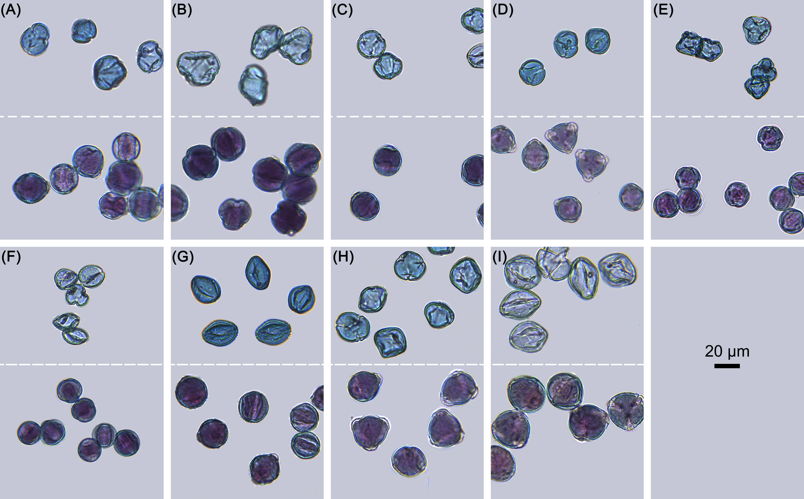
Fig. S2 Pollen morphology from two floral morphs of nine Actinidia taxa (stained by Alexander's stain). (A) A. chinensis, (B) A. chinensis var. deliciosa, (C) A. eriantha, (D) A. fulvicoma var. hirsuta, (E) A. callosa var. henryi, (F) A. rubricaulis var. coriacea, (G) A. melanandra, (H) A. polygama, (I) A. valvata. Pollen from functionally female and male flowers is shown above and below the dashed line, respectively.

