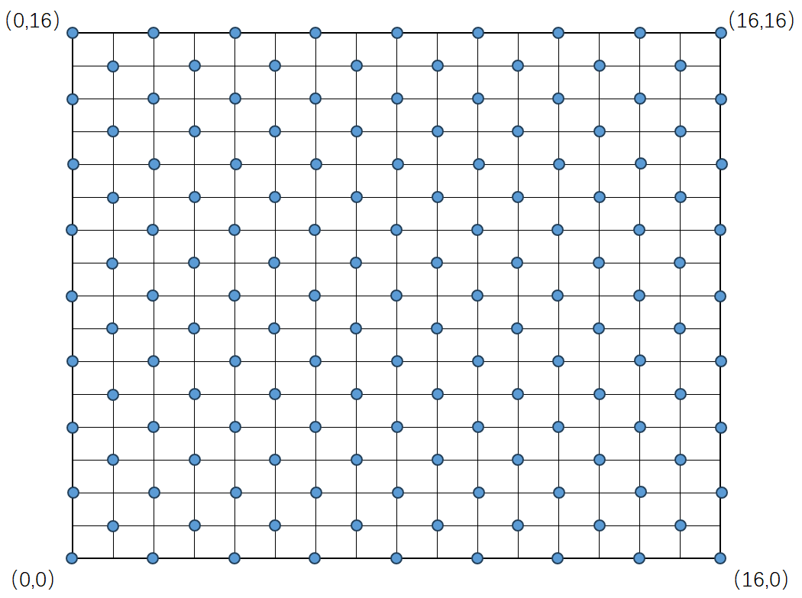
Fig. S1 Survey design diagram of quadrats within representative plots for each treatment

Table S1 The important value between stocking rates based on species
 | CK | HG | LG | MG
S. bre | 32.637±0.803 c | 63.605±3.849 a | 44.547±3.995 b | 54.472±3.225 a
C. son | 28.078±4.410 a | 20.342±1.684 a | 19.496±6.808 a | 18.039±4.221 a
T. ari | 7.038±2.439 b | 8.122±3.446 b | 17.695±3.09 ab | 21.507±1.019 a
C. amm | 10.550±5.785 a | 4.457±1.242 a | 5.950±2.878 a | 3.555±0.832 a
E. hum | 0.048±0.014 b | 1.462±0.649 a | 0.189±0.055 ab | 1.204±0.385 ab
K. col | 6.044±1.297 a | 1.383±1.223 b | 0.533±0.164 b | 0.115 b
O. gla | 3.599±3.150 a | - | 5.380±4.587 a | -
C. ste | 3.558±1.503 a | 0.912±0.537 a | 0.707±0.027 a | 0.690±0.158 a
B. pro | 2.530±1.888 a | - | 0.397±0.315 a | -
P. bif | 0.649 | 0.222 | 2.533±2.486 | 0.022
A. fri | 1.503±0.725 | - | 0.45 | -
L. chi | 0.198 | - | 2.814±2.148 | -
C. dur | 1.513±1.296 | - | 0.669±0.375 | 0.432
K. cer | 2.883±1.309 | - | 0.62 | -
C. mic | 0.542±0.339 a | 0.192 | 0.190±0.094 a | 0.288±0.151 a
N. pec | 0.081±0.021 a | - | 0.087±0.031 a | 0.055 a
P. tan | 0.774 | - | 0.239 | -
L. ili | 0.338 | - | 0.054±0.010 | -
A. sca | - | - | 0.445 | 0.042
I. lac | - | - | 1.107 | -
A. ten | 0.345 | - | 0.081 | -
T. ter | 0.161±0.061 b | 0.060±0.014 d | 0.251±0.214 a | 0.071 c
G. ver | - | 0.074 | - | -
M. rut | - | - | 0.022 | -
A. sco | - | - | - | 0.071
A. gal | 0.1 | - | - | -
A. tri | - | 0.045 | - | -
L. myo | 0.06 | - | 0.017 | -
E. ste | 0.162 | - | 0.124±0.088 | -
Note: “-”denotes that the species does not exist under this treatment.

Table S2 The important value between stocking rates based on functional groups
 | CK | HG | LG | MG
PG | 60.782±4.876 b | 83.946±2.188 a | 65.919±9.080 ab | 72.511±1.088 ab
PF | 12.295±4.980 a | 4.571±1.296 a | 8.754±1.884 a | 3.721±0.809 a
SS | 10.055±0.788 a | 0.976±0.601 b | 1.283±0.274 b | 0.977±0.259 b
AB | 16.976±4.757 a | - | 16.575±0.073 a | -
Note: “-”denotes that the functional groups does not exist under this treatment.

Table S3 The important value between stocking rates based on plant families
 | CK | HG | LG | MG
POA | 60.974±4.788 b | 83.946±2.188 a | 64.122±10.555 ab | 73.511±1.088 ab
AST | 21.188±3.735 ab | 12.579±2.639 b | 29.025±6.256 a | 25.062±0.650 ab
OTH | 8.335±2.570 a | 2.464±0.216 b | 1.360±0.447 b | 1.322±0.453 b
CHE | 7.770±2.011 a | 0.912±0.537 b | 3.167±2.061 b | 0.690±0.158 b
FAB | 1.841±0.967 a | - | 1.994±1.286 a | -
Note: “-”denotes that the plant families does not exist under this treatment.

Code：
library(tidyverse)
library(markovchain)
library(ggplot2)
library(tibble)

raw_data <- readLines("dataclass.csv")
metadata <- str_split(raw_data[1:3], "\\,", simplify = TRUE)
species_names <- metadata[1, -1]
functional_groups <- metadata[2, -1]
plant_families <- metadata[3, -1]

data_df <- map_dfr(raw_data[-(1:3)], ~ {
parts <- str_split(.x, "\\,", simplify = TRUE)
data.frame(
Treatment = factor(parts[1], levels = c("CK", "LG", "MG", "HG")),
matrix(as.numeric(parts[-1]), nrow = 1)
)
})

colnames(data_df)[-1] <- species_names
data_df[is.na(data_df)] <- 0

species_sum <- data_df %>%
group_by(Treatment) %>%
summarise(across(everything(), sum))
Species_Row <- species_sum %>%
select(-Treatment) %>%
apply(1, function(x) x/sum(x)) %>%
t() %>%
`rownames<-`(species_sum$Treatment)
Species_Col <- species_sum %>%
select(-Treatment) %>%
apply(2, function(x) x/sum(x)) %>% t() %>%
`colnames<-`(species_sum$Treatment)
transition_matrix <- function(mat) {
n <- nrow(mat)
tm <- matrix(0, nrow = n, ncol = n,
dimnames = list(rownames(mat), rownames(mat)))
for (i in 1:n) {
for (j in 1:n) {
sum_abs_diff <- sum(abs(mat[i,] - mat[j,]))
sum_total <- sum(mat[i,] + mat[j,])
bc_similarity <- 1 - (sum_abs_diff / sum_total)
tm[i, j] <- bc_similarity
}
tm[i,] <- tm[i,] / sum(tm[i,])
}
return(tm)
}

tm1_species <- transition_matrix(Species_Row)
tm2_species <- transition_matrix(t(Species_Row))
tm3_species <- transition_matrix(Species_Col)
tm4_species <- transition_matrix(t(Species_Col))

