Supplementary materials for

Demographic history and identification of threats under climate and anthropogenic activity provide insights into conservation for Cypripedium palangshanense
Jun-Yi Zhang^{1, 2, 3}, Jia Zhou^{1, 3}, Heng-Ning Deng^{1, 3}, Yue-Hong Cheng⁴, Pan-Yan Yang⁴, Xiao-Gang Shi⁴, Min Liao^{1, 3*}, Bo Xu^{1, 3*}
¹ Mountain Ecological Restoration and Biodiversity Conservation Key Laboratory of Sichuan Province, Chengdu Institute of Biology, Chinese Academy of Sciences, Chengdu 610213, China
² College of Life Sciences, Sichuan University, Chengdu 610064, China
³ University of Chinese Academy of Sciences, Beijing 100049, China
⁴ Wolong National Natural Reserve Administration Bureau, Wenchuan 623006, China
* Corresponding authors: Min Liao (liaomin@cib.ac.cn); Bo Xu (xubo@cib.ac.cn)

Supplementary Figures
Figure S1 Threat factors to the wild populations of Cypripedium palangshanense. (a) Habitat in WC populations, (b) and (c) Mudslides in WC populations, (d) Landslides in PW population, (e) Road construction in JZG population and (f) Grazing and land reclamation in SP population.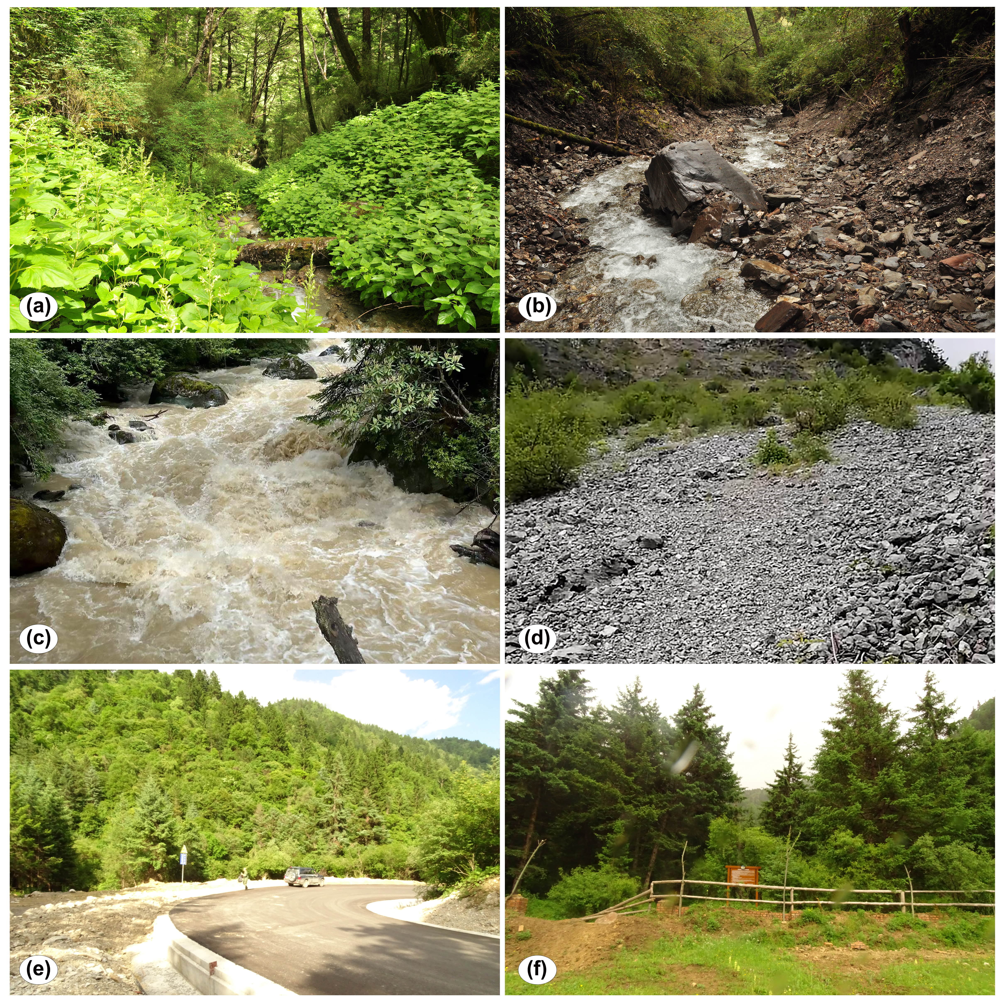

Figure S2. Estimation of genome size in Cypripedium palangshanense based on flow cytometry.
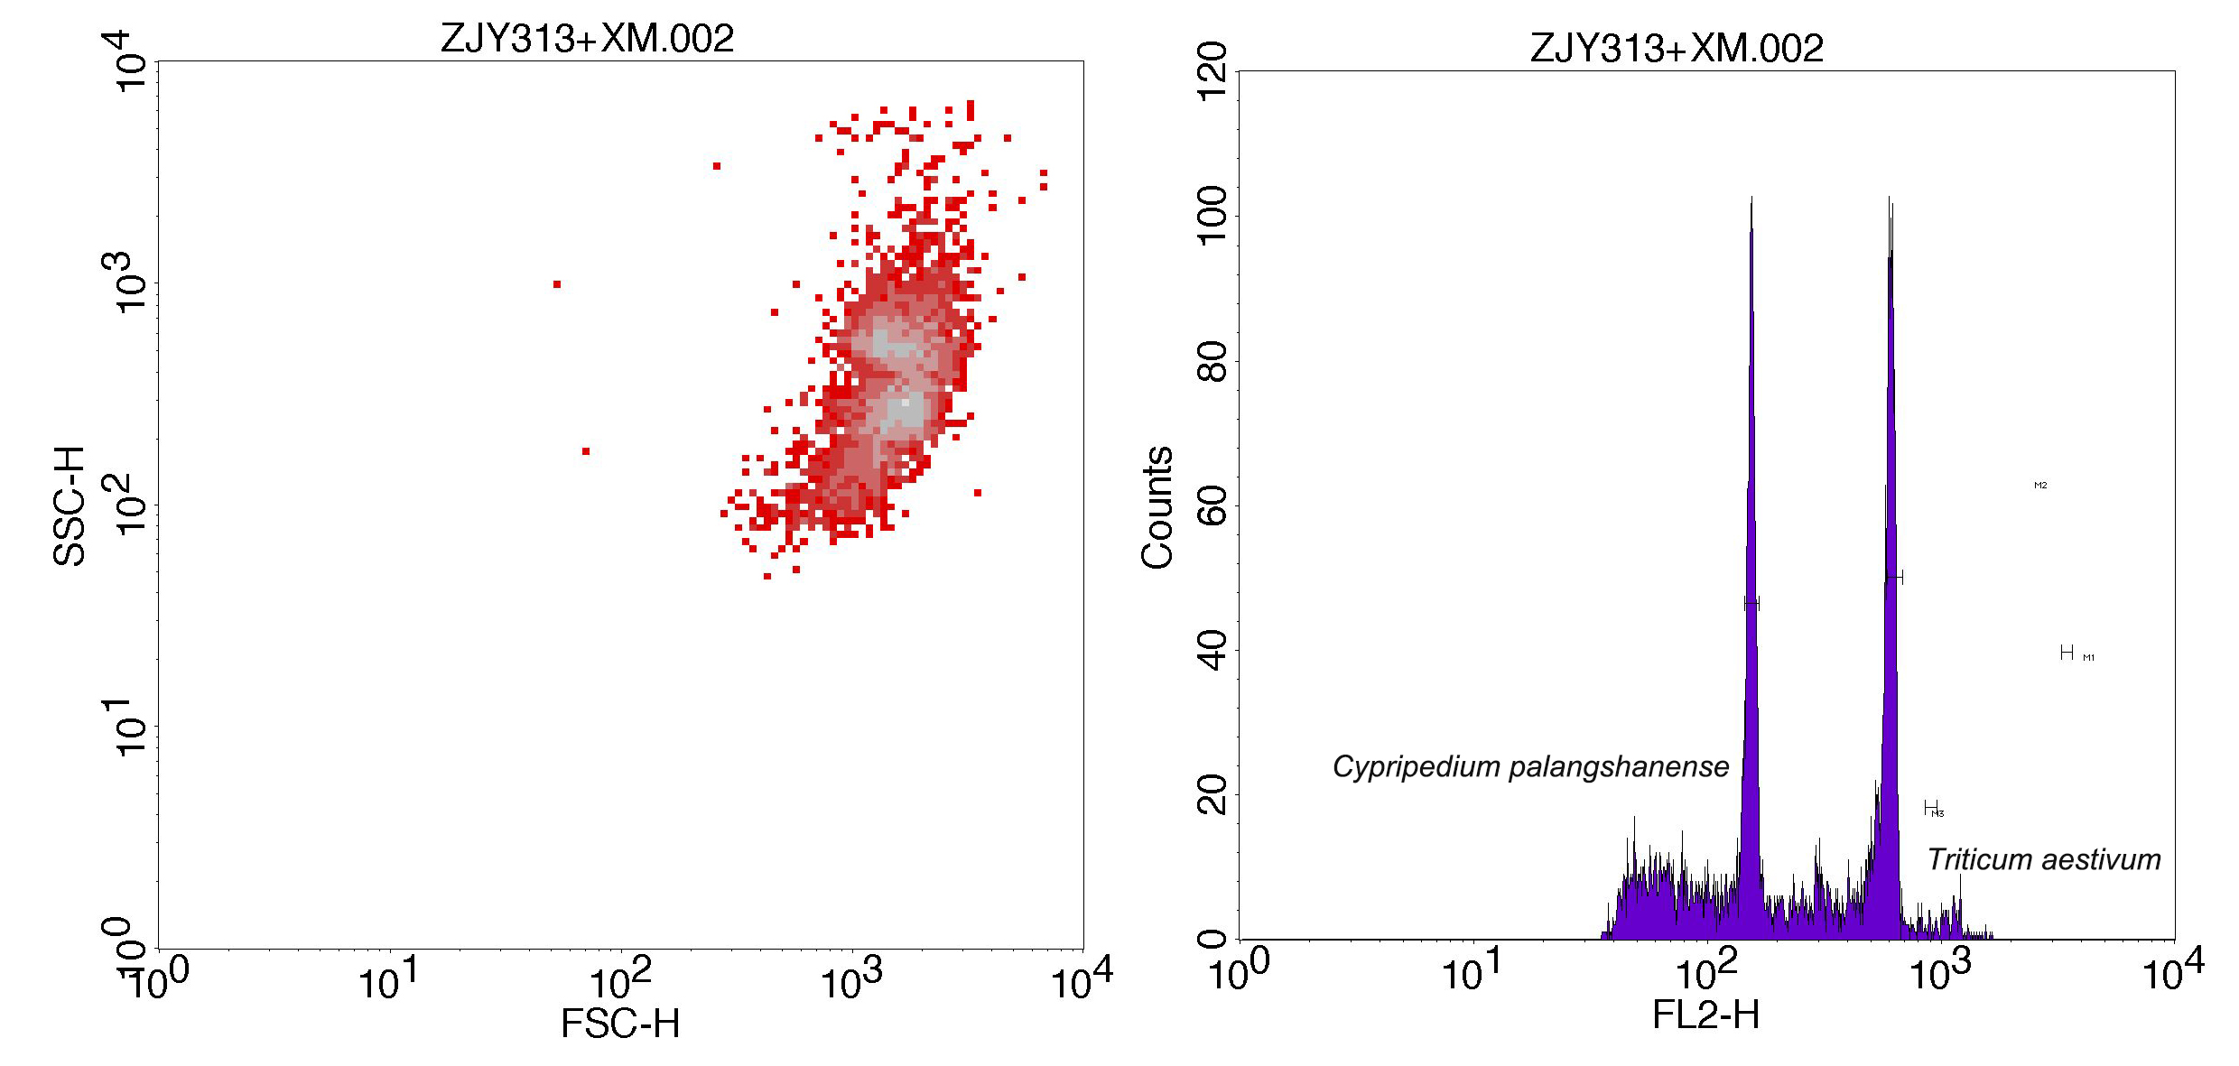

Figure S3 FASTSIMCOAL2 scenarios used for testing the divergence and demographic history of the lineages of the Cypripedium palangshanense
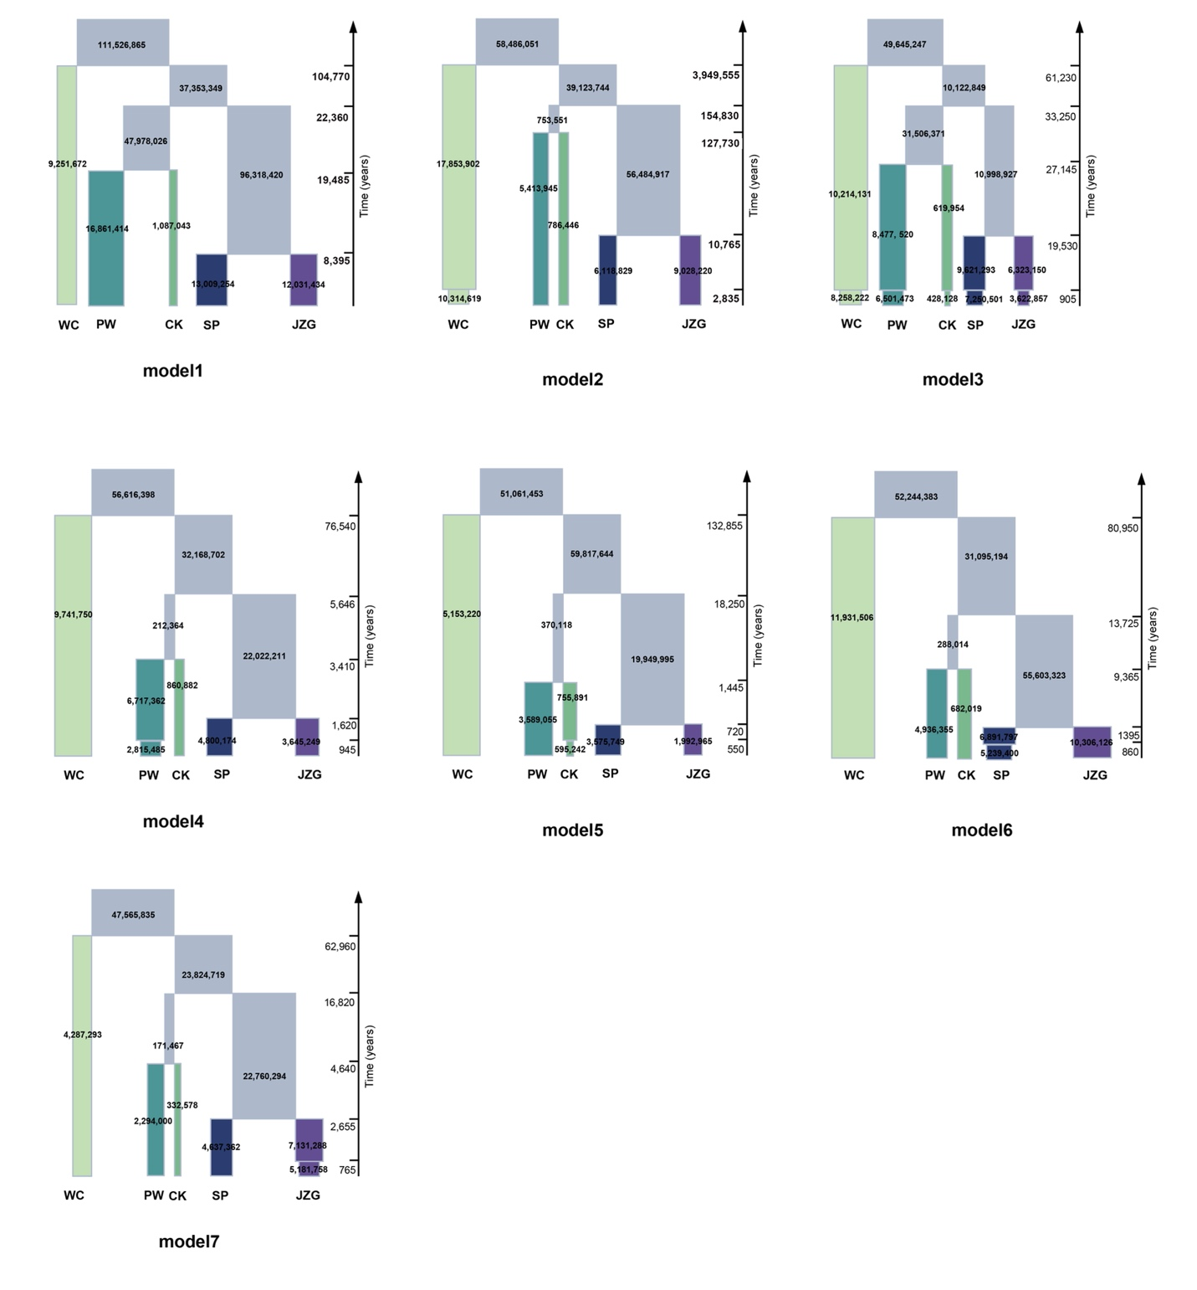

Figure S4 The Cypripedium palangshanense population encompasses two distinct habitat types: streamside valleys (wet, a, b) and mid-slope (dry, c, d) areas.
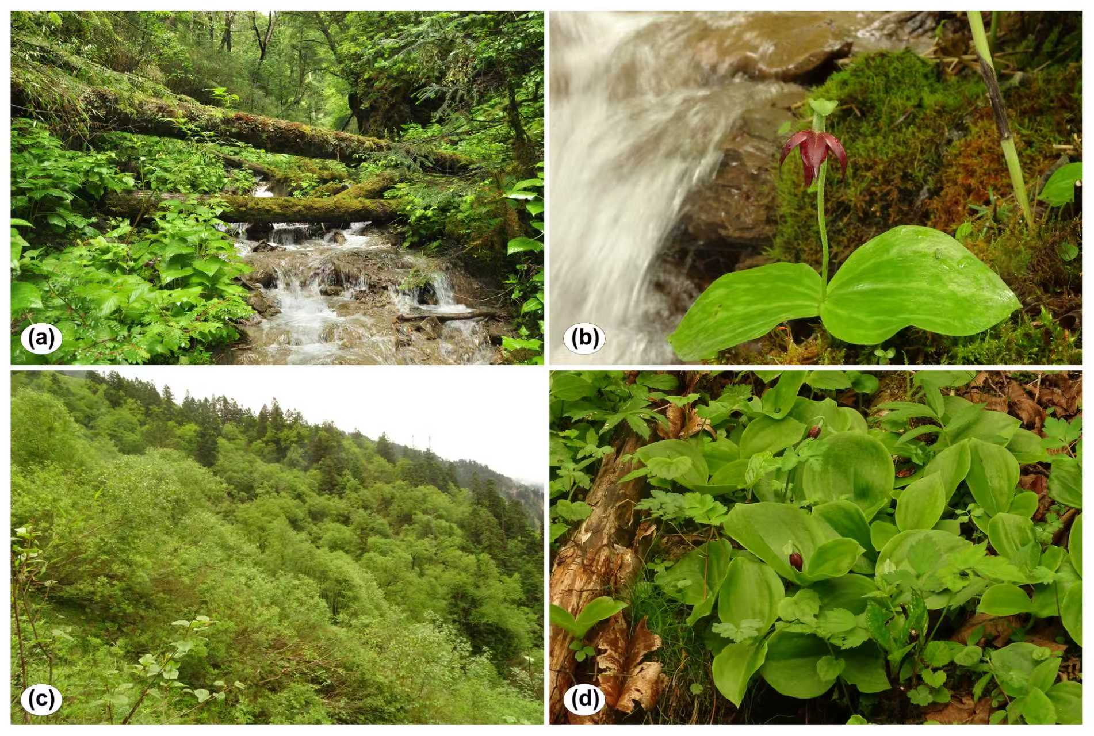

Figure S5 Geographical distributions of Cypripedium palangshanense.
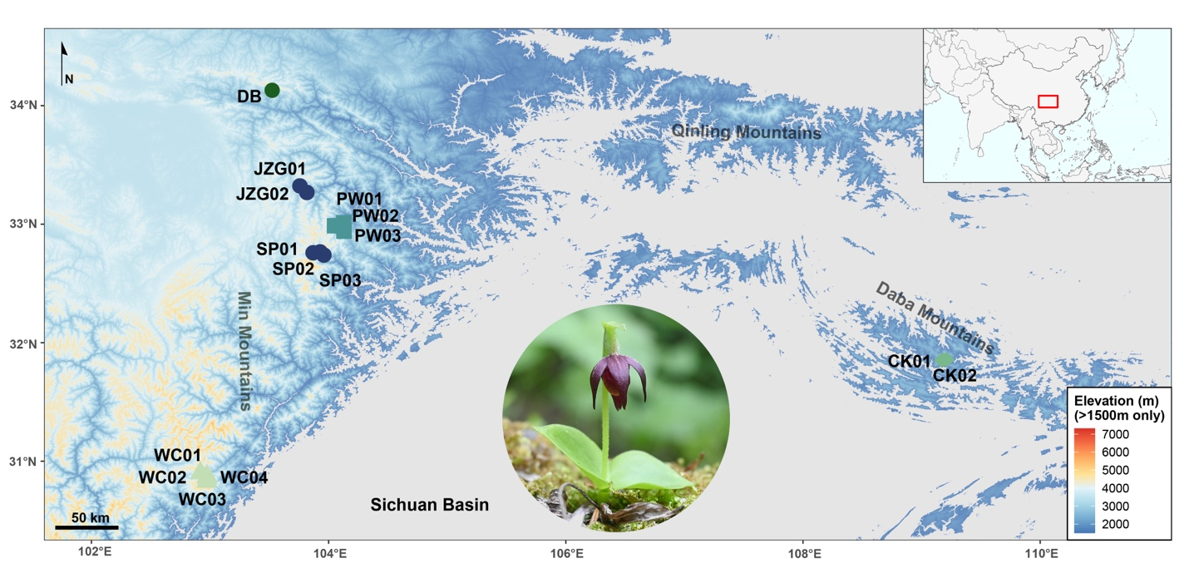

Figure S6 Three phylogenetic trees are constructed by (a) SNPs data, (b)151 single-copy gene data and (c) plastome data of all 54 individuals.
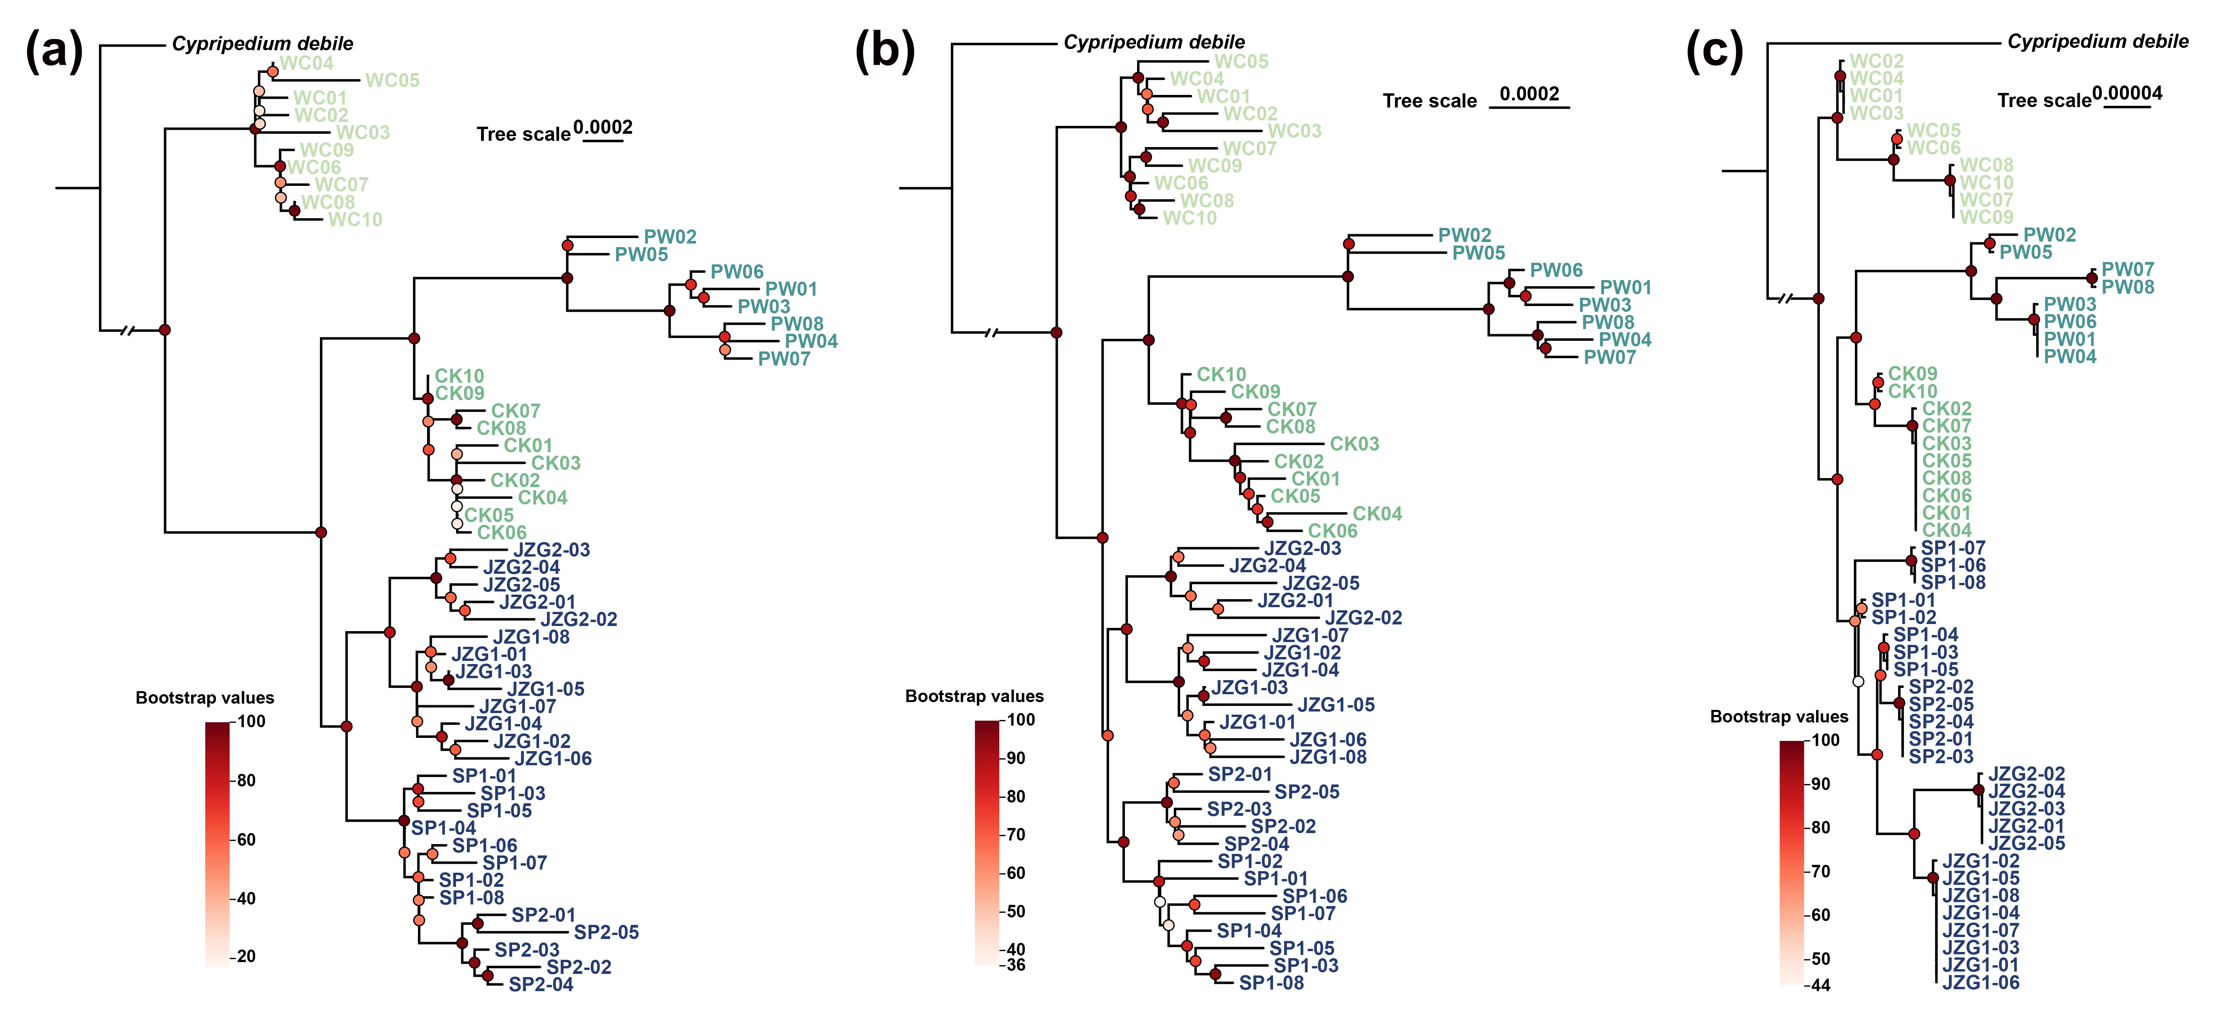

Figure S7 Cross validation error values form K= 2 to K= 7 in the ADMIXTURE analysis.
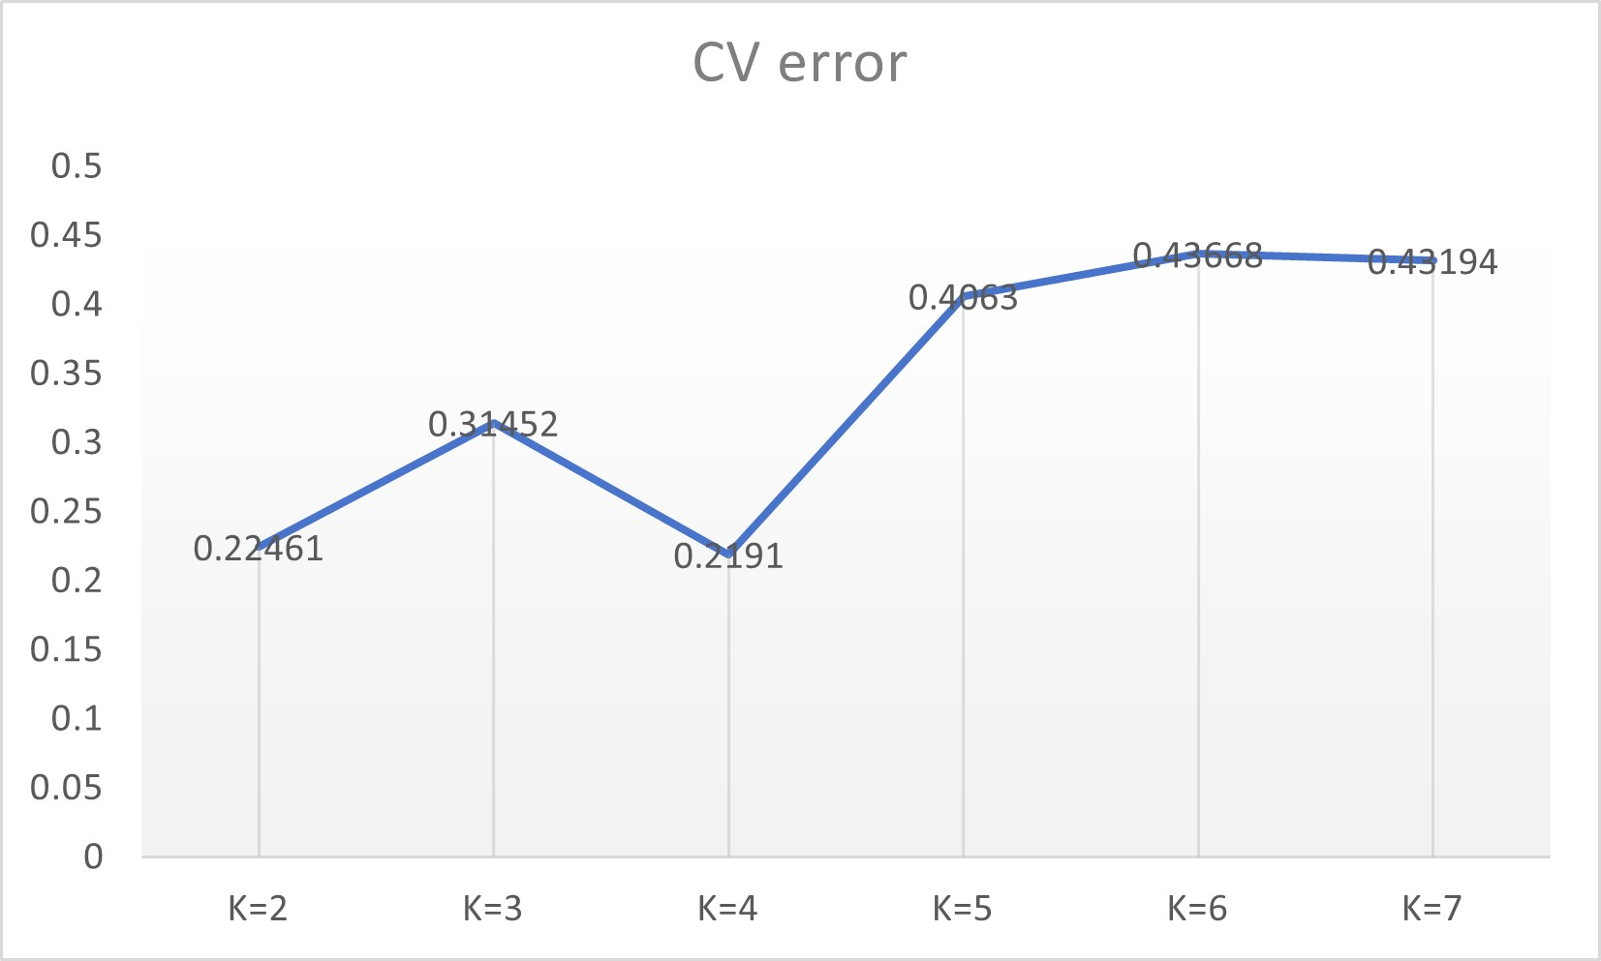

Figure S8 Risk of non-adaptedness barplot for three important environmental factors under the high-emission scenario (ssp585) and the low-emission scenario (ssp126).
