Supplementary data

Supplementary results

Salt stress impedes the germination progress of Bambara groundnut seeds

A preliminary study on the effects of salt stress on germination was evaluated to determine the extent of its impact. Under increasing salinity levels (0, 50, 100, 200, 300, and 400 mM NaCl), a progressive decline in germination percentage was observed across all Bambara groundnut genotypes (BGN-14 and BGN-25). For BGN-14, germination decreased from 100% at 0 mM to 93.3%, 80%,60%, 26.7%, and 0% at severe salt levels. BGN-14 followed a comparable trend, with germination declining from 93.3% to 80%,60%, 26.7%, and 0% at severe salt levels (Supplementary Figure S1). Overall, germination percentage showed an inverse relationship with increasing salinity, resulting in declines of −71.4% and −76.9%, compared to their control at 200 mM NaCl for BGN-14 and BGN-25, respectively. Based on these findings, a concentration of 200 mM NaCl was selected for all subsequent experiments to investigate the physiological and biochemical responses of Bambara groundnut seedlings to salt stress. This concentration was chosen as it represented a severe but sub-lethal stress level, inducing a significant reduction in germination (approximately 70-75%) while still permitting a sufficient number of seedlings to establish for a robust analysis in understanding salinity stress.

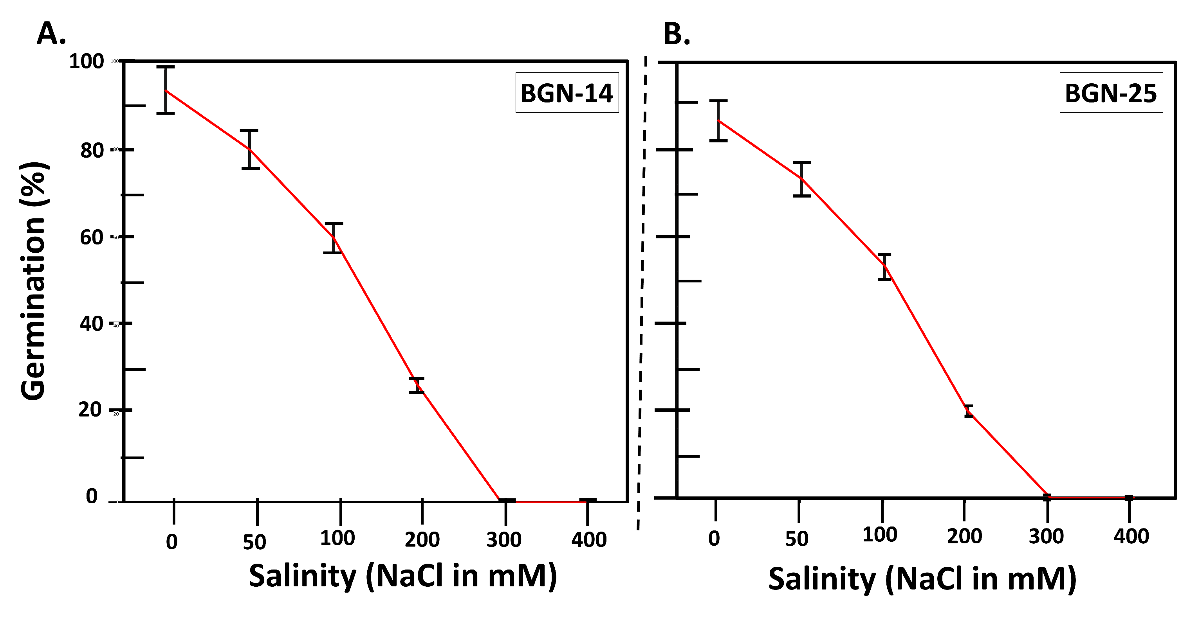
Supplementary Figure S1. Illustrates the effect of increasing NaCl concentrations (0, 50, 100, 200, 300, and 400 mM) on the germination percentage of four Bambara groundnut genotypes, BGN-14 (A) and BGN-25 (B). The trend shows a progressive decline in germination as salinity levels rise, with the highest salt concentrations (300 mM and 400 mM) completely inhibiting germination across all genotypes. The values are means ± standard errors (SE) (n=3).

Effects of Nitrate Priming on Germination under salt stress

To determine a suitable nitrate priming treatment for the two Bambara genotypes, seeds were germinated at 200 mM NaCl, a concentration subsequently chosen based on the results from Supplementary Figure S1 as suitable for studying salinity stress. The effectiveness of priming at this salinity level varied with genotype, priming agent, and concentration, influencing the extent to which seeds could overcome the inhibitory effects of salinity. For BGN-25, KNO₃ priming resulted in germination percentages of 46.7, 53.3, 46.7, 40.0, and 33.3%, while Mg(NO₃)₂ produced 46.7, 66.7, 80.0, 73.3, and 33.3%, respectively. For BGN-14, KNO₃ priming yielded 93.3, 80.0, 86.7, 93.3, and 93.3%, while Mg(NO₃)₂ resulted in 93.3, 93.3, 100.0, 66.7, and 80.0%, respectively. Overall, the effectiveness of priming differed among genotypes and concentrations, with KNO₃ and Mg(NO₃)₂ generally enhancing germination more effectively than NaNO₃ and NH₄NO₃. Lower priming concentrations (0.03% and 0.2%) tended to promote higher germination, whereas excessive concentrations often reduced performance. For the subsequent main trial, the 0.03% Mg(NO₃)₂ treatment was selected. This decision was based on its consistent performance in mitigating NaCl-induced germination inhibition for the Bambara genotypes. Specifically, it provided a substantial improvement for BGN-25 compared to its unprimed control and higher priming concentrations, while for BGN-14, it maintained a high germination percentage equivalent to the control, indicating no adverse effects. This concentration demonstrated an effective balance, providing a clear beneficial priming effect without the toxicity or osmotic stress often associated with higher salt concentrations.

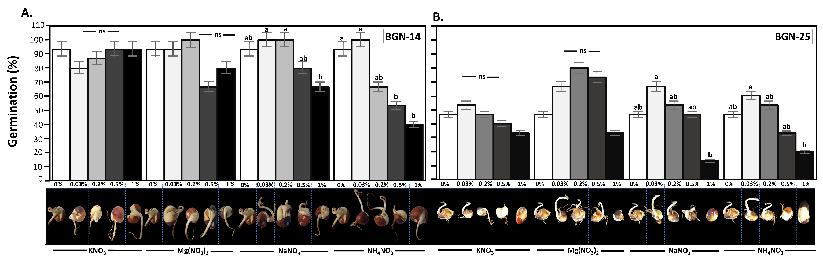
Supplementary Figure S2. Illustrates the effects of genotype BGN-14 (A) and BGN-25 (B), nitrate source (KNO₃, Mg(NO₃)₂, NaNO₃, and NH₄NO₃), and priming concentration (0, 0.03, 0.2, 0.5, and 1%) on germination percentage. The results show that KNO₃ and Mg(NO₃)₂ significantly enhanced germination, particularly at lower concentrations, while NaNO₃ and NH₄NO₃ were less effective. Among the genotypes, BGN-14 and BGN-52 showed greater tolerance and responded more positively to nitrate priming. The data are means ± SE (n=3), whereby different letters indicate significant differences among treatments as determined by Tukey’s HSD (p≤0.05).

Leaf SOD activity in response to Bambara groundnut genotypes (BGN-14 and BGN-25) under salinity and priming treatments
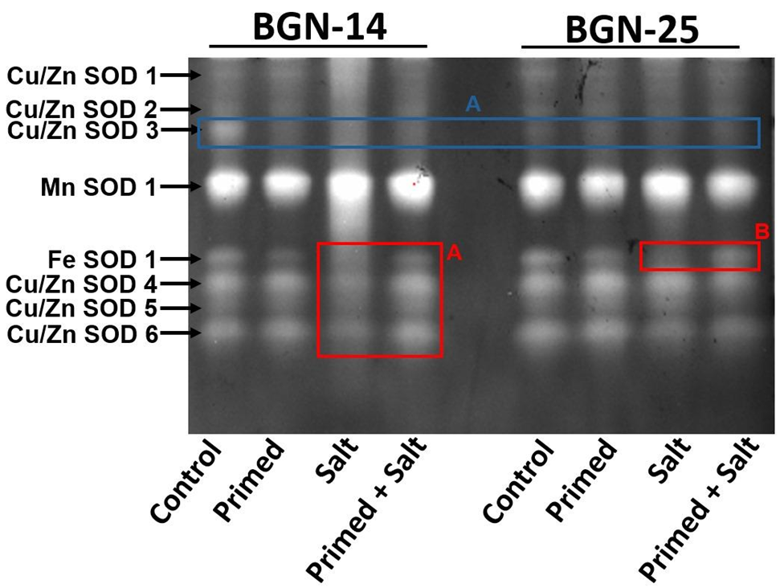
Supplementary Figure S3.| The image above shows SOD isoforms. Cu/Zn SOD 2 levels were measured, and levels were undetectable under “salt” treatment (BGN-14). Cu/Zn SOD 3 was shown to be only expressed in “control” of BGN-14, while in other treatments the levels were insignificant, also see block A (Blue colour). Interesting results were observed in Block A (Red colour), showing that “prime + salt” treatment increased the activity of Fe SOD1 and Cu/Zn SOD 4-6 in BGN-14. This could suggest that priming BNG-14 helps alleviate the effect of salt stress by increasing the activity of SOD, which is responsible for scavenging O₂⁻ and ROS species responsible for damaging lipid membrane and resulting in cell death when not monitored. While for BNG-25 this effect was clearly noted only in Fe SOD see red block B.

In this study, native polyacrylamide gels were employed to visualize the isozyme profiles of Superoxide dismutase (SOD), the first line of defense against ROS, which catalyzes the dismutation of superoxide (O₂⁻). The densitometric analysis was performed to quantify band size and intensity (Supplementary Figure S3 and Supplementary Figure S4), indicating their relative activity under the different treatments. Both Bambara groundnut genotypes expressed multiple superoxide dismutase (SOD) isoforms: six Cu/Zn-SODs, one Mn-SOD, and one Fe-SOD, showing treatment and genotype-dependent variation in activity. In BGN-14, the “primed + salt” treatment produced the highest and statistically significant (p < 0.05) Cu/Zn-SOD1 activity (+75.8%), followed by “salt” (+53.7%) and “primed” (+41.5%) compared with the control (Figure 5.4). In BGN-25, the corresponding increases were smaller and non-significant (p > 0.05): “salt” (+15.7%), “primed + salt” (+2.0%), and “primed” (−5.4%). Cu/Zn-SOD2 activity in BGN-14 was also highest under “primed + salt” (+27.1%), followed by “primed” (+13.7%), whereas “salt” treatment showed no detectable activity. A similar pattern occurred in BGN-25, where “primed + salt”, “primed”, and “salt” resulted in +20.8%, +24.7%, and +2.8% changes, respectively (Supplementary Figure S4). For Cu/Zn-SOD4, a genotype-specific trend emerged: in BGN-14, “primed + salt” again showed the highest activity (+40.8%), while in BGN-25, “salt” induced the strongest response (+49.7%), followed by “primed” (+26.2%) and “primed + salt” (+18.4%), with these differences significant (p < 0.05). Cu/Zn-SOD6 activity in BGN-14 increased under “primed + salt” (+48.6%) and “primed” (+18.7%) but declined under “salt” (−8.2%). In contrast, BGN-25 showed reduced activity across all treatments relative to the “control” (“primed + salt”, −18.2%; “primed”, −11.1%; “salt”, −31.7%). Fe-SOD activity was highest in the control, with no detectable bands under “salt” stress in either genotype. In contrast, Mn-SOD activity rose markedly under “salt” and “primed + salt” treatments, increasing by +20.6% and +17.0% in BGN-14 and by +24.2% and +10.3% in BGN-25, respectively.

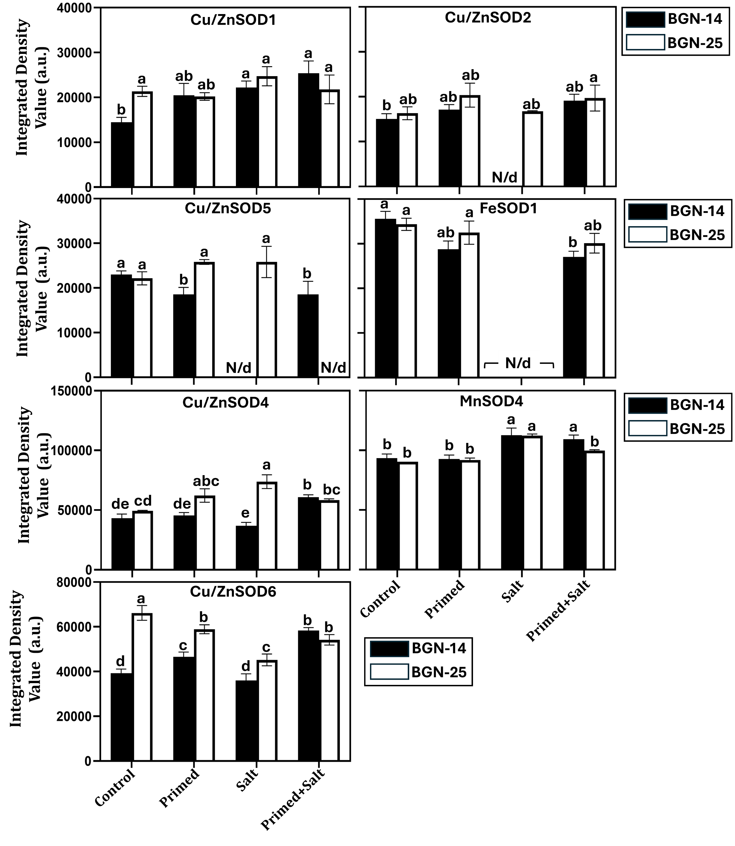
Supplementary Figure S4.| Leaf individual SOD isoform activities in response to Bambara groundnut genotypes (BGN-14 and BGN-25) under salinity and priming treatments. represent the integrated pixel density values of the superoxide dismutase isoforms as observed on 12% native acrylamide gel (Supplementary Figure S3). The relative pixel intensity values are determined using the Alpha Ease FC software, and the SOD activities are expressed as integrated density value (a.u.). The data are means ± SE (n=3), whereby different letters indicate significant differences among treatments as determined by Tukey’s HSD (p≤0.05). The same letters indicate that there was no significant difference between means, and N/d indicates that no isoforms were detected.

Supplementary method:

Seed germination test

The first phase of germination investigated the effect of salt stress on the germination of Bambara groundnut genotype (BGN-14 and BGN-25). Mature seeds were surface-sterilized following Zeng et al. (2012) using 70% ethanol (5 min) and 0.35 % sodium hypochlorite (20 min), then rinsed with distilled water. The sterilized seeds were placed in 15 cm Petri dishes lined with paper towels and moistened with sodium chloride (NaCl) solutions of 0, 50, 100, 200, 300, and 400 mM. Each dish contained five seeds, arranged in a randomized complete block design (RCBD) with three replicates. Seeds were incubated in a growth chamber (Model I-35 VL; Percival Scientific, Perry, IA) at 30/25 °C (day/night), under a 12 h photoperiod with fluorescent light (36 µmol s⁻¹ m⁻²). Germination was monitored daily for 10 days, and seeds were considered germinated once the radicle reached 3 mm (radicle emergence of ≥ 3 mm). NaCl was chosen as the salinizing agent because it is the predominant salt in naturally saline soils and effectively represents the combined osmotic and ionic stress encountered by plants under field salinity (Parida and Das, 2005). Different NaCl concentrations were applied to determine the salinity threshold at which germination becomes significantly inhibited, and to identify an appropriate stress level for subsequent plant growth experiments.

In the second phase of germination, seeds were primed with different nitrate sources potassium nitrate (KNO₃), ammonium nitrate (NH₄NO₃), sodium nitrate (NaNO₃), and magnesium nitrate [Mg(NO₃)₂] at concentrations of 0, 0.01, 0.2, 0.5, and 1%. Seeds were immersed in each priming solution for all four genotypes at a standard temperature of 24 °C for a soaking period of 24 hours (Ogbuethi et al., 2013). Subsequently, the seeds underwent a 5-minute air-drying period before being placed in petri dishes at room temperature. Their germination progress was evaluated under the selected salinity threshold (200 mM) determined in the previous germination screening, to determine the most effective priming concentration and nitrate source using the Germination percentage, germination index, and mean germination time formulas as described by Maguire (1962). This phase also aimed to establish the optimal priming concentration for each nitrate source, while avoiding over-priming, and to evaluate their effectiveness in enhancing salt stress tolerance. The outcomes of this experiment provided the foundation for evaluating the impact of seed priming and salinity during seedling/plant growth.

Identification and characterization of SOD isoforms

Superoxide dismutase (SOD) enzymatic activity was measured using an in-gel approaches, using a method modified from Beauchamp and Fridovich (1971). For protein extraction, leaves were ground into fine powder using liquid nitrogen and then 100 mg of the tissue samples were homogenised with 400 μl of the cold homogenising buffer [40 mM K₂HPO₄, pH 7.4, 1 mM ethylene diamine tetra-acetic acid (EDTA), 5% (w/v) polyvinylpyrrolidone (PVP) molecular weight = 40,000]. The homogenates were centrifuged at 12 000 x g for 15 minutes at 4°C and the resulting supernatant was used for protein concentrations according to Bradford (1976), using the RC DC Protein Assay Kit 11 (Bio-Rad Laboratories, Inc., Hercules, CA). The associated SOD isoform patterns were determined by incubating gels in 5 mM H₂O₂ (to inhibit both Cu/ZnSOD and FeSOD), or 5 mM KCN (to inhibit only Cu/ZnSOD), as MnSOD is resistant to both treatments (Beauchamp and Fridovich (1971). The gel images were captured and analysed for band intensities by densitometry using Alpha Ease FC software (Alpha Innotech Corporation).

Supplementary Reference:

Parida, A. K. and Das, A. B., 2005. Salt tolerance and salinity effects on plants: a review. Ecotoxicology and Environmental Safety, 60(3), 324–349.
Ogbuethi HC, Madukwe DK, and Ashilonu P. 2013. Assessment of hydro priming of seeds on performance of morphological indices of Bambara groundnut (Vigna subterrenea L.) landrace. Global Institution for Research and Education, 2(2): 17-22.
Maguire JD, 1962. Speed of germination- Aid in selection and evaluation for seedling emergence and vigor. Crop Sci 2: 176-177.
Beauchamp C, and Fridovich I. 1971. Superoxide dismutase: improved assays and an assay applicable to acrylamide gels. Analytical Biochemistry, 44(1): 276- 287.

