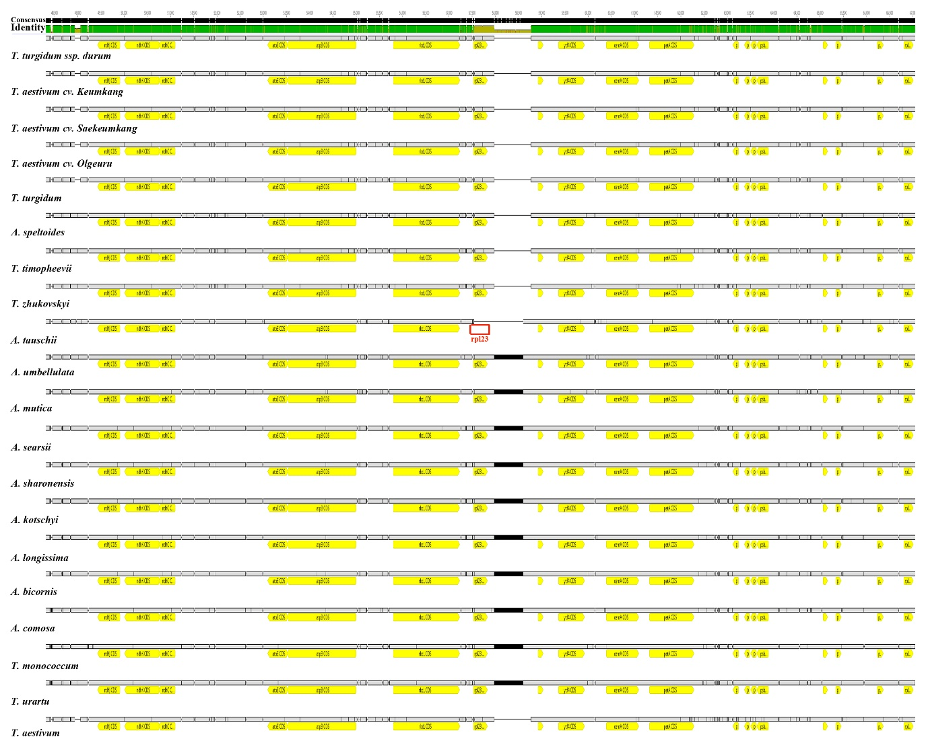
Figure S1. MAFFT alignment of chloroplast genomes from Triticum–Aegilops complex species. The red square highlights the missing copy of the rpl32 gene in the LSC region of Aegilops tauschii.
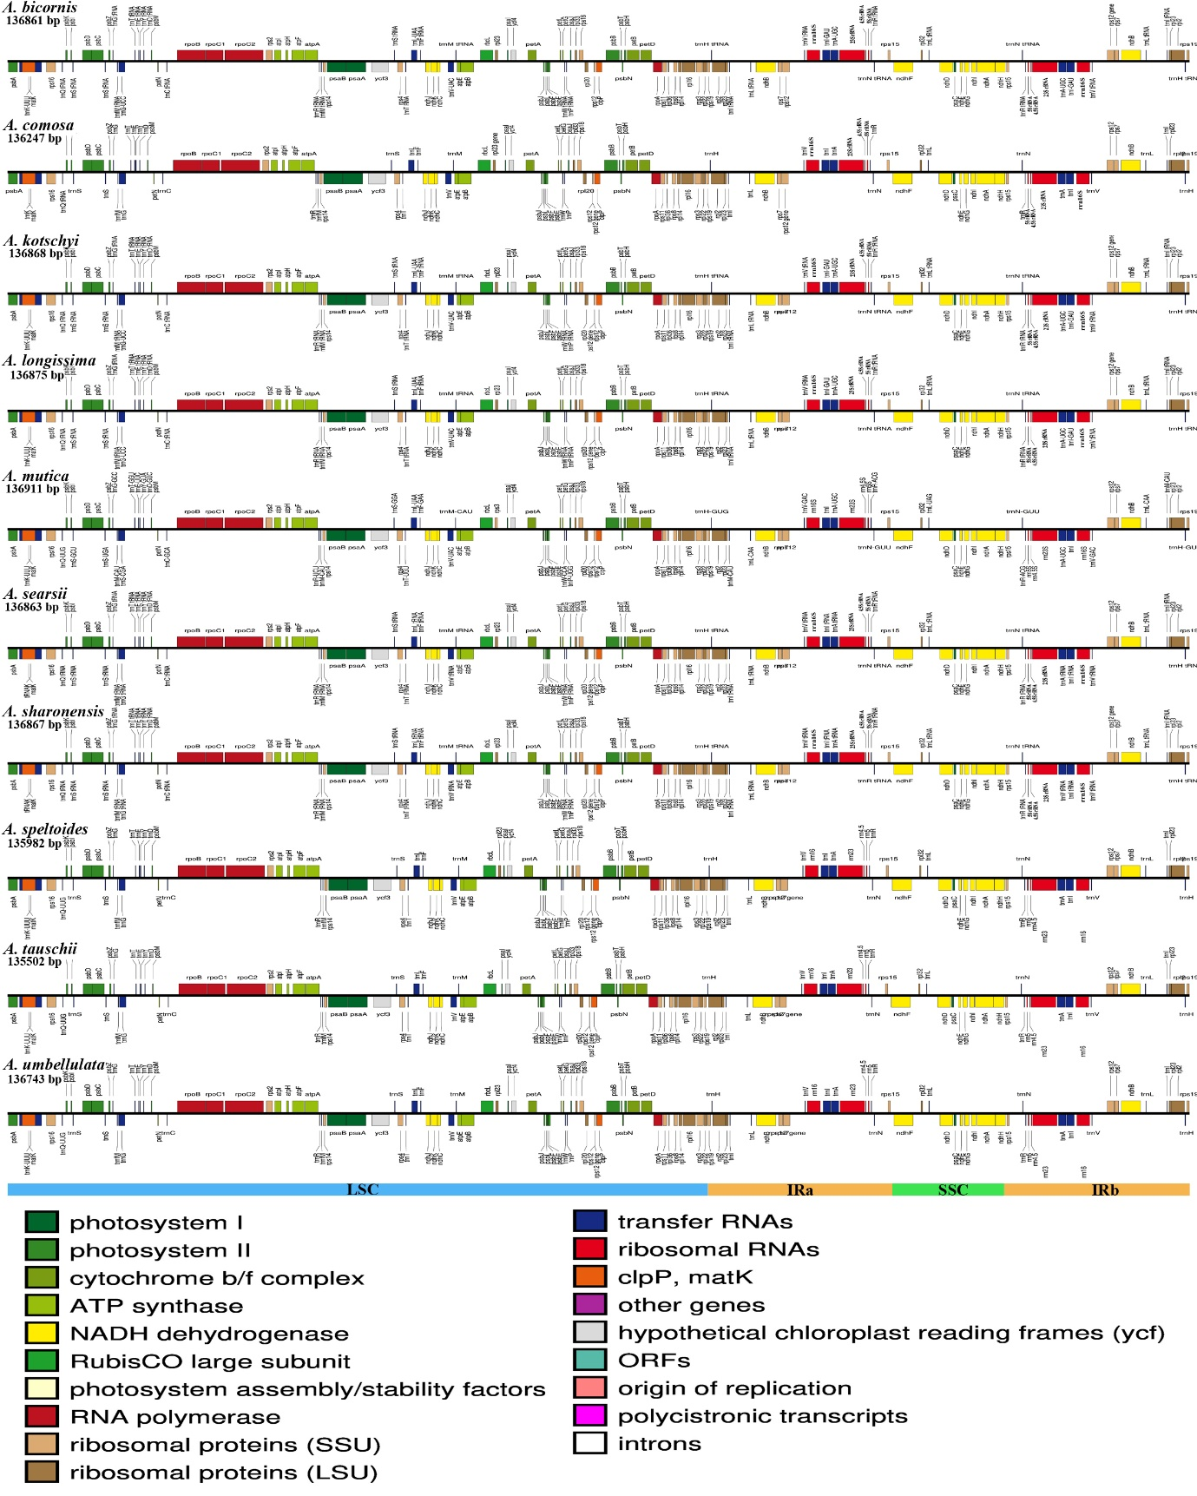Figure S2. Linear map of the chloroplast genome of selected Aegilops species. The map illustrates gene organization and structure along the chloroplast genome, highlighting conserved and variable regions among species.
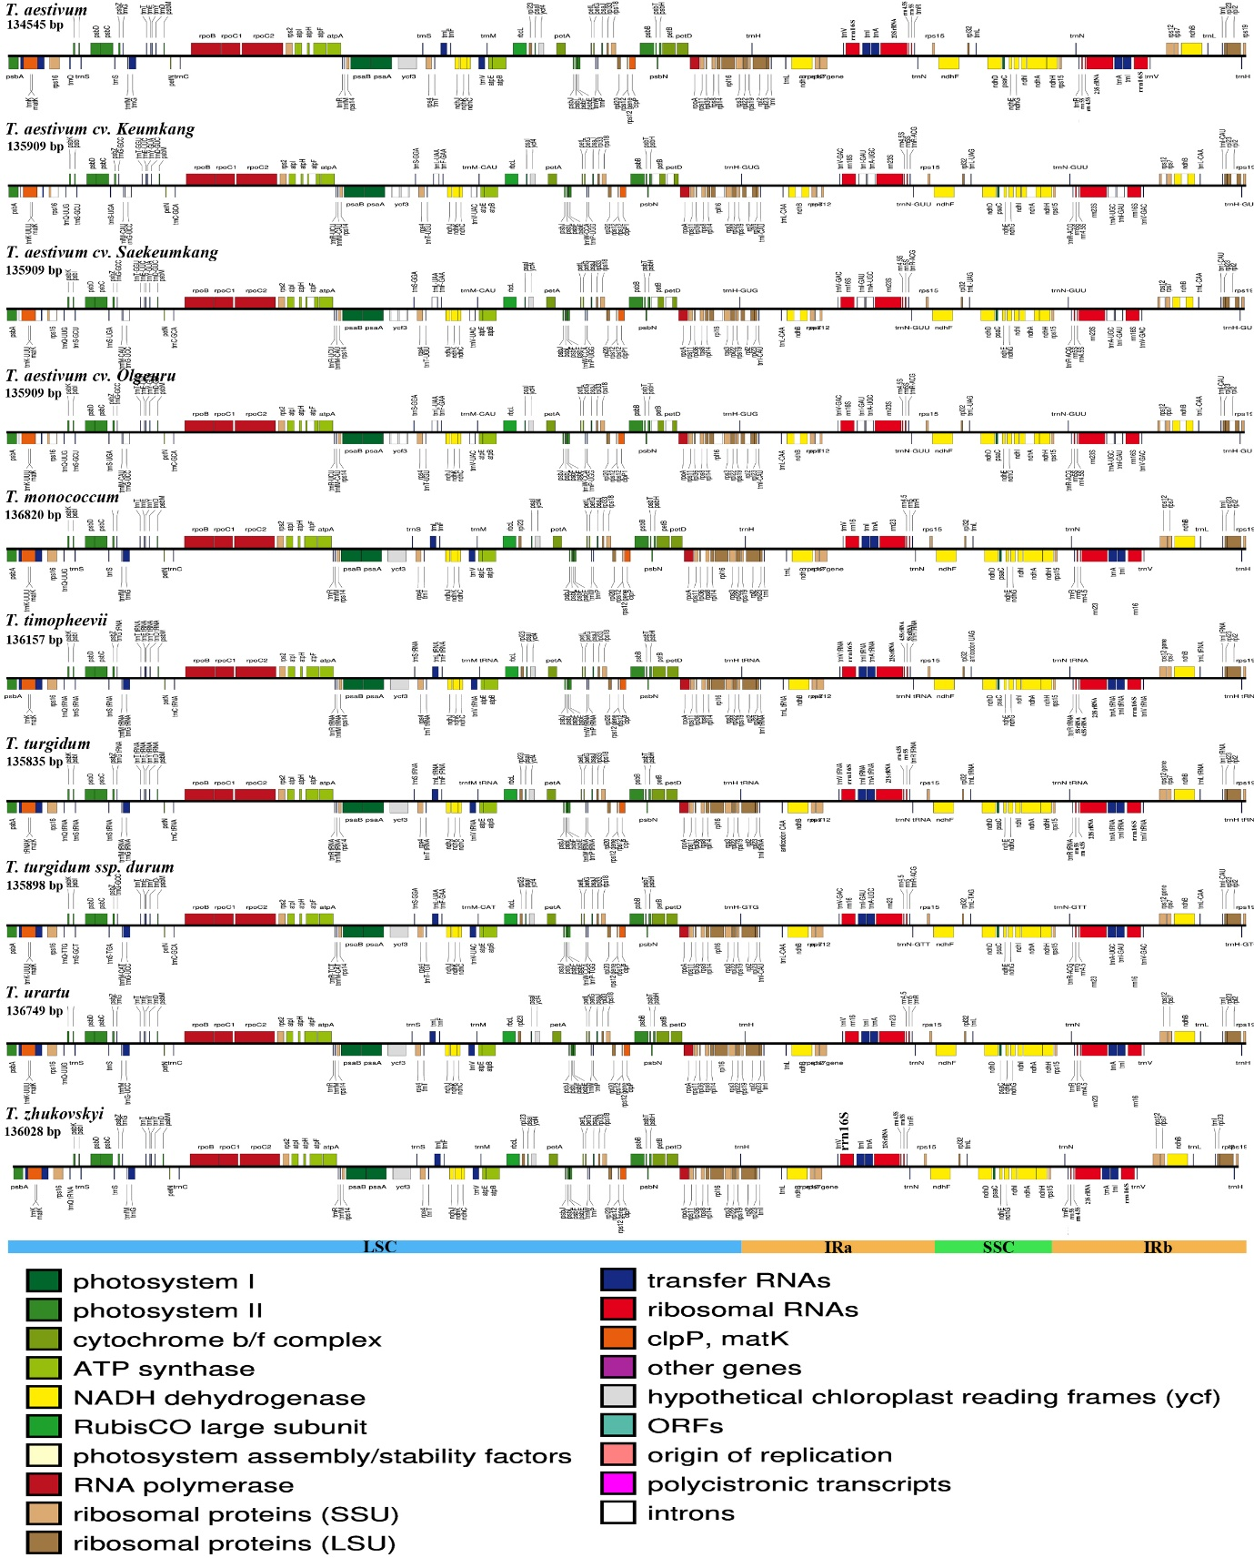
Figure S3. Linear map of the chloroplast genome of selected Triticum species. The map displays gene arrangement and structural features, emphasizing conserved and variable regions within the chloroplast genomes.

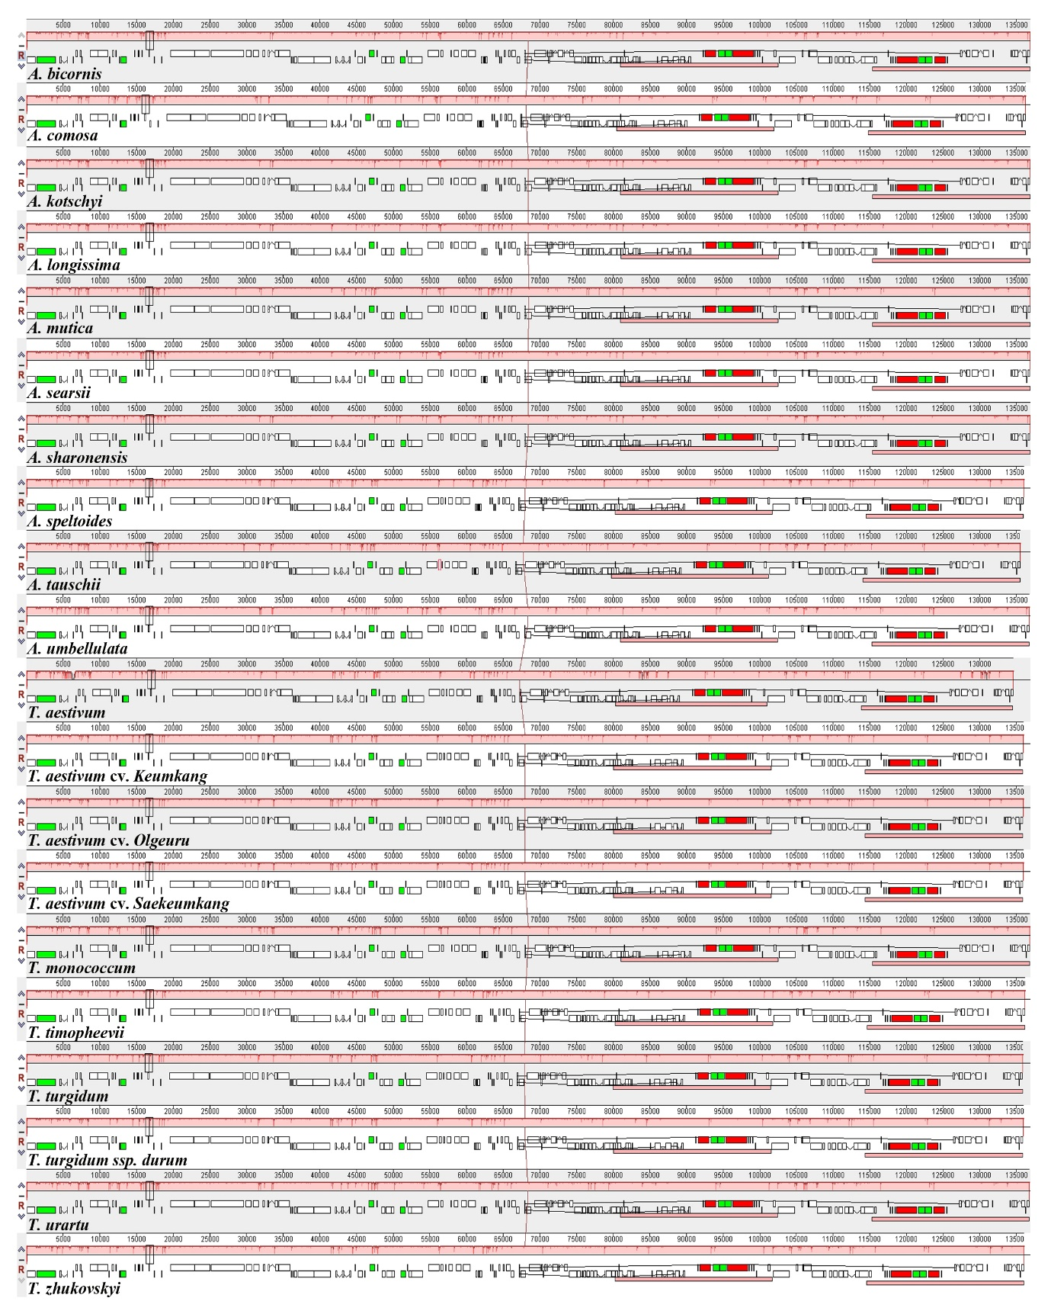
Figure S4. Multiple alignment of chloroplast genomes from the Triticum–Aegilops complex using Mauve. The alignment reveals LCBs indicating conserved genomic regions and structural rearrangements among the chloroplast genomes. Red box in A. tauschii highlight the location of missing copy of rpl23 gene

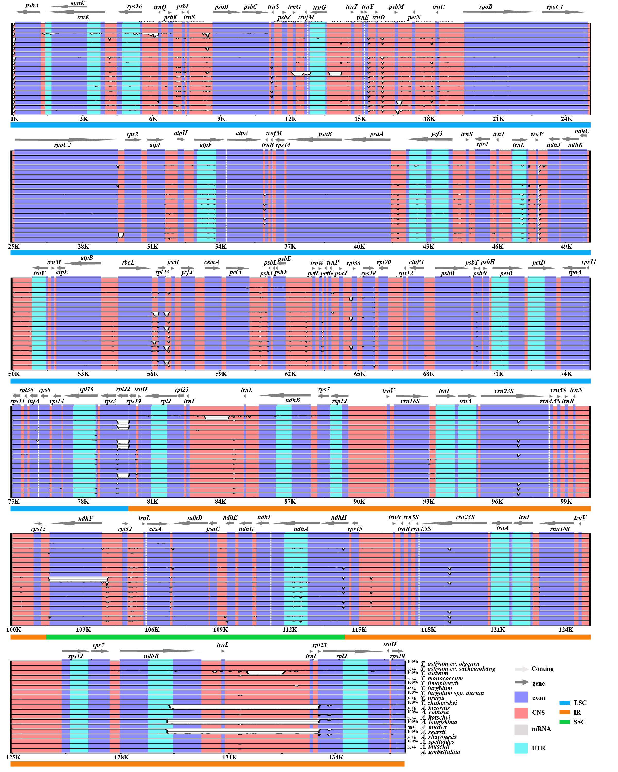
Figure S5. mVISTA analysis of chloroplast genomes in the Triticum–Aegilops complex. The plot shows sequence conservation and divergence across species, highlighting conserved regions and variable hotspots.

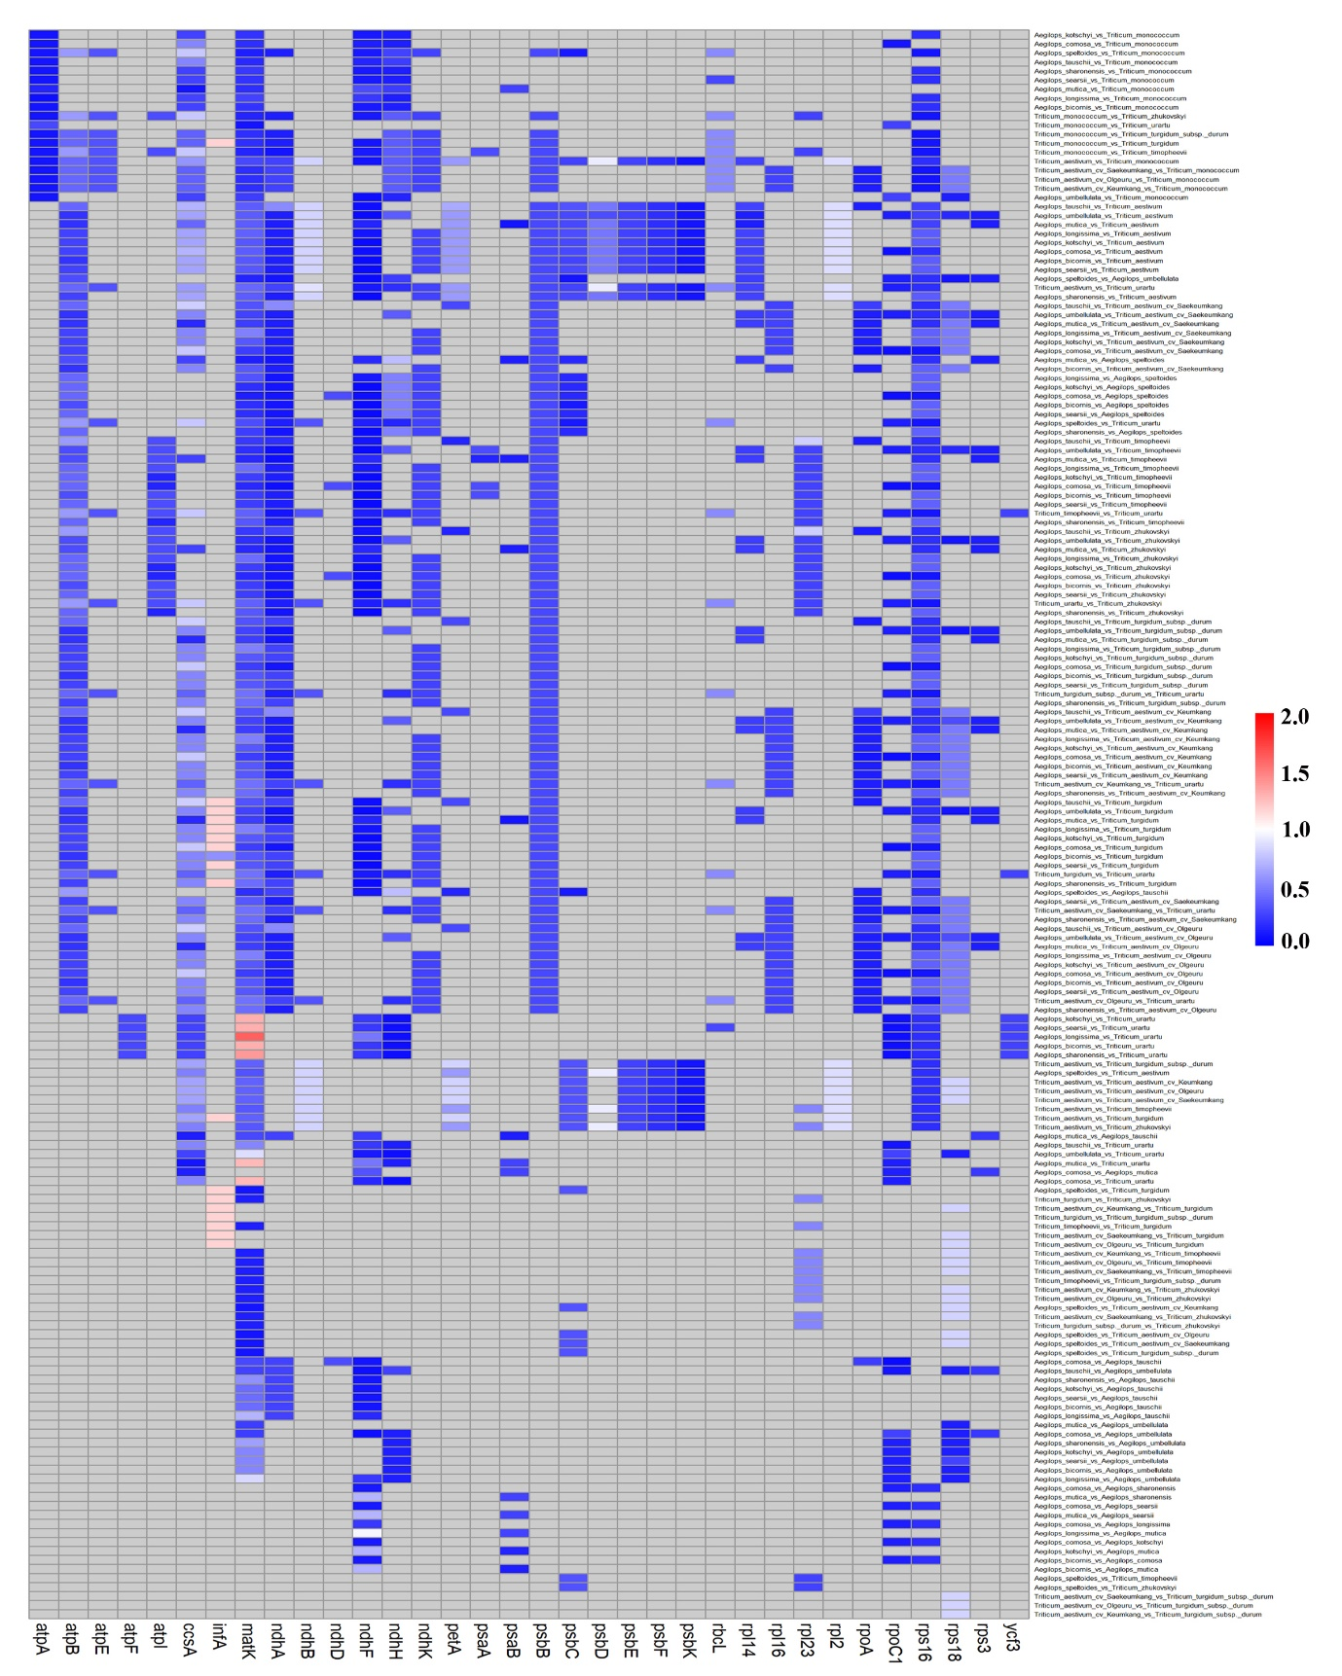
Figure S6. Heatmap of selective pressure (Ka/Ks ratios) among chloroplast genes in the Triticum–Aegilops complex. Ka/Ks values range from 0 to 2, where 0 indicates strong purifying (negative) selection with no amino acid changes tolerated, and values near 2 suggest positive (diversifying) selection favoring amino acid changes.

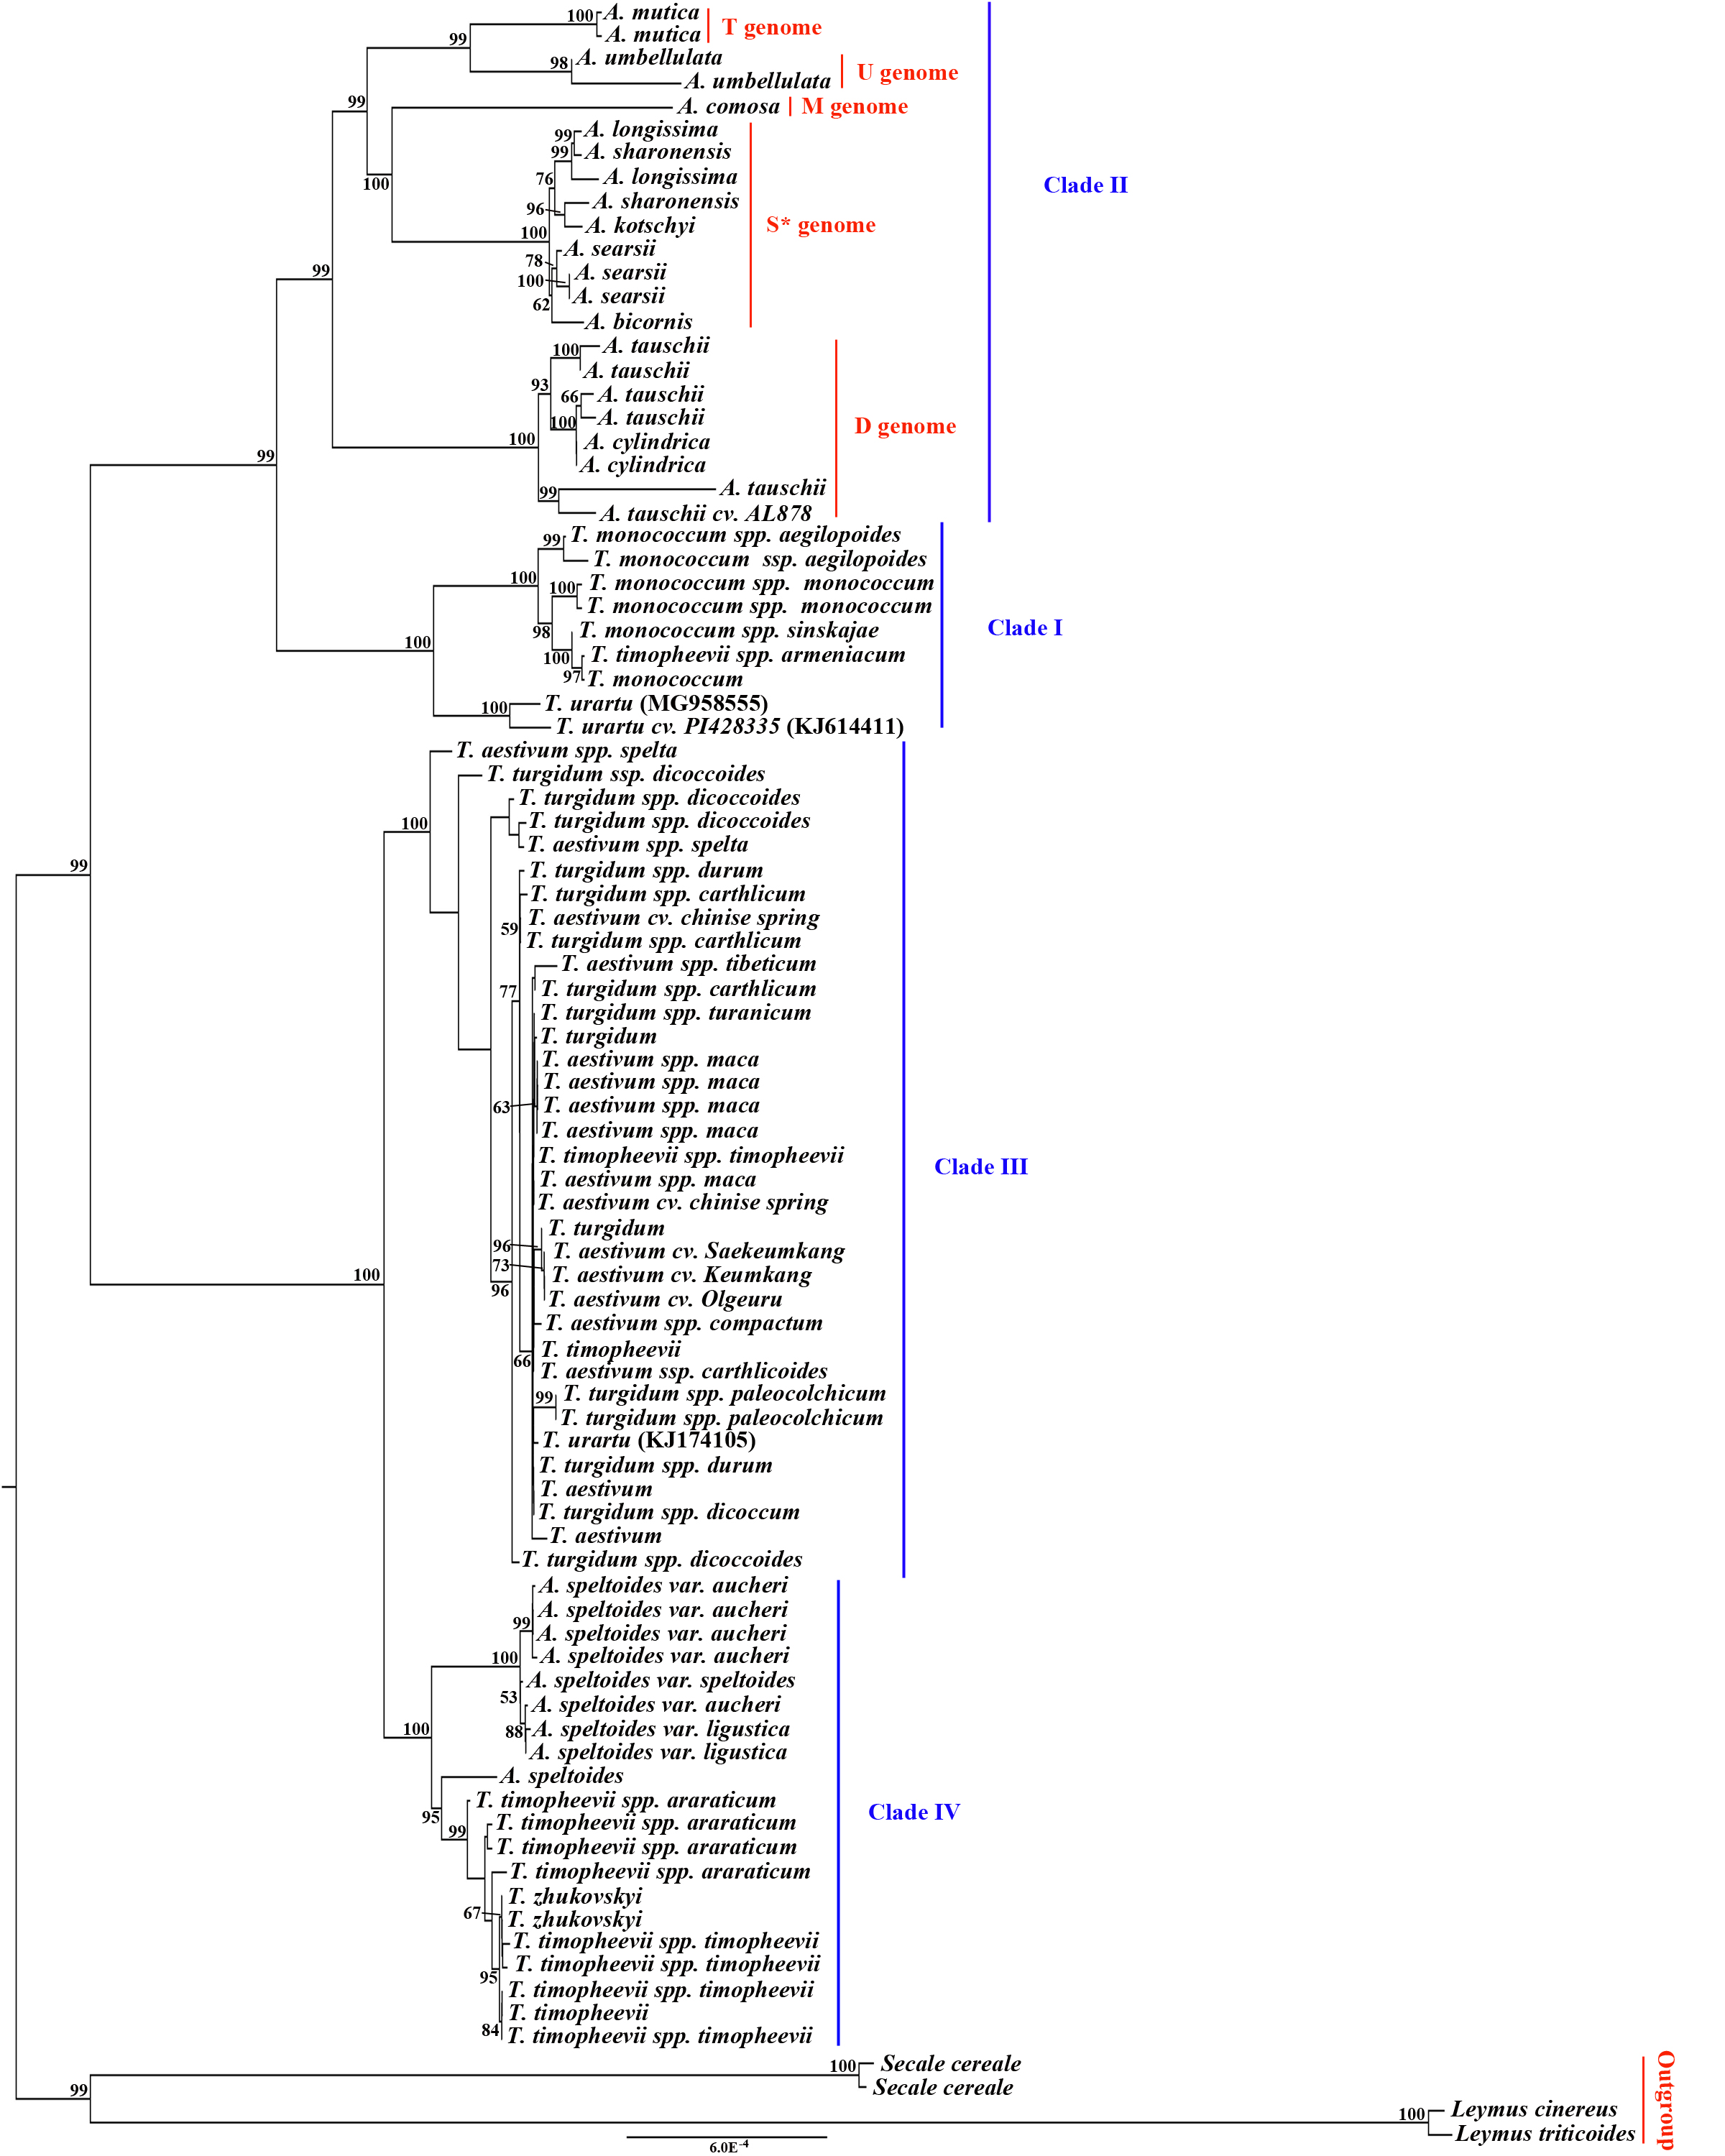
Figure S7. Maximum likelihood phylogenetic tree of the Triticum–Aegilops complex. The tree depicts evolutionary relationships among species based on chloroplast genome sequences, with branch support values indicated.

