GFP Chlorophyll Bright field Merge
35S::GFP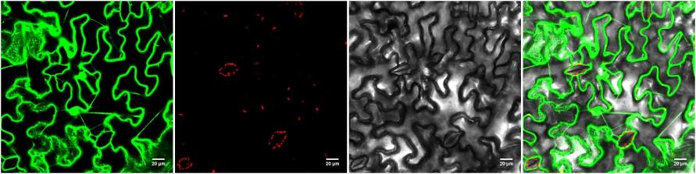
35S::LOC110688032-GFP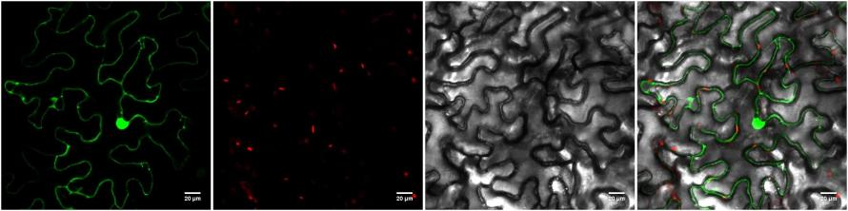

Fig 11 (A) Subcellular localization map of LOC110688032. Note: Fluorescence channel, chloroplast channel, brightfield, and overlay image from left to right for empty vector control (35S::GFP) and target gene protein (35S::LOC110688032-GFP), with scale bars of 20μm.

LOC110688032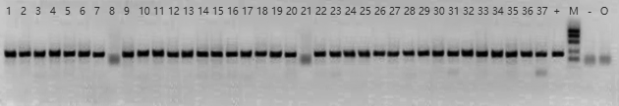

Fig 11 (B) PCR identification results for transgenic Arabidopsis positive lines. Note: Leftmost marker is positive control, rightmost marker is negative control, second from right is water control.

