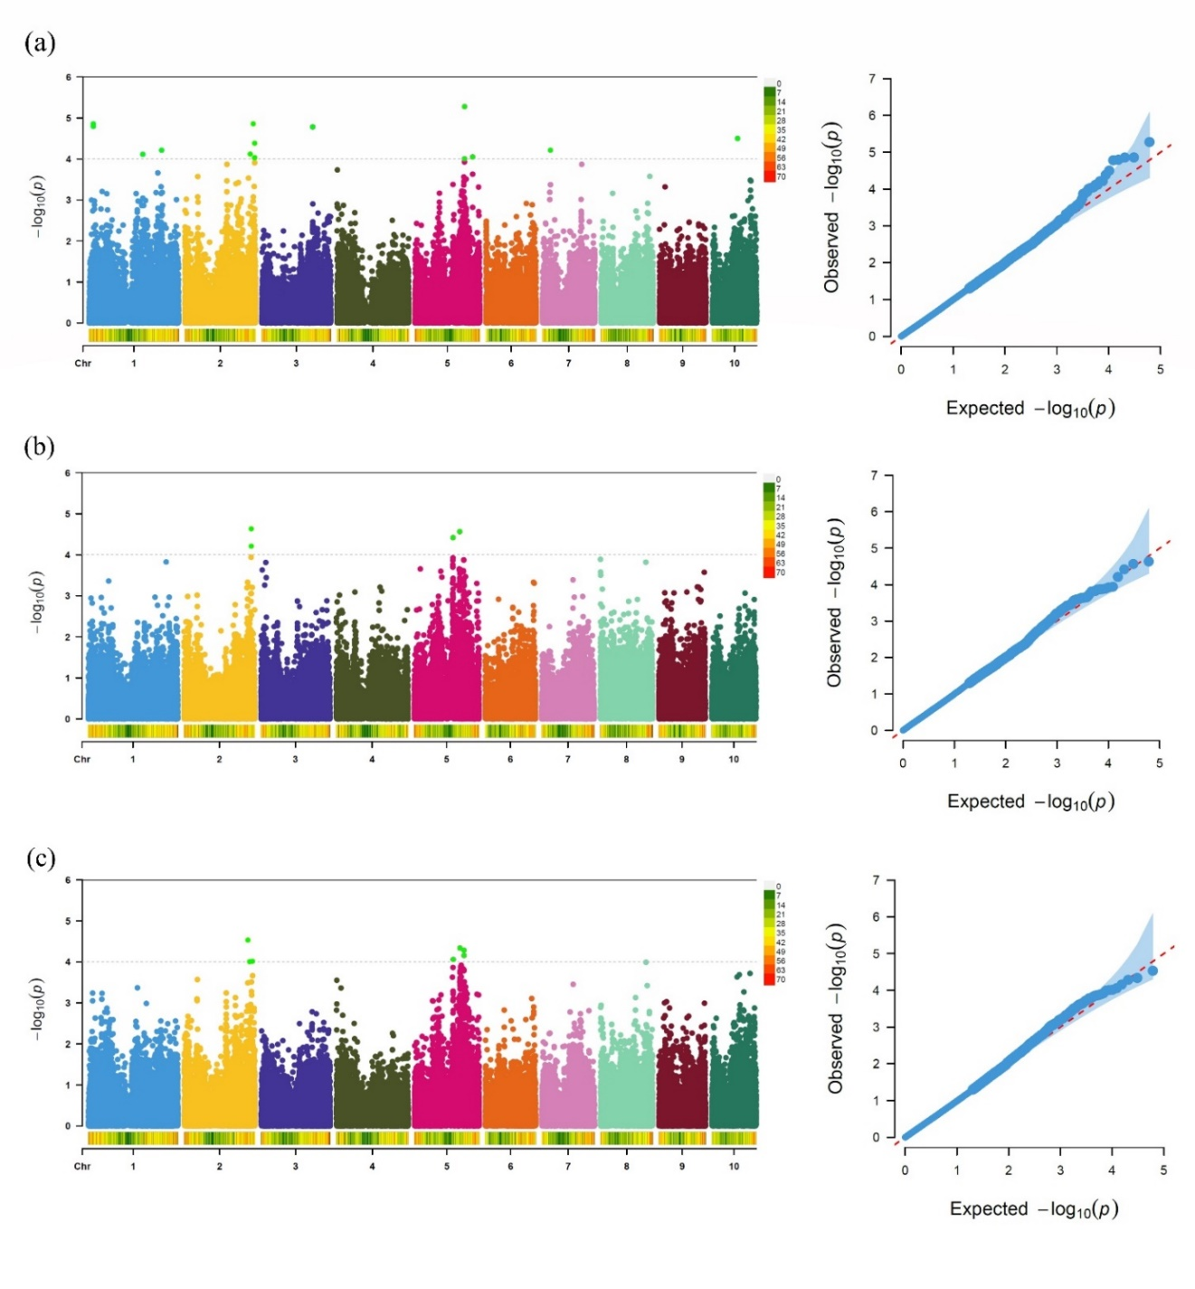
Figure S1 Genome-wide association results for pericarp thickness on the dorsal side (DES) across three environments. Manhattan and Q-Q plots for the 2023 environment, 2024 environment, and BLUP estimates (a–c) respectively. In the Manhattan plots, the x-axis represents physical positions across the 10 maize chromosomes, and the y-axis shows the –log₁₀(P) values of SNP-trait associations. The horizontal dashed line indicates the genome-wide significance threshold of –log₁₀(P) = 4. Q-Q plots display the expected versus observed –log₁₀(P) values, illustrating the fit of the association model and potential deviations indicating true associations.
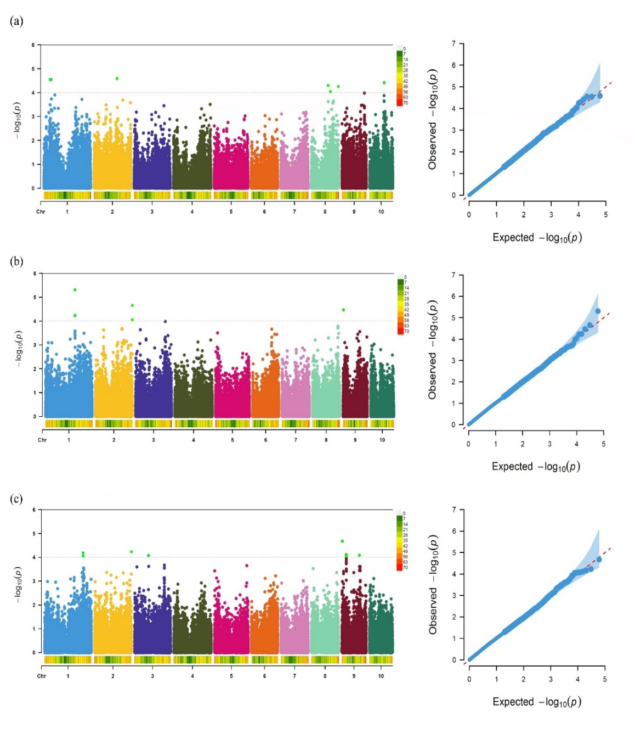
Figure S2 Genome-wide association results for glucose contents across three environments. Manhattan and Q-Q plots for the 2023 environment, 2024 environment, and BLUP estimates (a–c) respectively. In the Manhattan plots, the x-axis represents physical positions across the 10 maize chromosomes, and the y-axis shows the –log₁₀(P) values of SNP-trait associations. The horizontal dashed line indicates the genome-wide significance threshold of –log₁₀(P) = 4. Q-Q plots display the expected versus observed –log₁₀(P) values, illustrating the fit of the association model and potential deviations indicating true associations.

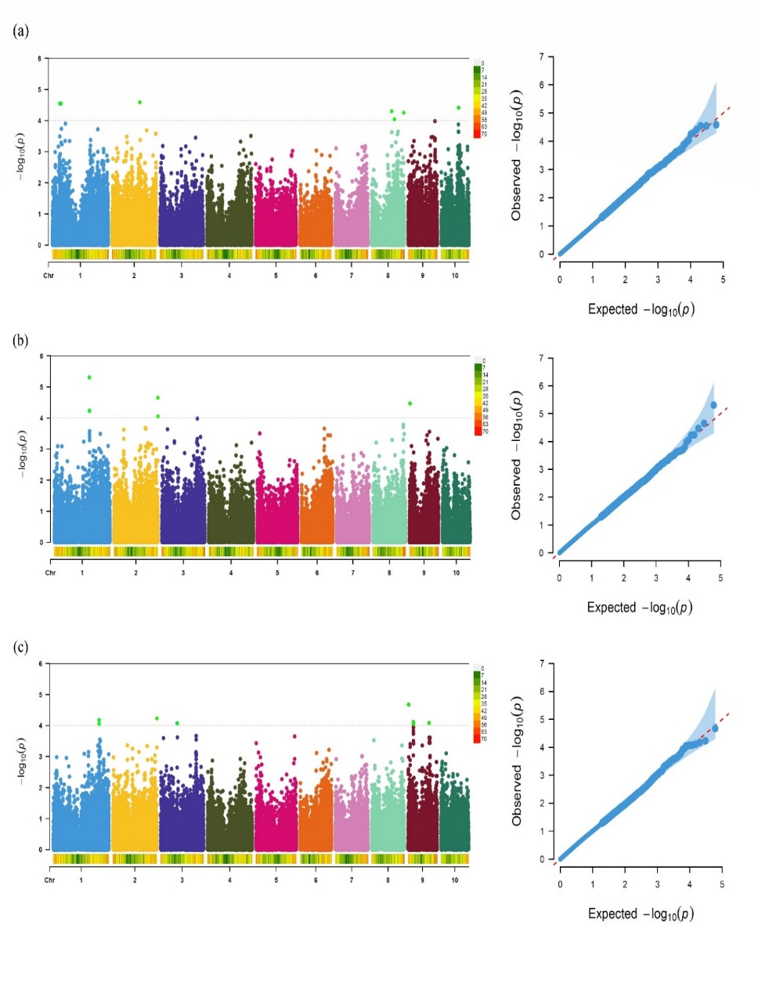

Figure S3 Genome-wide association results for pericarp thickness on the dorsal side (DES) across three environments. Manhattan and Q-Q plots for the 2023 environment, 2024 environment, and BLUP estimates (a–c) respectively. In the Manhattan plots, the x-axis represents physical positions across the 10 maize chromosomes, and the y-axis shows the –log₁₀(P) values of SNP-trait associations. The horizontal dashed line indicates the genome-wide significance threshold of –log₁₀(P) = 4. Q-Q plots display the expected versus observed –log₁₀(P) values, illustrating the fit of the association model and potential deviations indicating true associations.

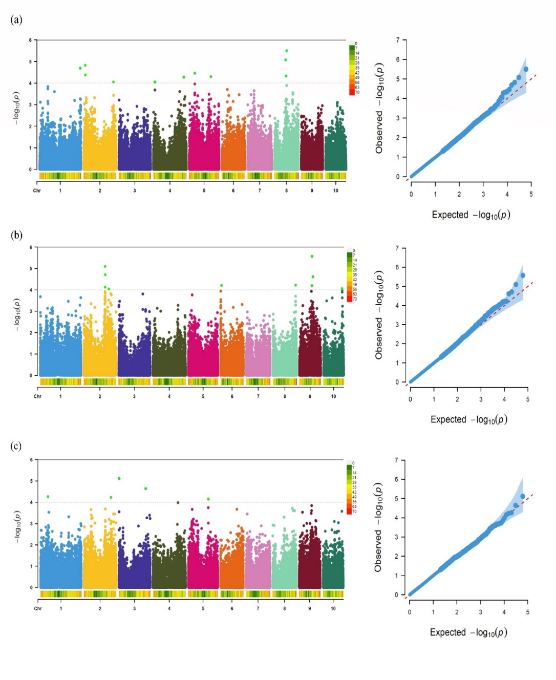
Figure S4. Genome-wide association results for Sucrose contents across three environments. Manhattan and Q-Q plots for the 2023 environment, 2024 environment, and BLUP estimates (a–c) respectively. In the Manhattan plots, the x-axis represents physical positions across the 10 maize chromosomes, and the y-axis shows the –log₁₀(P) values of SNP-trait associations. The horizontal dashed line indicates the genome-wide significance threshold of –log₁₀(P) = 4. Q-Q plots display the expected versus observed –log₁₀(P) values, illustrating the fit of the association model and potential deviations indicating true associations.

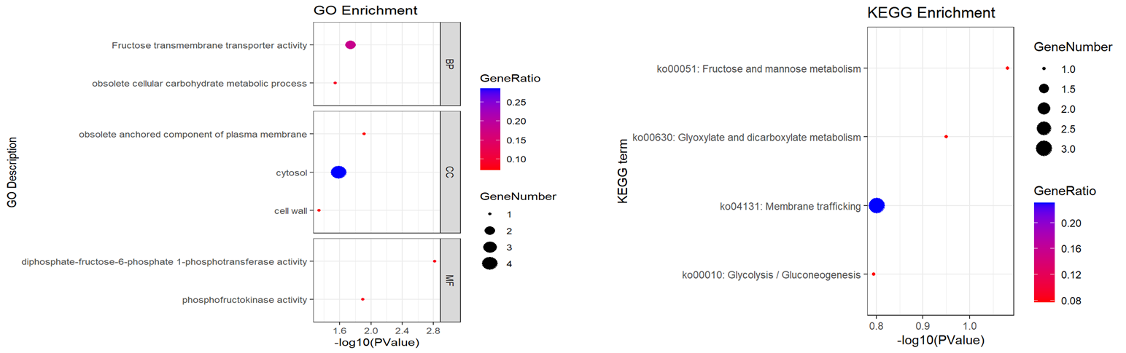
Figure S5. GO and KEGG enrichment analyses of candidate genes associated with Fructose-related traits. (a) Gene Ontology (GO) enrichment analysis; (b) Kyoto Encyclopedia of Genes and Genomes (KEGG) pathway enrichment analysis. Enrichment results are presented as bubble plots, where the x-axis represents the gene ratio (GeneRatio) and the y-axis corresponds to enriched GO terms or KEGG pathways. Bubble size reflects the number of associated genes, and bubble color indicates the gene ratio. Statistical significance is represented by the –log₁₀(P-value).

