Title page:

Title:
Genome-Wide Identiﬁcation, Classiﬁcation and Expression Analysis of Laccase Family Members in Solanum lycopersicum

Authors
Yanan Chen^{1†}, Xiaojing Liao¹, Xue Wang¹, Tongyan Du¹, Bo Qi¹, Faxiang Wan^{1*}, Jun Gao^{1*}
1. Faculty of Life Science and Food Engineering, Huaiyin Institute of Technology, Huaian, Jiangsu, The People’s Republic of China

First author: Yanan Chen

Corresponding author:
Faxiang Wan^{1*}: Room 318, Faculty of Life Science and Food Engineering, Huaiyin Institute of Technology, South Campus, 1 Meicheng Road, Huai’an City, Huaian Jiangsu 223003, P.R. China; E-mail: wanfaxiang@hyit.edu.cn
Jun Gao^{1*}: Room 217, Faculty of Life Science and Food Engineering, Huaiyin Institute of Technology, South Campus, 1 Meicheng Road, Huai’an City, Huaian Jiangsu 223003, P.R. China; E-mail: jgao@hyit.edu.cn

Authors' E-mail:
Yanan Chen, chenyanan@hyit.edu.cn
Xiaojing Liao, jshahygxy@163.com
Xue Wang, 19516216098@163.com
Tongyan Du, 19516783982@163.com
Bo Qi, mtsdhzhq@163.com
Faxiang Wan, wanfaxiang@hyit.edu.cn
Jun Gao, jgao@hyit.edu.cn

Supplementary Table S1. All the primer sequences used in this study
Primer names | Primer sequence (5’-3’)
q-SlCAC-F | CCTCCGTTGTGATGTAACTGG
q-SlCAC-R | ATTGGTGGAAAGTAACATCATCG
q-SlLAC1-F | TGTGGTGGCATGCGCATA
q-SlLAC1-R | GGGGGTTCCTTGCGATGG
q-SlLAC2-F | ATGGCGGATTTCCAGGGC
q-SlLAC2R | GACCGTCTGCCCAACCAT
q-SlLAC3-F | CTACCTGCTGAGGCTGCC
q-SlLAC3-R | GTTGGCCCCGGAAATCCT
q-SlLAC4-F | AACATAACCACCACCGCCA
q-SlLAC4-R | TTCGGGAGATCGGGGAGG
q-SlLAC5-F | CCTATGGTGGCACGCACA
q-SlLAC5-R | AGGATAAGCGCGACCACG
q-SlLAC6-F | GGTGGATGGGCTGCCATT
q-SlLAC6-R | GCACCACCGATAAGCCCC
q-SlLAC7-F | ACGCACGGAGTCAAGCAA
q-SlLAC7-R | CGTGCCACCAAAGTGTGC
q-SlLAC8-F | ATTGGCATGGGGTGAGGC
q-SlLAC8-R | CTATGGGCGTGCCACCAA
q-SlLAC9-F | GGTGGTGGTTGGGTTGCT
q-SlLAC9-R | CCCCATGTTGTGTGCACC
q-SlLAC10-F | TACAGCCACAGCCACTGC
q-SlLAC10-R | CTTGGGCCACGGGTACAG
q-SlLAC11-F | ATCAGTCCCCTGGCCGAT
q-SlLAC11-R | AGGCCTTGAATTCGCCCC
q-SlLAC12-F | TCGCGGTTGATGCTGCTT
q-SlLAC12-R | GGTAGCTGATCGGCCGTC
q-SlLAC13-F | TCCATGCATCTGTCGCGG
q-SlLAC13-R | CGTGCCGCGATGGATACT
q-SlLAC14-F | TGCAAGGGAAGGTGATCGTC
q-SlLAC14-R | GCTGGTCCATCTGCCCAT
q-SlLAC15-F | TTGGGTCGCCATTCGCTT
q-SlLAC15-R | TCAAGCCCCAACTTGTGTGT
q-SlLAC16-F | ACCGCGGATTTTCCAGGG
q-SlLAC16-R | CCCACTCGTTGTGCCCAT
q-SlLAC17-F | TTGCACCAGGCCAAACCA
q-SlLAC17-R | TGGCTGTTGCAGTCACGT
q-SlLAC18-F | CCCCTGGCCAGACAACAA
q-SlLAC18-R | AGTGCCCCGGTGTAATGC

Supplementary Table S2. Characteristics of the SlLAC genes identified in tomato.
Gene Name | Chromosome | Chromosome Start | Chromosome End | Exon Number | CDS Length (bp) | Number of Amino Acid | Molecular Weight（Da）
SlLAC1 | 2 | 34935369 | 34938249 | 4 | 1455 | 484 | 53770.44
SlLAC2 | 2 | 48733879 | 48736267 | 6 | 1641 | 546 | 60438.3
SlLAC3 | 2 | 48738906 | 48741397 | 6 | 1680 | 559 | 61815.9
SlLAC4 | 4 | 59397499 | 59401779 | 6 | 1704 | 567 | 63490.03
SlLAC5 | 5 | 56922377 | 56928943 | 7 | 1620 | 539 | 59561.31
SlLAC6 | 5 | 61521073 | 61532304 | 6 | 2103 | 700 | 78037.83
SlLAC7 | 6 | 31915866 | 31918654 | 7 | 1656 | 551 | 60545.75
SlLAC8 | 6 | 33312949 | 33315516 | 6 | 1704 | 567 | 61921.25
SlLAC9 | 6 | 47808335 | 47811568 | 6 | 1683 | 560 | 62521.12
SlLAC10 | 6 | 48191560 | 48194811 | 4 | 1431 | 476 | 52815.71
SlLAC11 | 6 | 48198255 | 48200580 | 6 | 1689 | 562 | 62574.03
SlLAC12 | 7 | 59867252 | 59871361 | 6 | 1719 | 572 | 63303.62
SlLAC13 | 9 | 4332066 | 4347114 | 8 | 1851 | 616 | 68099.31
SlLAC14 | 9 | 5238093 | 5240761 | 6 | 1710 | 569 | 63627.22
SlLAC15 | 9 | 5243883 | 5249276 | 5 | 1614 | 537 | 59706.66
SlLAC16 | 9 | 5730146 | 5734142 | 6 | 1611 | 536 | 58428.19
SlLAC17 | 10 | 59897137 | 59900195 | 6 | 1671 | 556 | 61093.47
SlLAC18 | 10 | 64526289 | 64530077 | 6 | 1674 | 557 | 61407.97

Gene Name | Theoretical pI | Instability Index | Aliphatic Index | Grand Average of Hydropathicity | Location Prediction
SlLAC1 | 7.63 | 32.85 | 81.38 | -0.201 | Extracellular, Lysosomal
SlLAC2 | 8.46 | 26.45 | 85 | -0.111 | Lysosomal, Extracellular
SlLAC3 | 8.22 | 29.31 | 86.89 | -0.069 | Lysosomal, Extracellular
SlLAC4 | 6.05 | 31.29 | 85.22 | -0.215 | Lysosomal
SlLAC5 | 9.34 | 25.19 | 81.76 | -0.169 | Extracellular, Lysosomal
SlLAC6 | 9.02 | 39.42 | 76.03 | -0.35 | Extracellular
SlLAC7 | 8.24 | 33.44 | 83.47 | -0.113 | Extracellular
SlLAC8 | 6.8 | 35.76 | 82.22 | -0.076 | Extracellular
SlLAC9 | 9 | 35.19 | 90.46 | -0.068 | Plasma Membrane, Lysosomal
SlLAC10 | 8.78 | 29.59 | 77.02 | -0.251 | Extracellular
SlLAC11 | 7.64 | 33.36 | 84.27 | -0.119 | Extracellular, Plasma Membrane
SlLAC12 | 9.01 | 27.49 | 84.04 | -0.079 | Extracellular, Plasma Membrane
SlLAC13 | 9.23 | 30.84 | 76.46 | -0.335 | Extracellular, Nuclear
SlLAC14 | 9.01 | 32.45 | 89.21 | -0.141 | Extracellular, Lysosomal
SlLAC15 | 9.7 | 29.94 | 81.62 | -0.19 | Extracellular
SlLAC16 | 9.25 | 27.85 | 86.88 | -0.098 | Extracellular
SlLAC17 | 9.38 | 32.65 | 84.14 | -0.056 | Extracellular
SlLAC18 | 9.26 | 32.09 | 88.19 | -0.001 | Plasma Membrane, Extracellular

Supplementary Table S3. Cis-acting elements in the promoter regions of the SlLACs genes
Abiotic stress
Gene name | MYB binding site involved in drought-inducibility | defense and stress responsiveness | circadian control | light responsiveness | low-temperature responsiveness | anaerobic induction
SlLAC1 | 0 | 0 | 1 | 10 | 1 | 5
SlLAC2 | 0 | 0 | 0 | 14 | 0 | 1
SlLAC3 | 1 | 0 | 0 | 10 | 0 | 1
SlLAC4 | 0 | 1 | 0 | 6 | 1 | 0
SlLAC5 | 0 | 2 | 0 | 7 | 0 | 0
SlLAC6 | 0 | 0 | 0 | 14 | 0 | 2
SlLAC7 | 0 | 0 | 0 | 9 | 0 | 1
SlLAC8 | 0 | 0 | 0 | 14 | 0 | 3
SlLAC9 | 2 | 2 | 0 | 11 | 0 | 0
SlLAC10 | 0 | 0 | 0 | 12 | 2 | 2
SlLAC11 | 1 | 2 | 0 | 14 | 1 | 3
SlLAC12 | 0 | 0 | 0 | 10 | 0 | 1
SlLAC13 | 0 | 1 | 0 | 11 | 0 | 0
SlLAC14 | 0 | 0 | 1 | 11 | 0 | 1
SlLAC15 | 0 | 1 | 0 | 14 | 0 | 3
SlLAC16 | 0 | 0 | 0 | 10 | 1 | 0
SlLAC17 | 1 | 0 | 1 | 12 | 10 | 3
SlLAC18 | 1 | 1 | 1 | 11 | 1 | 0

Hormone-related elements
Gene name | gibberellin-responsive | salicylic acid responsiveness | abscisic acid responsiveness | auxin responsiveness | MeJA-responsiveness
SlLAC1 | 1 | 1 | 1 | 1 | 4
SlLAC2 | 0 | 0 | 0 | 1 | 8
SlLAC3 | 2 | 0 | 2 | 0 | 0
SlLAC4 | 0 | 1 | 0 | 0 | 4
SlLAC5 | 0 | 0 | 0 | 0 | 2
SlLAC6 | 1 | 0 | 4 | 0 | 4
SlLAC7 | 1 | 0 | 1 | 0 | 8
SlLAC8 | 0 | 1 | 0 | 1 | 2
SlLAC9 | 3 | 1 | 2 | 1 | 4
SlLAC10 | 0 | 0 | 1 | 0 | 2
SlLAC11 | 0 | 2 | 2 | 1 | 2
SlLAC12 | 2 | 0 | 0 | 0 | 0
SlLAC13 | 2 | 0 | 5 | 0 | 4
SlLAC14 | 0 | 0 | 0 | 1 | 0
SlLAC15 | 3 | 0 | 2 | 0 | 0
SlLAC16 | 2 | 0 | 1 | 0 | 2
SlLAC17 | 3 | 0 | 1 | 1 | 0
SlLAC18 | 0 | 0 | 0 | 0 | 4

Plant growth and development
Gene name | seed-specific regulation | zein metabolism regulation | meristem expression | endosperm expression | differentiation of the palisade mesophyll cells | MYB binding site involved in flavonoid biosynthetic genes regulation
SlLAC1 | 0 | 0 | 1 | 0 | 0 | 0
SlLAC2 | 0 | 0 | 0 | 0 | 0 | 0
SlLAC3 | 0 | 0 | 0 | 0 | 0 | 0
SlLAC4 | 0 | 0 | 1 | 0 | 0 | 0
SlLAC5 | 0 | 0 | 0 | 0 | 0 | 0
SlLAC6 | 0 | 0 | 0 | 0 | 0 | 0
SlLAC7 | 0 | 0 | 0 | 2 | 0 | 0
SlLAC8 | 0 | 0 | 0 | 0 | 1 | 1
SlLAC9 | 0 | 0 | 0 | 1 | 0 | 0
SlLAC10 | 0 | 0 | 0 | 0 | 0 | 0
SlLAC11 | 0 | 1 | 0 | 0 | 0 | 0
SlLAC12 | 0 | 1 | 0 | 0 | 0 | 0
SlLAC13 | 0 | 1 | 0 | 0 | 0 | 1
SlLAC14 | 0 | 0 | 0 | 1 | 1 | 0
SlLAC15 | 0 | 2 | 0 | 0 | 0 | 0
SlLAC16 | 0 | 2 | 1 | 0 | 0 | 0
SlLAC17 | 0 | 1 | 0 | 0 | 0 | 0
SlLAC18 | 1 | 1 | 0 | 0 | 0 | 0

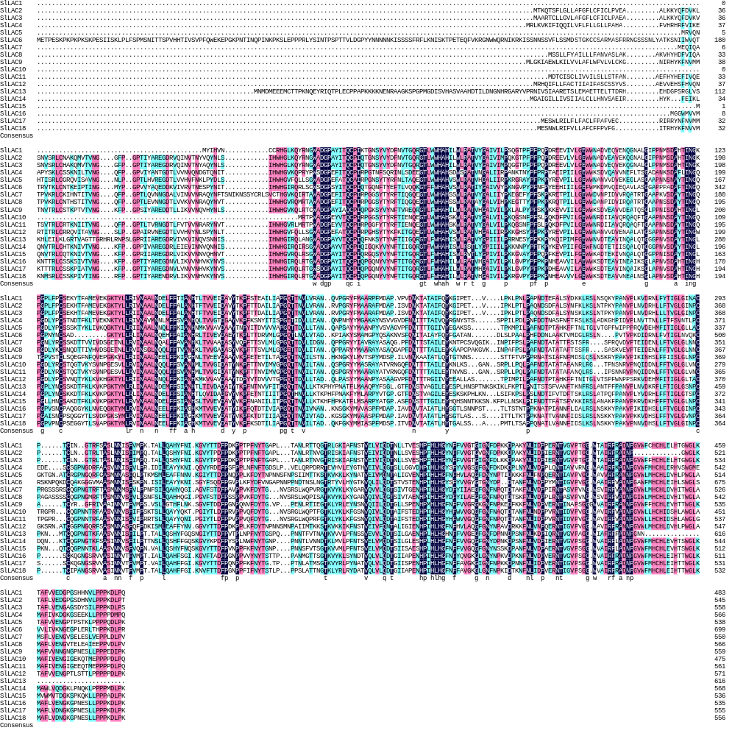
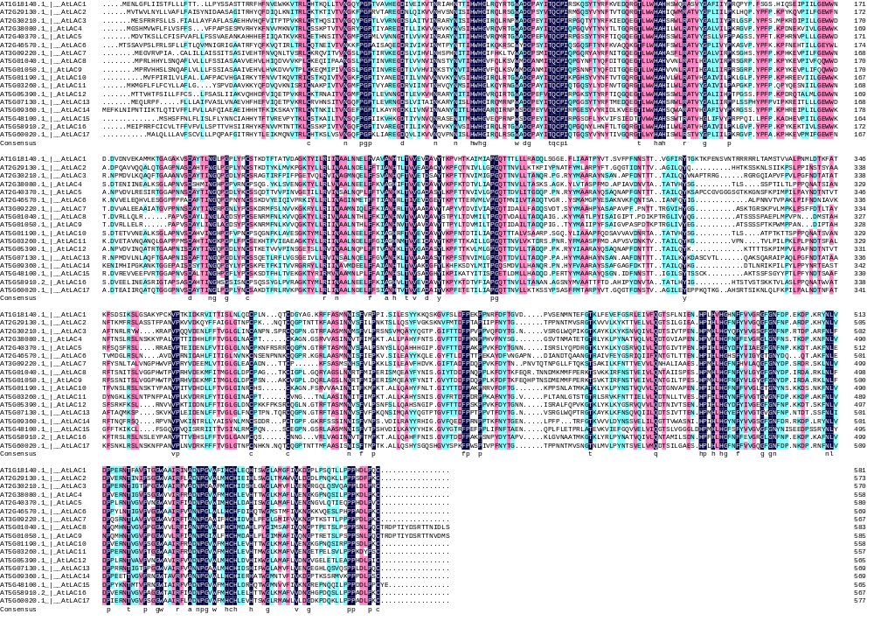
Fig. S1. Sequence alignment of tomato SlLACs and AtLACs protein

