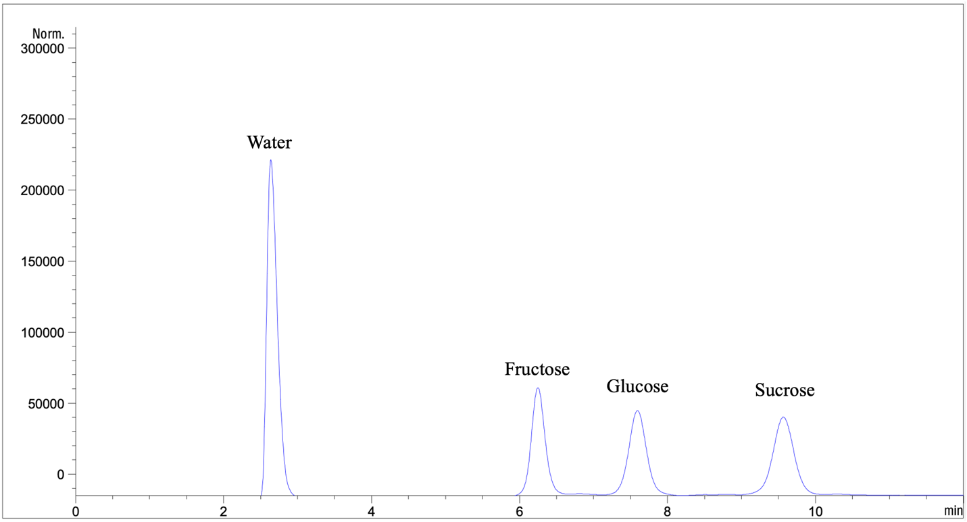
Supplementary Fig. A The HPLC chromatogram of 10 mg/mL sugars content.
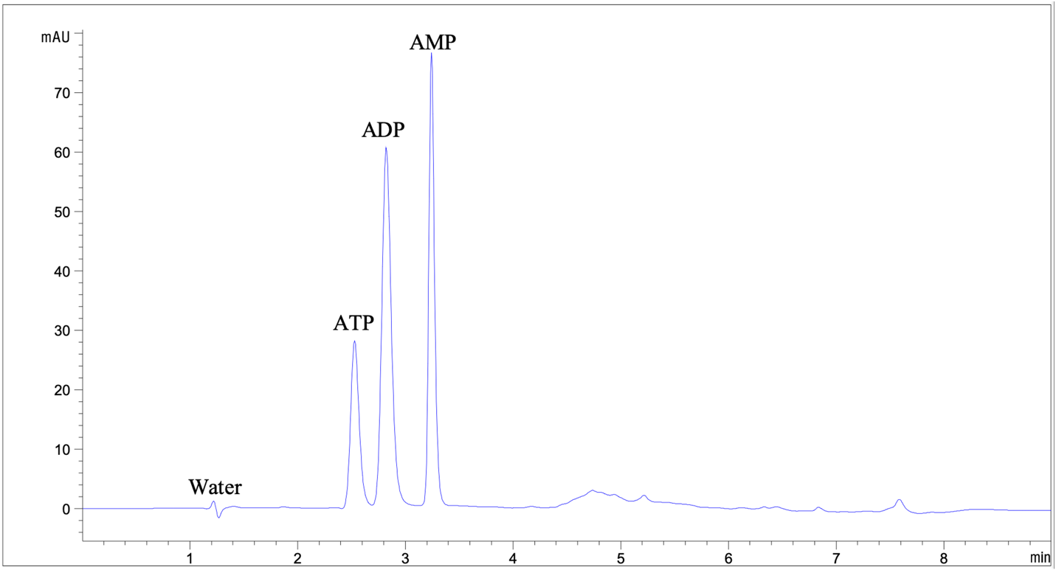
Supplementary Fig. B The HPLC chromatogram of 10 µg/mL adenylate content.

