Additional Figures

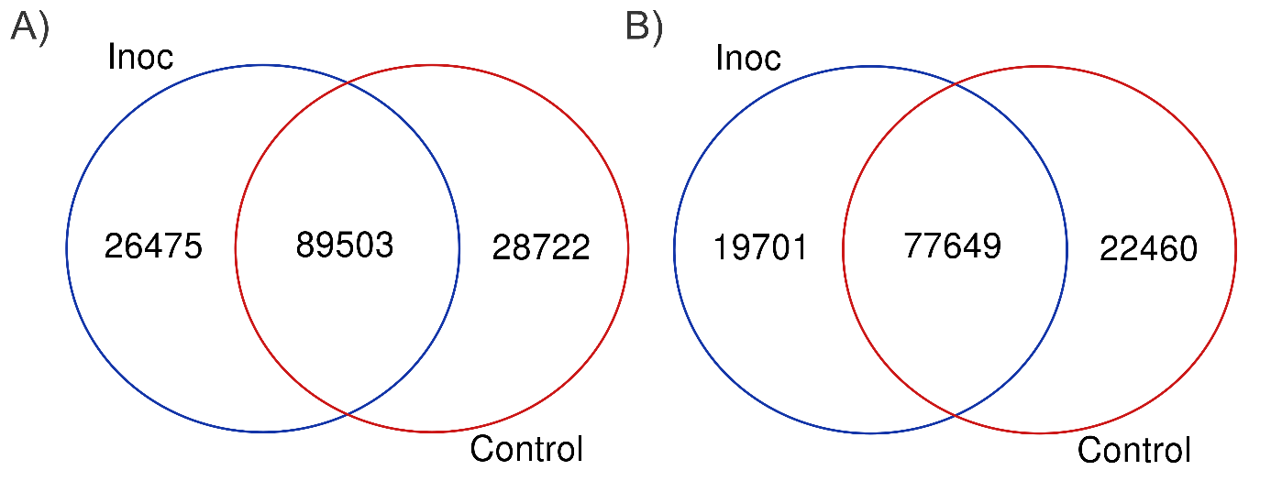
Figure S1. Venn diagram showing the number of assembled transcripts in inoculated and control transcriptomes of P. radiata (A) and P. pinea (B).

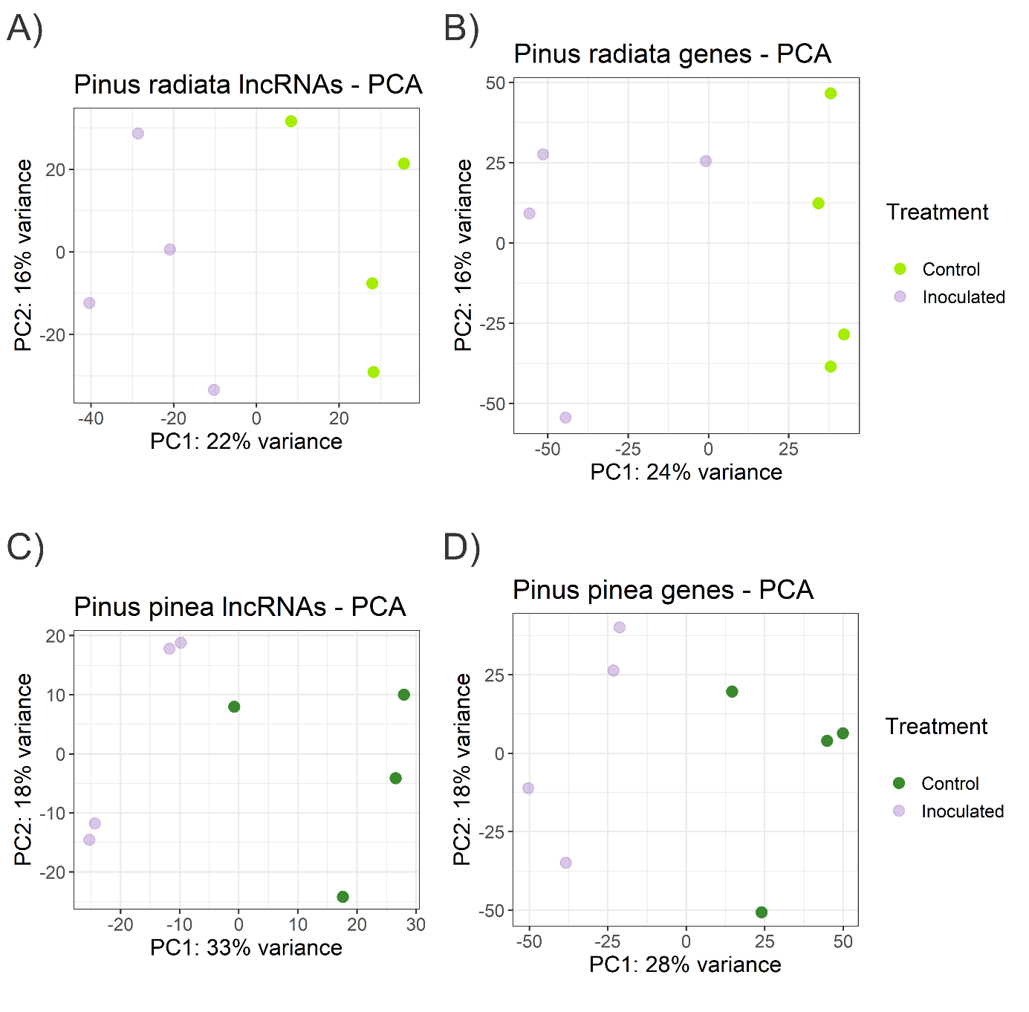
Figure S2. Two-dimensional scatterplot of the principal component analyses (PCA) for Pinus radiata (A) lncRNAs and (B) protein-coding RNA, and P. pinea (C) lncRNAs and (D) protein-coding RNA, based on rlog-transformed counts.

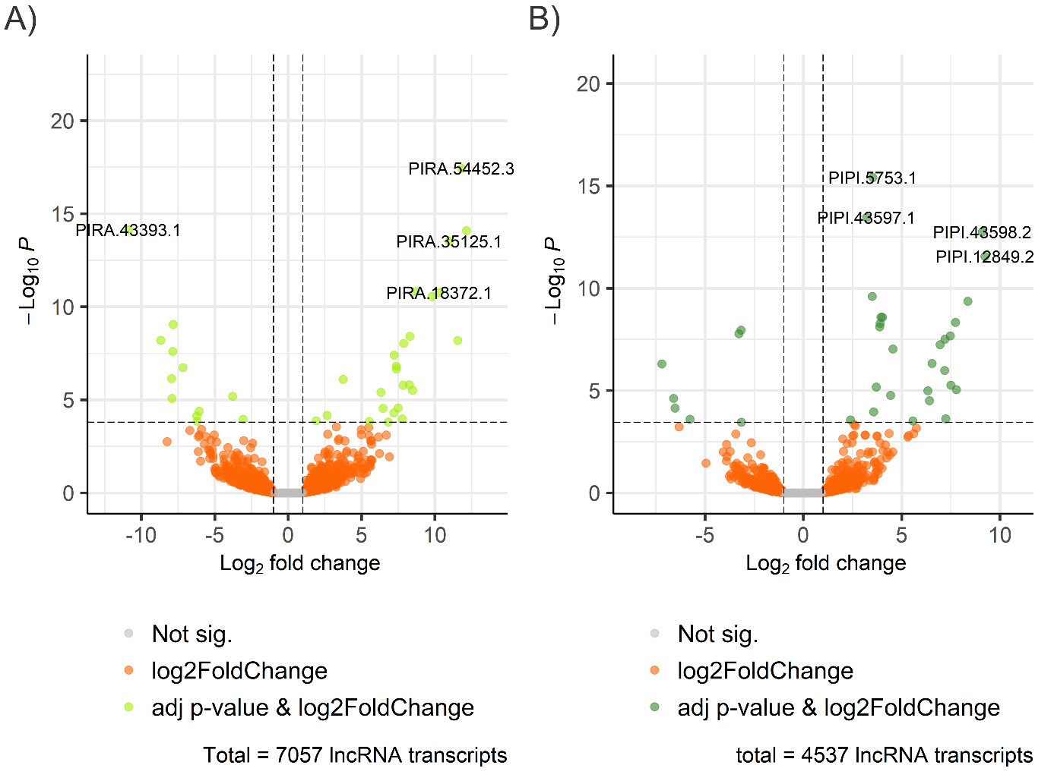
Figure S3. Volcano plots representing the differentially expressed lncRNAs (DELncRNAs) in (A) Pinus radiata and (B) P. pinea infected by Fusarium circinatum. The x-axis represents log₂ fold change, and the y-axis represents log₁₀ p-value. P-value < 0.05 and |log₂ fold change| ≥ 1.

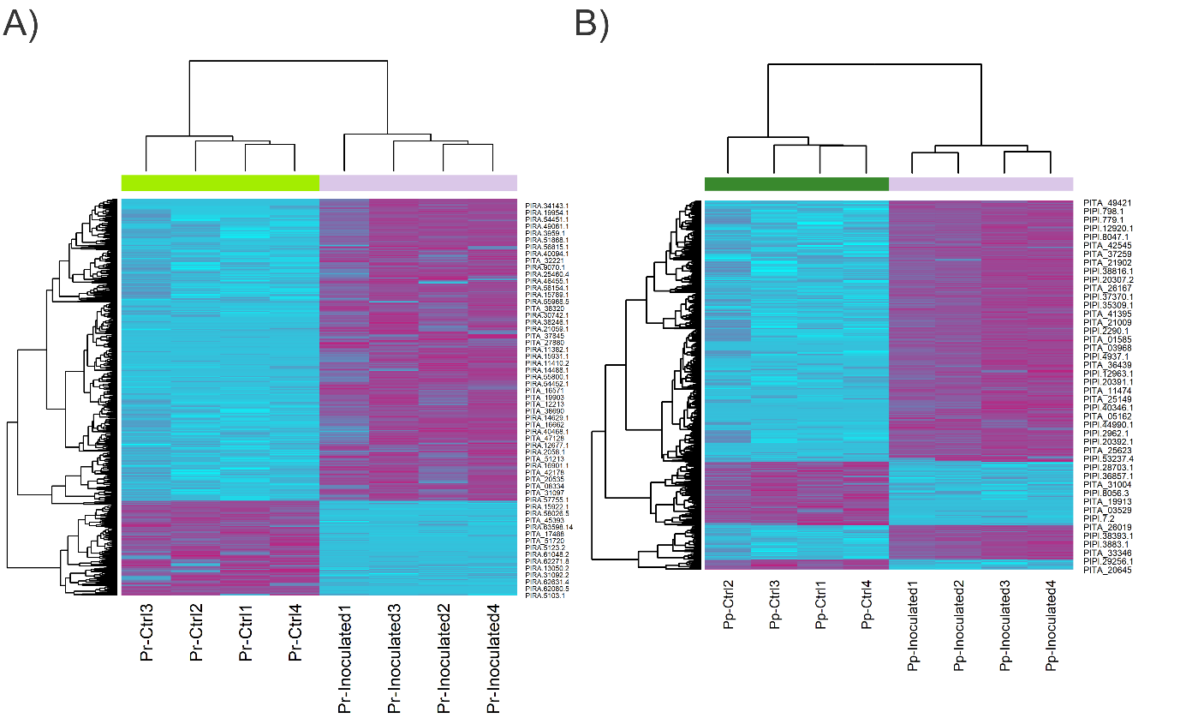
Figure S4. Hierarchical clustering plot of the differentially expressed genes of (A) Pinus radiata and (B) Pinus pinea in response to F. circinatum. The plots show the scaled expression levels of the genes. Different columns represent different libraries, and different rows represent the differentially expressed genes. Purplish: relatively high expression; Blue: relatively low expression.

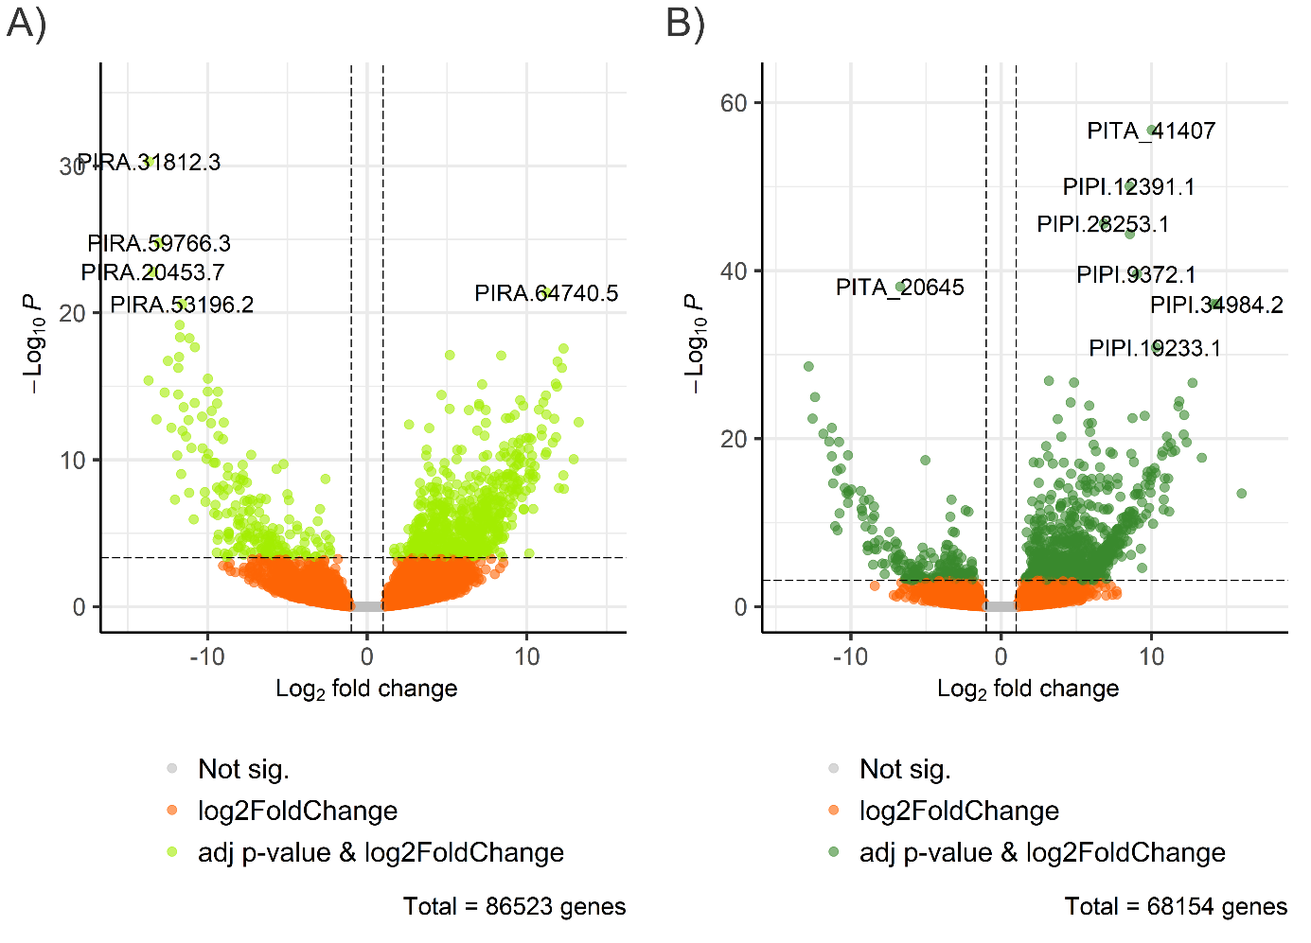
Figure S5. Volcano plot representing the differentially expressed genes (DEGs) in (A) Pinus radiata and (B) Pinus pinea infected by Fusarium circinatum. The x-axis represents log2 fold change, and the y-axis represents log₁₀ p-value. Adjusted p-value < 0.05 and |log2 fold change| ≥ 1.

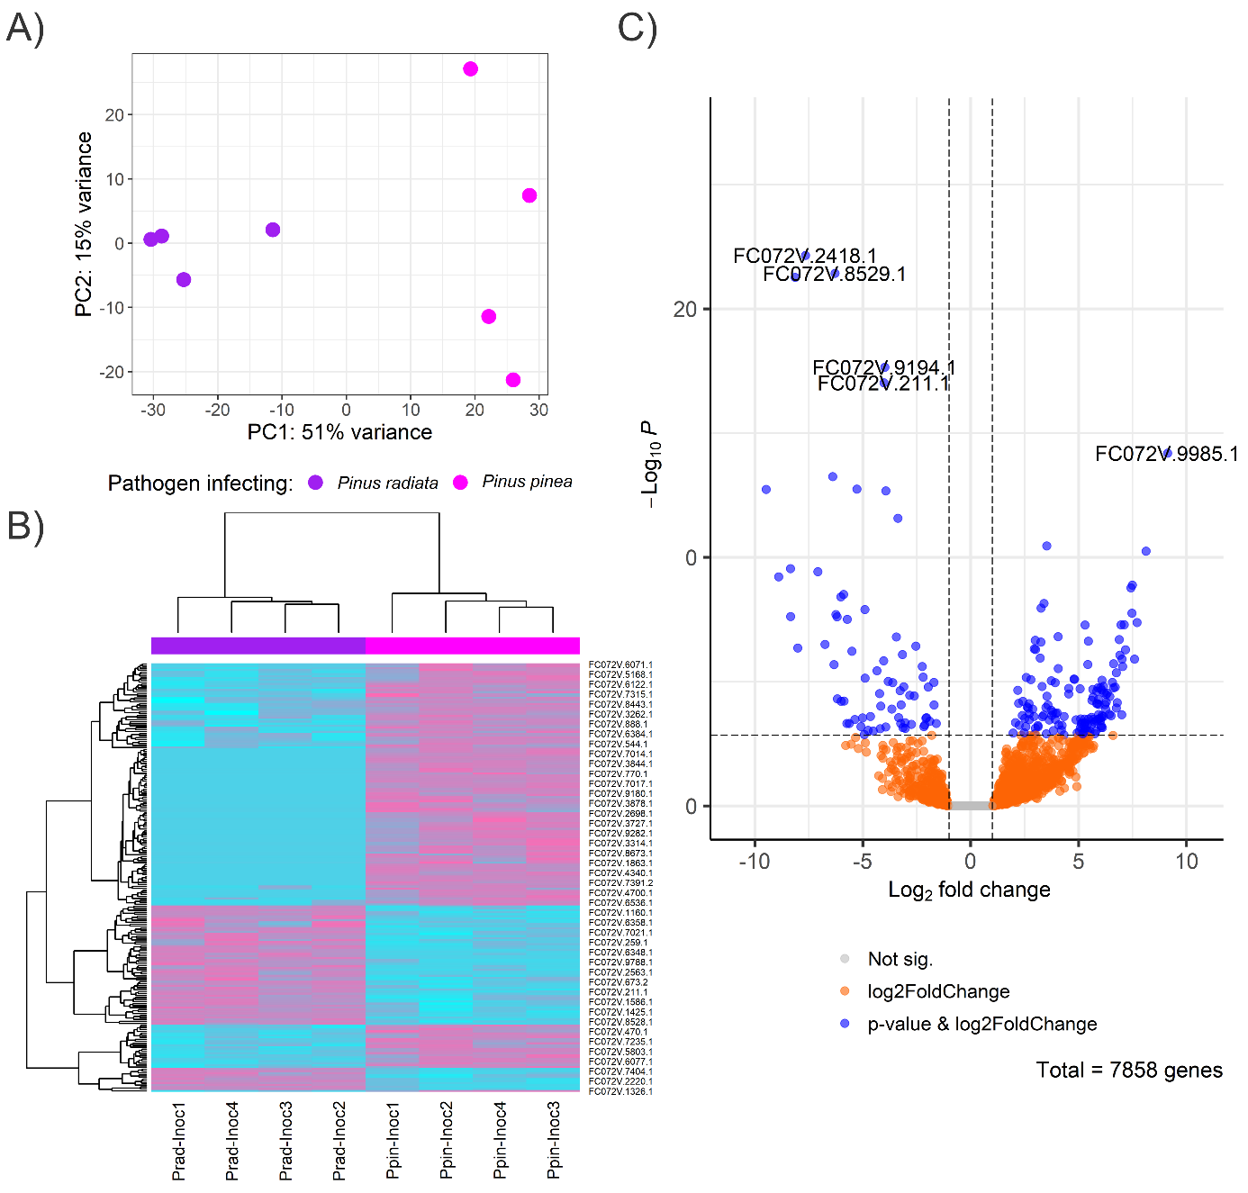
Figure S6. (A) Two-dimensional scatterplot of the principal component analyses (PCA) for Fusarium circinatum protein-coding transcripts under Pinus pinea infection compared to P. radiata infection based on rlog-transformed counts. (B) Hierarchical clustering plot of the differentially expressed genes of F. circinatum under P. pinea infection compared to P. radiata infection. The plots show the scaled expression levels of the genes. Different columns represent different libraries, and different rows represent the differentially expressed genes. Pinkish: relatively high expression; Blue: relatively low expression. (C) Volcano plot representing the differentially expressed genes (DEGs) in F. circinatum under P. pinea infection compared to P. radiata infection. The x-axis represents log2 fold change, and the y-axis represents log₁₀ p-value. Adjusted p-value < 0.05 and |log2 fold change| > 1.

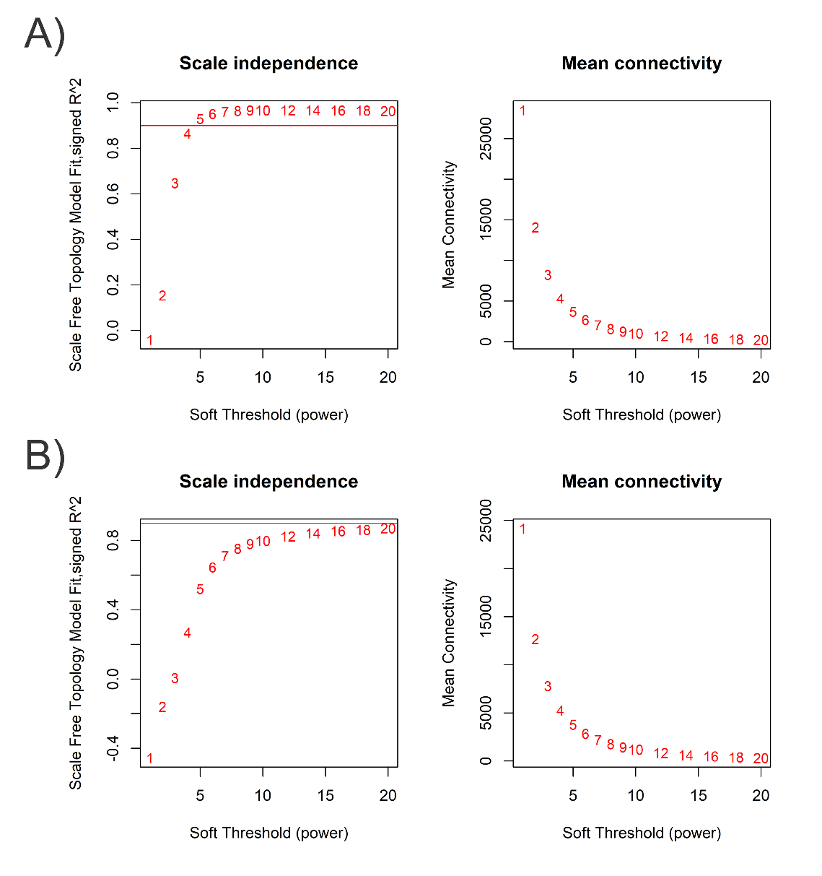
Figure S7. Selection of soft-thresholding power (β) for network construction. A) For P. radiata, a power of β = 6 was selected, yielding a scale-free topology fit of R² = 0.952, slope = −1.88, and mean connectivity = 2,680. B) For P. pinea, a power of β = 12 was chosen, corresponding to R² = 0.824, slope = −1.39, and mean connectivity = 852.

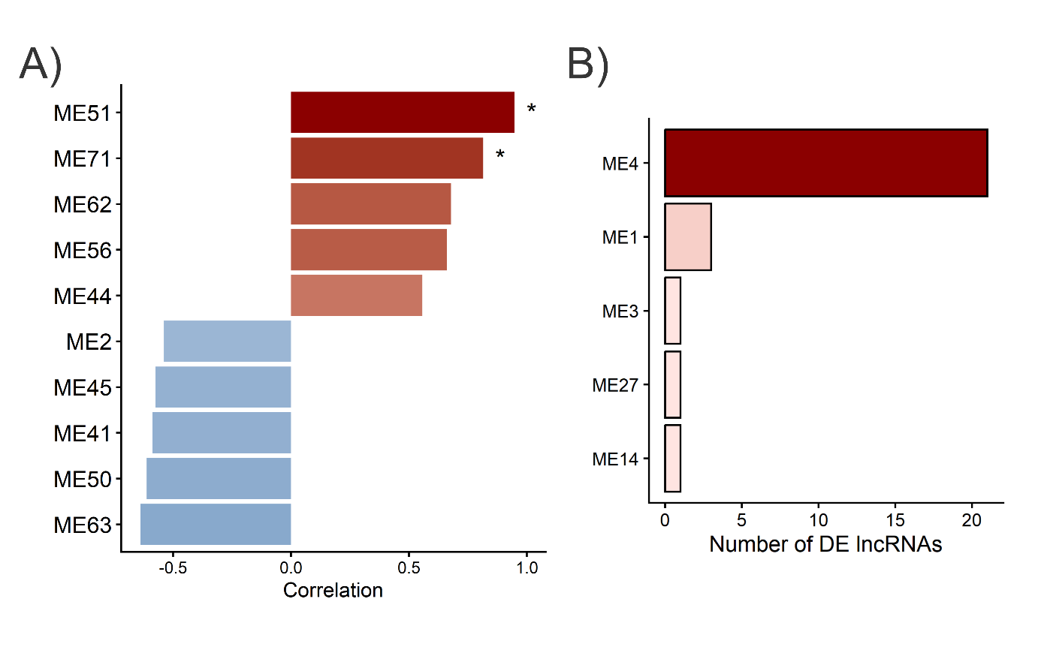
Figure S8. Co-expression modules and network connectivity of DELncRNAs in P. radiata. A) Top 10 modules ranked by absolute correlation with infection condition. Bars represent correlation coefficients; asterisks indicate significant associations (|r| > 0.6, p < 0.05). B) Distribution of differentially expressed lncRNAs (DELncRNAs) across the five modules in which they were detected.

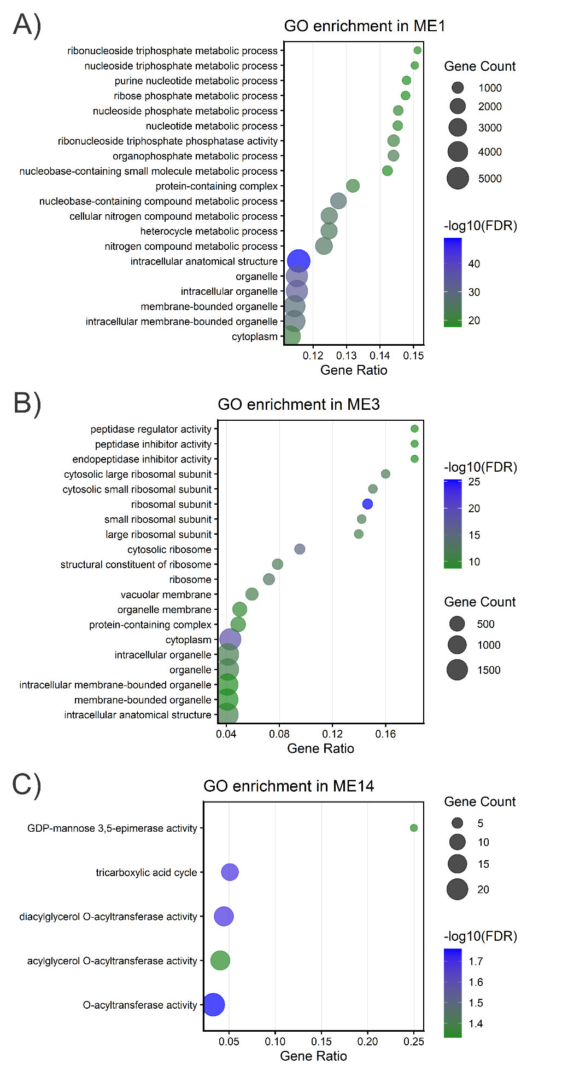
Figure S9. Top enriched Gene Ontology (GO) terms associated with genes from modules (A) ME1, (B) ME3 and (C) ME14, harboring DELncRNAs in P. radiata. No GO enriched terms were found in ME27.
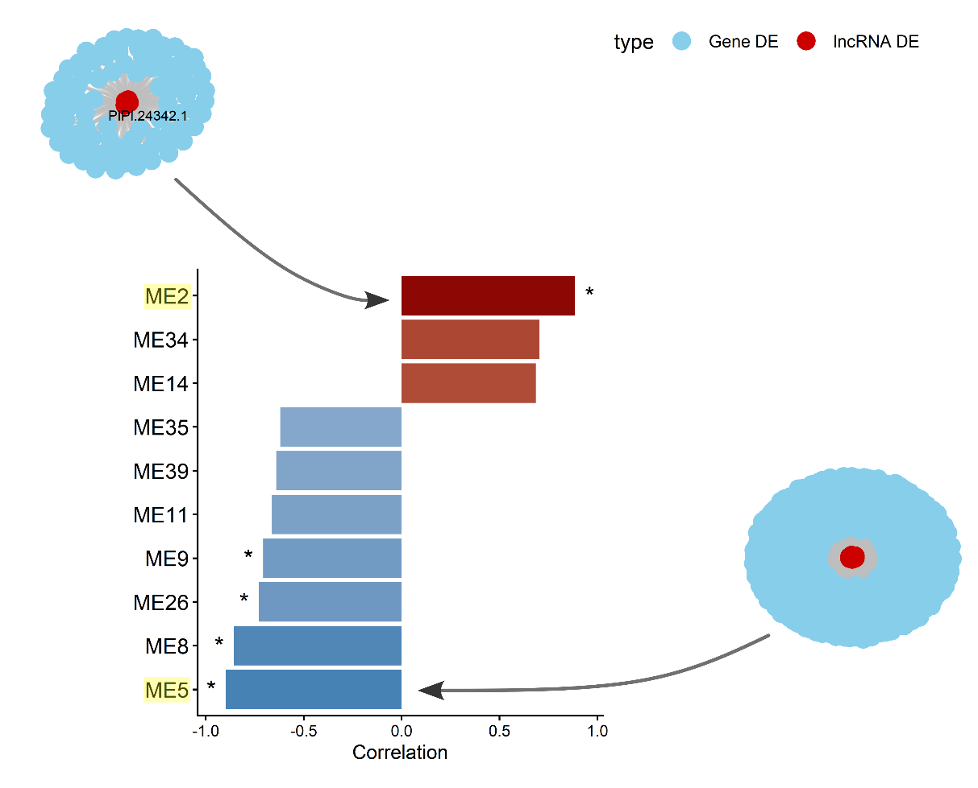
Figure S10. Top 10 co-expression modules ranked by correlation with infection condition in P. pinea. Bars represent correlation coefficients; asterisks indicate significant associations (|r| > 0.6, p < 0.05). The global co-expression network of the modules with DELncRNAs that, in turn, showed the strongest correlation with the infection is represented. The yellow-highlighted modules contain DELncRNAs. The network was constructed from DELncRNAs and differentially expressed (DE) genes of common modules. Red nodes represent DELncRNAs and blue nodes represent DEGs.

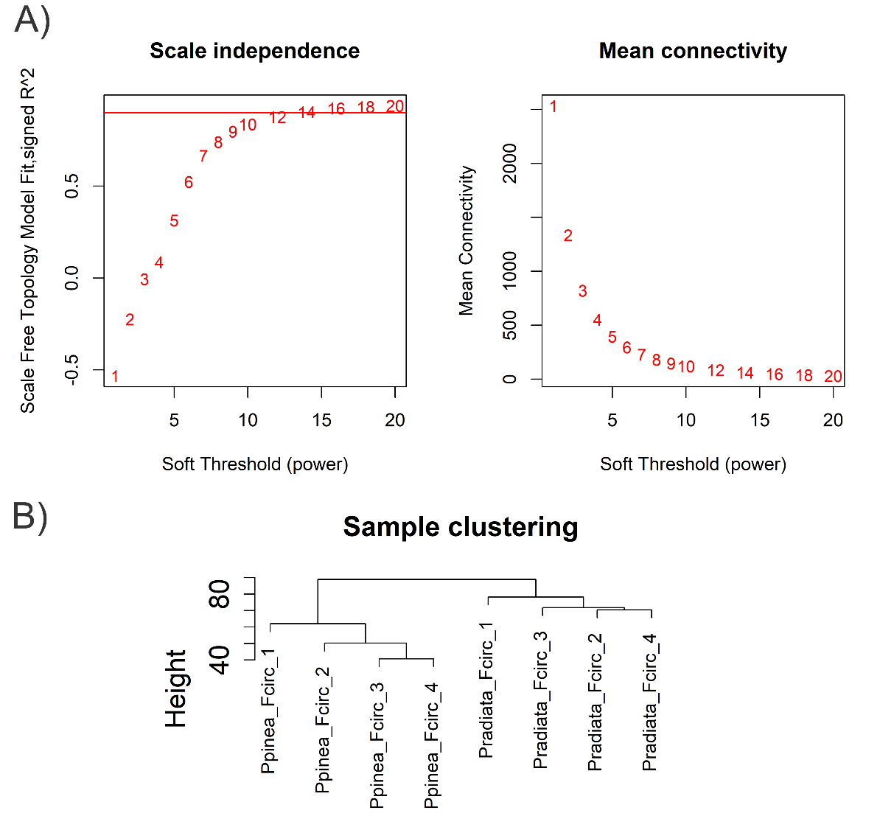
Figure S11. A) Analysis of the scale-free topology criterion and mean connectivity across different soft-thresholding powers. A threshold of β = 12 was selected (horizontal red line indicates the standard R² = 0.90 cut-off). B) Hierarchical clustering of samples based on variance-stabilized expression values.

