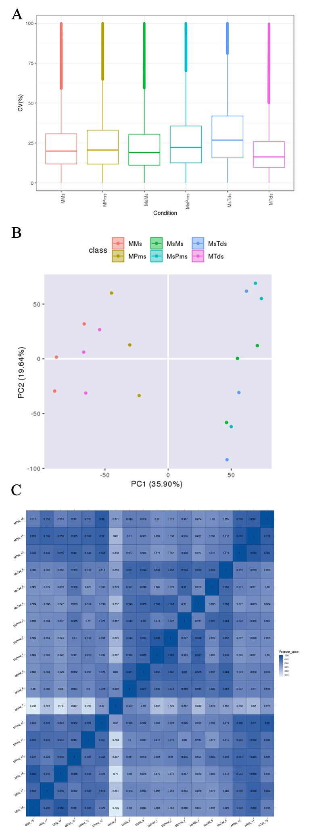
Supplementary Figure S1. Quality control of the DIA-MS proteomic data.
(A) Box plot showing the distribution of the coefficient of variation (CV) for quantified proteins within each experimental group (MMs, MPms, MsMs, etc.). The low median CV values across all groups indicate high technical reproducibility among biological replicates.
(B) Principal component analysis (PCA) score plot of the global proteome profiles from all 18 samples. Samples are colored by genotype (CMS line C2P5A and maintainer line C2P5B) and shaped by developmental stage (Pms, Tds, Ms). The tight clustering of biological replicates within each group demonstrates excellent experimental reproducibility. The primary separation along PC1 is driven by genotype, confirming that the CMS condition is the major source of proteomic variation.
(C) Heatmap of Pearson correlation coefficients between all sample pairs based on global protein expression profiles. Darker blue indicates higher correlation. The strong block diagonal pattern (high correlation within groups) and clear distinction between groups further validate the robustness and biological consistency of the dataset.
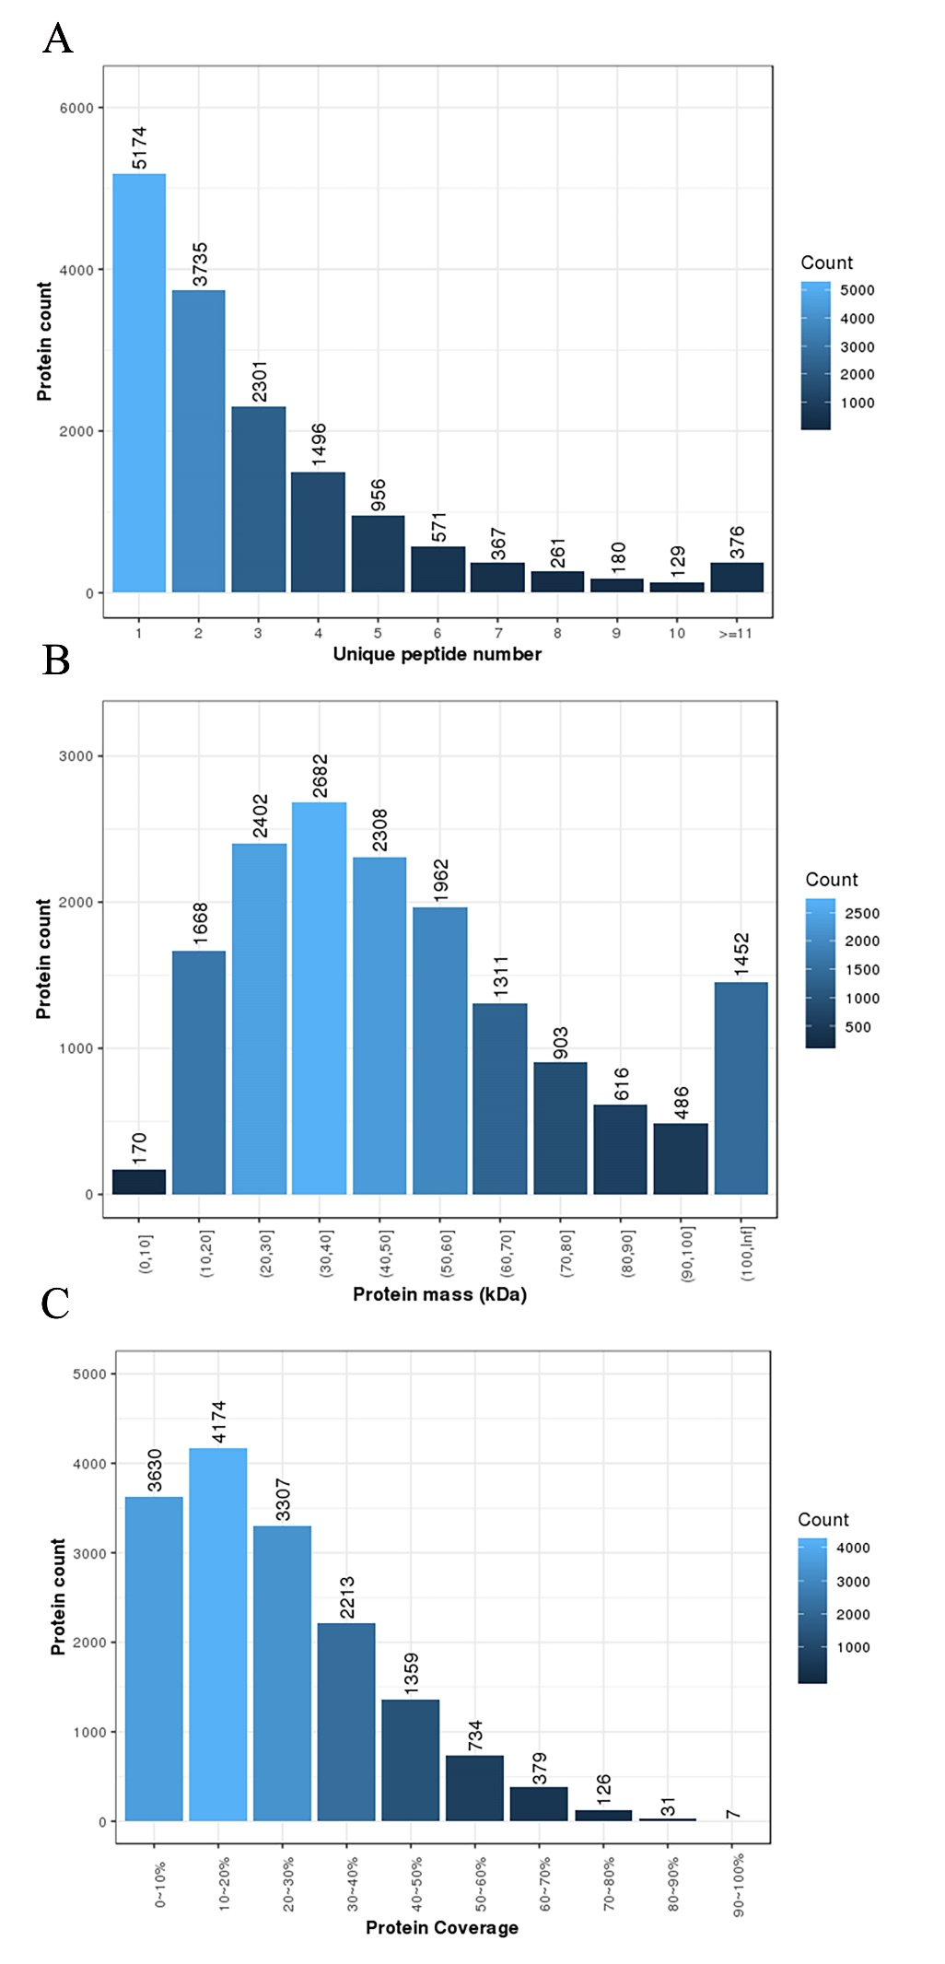
Supplementary Figure S2. Characteristics of the DDA-based spectral library for DIA-MS quantification.
(A) Distribution of the number of unique peptides matched to each protein group. The majority of proteins were identified by multiple unique peptides, ensuring high-confidence spectral library construction.
(B) Distribution of the molecular weights (in kilodaltons, kDa) of the proteins identified in the spectral library.
(C) Distribution of sequence coverage percentages for the identified proteins. Higher coverage indicates more comprehensive peptide sampling, which enhances the specificity and accuracy of subsequent DIA quantification.
The spectral library was constructed from pooled anther samples using data-dependent acquisition (DDA) mass spectrometry and the MaxQuant software, encompassing a total of 88,974 peptides and 15,960 protein groups. These quality metrics demonstrate the depth, robustness, and suitability of the library for high-resolution DIA-MS analysis.
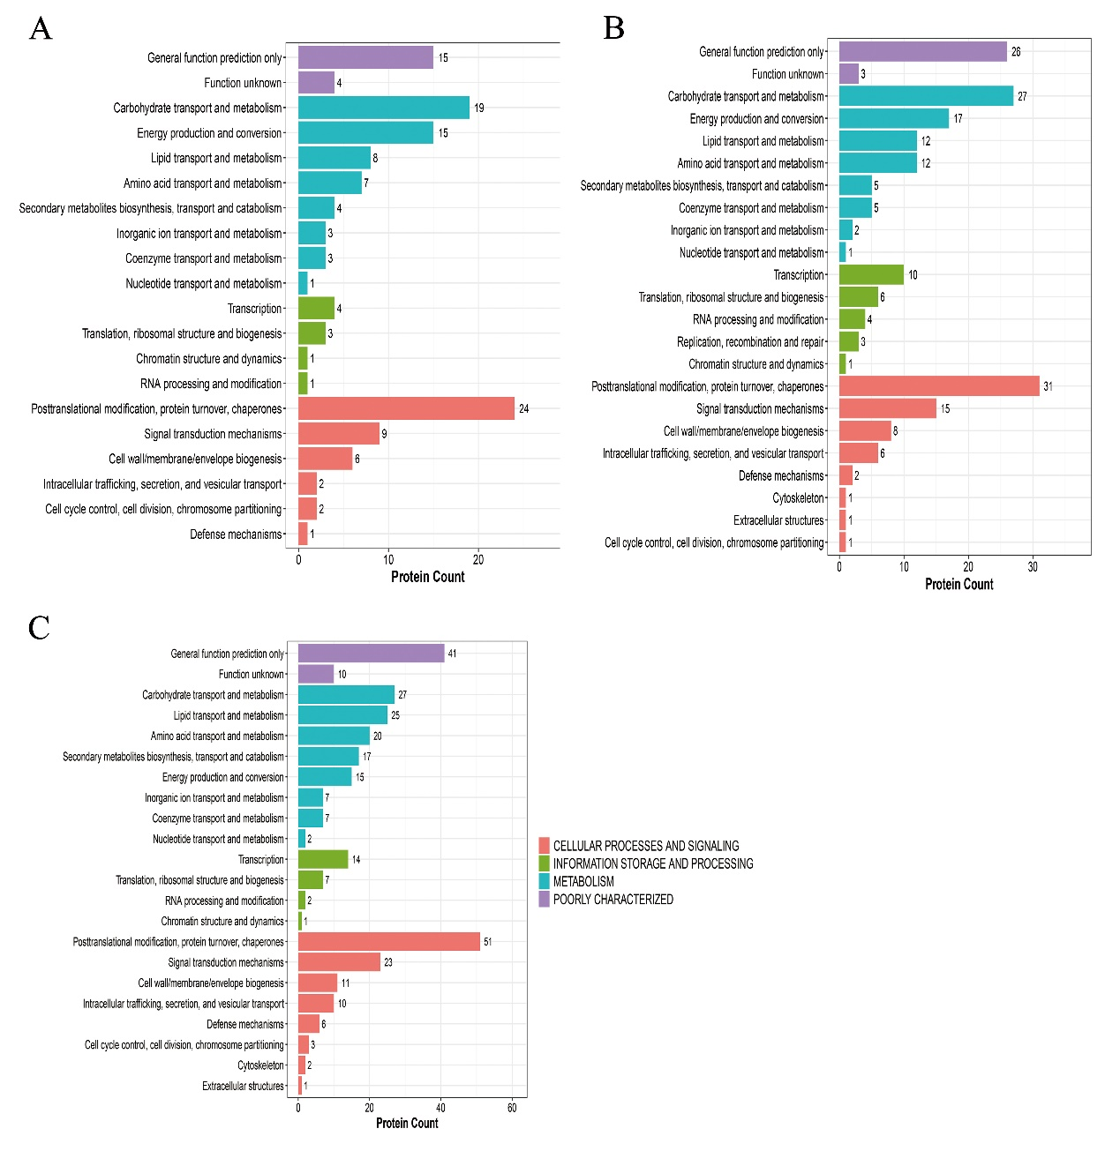
Supplementary Figure S3. KOG annotation of DEPs at different stages of anther development between the C2P5A and the C2P5B.
(A) DEPs KOG annotation at the Pms stage. (B) DEPs KOG annotation at the Tds stage. (C) DEPs KOG annotation at the Ms stage.

