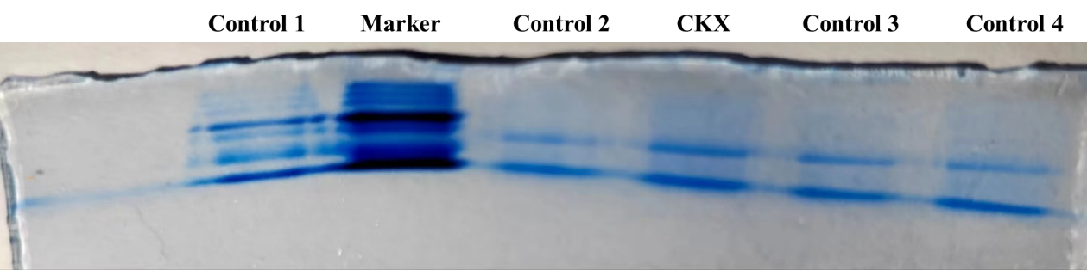
Supplementary Figure S2b full-length original, unprocessed blot image of SDS-PAGE gel electrophoresis analysis of elution products during Pull down-MS. Control 1 represents the untreated total nuclear protein. Marker represents BeyoColor ™ Color pre-dyed protein molecular weight standard (10-170kD). Control 2 represents the purified product obtained after conducting pull-down experiments using probes without biotin tags attached. CKX represents the purified product obtained after conducting pull-down experiments using probes with biotin tags attached. Control 3 represents the supernatant remaining after pulling down the total nucleoprotein solution using probes not labeled with biotin tags. Control 4 represents the supernatant remaining after pulling down the total nucleoprotein solution using probes labeled with biotin tags.

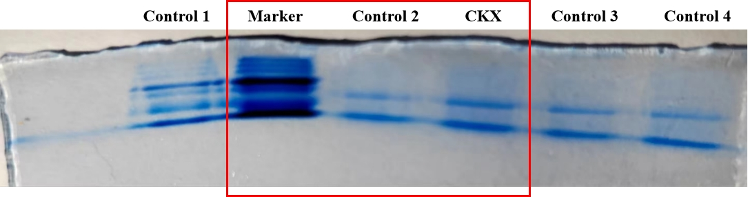
*The copy marked with a red box in the figure is used for the Figure panel.

