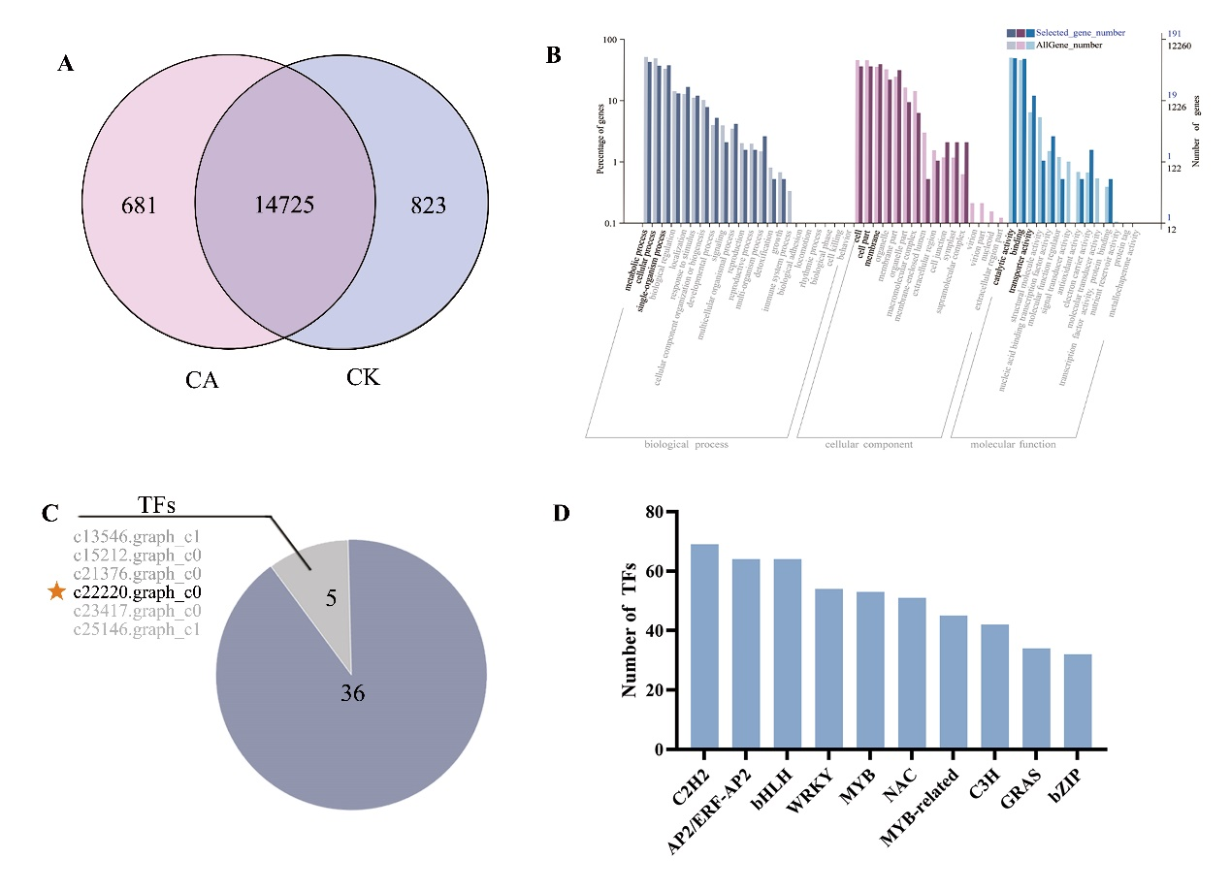
Figure S1. Identified PaMYBS3 by RNA-seq analysis. A high-quality Unigene.fa file was analyzed based on the Illumina HiSeq high-throughput sequencing in P. auriculata L.. (A) The Venn analysis of the transcriptome data identified genes specifically expressed during cold acclimation. (B) GO classification map analysis based on 681 genes. (C) The number of TFs in 41 differentially expressed genes. (D) Transcription factor prediction was performed using the Plant Transcription Factor Database (PlantTFDB; http://planttfdb.cbi.pku.edu.cn), and the top 10 transcription factors were identified and quantified. The above transcriptome analysis was all conducted on the BMKCloud (https://international.biocloud.net) completed.

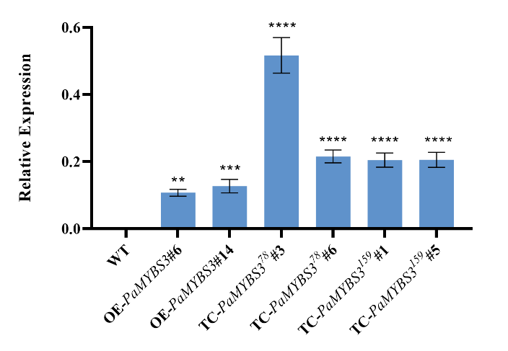
Figure S2. Identification of the expression efficiency of 6 lines in A. thaliana. Error bars indicate ± SE (n = 3). Asterisks indicate significant differences between different groups (**P < 0.01, ***P < 0.001, ****P < 0.0001).
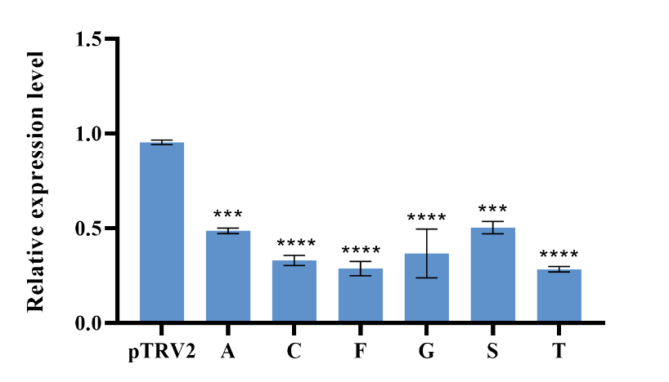
Figure S3. Identification of PaMYBS3 silencing efficiency in the 6 VIGS lines screened. A. C, F, G, S, and T were the selected VIGS lines numbers. Error bars indicate ± SE (n =3). Asterisks indicate significant differences between different groups (***P < 0.001, ****P < 0.0001).

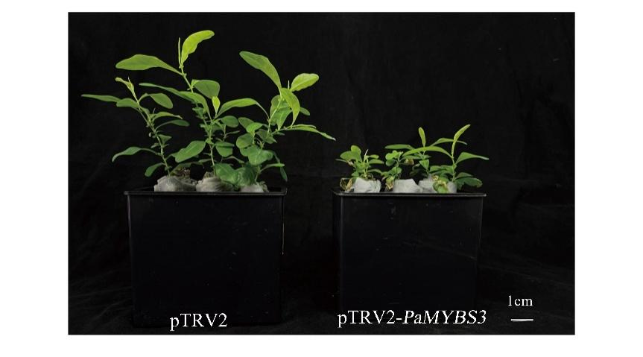
Figure S4. Effect of PaMYBS3 knockdown on phenotype in VIGS lines.

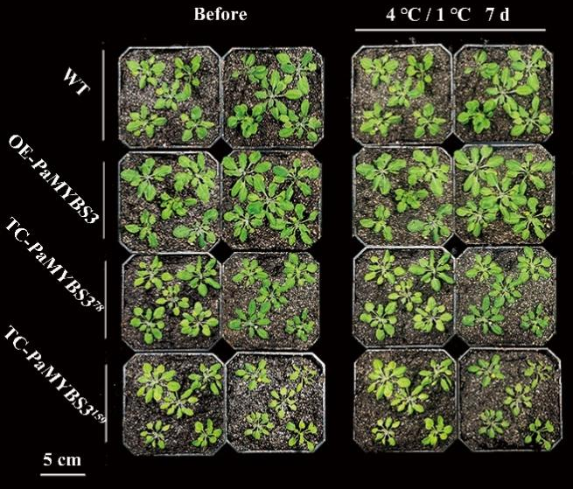
Figure S5. Phenotypic responses in 40-day-old OE-PaMYBS3 and TC-PaMYBS3 lines after 7 d cold acclimation at 4 °C/1 °C.

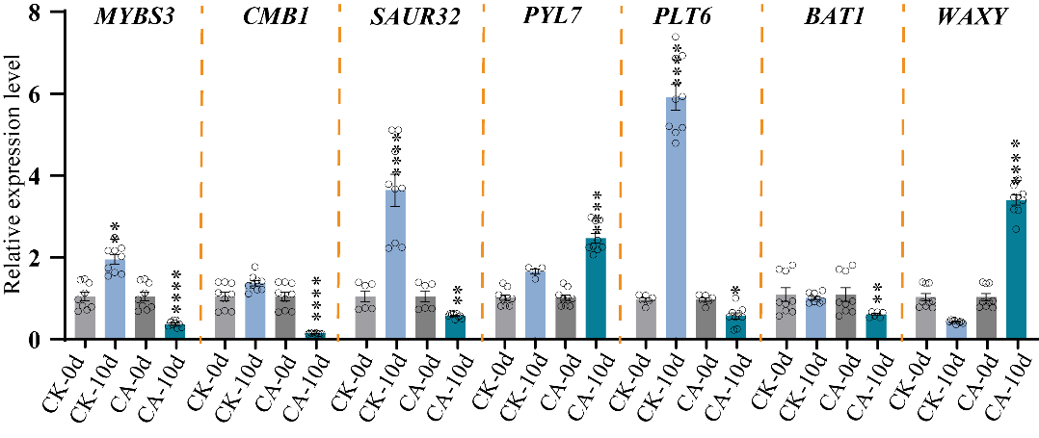
Figure S6. Expression level of key genes during cold acclimation in P. auriculata L..Error bars indicate ± SE (n = 9). Asterisks indicate significant differences between different groups (*P < 0.05, **P < 0.01, ****P < 0.0001)
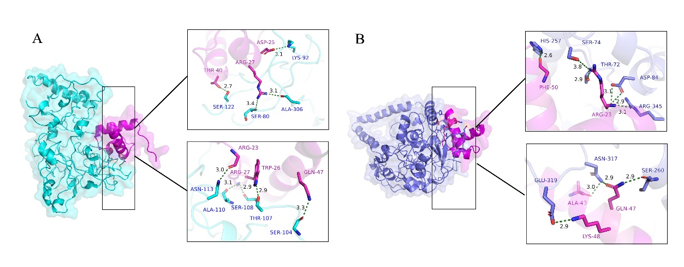
Figure S7. Predicted the binding energy and interactions of the conserved MYBs conserved domain with the TC-PAMYBS3¹⁵⁹ (A) and TC-PAMYBS3⁷⁸ (B) protein-protein interactions. The protein structures were modeled using AlphaFold, preprocessed with Discovery Studio software, and visualized in PyMOL. Protein-protein docking was studied using the ZDock module in Discovery Studio. Additionally, protein interaction binding energies and interactions were evaluated using PDBePISA (https://www.ebi.ac.uk/msd-srv/prot_int/pistart.html).

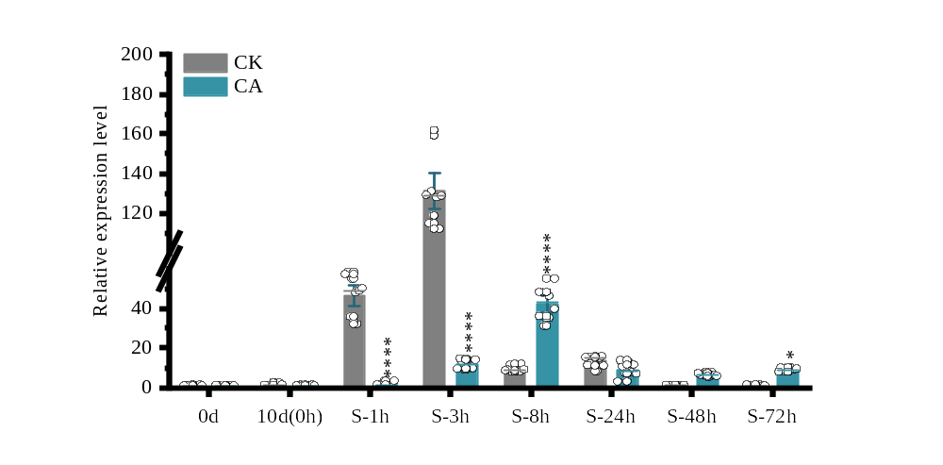
Figure S8. The spatiotemporal and temporal expression patterns of PaDREB1A by RT-qPCR during cold acclimation and cold stress in P. auriculata L.

