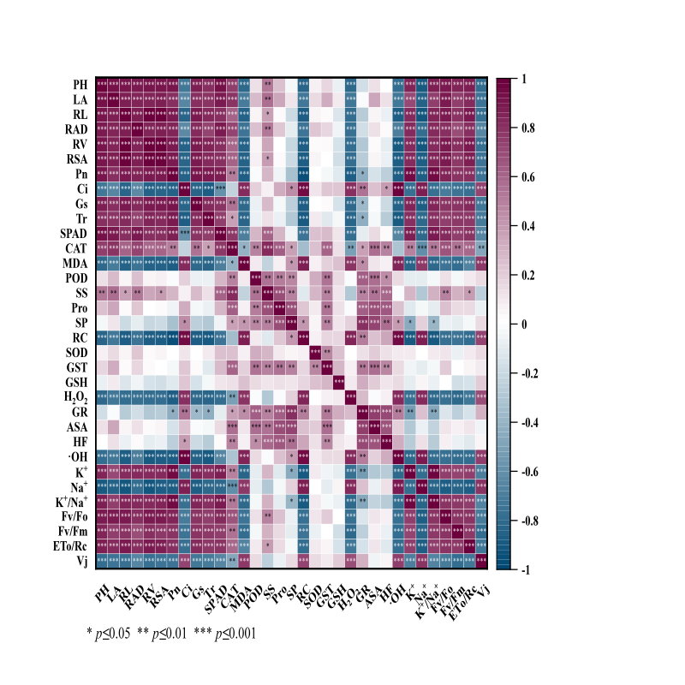
Fig. S1. Correlation analysis between measured parameters of 'Gongnong No.1' alfalfa plant under salt stress.
Note:The PH is plant height,LA is the leaf area,RL is the root length, RAD is the mean root diameter,Where RV is the root volume, RSA is the root surface area, Pn is the net photosynthetic rate, Ci is the intercellular CO₂ concentration, Gs is for the stomatal conductance,Tr is the leaf transpiration rate, SPAD is the relative chlorophyll content, CAT for catalase activity, MDA for malondialdehyde content, POD for peroxidase activity,SS is the soluble sugar content, Pro is for the proline content, SP is the soluble protein content, RC is the relative conductivity, SOD for the superoxide dismutase activity,GST is a glutathione S-transferase,GSH reduced glutathione content, H₂O₂ is the hydrogen peroxide content,GR for the glutathione reductase activity, ASA reduced the ascorbic acid content, HF for the hydroxyl radical clearance rate, ·OH for the hydroxyl radical content, K⁺ is the potassium ion content, Na⁺ is the sodium ion content,K⁺/Na⁺ as K⁺ and Na⁺ ion ratio, Fv/Fo is for the potential photochemical activity of PSII, Fv/Fm for the maximum photochemical efficiency, ETo/Rc is the unit reflection center, Vj is the variable fluorescence at point J, the same below.
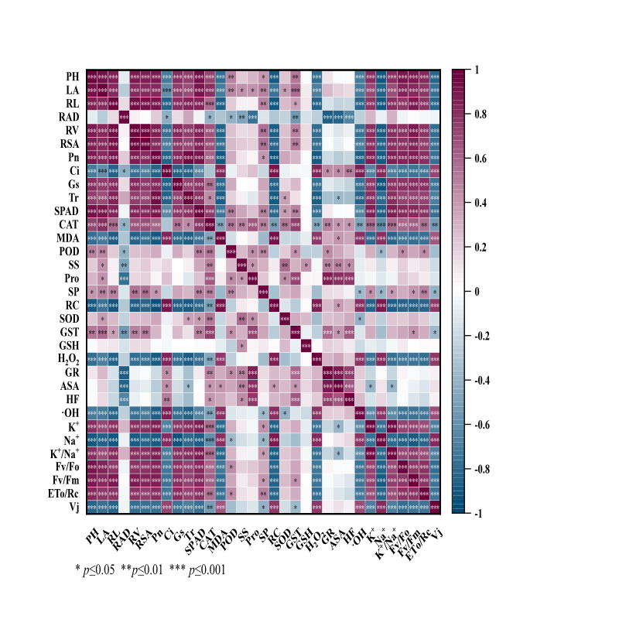
Fig. S2. Correlation analysis between measured parameters of 'Zhongmu No.3' alfalfa plants under salt stress.

Table S1 Principal component loading matrix and variance contribution rate of 'Gongnong No.1 'alfalfa
Indicator | PC1 |  | PC2 |  | PC3 |  | PC4 |  | PC5
PH | 0.220 |  | 0.080 |  | -0.024 |  | 0.034 |  | 0.096
LA | 0.204 |  | 0.144 |  | 0.008 |  | -0.143 |  | -0.005
L | 0.221 |  | 0.015 |  | -0.028 |  | 0.004 |  | -0.122
T | 0.205 |  | 0.087 |  | 0.108 |  | 0.178 |  | -0.021
V | 0.221 |  | 0.006 |  | -0.040 |  | -0.012 |  | -0.126
SA | 0.220 |  | 0.013 |  | -0.031 |  | 0.051 |  | -0.110
Pn | 0.222 |  | -0.042 |  | 0.059 |  | 0.044 |  | 0.094
Ci | -0.200 |  | 0.147 |  | 0.073 |  | 0.163 |  | 0.210
Gs | 0.214 |  | -0.024 |  | -0.016 |  | -0.015 |  | -0.029
Tr | 0.206 |  | -0.059 |  | 0.042 |  | -0.207 |  | -0.079
SPAD | 0.204 |  | 0.114 |  | 0.181 |  | 0.077 |  | 0.177
CAT | 0.141 |  | 0.282 |  | 0.026 |  | 0.110 |  | 0.112
MDA | -0.204 |  | 0.067 |  | 0.100 |  | -0.125 |  | -0.041
POD | 0.008 |  | 0.282 |  | 0.145 |  | 0.094 |  | -0.337
SS | 0.084 |  | 0.308 |  | 0.012 |  | 0.318 |  | 0.212
Pro | 0.010 |  | 0.329 |  | -0.172 |  | 0.091 |  | 0.241
SP | -0.054 |  | 0.305 |  | -0.248 |  | -0.135 |  | -0.098
RC | -0.213 |  | 0.107 |  | -0.014 |  | 0.046 |  | 0.055
SOD | 0.011 |  | 0.130 |  | 0.584 |  | 0.133 |  | -0.380
GST | 0.006 |  | 0.293 |  | 0.262 |  | -0.051 |  | -0.134
GSH | -0.026 |  | 0.114 |  | 0.423 |  | -0.638 |  | 0.465
H2O2 | -0.202 |  | 0.011 |  | 0.055 |  | 0.072 |  | -0.058
GR | -0.078 |  | 0.327 |  | -0.108 |  | -0.189 |  | -0.060
ASA | -0.001 |  | 0.333 |  | -0.158 |  | -0.254 |  | -0.225
HF | -0.030 |  | 0.301 |  | -0.191 |  | 0.128 |  | 0.105
·OH | -0.208 |  | 0.114 |  | 0.044 |  | 0.204 |  | 0.161
K⁺ | 0.209 |  | -0.069 |  | 0.168 |  | 0.199 |  | 0.199
Na⁺ | -0.216 |  | -0.012 |  | 0.030 |  | 0.180 |  | 0.084
K⁺/Na⁺ | 0.212 |  | -0.049 |  | 0.168 |  | 0.153 |  | 0.184
Fv/Fo | 0.206 |  | 0.082 |  | 0.005 |  | -0.050 |  | 0.068
Fv/Fm | 0.199 |  | 0.011 |  | -0.170 |  | -0.071 |  | 0.085
Eto/Rc | 0.203 |  | 0.044 |  | -0.069 |  | -0.038 |  | -0.192
Vj |  | -0.187 |  | 0.017 |  | 0.246 |  | 0.068 | -0.096
Eigenvalue |  | 18.923 |  | 6.578 |  | 1.608 |  | 0.967 | 0.819
Variance |  | 57.342 |  | 19.932 |  | 4.873 |  | 2.929 | 2.482

Table S2 Principal component loading matrix and variance contribution rate of 'Zhongmu No.3'alfalfa
Indicator | PC1 |  | PC2 |  | PC3 |  | PC4 |  | PC5
PH | 0.222 |  | 0.067 |  | 0.116 |  | 0.086 |  | 0.027
LA | 0.208 |  | 0.140 |  | 0.007 |  | 0.079 |  | 0.016
L | 0.223 |  | -0.033 |  | 0.049 |  | 0.069 |  | 0.086
T | 0.024 |  | -0.352 |  | 0.039 |  | 0.246 |  | 0.083
V | 0.220 |  | 0.013 |  | 0.031 |  | 0.058 |  | 0.137
SA | 0.214 |  | 0.035 |  | 0.031 |  | 0.007 |  | 0.145
Pn | 0.226 |  | -0.044 |  | 0.024 |  | 0.063 |  | 0.000
Ci | -0.196 |  | 0.169 |  | 0.030 |  | 0.208 |  | 0.006
Gs | 0.208 |  | -0.040 |  | 0.059 |  | 0.173 |  | 0.063
Tr | 0.205 |  | -0.106 |  | 0.111 |  | 0.111 |  | 0.006
SPAD | 0.218 |  | 0.075 |  | 0.033 |  | 0.150 |  | 0.046
CAT | 0.161 |  | 0.236 |  | 0.015 |  | 0.146 |  | 0.093
MDA | -0.208 |  | 0.105 |  | 0.061 |  | 0.005 |  | 0.061
POD | 0.089 |  | 0.194 |  | 0.326 |  | 0.133 |  | 0.542
SS | 0.039 |  | 0.247 |  | 0.384 |  | 0.205 |  | 0.227
Pro | 0.032 |  | 0.357 |  | 0.059 |  | 0.066 |  | 0.179
SP | 0.114 |  | 0.107 |  | 0.021 |  | 0.279 |  | 0.422
RC | -0.220 |  | 0.095 |  | 0.074 |  | 0.061 |  | 0.083
SOD | 0.076 |  | 0.167 |  | 0.408 |  | 0.414 |  | 0.027
GST | 0.097 |  | 0.271 |  | 0.199 |  | 0.101 |  | 0.374
GSH | 0.011 |  | 0.059 |  | 0.641 |  | 0.280 |  | 0.007
H2O2 | -0.206 |  | 0.074 |  | 0.029 |  | 0.075 |  | 0.022
GR | -0.019 |  | 0.369 |  | 0.040 |  | 0.164 |  | 0.011
ASA | -0.040 |  | 0.349 |  | 0.036 |  | 0.239 |  | 0.119
HF | -0.031 |  | 0.326 |  | 0.032 |  | 0.140 |  | 0.345
·OH | -0.197 |  | 0.057 |  | 0.229 |  | 0.110 |  | 0.029
K⁺ | 0.204 |  | -0.056 |  | 0.078 |  | 0.300 |  | 0.082
Na⁺ | -0.222 |  | 0.001 |  | 0.014 |  | 0.171 |  | 0.050
K⁺/Na⁺ | 0.205 |  | -0.060 |  | 0.055 |  | 0.250 |  | 0.087
Fv/Fo | 0.205 |  | 0.040 |  | 0.038 |  | 0.197 |  | 0.070
Fv/Fm | 0.211 |  | 0.017 |  | 0.044 |  | 0.119 |  | 0.050
Eto/Rc | 0.204 |  | 0.004 |  | 0.059 |  | 0.123 |  | 0.253
Vj |  | -0.198 |  | -0.008 |  | 0.067 |  | 0.085 | 0.028
Eigenvalue |  | 18.309 |  | 6.486 |  | 1.672 |  | 1.133 | 0.974
Variance |  | 55.482 |  | 19.655 |  | 5.065 |  | 3.433 | 2.951

