Figure S1.‌ Average sequencing quality per read as determined using FastQC software in RNA-seq samples of safflower seedlings. The horizontal axis shows the average sequencing quality (Phred score), and the vertical axis shows the frequency of reads. The average sequencing quality per read (most nucleotides) had a Phred score of 36.

Figure S2. )‌A(‌ Distribution of studied samples based on PCA analysis. The samples of the two groups (control and stressed) are well separated, indicating no batch effect. )B( ‌RNA-seq samples before normalization. )C( RNA-seq samples after normalization. C1 & C2 are the control replicates, and S1 & S2 are the drought-stress replicates.

Figure S3.‌ Graphical results of gen ontology (GO) in the safflower seedling for: )A(‌ Up-regulated genes and )B( Down-regulated genes using g.Profiler online tool. Magnitude of significance was determined by -log10 adj p-value on Y axis and GO categories (MF, BP and CC) were depicted on X axis.

Figure S4‌. (A) Functional analysis of up-regulated DEGs in in safflower cv. Arak 2811 under continuous drought stress using g.Profiler online tool. (B) Functional analysis of down-regulated DEGs in in safflower cv. Arak 2811 under continuous drought stress using g.Profiler online tool. blue: molecular function (MF); green: biological process (BP), red: cellular component (CC).

Figure S5:‌The top-ranked 10 genes involved in the photosynthesis pathway with down-regulated genes. Analysis was conducted in CytoHubba by degree centrality with a degree score.in this network, the color intensity defines the rank of the genes, the higher the color intensity and closer to red, the higher the score, and the closer to yellow, the lower the score. Genes with higher scores are more important and are hub genes.

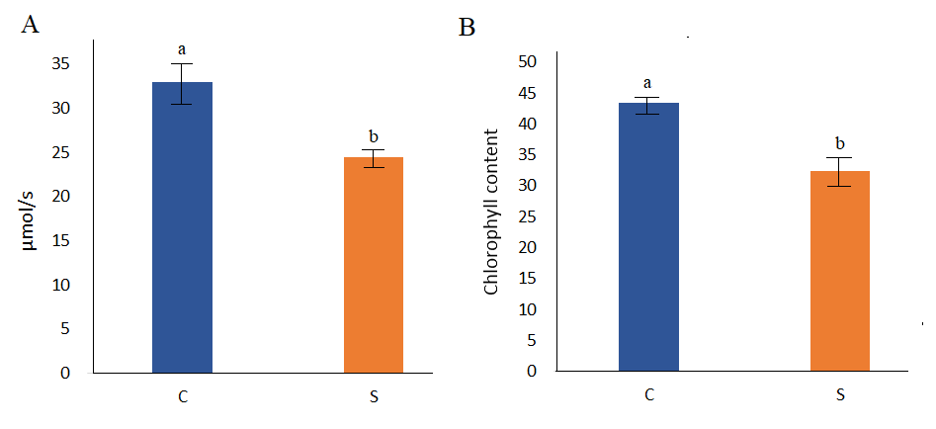
Figure S6. (A) Comparison of photosynthesis rate in leaves of safflower in control (C) and drought stress (S) conditions. (B) Cholorophyll content of safflower leaves in control (C) and drought stress (S) conditions. Significant differences (p < 0.01) are shown with different letters. In the case of both traits, mean of drought-stressed sample was drastically decreased relative to control sample (~25% reduction).

