Support information
Figure S1. The physiological indicators of P. tenuifolia seedlings under cold stress. Changes of individual plant fresh weight (A) and height (B), as well as the content of CAT (C), POD (D), and SOD (E) under cold stress. Data are presented as mean ±SE (n=3). Different lowercase letters indicate significant differences among treatments at P<0.05.
Figure S2. Analysis of the Transcriptome of P. tenuifolia seedlings under cold stress. the correlation heat map showed strong correlations among samples, with a correlation coefficient exceeding 0.7, indicating excellent reproducibility.
Figure S3 Comprehensive analysis of the PtWRKY gene family in P. tenuifolia. (A) Intraspecific collinearity analysis identified 572 homologous regions among PtWRKY genes. (B) Distribution of cis-acting elements in PtWRKY gene promoters, categorized into four classes: hormone-responsive, growth and development-related, stress and defense-related, and light-responsive elements.
Figure S4 Expression pattern of PtWRKY genes under cold stresses. (A) Heatmap analysis of 57 PtWRKY genes under cold stress. (B-F) Validation and selection via qRT-PCR with primers targeting Elongation1, GAPDH, β-actin1, β-actin2, and Cdc42.
Figure S5 Protein sequence alignment was performed in the NCBI database, and the top 5 genes with the highest homology to Pt13G01037 were identified, including AtWRKY75 and AtWRKY45 from A. thaliana, as well as WRKY75 from Ziziphus jujuba, Cajanus cajan and Theobroma cacao.
Figure S6 Protein sequence alignment was performed in the NCBI database, and the top 5 genes with the highest homology to Pt17G01891 were identified, including AtWRKY27 from A. thaliana, as well as WRKY29 from Gastrolobium bilobum, Rosa rugosa, Vigna radiata var. radiata and Durio zibethinus.

Table S1 Climatic Conditions in Yulin, Northern Shaanxi, from August to September Over the Three Consecutive Years of 2023–2025.
Table S2 qRT-PCR primers in this study.
Table S3 Expression levels and phylogenetic classification of 104 PtWRKY genes under cold stress; expression pattern heatmap of highly expressed genes and low-temperature responsive elements.
Table S4 Sequencing data statistics and quality control analysis.
Table S5 Volcano diagram of DEGs between cold-treated (CS) and control (CK) groups in P. tenuifolia seedlings.
Table S6 GO enrichment analysis of P. tenuifolia seedlings under cold stress.
Table S7 KEGG enrichment analysis of P. tenuifolia seedlings under cold stress.
Table S8 Prediction of subcellular location of PtWRKY genes family Physicochemical properties.
Figure S1 The physiological indicators of P. tenuifolia seedlings under cold stress. Changes of individual plant fresh weight (A) and height (B), as well as the content of CAT (C), POD (D), and SOD(E) under cold stress. Data are presented as mean ±SE (n=3). Different lowercase letters indicate significant differences among treatments at P<0.05.

Figure S2 Analysis of the Transcriptome of P. tenuifolia seedlings under cold stress. the correlation heat map showed strong correlations among samples, with a correlation coefficient exceeding 0.7, indicating excellent reproducibility.

Figure S3 Comprehensive analysis of the PtWRKY gene family in P. tenuifolia. (A) Intraspecific collinearity analysis identified 572 homologous regions among PtWRKY genes. (B) Distribution of cis-acting elements in PtWRKY gene promoters, categorized into four classes: hormone-responsive, growth and development-related, stress and defense-related, and light-responsive elements.
Figure S4 Expression pattern of PtWRKY genes under cold stresses. (A) Heatmap analysis of 57 PtWRKY genes under cold stress. (B-F) Validation and selection via qRT-PCR with primers targeting Elongation1, GAPDH, β-actin1, β-actin2, and Cdc42.

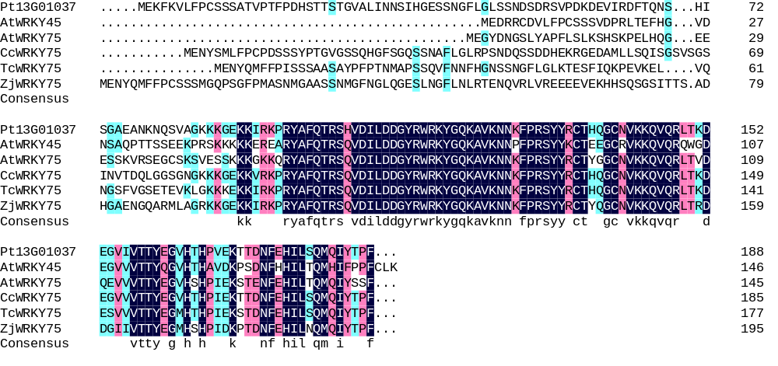
Figure S5 Protein sequence alignment was performed in the NCBI database, and the top 5 genes with the highest homology to Pt13G01037 were identified, including AtWRKY75 and AtWRKY45 from A. thaliana, as well as WRKY75 from Ziziphus jujuba, Cajanus cajan and Theobroma cacao.

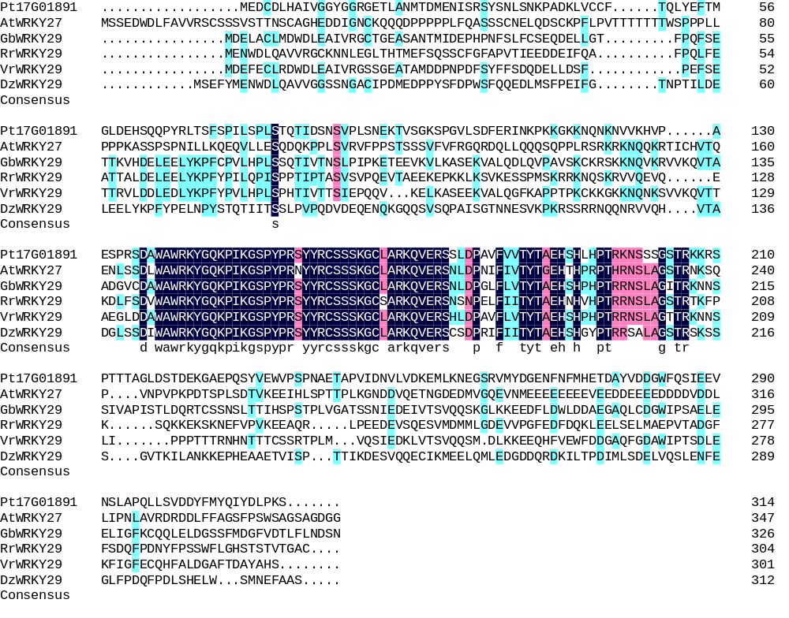
Figure S6 Protein sequence alignment was performed in the NCBI database, and the top 5 genes with the highest homology to Pt17G01891 were identified, including AtWRKY27 from A. thaliana, as well as WRKY29 from Gastrolobium bilobum, Rosa rugosa, Vigna radiata var. radiata and Durio zibethinus.

Table S1 Climatic Conditions in Yulin, Northern Shaanxi, from August to September Over the Three Consecutive Years of 2023–2025.
Year | Month | Average temperature/℃ |  | Extreme temperature/℃ |  | Sunlight duration/hour
Year | Month | Maximum | Minimum | Maximum | Minimum | Average | Maximum
2025 | 8 | 27.0 | 18.4 | 31.7 | 12.7 | 9.1 | 12.7
2025 | 9 | 22.1 | 12.6 | 27.3 | 8.6 | 8.2 | 12.0
2025 | 10 | 14.2 | 6.4 | 19.3 | -1.3 | 5.9 | 9.6
2024 | 8 | 27.4 | 18.5 | 34.0 | 14.8 | 10.4 | 12.8
2024 | 9 | 22.7 | 14.6 | 27.4 | 6.1 | 7.4 | 11.5
2024 | 10 | 16.2 | 7.0 | 20.6 | 1.1 | 7.7 | 10.9
2023 | 8 | 29.3 | 18.7 | 34.5 | 12.2 | 11 | 12.8
2023 | 9 | 24.2 | 14.0 | 30.3 | 5.1 | 8.8 | 11.8
2023 | 10 | 18.2 | 6.1 | 23.3 | 1.2 | 8.4 | 11.0

Table S2 qRT-PCR primers in this study.
Primer Name | Sequence (5′ to 3′)
GAPDH | F:ACAGCAACGTGCTTCTCACC
GAPDH | R:CCCTTCATCCACCACCGACTA
Pt15G02230 | F:CAAATGCTCTTTCGCTCCAA
Pt15G02230 | R:GATTCTTTCCATCGCTACTG
Pt17G01379 | F:GACTGGCTGGAGAAAGATGCT
Pt17G01379 | R:TGTCCTCTGTTACTGGTGCTA
Pt19G00021 | F:GACAATAGTGAAACACCAGG
Pt19G00021 | R:AAGTATGCCCTTGGAGTAG
P13tG01372 | F:ACAAGGGTACTCATAACCATCC
P13tG01372 | R:CAGGCTCATCCTCATCAAAT
Pt19G00931 | F:GCCTATTTCCATTGCCTATC
Pt19G00931 | R:GTCATCCCTTGGTTCATCTT
Pt13G01678 | F:GAATCTCCACCTTTAATCCTAA
Pt13G01678 | R:CTTTCTGTCCATACTTCCTCC
Pt17G01907 | F:CGTGGATTATTATCAGGAGC
Pt17G01907 | R:GCCCAGCAGTTCTGTTTATT
Pt1G02821 | F:GGGAATGGGAGAAGAAACC
Pt1G02821 | R:AACCTGCTCAACCGACCTA
Pt2G00949 | F:CTCCAAACTCTTCGGTGAT
Pt2G00949 | R:TCTTCTTTCCCTTGCTGAC
Pt8G01053 | F:TCCTACCTGCTGTCCATCG
Pt8G01053 | R:TGCTTCCCATTGGTGACGCTA
Pt18G01921 | F:AGCAACCCGTGACTCCTAAC
Pt18G01921 | R:TTGTGGCTGGTCCTCCTCTT
Pt13G01037 | F:CAACAGTTCCAACCTTCC
Pt13G01037 | R:GATGTGACTATTCTGCGTG
Pt17G01891 | F:TCAGCCCTATCCTTTCTCCTC
Pt17G01891 | R:TATTTACGCCAAGCCCAC
Pt14G00989 | F:TAACGCTATGGCCGATGCTG
Pt14G00989 | R:GGTGATGTTGTGGTGGAGGT
Pt18G00008 | F:ACTCCACCATCTGATTCCT
Pt18G00008 | R:TGCTGGCGACGATTGTTAT
Elongation1 | TCGTAATGCTGGGTGGGG
Elongation1 | CAGCAGGAAACATCAACCGA
β-actin1 | GATGACATGGAAAAGATTTGGCATC
β-actin1 | AAGGATGGCATGAGGGAGGGCGTAA
β-actin1 | CAATCCCAAGGCTAATCGTGA
β-actin1 | CCCGAATCCAGCACAATACC
Cdc42 | CTGCTGGACAGGAAGATTACG
Cdc42 | CTCGGACATTCTCGAATGAAG
Table S4 Sequencing data statistics and quality control analysis.
Sample | Raw_Reads | Clean_Reads | Clean_Bases | Error_Rate | Q20 | Q30 | GC_pct
CK0_1 | 43915202 | 42735992 | 6.41G | 0.01 | 98.67 | 95.81 | 43.11
CK0_2 | 43651546 | 42456800 | 6.37G | 0.01 | 98.48 | 95.22 | 43.14
CK0_3 | 45294812 | 44223688 | 6.63G | 0.01 | 98.58 | 95.54 | 43.16
CK1_1 | 45429686 | 44288686 | 6.64G | 0.01 | 98.73 | 95.97 | 43.13
CK1_2 | 44077040 | 42906350 | 6.44G | 0.01 | 98.61 | 95.6 | 43.16
CK1_3 | 50236092 | 48960706 | 7.34G | 0.01 | 98.69 | 95.85 | 43.16
CS1_1 | 44547744 | 43151242 | 6.47G | 0.01 | 98.55 | 95.48 | 43.29
CS1_2 | 43337588 | 42063988 | 6.31G | 0.01 | 98.68 | 95.8 | 43.21
CS1_3 | 46092528 | 42793464 | 6.42G | 0.01 | 97.53 | 93.07 | 43.56
CK3_1 | 40473438 | 39672406 | 5.95G | 0.01 | 98.75 | 96.00 | 43.32
CK3_2 | 39450144 | 38618012 | 5.79G | 0.01 | 98.70 | 95.88 | 43.22
CK3_3 | 39280582 | 38453138 | 5.77G | 0.01 | 98.67 | 95.77 | 43.26
CS3_1 | 42753628 | 41864388 | 6.28G | 0.01 | 98.58 | 95.5 | 43.48
CS3_2 | 44821742 | 43810022 | 6.57G | 0.01 | 98.63 | 95.67 | 43.43
CS3_3 | 40367122 | 39449476 | 5.92G | 0.01 | 98.63 | 95.69 | 43.47
CK5_1 | 41207778 | 40211816 | 6.03G | 0.01 | 98.67 | 95.77 | 43.31
CK5_2 | 42967702 | 42111776 | 6.32G | 0.01 | 98.61 | 95.53 | 43.3
CK5_3 | 40640332 | 39526522 | 5.93G | 0.01 | 98.66 | 95.72 | 43.38
CS5_1 | 44324040 | 43290160 | 6.49G | 0.01 | 98.56 | 95.49 | 43.28
CS5_2 | 46043808 | 43917174 | 6.59G | 0.01 | 98.69 | 95.84 | 43.24
CS5_3 | 42154264 | 40811380 | 6.12G | 0.01 | 98.45 | 95.12 | 43.3
CK7_1 | 48756290 | 47873522 | 7.18G | 0.01 | 98.70 | 95.87 | 43.28
CK7_2 | 44154486 | 43326272 | 6.5G | 0.01 | 98.63 | 95.65 | 43.28
CK7_3 | 43916338 | 43089734 | 6.46G | 0.01 | 98.53 | 95.38 | 43.05
CS7_1 | 49597248 | 48470648 | 7.27G | 0.01 | 98.61 | 95.65 | 43.15
CS7_2 | 46760370 | 45531450 | 6.83G | 0.01 | 98.72 | 96.00 | 43.13
CS7_3 | 43868156 | 42892058 | 6.43G | 0.01 | 98.65 | 95.71 | 43.18

Table S8 Prediction of subcellular location of PtWRKY genes family Physicochemical properties.
Sequence ID | Number of Amino Acid | Molecular Weight | Theoretical pI | Instability Index | Aliphatic Index | Grand Average of Hydropathicity | Prediction of subcellular  location
Pt1G02821 | 368 | 42077.79 | 5.59 | 57.92 | 62.26 | -0.742 | Nuclear
Pt13G01372 | 600 | 65206.28 | 8.39 | 60.25 | 49.75 | -0.85 | Nuclear
Pt3G02486 | 521 | 58479.37 | 7.55 | 62.31 | 50.96 | -0.896 | Nuclear
Pt7G01399 | 299 | 34010.67 | 6.08 | 50.63 | 61.34 | -0.791 | Nuclear
Pt11G01665 | 343 | 37618.83 | 9.81 | 39.24 | 61.37 | -0.64 | Nuclear
Pt17G01907 | 356 | 40701.36 | 6.97 | 58.49 | 66.54 | -0.744 | Nuclear
Pt5G00252 | 567 | 62122.02 | 6.51 | 44.4 | 64.59 | -0.7 | Nuclear
Pt8G00938 | 221 | 24949.45 | 5.12 | 48.7 | 52.08 | -0.583 | Nuclear
Pt14G00989 | 328 | 36163.24 | 9.6 | 52 | 66.95 | -0.564 | Nuclear
Pt18G00932 | 433 | 47215.12 | 7.65 | 67.6 | 58.34 | -0.642 | Extracellular
Pt15G02230 | 312 | 35082.4 | 9.32 | 45.74 | 59.46 | -0.936 | Nuclear
Pt2G00439 | 622 | 67528.52 | 6.53 | 40.14 | 73.31 | -0.458 | Plasma membrane
Pt18G00931 | 161 | 17723.44 | 8.39 | 41.52 | 52.73 | -0.793 | Nuclear
Pt1G00648 | 339 | 37397.26 | 5.73 | 48.92 | 49.62 | -0.785 | Nuclear
Pt16G00960 | 348 | 39521.06 | 5.85 | 46.37 | 58.53 | -0.766 | Nuclear
Pt3G00718 | 348 | 38481.8 | 9.65 | 44.86 | 68.65 | -0.593 | Nuclear
Pt1G00022 | 409 | 46057.94 | 8.07 | 54.94 | 55.5 | -0.878 | Vacuoles
Pt19G00021 | 316 | 35299.56 | 6.91 | 37.09 | 62.06 | -0.841 | Nuclear
Pt8G01053 | 356 | 38730.08 | 9.69 | 50.6 | 66.32 | -0.493 | Nuclear
Pt10G01763 | 284 | 30791.83 | 9.53 | 48.1 | 71.44 | -0.555 | Nuclear
Pt18G01921 | 312 | 34894.91 | 6.75 | 56.76 | 58.11 | -0.741 | Nuclear
Pt18G01031 | 547 | 60018.15 | 8.85 | 62.91 | 60.99 | -0.755 | Nuclear
Pt17G01891 | 314 | 35166.23 | 6.19 | 49.02 | 61.43 | -0.738 | Nuclear
Pt5G00603 | 508 | 56818.51 | 8.75 | 57.55 | 68.82 | -0.821 | Chloroplast
Pt13G01595 | 345 | 39051.41 | 5.31 | 52.77 | 61.94 | -0.692 | Nuclear
Pt19G00494 | 576 | 62195.1 | 6.64 | 42.86 | 63.28 | -0.633 | Nuclear
Pt13G01826 | 733 | 79051.13 | 6.14 | 53.89 | 56.18 | -0.719 | Nuclear
Pt4G00901 | 354 | 38857.27 | 6.51 | 61.38 | 57.85 | -0.616 | Nuclear
Pt15G00974 | 582 | 63241.11 | 8.27 | 51.09 | 60.12 | -0.733 | Nuclear
Pt13G00444 | 343 | 38516.67 | 9.67 | 60.71 | 62.59 | -0.759 | Nuclear
Pt3G01172 | 288 | 32104.15 | 8.56 | 55.38 | 67.05 | -0.766 | Nuclear
Pt1G00624 | 343 | 38478.4 | 5.88 | 46.6 | 68.19 | -0.528 | Nuclear
Pt18G00061 | 721 | 78095.03 | 6.23 | 53.59 | 54.8 | -0.798 | Nuclear
Pt10G01459 | 396 | 43574.35 | 9.13 | 43.64 | 66.41 | -0.718 | Nuclear
Pt9G01175 | 592 | 63568.93 | 6.53 | 42.92 | 57.96 | -0.769 | Nuclear
Pt1G02392 | 314 | 35254.63 | 6.28 | 47.88 | 68.95 | -0.763 | Nuclear
Pt11G01306 | 514 | 56307.05 | 7.96 | 51.38 | 63.13 | -0.797 | Nuclear
Pt3G00539 | 481 | 53285.76 | 9.28 | 51.21 | 60.15 | -0.971 | Nuclear
Pt18G01766 | 344 | 38600.96 | 9.59 | 54.16 | 69.77 | -0.662 | Nuclear
Pt11G00084 | 331 | 36423.31 | 9.45 | 47.48 | 69.24 | -0.595 | Nuclear
Pt14G00054 | 315 | 35309.72 | 5.7 | 53.7 | 52.92 | -0.91 | Nuclear
Pt4G00275 | 429 | 47602.13 | 6.71 | 51.46 | 55.62 | -1.055 | Nuclear
Pt6G00559 | 271 | 29261.32 | 4.97 | 66.05 | 52.25 | -0.67 | Nuclear
Pt17G01289 | 174 | 19903.36 | 8.82 | 49.41 | 54.31 | -0.826 | Nuclear
Pt1G01388 | 268 | 29025.24 | 5.16 | 63.2 | 56.83 | -0.603 | Nuclear
Pt2G00949 | 313 | 34688.41 | 6.4 | 61.75 | 48.91 | -0.843 | Nuclear
Pt18G00008 | 243 | 27252.15 | 5.59 | 71.95 | 50.95 | -0.967 | Nuclear
Pt5G00357 | 588 | 63244.81 | 6.66 | 44.55 | 60.53 | -0.708 | Nuclear
Pt1G02284 | 174 | 19719.12 | 9.17 | 45.26 | 56.55 | -0.824 | Nuclear
Pt13G01037 | 188 | 21286.82 | 9.38 | 33.5 | 58.51 | -0.842 | Nuclear
Pt17G01379 | 154 | 17499.19 | 5.5 | 39.18 | 49.94 | -1.001 | Nuclear
Pt2G01680 | 368 | 40728.09 | 5.05 | 63.49 | 58.29 | -0.704 | Nuclear
Pt13G00247 | 496 | 54525.15 | 7.66 | 60.7 | 60.44 | -0.668 | Nuclear
Pt2G02201 | 362 | 39379.32 | 9.15 | 45.94 | 69.53 | -0.492 | Nuclear
Pt9G01296 | 542 | 59364.66 | 5.89 | 38.97 | 65.59 | -0.699 | Nuclear
Pt13G01678 | 361 | 40711.33 | 6.11 | 52.53 | 66.48 | -0.694 | Nuclear
Pt6G01102 | 249 | 27428.49 | 8.31 | 50.14 | 65.3 | -0.912 | Nuclear
Pt6G01097 | 184 | 19929.18 | 8.28 | 53.53 | 62.99 | -0.778 | Nuclear
Pt9G00392 | 115 | 12957.43 | 4.72 | 38.77 | 61.91 | -0.757 | Chloroplast
Pt2G01811 | 346 | 38480.51 | 9.66 | 44 | 64.45 | -0.653 | Nuclear
Pt1G01901 | 588 | 63193.43 | 7.57 | 45.1 | 64.42 | -0.544 | Nuclear
Pt13G02091 | 280 | 31986.33 | 5.56 | 72.4 | 40.71 | -1.094 | Nuclear
Pt9G01077 | 321 | 36339.77 | 6.3 | 62.33 | 51.9 | -0.924 | Nuclear
Pt6G02155 | 273 | 31107.51 | 6.46 | 58.23 | 52.82 | -1.089 | Nuclear
Pt1G02525 | 333 | 35909.88 | 9.42 | 44.91 | 64.17 | -0.605 | Nuclear
Pt13G01897 | 466 | 50111.45 | 5.44 | 46.24 | 54.1 | -0.652 | Nuclear
Pt1G02169 | 225 | 25417.76 | 8.76 | 45.39 | 62.44 | -0.697 | Nuclear
Pt10G00092 | 97 | 10946.73 | 9.76 | 43.75 | 80.31 | -0.579 | Cytoplasm
Pt13G02113 | 281 | 31227.88 | 8.68 | 52.39 | 58.29 | -0.676 | Nuclear
Pt11G00837 | 410 | 44541.65 | 6.33 | 70.56 | 62.56 | -0.616 | Chloroplast
Pt3G01239 | 102 | 12036.99 | 9.37 | 48.3 | 74.41 | -0.596 | Cytoplasm
Pt15G01282 | 255 | 27515.91 | 9.24 | 50.5 | 62.43 | -0.378 | Nuclear
Pt17G00735 | 584 | 62938.85 | 6.87 | 53.56 | 62.04 | -0.628 | Nuclear
Pt17G00574 | 227 | 24215.89 | 6.57 | 50.26 | 70.31 | -0.386 | Nuclear
Pt18G00124 | 474 | 52066.43 | 5.51 | 48.17 | 55.23 | -0.759 | Nuclear
Pt8G00049 | 483 | 53289.16 | 5.58 | 45.25 | 63.69 | -0.707 | Nuclear
Pt17G00575 | 372 | 41735.1 | 5.87 | 45.76 | 55.59 | -0.98 | Peroxisomes
Pt13G01232 | 410 | 44555.68 | 6.33 | 70.77 | 62.8 | -0.615 | Chloroplast
Pt19G00319 | 208 | 23188.03 | 9.03 | 43.41 | 69.9 | -0.657 | Peroxisomes
Pt1G01386 | 268 | 29025.24 | 5.16 | 63.2 | 56.83 | -0.605 | Nuclear
Pt3G00567 | 376 | 41729.77 | 5.61 | 61.99 | 58.35 | -0.877 | Nuclear
Pt15G01242 | 102 | 11309.56 | 5.3 | 59 | 55.39 | -0.959 | Nuclear
Pt6G01096 | 152 | 17376.72 | 9.13 | 51.35 | 76.84 | -0.822 | Cytoplasm
Pt7G01077 | 204 | 22719.54 | 8.87 | 50.7 | 61.72 | -0.646 | Nuclear
Pt1G00645 | 210 | 22871.67 | 9.63 | 43.85 | 66.38 | -0.679 | Peroxisomes
Pt18G00384 | 321 | 36216.47 | 9.45 | 46.73 | 56.73 | -1.03 | Nuclear
Pt19G00717 | 526 | 57420.54 | 5.14 | 45.6 | 65.68 | -0.742 | Nuclear
Pt19G00322 | 366 | 40697.69 | 9.05 | 47.01 | 60.27 | -0.526 | Chloroplast
Pt9G00390 | 343 | 37612.36 | 6.41 | 52.17 | 50.64 | -0.765 | Nuclear
Pt6G00075 | 183 | 20436.95 | 8.47 | 53.04 | 65.03 | -0.722 | Nuclear
Pt4G00032 | 425 | 46857.1 | 6.68 | 40.37 | 65.22 | -0.711 | Nuclear
Pt16G01363 | 356 | 38562.99 | 9.66 | 56.77 | 68.51 | -0.424 | Nuclear
Pt11G00545 | 222 | 25275.65 | 8.89 | 47.91 | 61.13 | -0.704 | Nuclear
Pt11G01053 | 218 | 24808.36 | 8.8 | 41.08 | 50.96 | -0.915 | Nuclear
Pt15G00308 | 159 | 17483.86 | 9.63 | 47.8 | 52.2 | -0.794 | Nuclear
Pt19G01174 | 423 | 46734.96 | 6.01 | 48 | 61.75 | -0.642 | Nuclear
Pt18G01652 | 195 | 21797.14 | 9.1 | 61.19 | 47.54 | -1.01 | Nuclear
Pt17G01095 | 220 | 25016.28 | 8.76 | 46.77 | 61.68 | -0.701 | Nuclear
Pt1G02795 | 135 | 15325.56 | 10.69 | 41.82 | 57.78 | -1.03 | Nuclear
Pt1G00137 | 320 | 35708.65 | 5.41 | 52.23 | 70.09 | -0.689 | Nuclear
Pt2G00638 | 424 | 46760 | 5.65 | 45.04 | 62.62 | -0.817 | Nuclear
Pt6G01370 | 617 | 66649.08 | 5.89 | 41.13 | 64.29 | -0.579 | Nuclear
Pt3G00296 | 631 | 68549.83 | 5.64 | 52.09 | 65.28 | -0.626 | Nuclear
Pt1G00302 | 318 | 35815.05 | 8.12 | 43.92 | 56.45 | -0.976 | Nuclear

