AaMYB114 promotes the coloration of Actinidia arguta by synthesizing and transporting anthocyanins

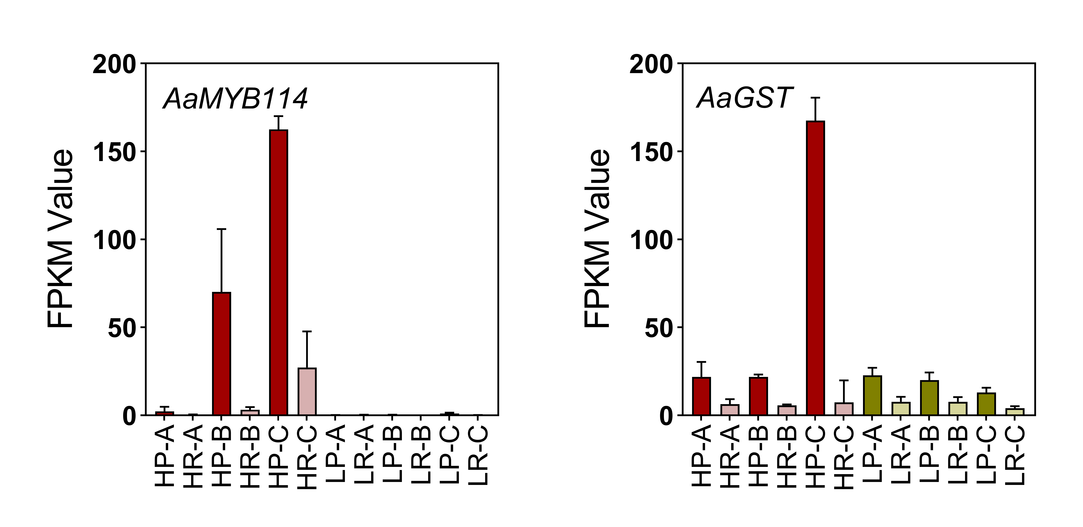
Fig. S1 FPKM Value and relative expression for AaMYB114 and AaGST in samples.
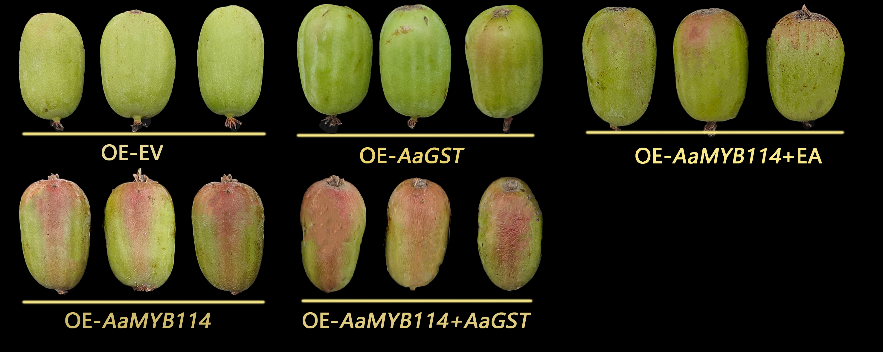
Fig. S2 Phenotypic effects of transient overexpression in A. arguta (‘Sadowa’) fruit peel.
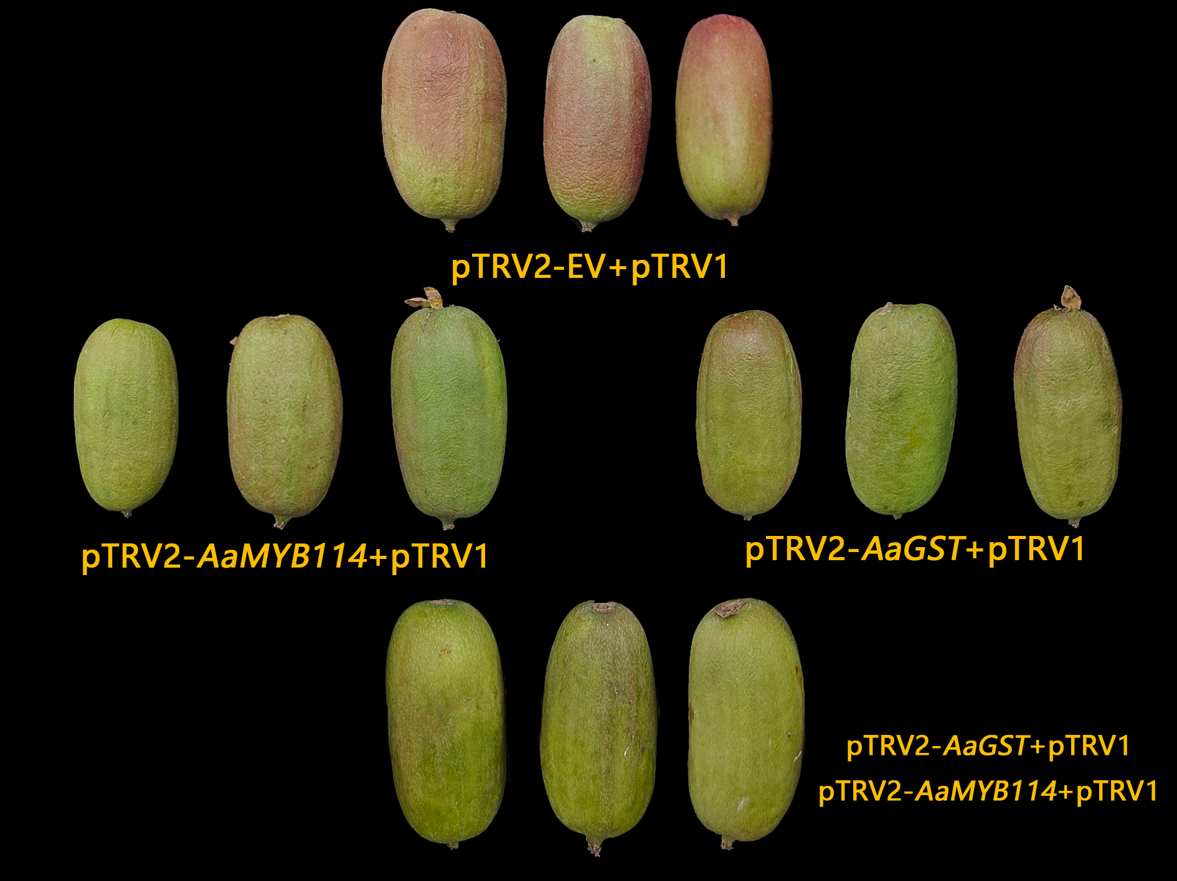
Fig. S3 Functional validation of AaMYB114 and AaGST by virus-induced gene silencing (VIGS) in A. arguta fruits.
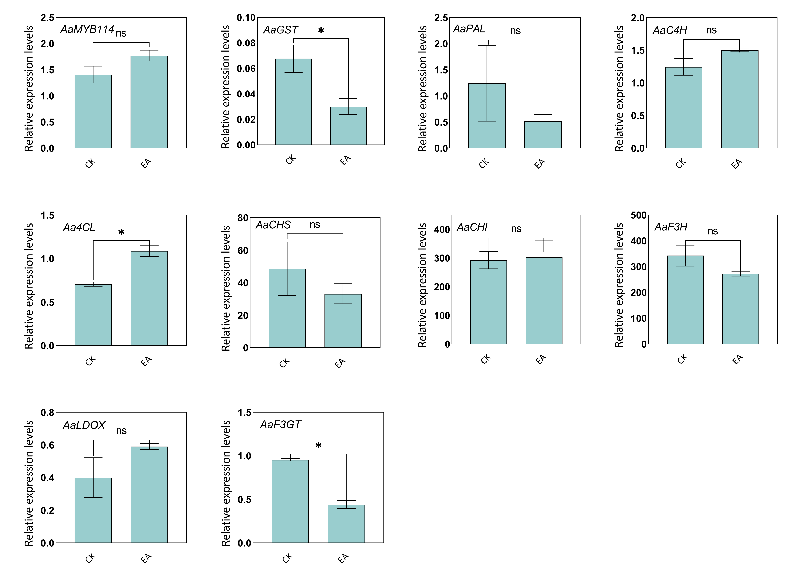
Fig. S4 Expression analysis of anthocyanin pathway genes of ethacrynic acid (EA) treatment in A. arguta fruits. Data represent the mean ± SD (n = 3). Statistical significance was evaluated using Student’s t-test: * P < 0.05.

Fig. S5 Expression analysis of anthocyanin pathway genes in AaMYB114 and AaGST silenced fruits

Tab. S1 Differential expression of transcription factors in the MEyellow module
GeneID | logFC
Aar36425 | 1.616
Aar03375 | 1.364
Aar44000 | 2.647
novel.18362 | 2.325
Aar32600 | -

Tab. S2 Primer sequences used in this study
Name of primer | Primer sequence | application
AaActin-F | TGCATGAGCGATCAAGTTTCAAG | Real-time quantitative PCR
AaActin-R | TGTCCCATGTCTGGTTGATGACT | Real-time quantitative PCR
AaPAL-F | AACCGGATTAAGGAGTGCCG | Real-time quantitative PCR
AaPAL-R | GGTGACTGCACCTTCTCTCC | Real-time quantitative PCR
AaC4H-F | GACACCCAAAAGCTCCCGTA | Real-time quantitative PCR
AaC4H-R | CTCTGCGGGGATGTCGTATC | Real-time quantitative PCR
Aa4CL-F | AGTCGAAATCAGCCCAGACG | Real-time quantitative PCR
Aa4CL-R | GTCGCTGTGCATGTAGAGGT | Real-time quantitative PCR
AaCHS-F | TTGGTCAGGCCTTGTTTGGT | Real-time quantitative PCR
AaCHS-R | TCCGGTAAGATGGTTTGGGC | Real-time quantitative PCR
AaCHI-F | GCCGTTAAGTGGAAGGGGAA | Real-time quantitative PCR
AaCHI-R | AATTTCTCAAAGGGGCCGGT | Real-time quantitative PCR
AaF3H-F | GCGTACAACGTGTTCAGCAG | Real-time quantitative PCR
AaF3H-R | ACACGCCTCCACGATCTTAC | Real-time quantitative PCR
AaF3'H2-F | GGTGTTGAACCTCACACCGA | Real-time quantitative PCR
AaF3'H2-R | GACAGCGACCCAGTTATCGT | Real-time quantitative PCR
AaLDOX-F | ATCTCGTGGGCCATGTTCTG | Real-time quantitative PCR
AaLDOX-R | AATGTGTTGGGCAAAGGTGC | Real-time quantitative PCR
AaUFGT-F | TGATCGGTCGGCCATTCTTT | Real-time quantitative PCR
AaUFGT-R | GTTCGAGTGCACGCATTGTT | Real-time quantitative PCR
Aar44404.1-F | GCGCACAACTTCAACGACTT | Real-time quantitative PCR
Aar44404.1-R | TCAGGTCAGCGAGTGTGAAC | Real-time quantitative PCR
Aar27516.1-F | CGATCTCAGTTCCTGCGTCA | Real-time quantitative PCR
Aar27516.1-R | CCACTTCCATTTCCAGGCGT | Real-time quantitative PCR
Name of primer | Primer sequence | application
Aar18715.1-F | TGGGTCCCACAATTTAGGCC | Real-time quantitative PCR
Aar18715.1-R | CAGAGCTCAATGGACCCACA | Real-time quantitative PCR
Aar34476.1-F | CCAAGCCAAGCAGTGCATTT | Real-time quantitative PCR
Aar34476.1-R | CGCAACTTCTGTCGCTGATG | Real-time quantitative PCR
Aar13425.1-F | TCAACACCATAGGATGTGCCA | Real-time quantitative PCR
Aar13425.1-R | GCGCAGATCCATCCGACAAT | Real-time quantitative PCR
Aar44000.1-F | GCTAATTGCGGGTCGACTTC | Real-time quantitative PCR
Aar44000.1-R | TTTGCCCTCCAACGAAGGTT | Real-time quantitative PCR
Q-AaGST-F | ATCTCCTCTGTTGTCCTCGG | Real-time quantitative PCR
Q-AaGST-R | AGACCTCCATACCTTCTTGCT | Real-time quantitative PCR
AaGST-F | ATGTCTGATGAATTGGTTCTTTTGAG | Gene cloning
AaGST-R | CTAGTGGATTCCAAACCACTTATTAAC | Gene cloning
AaGST-121-F | gagaacacgggggactctagaATGTCTGATGAATTGGTTCTTTTGA | Vector construction
AaGST-121-R | ggactgaccacccggggatccGTGGATTCCAAACCACTTATTAACC | Vector construction
AaMYB114-F | ATGGAAACTGTTCCTTTAGGAGTGA | Gene cloning
AaMYB114-R | TTAATCATCACCTAAGAGACTCCATAGG | Gene cloning
AaMYB114-121-F | gagaacacgggggactctagaATGGAAACTGTTCCTTTAGGAGTGA | Vector construction
AaMYB114-121-R | ggactgaccacccggggatccTTAATCATCACCTAAGAGACTCCATAGG | Vector construction
AaMYB114-BD-F | atggccatggaggccgaattcATGGAAACTGTTCCTTTAGGAGTGA | Vector construction
AaMYB114-BD-R | ccgctgcaggtcgacggatccTTAATCATCACCTAAGAGACTCCATAGG | Vector construction
AaMYB114-AD-F | gccatggaggccagtgaattcATGGAAACTGTTCCTTTAGGAGTGA | Real-time quantitative PCR
AaMYB114-AD-R | cagctcgagctcgatggatccTTAATCATCACCTAAGAGACTCCATAGG | Real-time quantitative PCR

Name of primer | Primer sequence | application
AaGSTpro-F | AGGGGCTAACTGGGTTGTTG | Promoter amplification
AaGSTpro-R | GCAACTGTTAAAGAATGGCACC | Promoter amplification
AaGST-His-F | gactcactatagggcgaattcATCGGATCGAAATCGGGCAG | Vector construction
AaGST-His-R | gattcgcgaacgcgtgagctcATTTGGACGGGTTGGGATCG | Vector construction
AaGST-0800-F | gtcgacggtatcgataagcttATCGGATCGAAATCGGGCAG | Vector construction
AaGST-0800-R | cgctctagaactagtggatccATTTGGACGGGTTGGGATCG | Vector construction
AaPALpro-F | TACCTACTCATTTGGTTTGGTGATGTGT | Promoter amplification
AaPALpro-R | CCCAATTGAGCGGGTCGC | Promoter amplification
AaPAL-His-F | gactcactatagggcgaattcCCTACTCATTTGGTTTGGTGATGT | Vector construction
AaPAL-His-R | gattcgcgaacgcgtgagctcTCTGTTGATGGAATGAAACTGAAAC | Vector construction
AaPAL-0800-F | gtcgacggtatcgataagcttCCTACTCATTTGGTTTGGTGATGT | Vector construction
AaPAL-0800-R | cgctctagaactagtggatccTCTGTTGATGGAATGAAACTGAAAC | Vector construction
AaCHSpro-F | CCCGCGGACCCGAAACCT | Promoter amplification
AaCHSpro-R | TTTCGCTGGAAAAAGTGTTGG | Promoter amplification
AaCHS-His-F | gactcactatagggcgaattcTTCTAAGTTTGGCGGGAGCC | Vector construction
AaCHS-His-R | gattcgcgaacgcgtgagctcTTCAACTACCAGTATGGATGGGAC | Vector construction
AaCHIpro-F | ggactttcatggcaaaatcaaatat | Promoter amplification
AaCHIpro-R | acagaaattattgtacaagccact | Promoter amplification
AaCHI-His-F | gactcactatagggcgaattcGGACTTTCATGGCAAAATCAAAT | Vector construction
AaCHI-His-R | gattcgcgaacgcgtgagctcAACCCCATATCTAAATCACCATTACG | Vector construction
AaCHI-0800-F | gtcgacggtatcgataagcttGGACTTTCATGGCAAAATCAAAT | Vector construction
AaCHI-0800-R | cgctctagaactagtggatccAGCTCTCTCAGTTTTTATGTGTCTTTG | Vector construction
AaF3Hpro-F | caaacaagaatcttcatctcaaccat | Promoter amplification
AaF3Hpro-R | ccagcgaacgaatctatgg | Promoter amplification
AaF3H-His-F | gactcactatagggcgaattcCAAACAAGAATCTTCATCTCAACCA | Vector construction
AaF3H-His-R | gattcgcgaacgcgtgagctcCCAGCGAACGAATCTATGGG | Vector construction

Name of primer | Primer sequence | application
AaF3H-0800-F | gtcgacggtatcgataagcttCAAACAAGAATCTTCATCTCAACCA | Vector construction
AaF3H-0800-R | cgctctagaactagtggatccCCAGCGAACGAATCTATGGG | Vector construction
AaLDOXpro-F | TTGTTCTGATTGTAATGGGTGAAAC | Promoter amplification
AaLDOXpro-R | TCCGTACGTGTGAATTTGTGACA | Promoter amplification
AaLDOX-His-F | gactcactatagggcgaattcTTGTTCTGATTGTAATGGGTGAAAC | Vector construction
AaLDOX-His-R | gattcgcgaacgcgtgagctcTCCGTACGTGTGAATTTGTGACA | Vector construction
AaF3GTpro-F | tttcacaatgcaagcacaca | Promoter amplification
AaF3GTpro-R | tgattttggttatagcttttttggtg | Promoter amplification
AaF3GT-His-F | gactcactatagggcgaattcTTTCACAATGCAAGCACACAGTT | Vector construction
AaF3GT-His-R | gattcgcgaacgcgtgagctcCTTTGATTTTGGTTATAGCTTTTTTGG | Vector construction

Tab.S3 Phylogenetic analysis of MYB transcription factors
Gene Family | Locus ID | Gene/Protein Name
MYB Transcription Factor Family | At1g06180 | AtMYB13
MYB Transcription Factor Family | At1g08810 | AtMYB60
MYB Transcription Factor Family | At1g09540 | AtMYB61
MYB Transcription Factor Family | At1g14350 | AtMYB124
MYB Transcription Factor Family | At1g16490 | AtMYB58
MYB Transcription Factor Family | At1g17950 | AtMYB52
MYB Transcription Factor Family | At1g18570 | AtMYB51
MYB Transcription Factor Family | At1g18710 | AtMYB47
MYB Transcription Factor Family | At1g22640 | AtMYB3
MYB Transcription Factor Family | At1g25340 | AtMYB116
MYB Transcription Factor Family | At1g26780 | AtMYB117
MYB Transcription Factor Family | At1g34670 | AtMYB93
MYB Transcription Factor Family | At1g35515 | AtMYB8
MYB Transcription Factor Family | At1g48000 | AtMYB112
MYB Transcription Factor Family | At1g56160 | AtMYB72
MYB Transcription Factor Family | At1g56650 | AtMYB75
MYB Transcription Factor Family | At1g57560 | AtMYB50
MYB Transcription Factor Family | At1g63910 | AtMYB103
MYB Transcription Factor Family | At1g66230 | AtMYB20
MYB Transcription Factor Family | At1g66370 | AtMYB113
MYB Transcription Factor Family | At1g66380 | AtMYB114
MYB Transcription Factor Family | At1g66390 | AtMYB90
MYB Transcription Factor Family | At1g68320 | AtMYB62
MYB Transcription Factor Family | At1g69560 | AtMYB105
MYB Transcription Factor Family | At1g73410 | AtMYB54
MYB Transcription Factor Family | At1g74080 | AtMYB122
MYB Transcription Factor Family | At1g74430 | AtMYB95
MYB Transcription Factor Family | At1g74650 | AtMYB31
MYB Transcription Factor Family | At1g79180 | AtMYB63
MYB Transcription Factor Family | At2g02820 | AtMYB88
MYB Transcription Factor Family | At2g16720 | AtMYB7
MYB Transcription Factor Family | At2g23290 | AtMYB70
MYB Transcription Factor Family | At2g25230 | AtMYB100
MYB Transcription Factor Family | At2g26950 | AtMYB104
MYB Transcription Factor Family | At2g26960 | AtMYB81
MYB Transcription Factor Family | At2g31180 | AtMYB14
MYB Transcription Factor Family | At2g32460 | AtMYB101
MYB Transcription Factor Family | At2g36890 | AtMYB38
MYB Transcription Factor Family | At2g37630 | AtMYB91
MYB Transcription Factor Family | At2g39880 | AtMYB25
MYB Transcription Factor Family | At2g47190 | AtMYB2
MYB Transcription Factor Family | At2g47460 | AtMYB12
MYB Transcription Factor Family | At3g01140 | AtMYB106
MYB Transcription Factor Family | At3g01530 | AtMYB57
MYB Transcription Factor Family | At3g02940 | AtMYB107
MYB Transcription Factor Family | At3g06490 | AtMYB108
MYB Transcription Factor Family | At3g08500 | AtMYB83
MYB Transcription Factor Family | At3g09230 | AtMYB1
MYB Transcription Factor Family | At3g09370 | AtMYB3R3
MYB Transcription Factor Family | At3g11440 | AtMYB65
MYB Transcription Factor Family | At3g12720 | AtMYB67
MYB Transcription Factor Family | At3g12820 | AtMYB10
MYB Transcription Factor Family | At3g13540 | AtMYB5
MYB Transcription Factor Family | At3g13890 | AtMYB26
MYB Transcription Factor Family | At3g23250 | AtMYB15
MYB Transcription Factor Family | At3g24310 | AtMYB71
MYB Transcription Factor Family | At3g27780 | AtMYB118
MYB Transcription Factor Family | At3g27810 | AtMYB21
MYB Transcription Factor Family | At3g27920 | AtMYB0
MYB Transcription Factor Family | At3g28470 | AtMYB35
MYB Transcription Factor Family | At3g28910 | AtMYB30
MYB Transcription Factor Family | At3g29020 | AtMYB110
MYB Transcription Factor Family | At3g30210 | AtMYB121
MYB Transcription Factor Family | At3g46130 | AtMYB48
MYB Transcription Factor Family | At3g47600 | AtMYB94
MYB Transcription Factor Family | At3g48920 | AtMYB45
MYB Transcription Factor Family | At3g49690 | AtMYB84
MYB Transcription Factor Family | At3g50060 | AtMYB77
MYB Transcription Factor Family | At3g53200 | AtMYB27
MYB Transcription Factor Family | At3g55730 | AtMYB109
MYB Transcription Factor Family | At3g60460 | AtMYB125
MYB Transcription Factor Family | At3g61250 | AtMYB17
MYB Transcription Factor Family | At3g62610 | AtMYB11
MYB Transcription Factor Family | At4g00540 | AtMYB3R2
MYB Transcription Factor Family | At4g01680 | AtMYB55
MYB Transcription Factor Family | At4g05100 | AtMYB74
MYB Transcription Factor Family | At4g09460 | AtMYB6
MYB Transcription Factor Family | At4g12350 | AtMYB42
MYB Transcription Factor Family | At4g13480 | AtMYB79
MYB Transcription Factor Family | AT4G17785 | AtMYB39
MYB Transcription Factor Family | At4g18770 | AtMYB98
MYB Transcription Factor Family | At4g21440 | AtMYB102
MYB Transcription Factor Family | At4g22680 | AtMYB85
MYB Transcription Factor Family | At4g25560 | AtMYB18
MYB Transcription Factor Family | At4g26930 | AtMYB97
MYB Transcription Factor Family | At4g28110 | AtMYB41
MYB Transcription Factor Family | At4g32730 | AtMYB3R1
MYB Transcription Factor Family | At4g33450 | AtMYB69
MYB Transcription Factor Family | At4g34990 | AtMYB32
MYB Transcription Factor Family | At4g37260 | AtMYB73
MYB Transcription Factor Family | At4g37780 | AtMYB87
MYB Transcription Factor Family | At4g38620 | AtMYB4
MYB Transcription Factor Family | At5g02320 | AtMYB3R5
MYB Transcription Factor Family | At5g06100 | AtMYB33
MYB Transcription Factor Family | At5g07690 | AtMYB29
MYB Transcription Factor Family | At5g07700 | AtMYB76
MYB Transcription Factor Family | At5g10280 | AtMYB92
MYB Transcription Factor Family | At5g11050 | AtMYB64
MYB Transcription Factor Family | At5g11510 | AtMYB3R4
MYB Transcription Factor Family | At5g12870 | AtMYB46
MYB Transcription Factor Family | At5g14340 | AtMYB40
MYB Transcription Factor Family | At5g14750 | AtMYB66
MYB Transcription Factor Family | At5g15310 | AtMYB16
MYB Transcription Factor Family | At5g16600 | AtMYB43
MYB Transcription Factor Family | At5g16770 | AtMYB9
MYB Transcription Factor Family | At5g17800 | AtMYB56
MYB Transcription Factor Family | At5g23000 | AtMYB37
MYB Transcription Factor Family | At5g26660 | AtMYB86
MYB Transcription Factor Family | At5g35550 | AtMYB123
MYB Transcription Factor Family | At5g39700 | AtMYB89
MYB Transcription Factor Family | At5g40330 | AtMYB23
MYB Transcription Factor Family | At5g40350 | AtMYB24
MYB Transcription Factor Family | At5g40360 | AtMYB115
MYB Transcription Factor Family | At5g40430 | AtMYB22
MYB Transcription Factor Family | At5g49330 | AtMYB111
MYB Transcription Factor Family | At5g49620 | AtMYB78
MYB Transcription Factor Family | At5g52260 | AtMYB19
MYB Transcription Factor Family | At5g52600 | AtMYB82
MYB Transcription Factor Family | At5g54230 | AtMYB49
MYB Transcription Factor Family | At5g55020 | AtMYB120
MYB Transcription Factor Family | At5g56110 | AtMYB80
MYB Transcription Factor Family | At5g57620 | AtMYB36
MYB Transcription Factor Family | At5g58850 | AtMYB119
MYB Transcription Factor Family | At5g59780 | AtMYB59
MYB Transcription Factor Family | At5g60890 | AtMYB34
MYB Transcription Factor Family | At5g61420 | AtMYB28
MYB Transcription Factor Family | At5g62320 | AtMYB99
MYB Transcription Factor Family | At5g62470 | AtMYB96
MYB Transcription Factor Family | At5g65230 | AtMYB53
MYB Transcription Factor Family | At5g65790 | AtMYB68
MYB Transcription Factor Family | At5g67300 | AtMYB44

