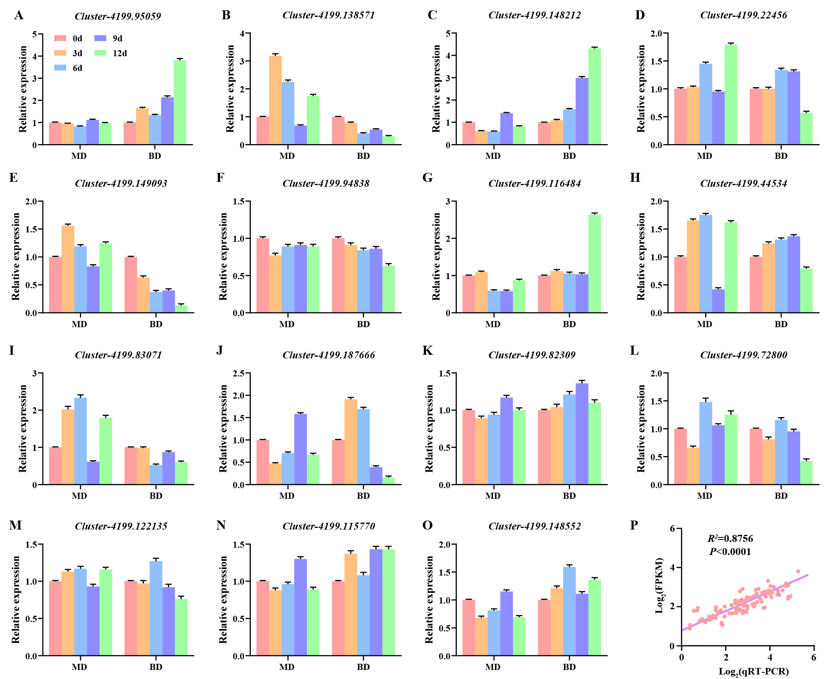
Figure S1 Quantitative reverse transcription polymerase chain reaction of fifteen genes.
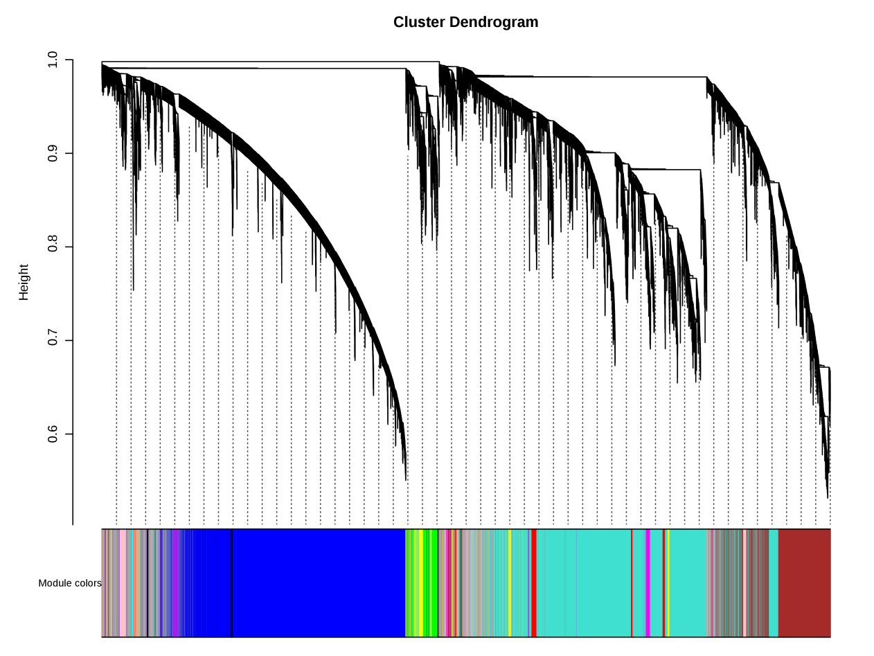
Figure S2 Identification of co-expression modules in Kentucky bluegrass under drought stress.
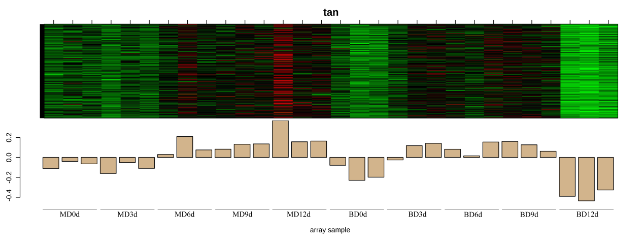
Figure S3 Correlation study of co-expressed genes in the tan module.
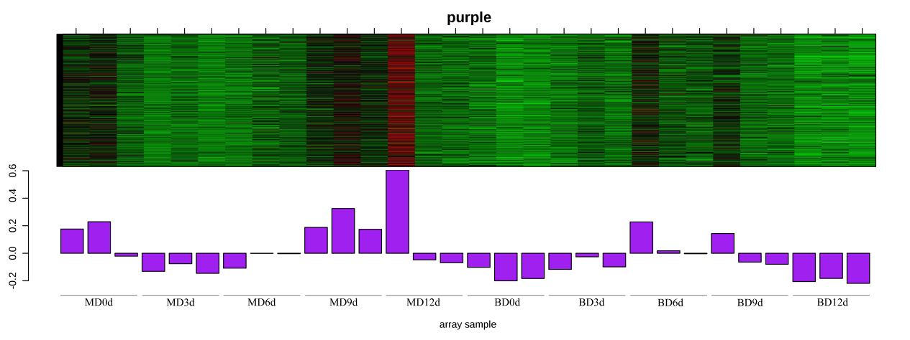
Figure S4 Correlation study of co-expressed genes in the purple module.
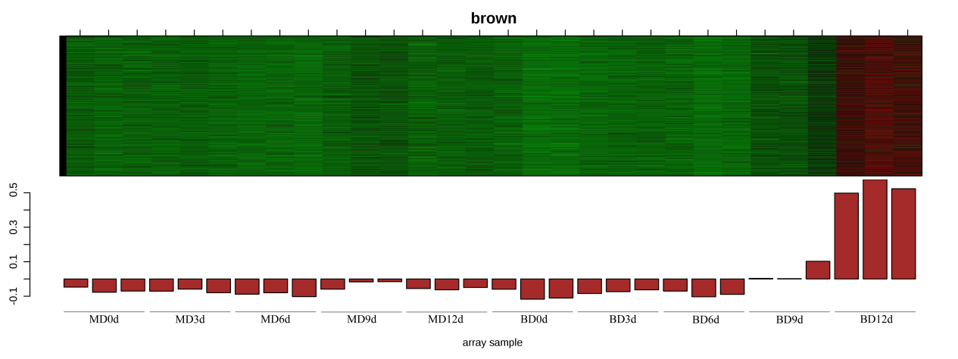
Figure S5 Correlation study of co-expressed genes in the brown module.

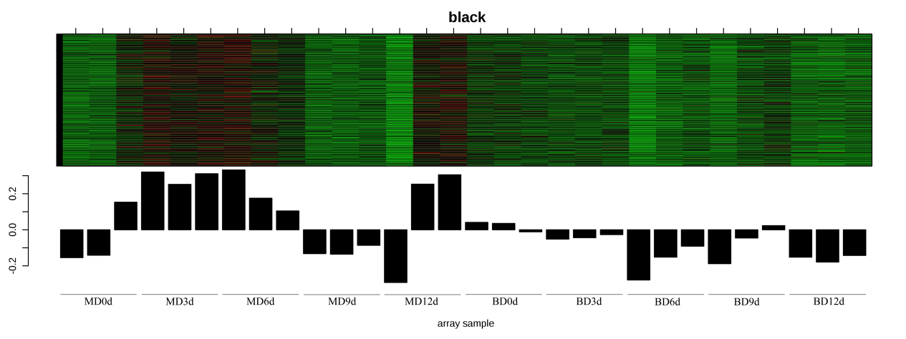
Figure S6 Correlation study of co-expressed genes in the black module.
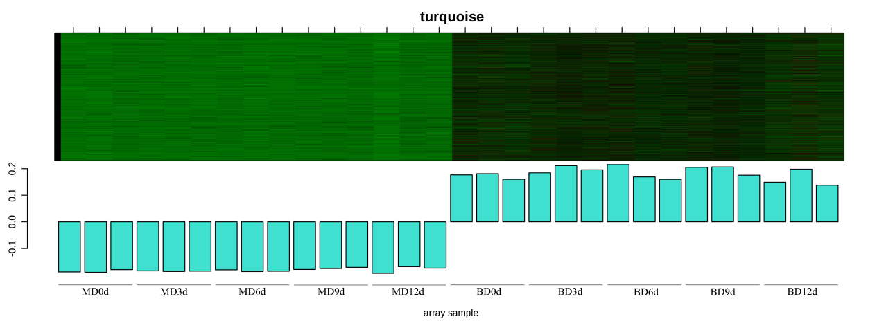
Figure S7 Correlation study of co-expressed genes in the turquoise module..
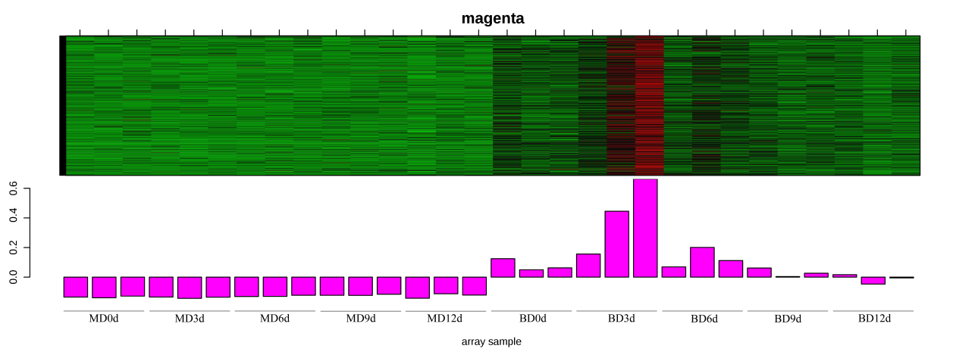
Figure S8 Correlation study of co-expressed genes in the magenta module.
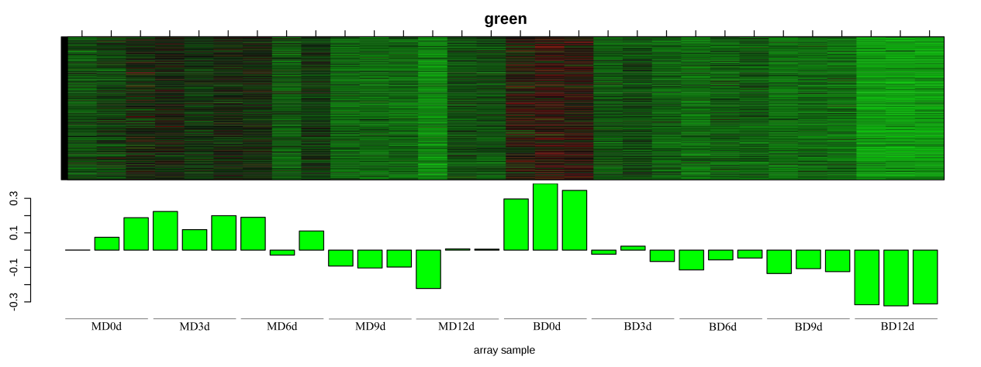
Figure S9 Correlation study of co-expressed genes in the green module.
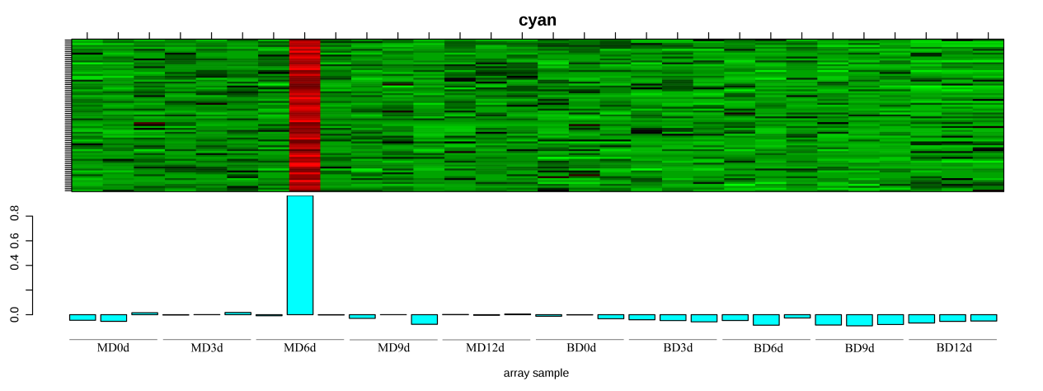
Figure S10 Correlation study of co-expressed genes in the cyan module.
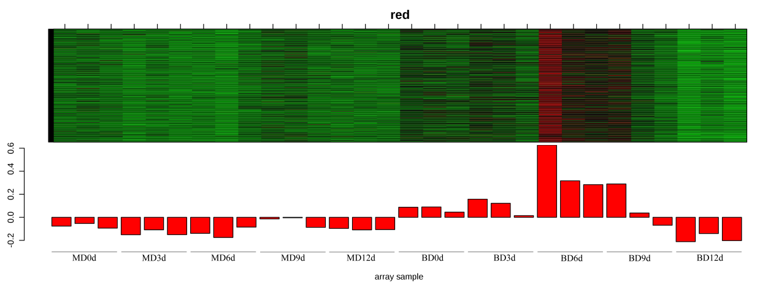
Figure S11 Correlation study of co-expressed genes in the red module.
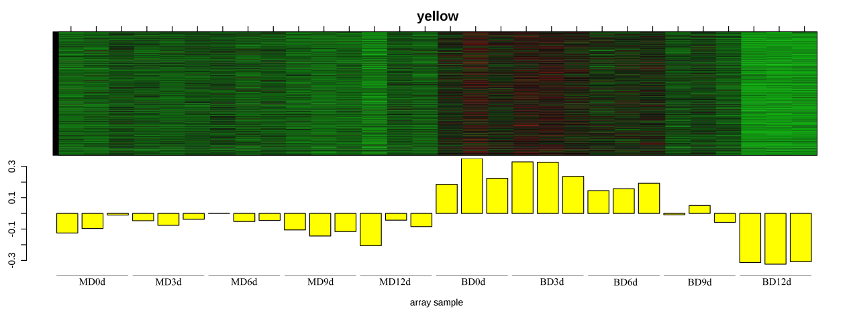
Figure S12 Correlation study of co-expressed genes in the yellow module.
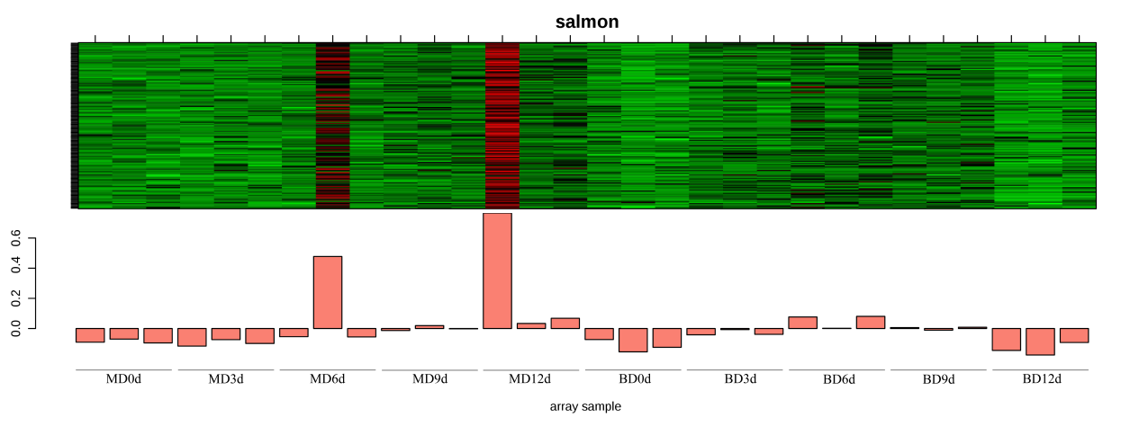
Figure S13 Correlation study of co-expressed genes in the salmon module.
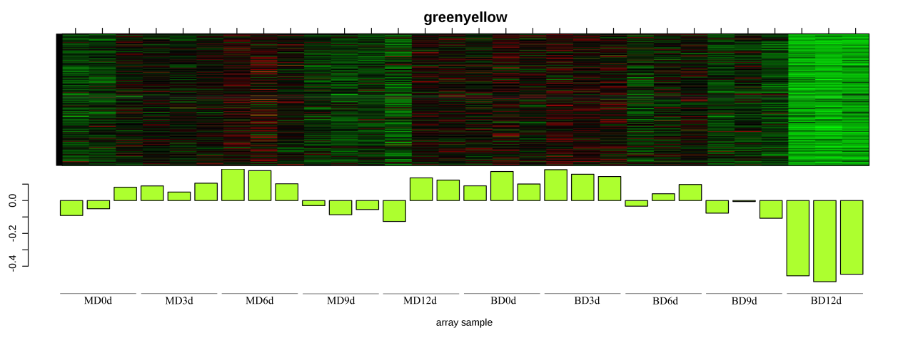
Figure S14 Correlation study of co-expressed genes in the greenyellow module.
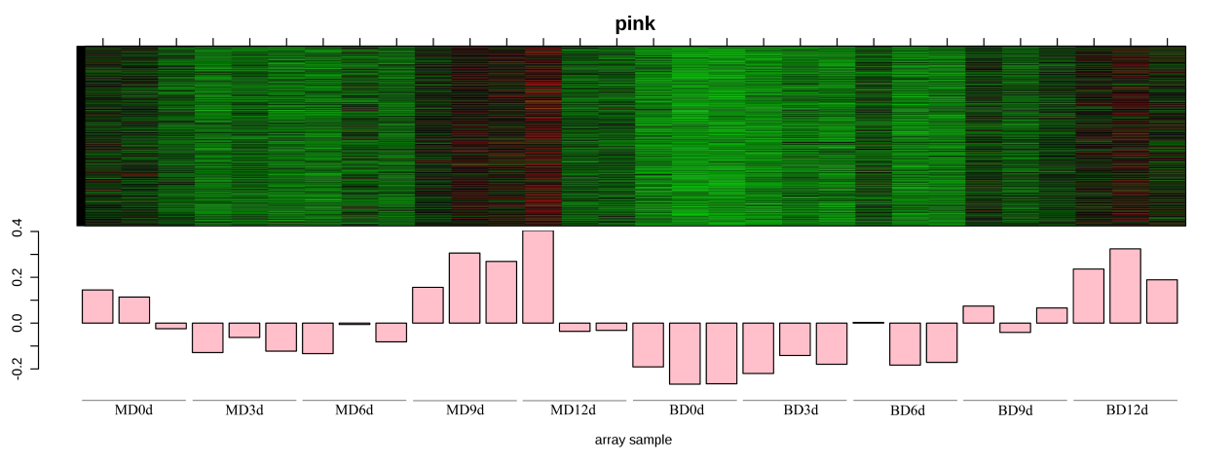
Figure S15 Correlation study of co-expressed genes in the pink module.
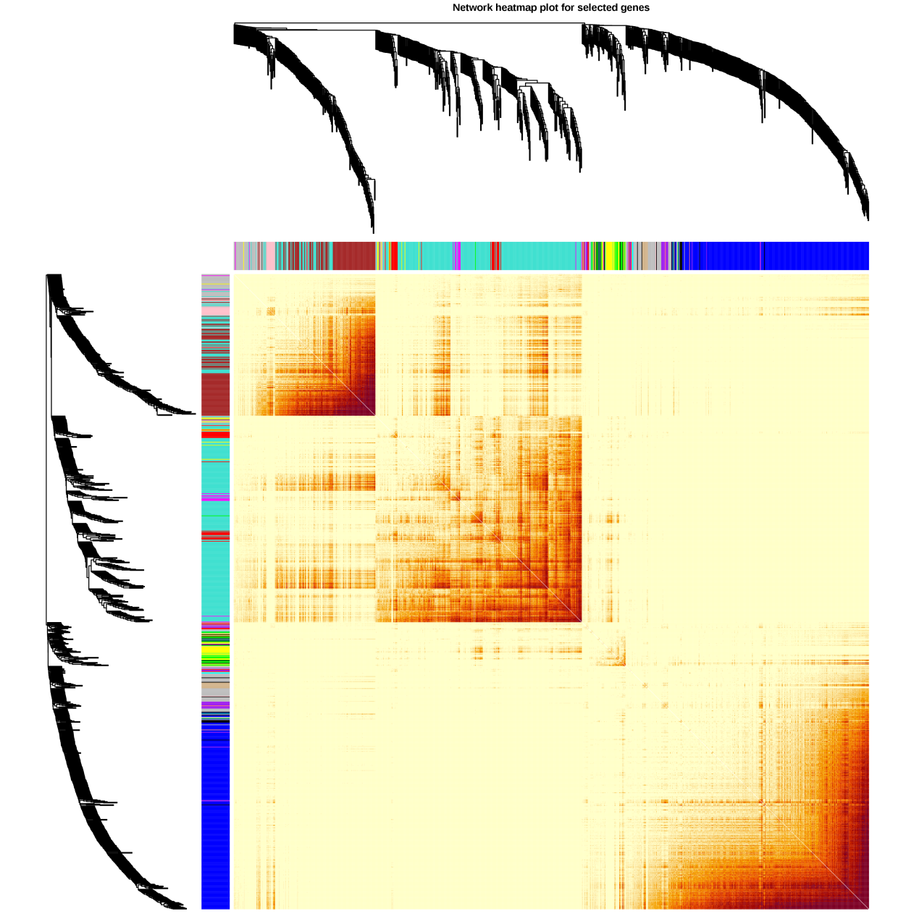
Figure S16 Topological overlap matrix (TOM) heatmap visualizing the highly interconnected co-expression network within drought-responsive modules.
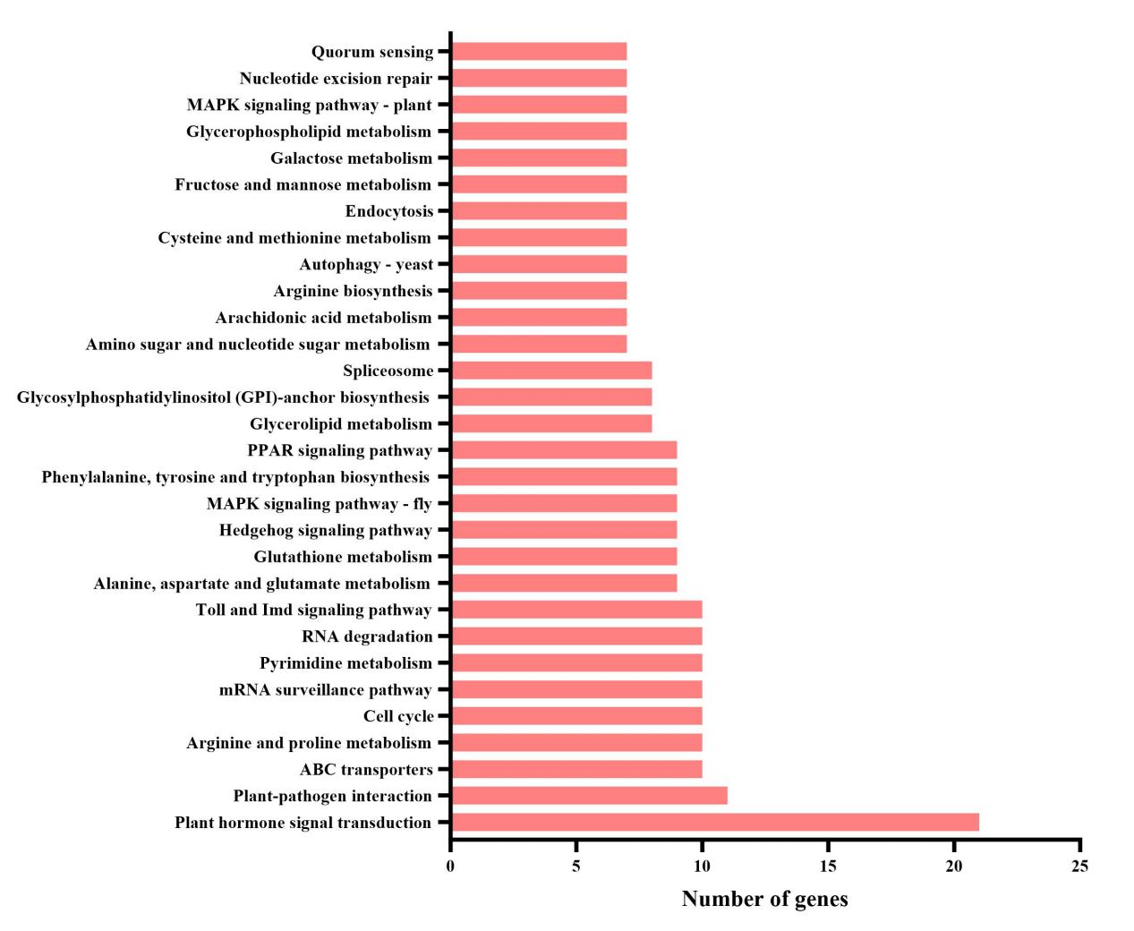
Figure S17 KEGG pathway enrichment analysis of the blue co-expression module.
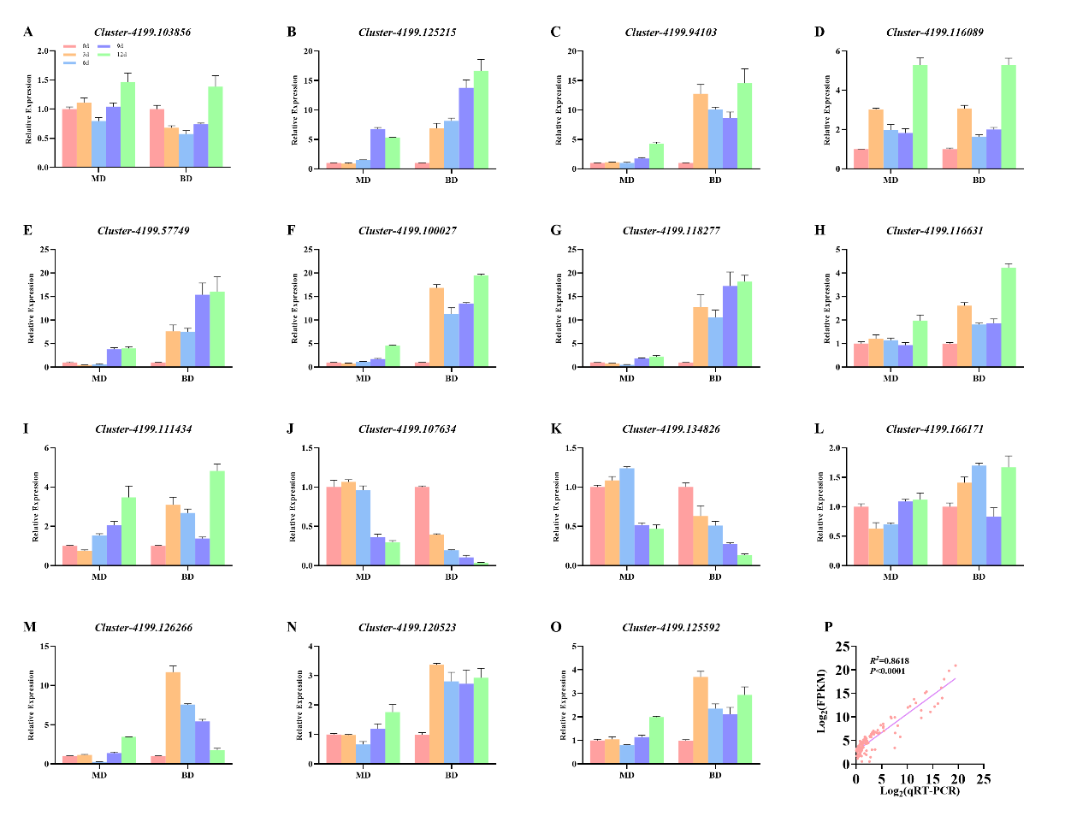
Figure S18 Validation of ABA signaling pathway gene expression by qRT‑PCR..

