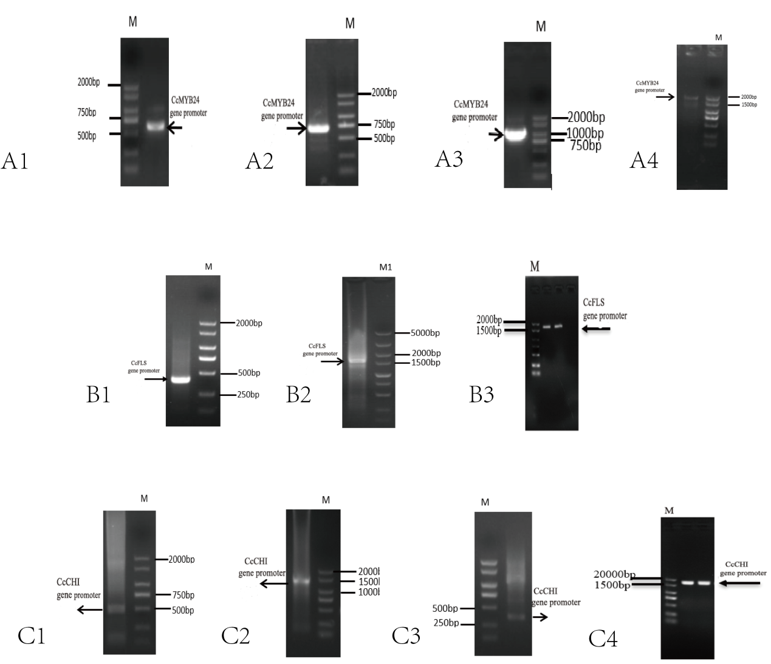
Supplementary Fig. S2 Amplification of promoter fragments of CcMYB24, CcFLS and CcCHI from Cymbidium genomic DNA.
(A) Agarose gel electrophoresis of PCR products corresponding to different fragments of the CcMYB24 gene promoter. Lanes A1–A4 represent four promoter fragments with distinct lengths, amplified using specific primer pairs designed according to the genomic sequence upstream of the CcMYB24 coding region. Lane M shows the DNA size marker (bp), with bands at 250, 500, 750, 1 000, 1 500 and 2 000 bp indicated on the left. The main bands in lanes A1–A4 migrate between approximately 500–2 000 bp, corresponding to the expected sizes of the cloned CcMYB24 promoter fragments used for functional and reporter assays.
(B) PCR amplification of CcFLS promoter fragments. Lanes B1–B3 represent three promoter fragments of different sizes. Lane M1 indicates the DNA ladder. The bands in lanes B1–B3 range from ~250 bp to ~2 000 bp, matching the predicted promoter fragment lengths for CcFLS that were subsequently inserted into reporter constructs for dual-luciferase analysis.
© PCR amplification of CcCHI promoter fragments. Lanes C1–C4 correspond to four distinct promoter fragments of the CcCHI gene. Lane M denotes the DNA marker. Single, specific bands are observed in each lane, with sizes spanning ~250–2 000 bp, consistent with the designed CcCHI promoter regions.

