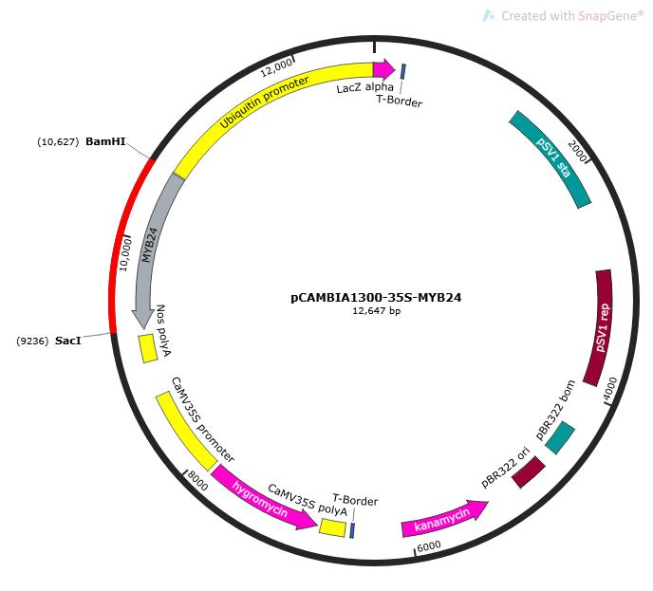
Figure S-1 Plant expression vector pCAMBIA1300-35s-CcMYB24-GFP

CcMYB24
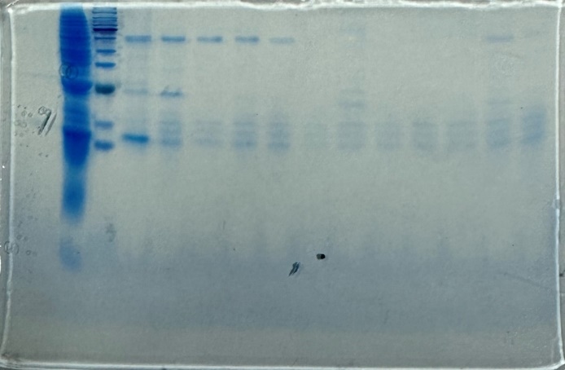
Figure S-2 SDS-PAGE analysis of GST-affinity purified CcMYB24

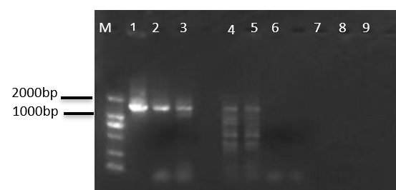
Figure S-4 Electrophoretic image of CcMYB24 gene overexpre s sion po sitive plant s detection
Note: M：DL2000， The bands corresponding to 1, 2, and 3 in the figure are the products of transgenic PCR amplification, while bands 4, 5, and 9 are the products of positive control PCR amplification. Bands 7, 8, and 9 correspond to wild-type Dendrobium officinale without bands.

