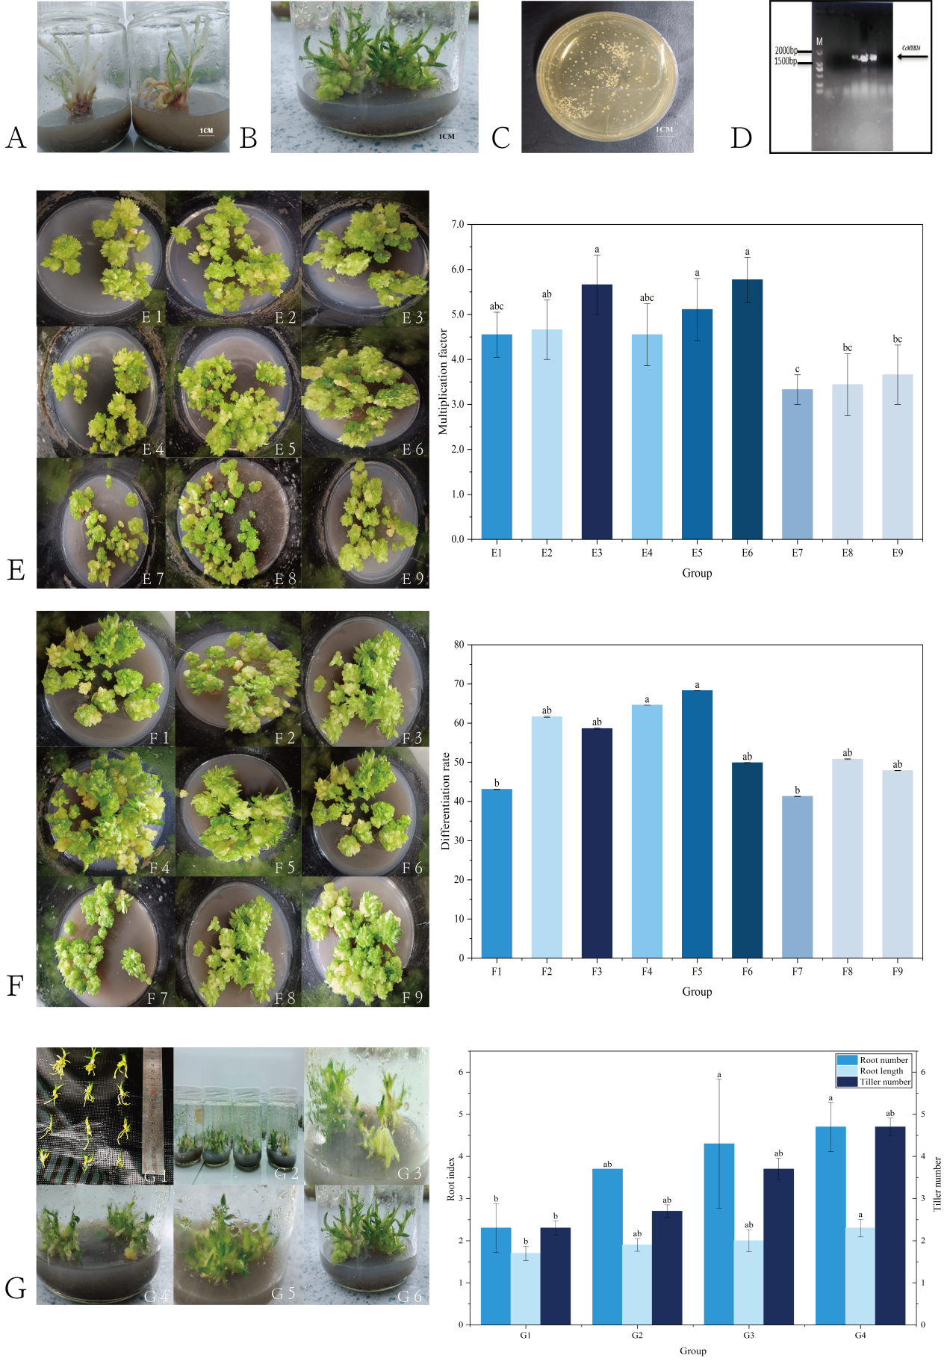
Supplementary Fig. S1 Establishment and optimization of the tissue culture and transformation system for Dendrobium officinale and molecular identification of CcMYB24-overexpressing lines.
(A) Initial in vitro culture of protocorm-like bodies (PLBs) derived from D. officinale. Explants were cultured on basal medium to induce protocorm formation under aseptic conditions.
(B) Proliferation of PLBs and shoot multiplication in culture bottles under optimized proliferation conditions. Robust clump formation and multiple shoot emergence indicate effective multiplication.
© Activation and contamination control of Agrobacterium tumefaciens cultures. A representative Petri dish shows bacterial growth used for transformation and the absence of fungal or bacterial contaminants in plant tissue cultures.
(D) PCR identification of CcMYB24-overexpressing D. officinale plants. Agarose gel electrophoresis shows amplification of the CcMYB24 transgene from genomic DNA of putative transformants. Lane M, DNA marker; lane C, negative control (wild-type); lanes 1–n, independent transgenic lines. A specific band at approximately 1 500–2 000 bp corresponds to the expected size of the CcMYB24 coding sequence, confirming successful integration of the transgene.
(E) Effects of nine proliferation media (E1–E9) on PLB multiplication. The upper panel shows representative PLBs grown on nine different media, numbered 1–9 on the photographs, each corresponding to a distinct combination of 6-BA, NAA and organic additives (see Methods for detailed compositions). The lower bar graph presents the multiplication coefficient for treatments E1–E9, which match image E1–9 in the upper panel, respectively. Bars represent mean ± SE (n ≥ 3). Different lowercase letters above the bars indicate statistically significant differences among treatments according to one-way ANOVA followed by Tukey’s test (P < 0.05).
(F) Effects of nine differentiation media (F1–F9) on shoot induction from PLBs. The upper panel shows the morphological appearance of PLBs and emerging shoots under nine different differentiation media, with culture dishes labelled F1–9, corresponding to treatments F1–F9, respectively. The lower bar chart shows the differentiation rate (%) for each group (F1–F9). Data are presented as mean ± SE (n ≥ 3); different lowercase letters indicate significant differences among treatments (P < 0.05, one-way ANOVA, Tukey’s test).
(G) Rooting and plantlet growth under different rooting media (G1–G4). The left images display representative plantlets cultured on four rooting media, labelled G1–4 in the photographs, corresponding to treatments G1–G4, respectively. Additional images G5 and G6 illustrate typical root systems and tillering performance under the optimal rooting condition. The three bar graphs on the right summarize the effects of different rooting media on root number, root length and tiller number per plant. Values are mean ± SE (n ≥ 3). Different lowercase letters indicate significant differences among treatments (P < 0.05, one-way ANOVA, Tukey’s test).

