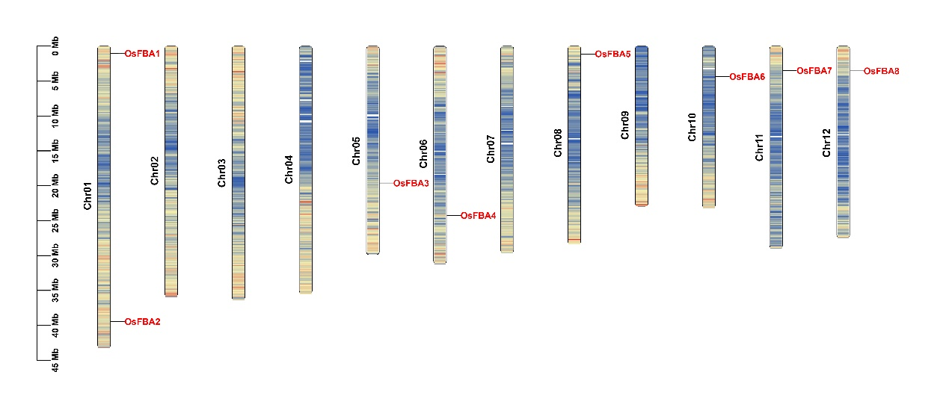
Fig. S1 Distribution of OsFBAs on rice chromosomes. OsFBAs are marked in red. The vertical coordinate indicates chromosome length (Mb) and chromosome numbering is on the left side of the chromosomes.
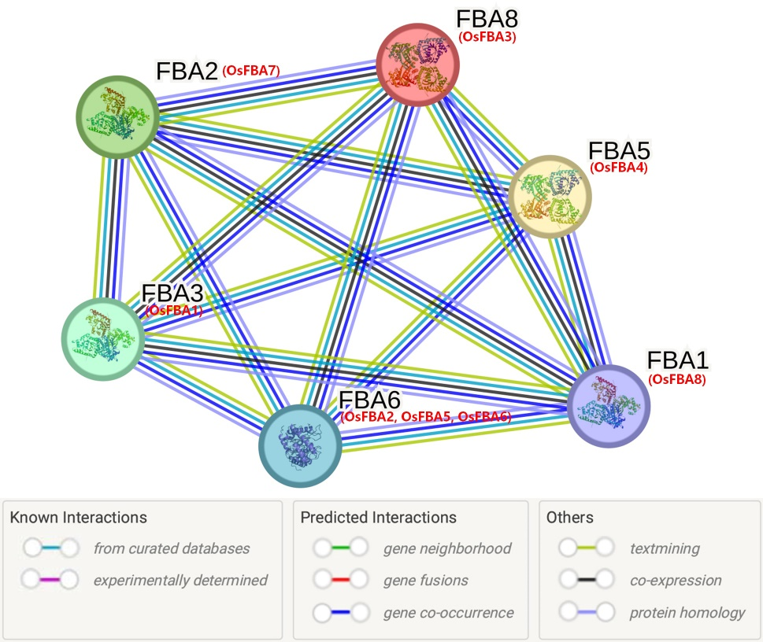
Fig. S2 Interaction networks of OsFBA proteins in rice according to the orthologues in Arabidopsis. The amino acid sequences of OsFBAs were employed to search the STRING database, network node represents proteins, and edge represents protein–protein associations. The colored lines between the nodes indicate the different kinds of interactions. The corresponding orthologues in rice are in brackets. The ﬁlled and empty nodes delineate the proteins with known or predicted 3D structures and unknown 3D structures, respectively.

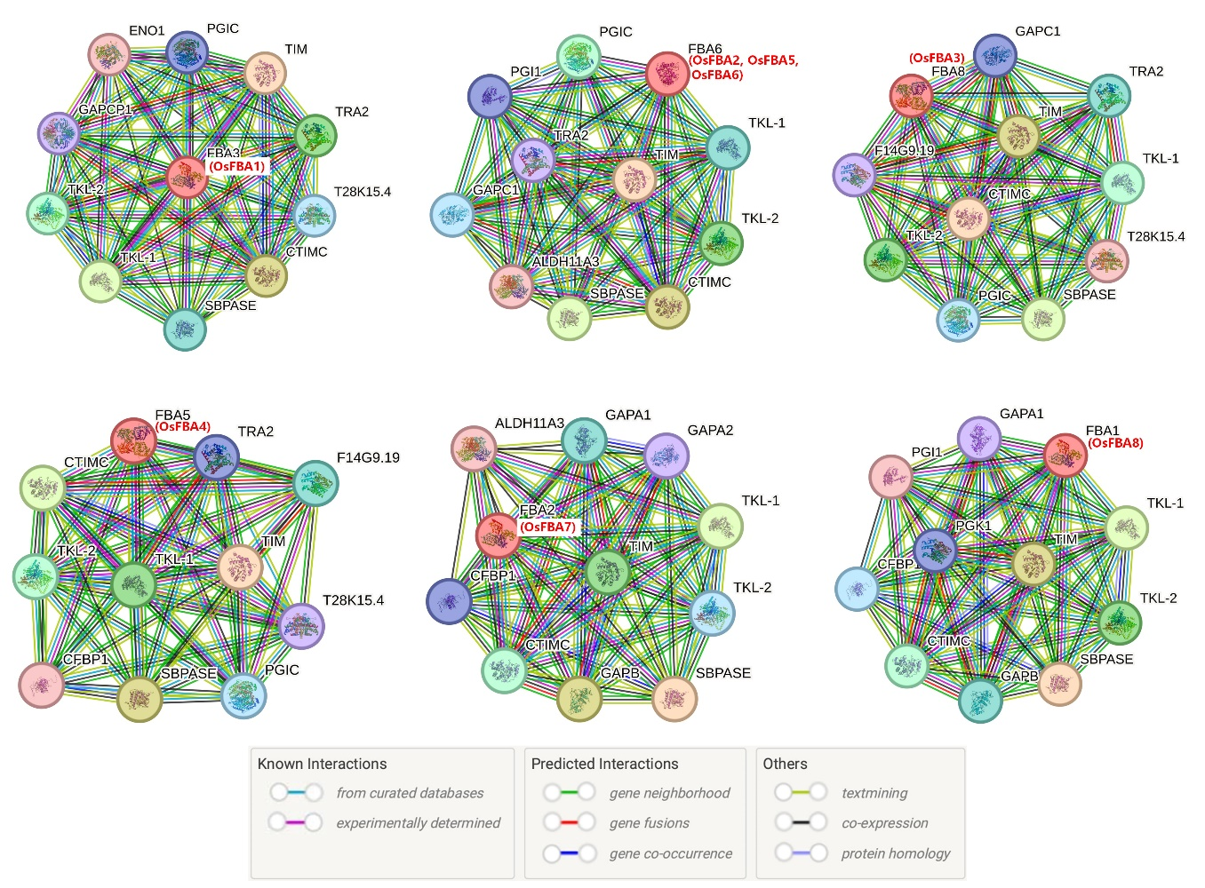
Fig. S3 Interaction networks of OsFBA proteins with other functional proteins from different families according to the orthologues in Arabidopsis. The amino acid sequences of each OsFBA protein in rice were employed to search the STRING database according to the orthologues in Arabidopsis. The network node represents proteins, and the edge represents protein-protein associations. The different colored lines between the nodes indicate the different kinds of interactions. The corresponding orthologues in rice are in brackets. The ﬁlled and empty nodes delineate the proteins with known or predicted 3D structures and unknown 3D structures, respectively.
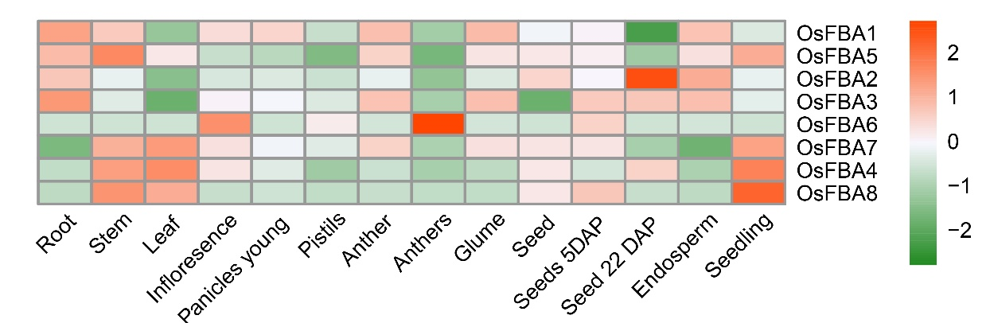
Fig. S4 Transcriptional expression profiles of OsFBAs in various rice tissues and developmental stages. Transcript levels are depicted by different colors on the scale. Green and red represent low and high expression levels, respectively. The heatmap was prepared using R software package “pheatmap”.

