Supplementary materials
Figures S4-S9 Licorice
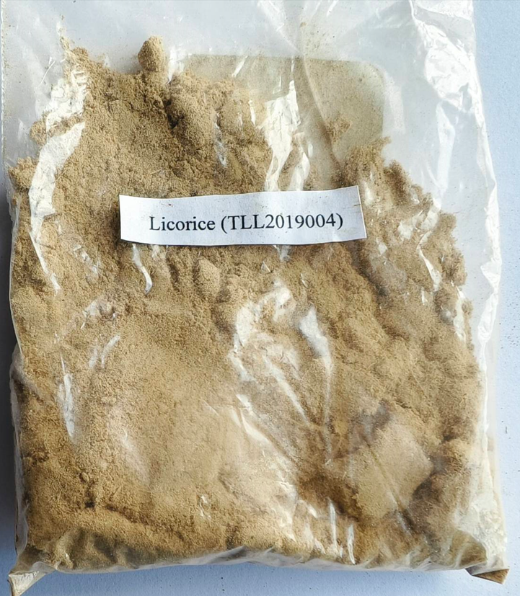
Figure S4 Licorice (TLL2019004)

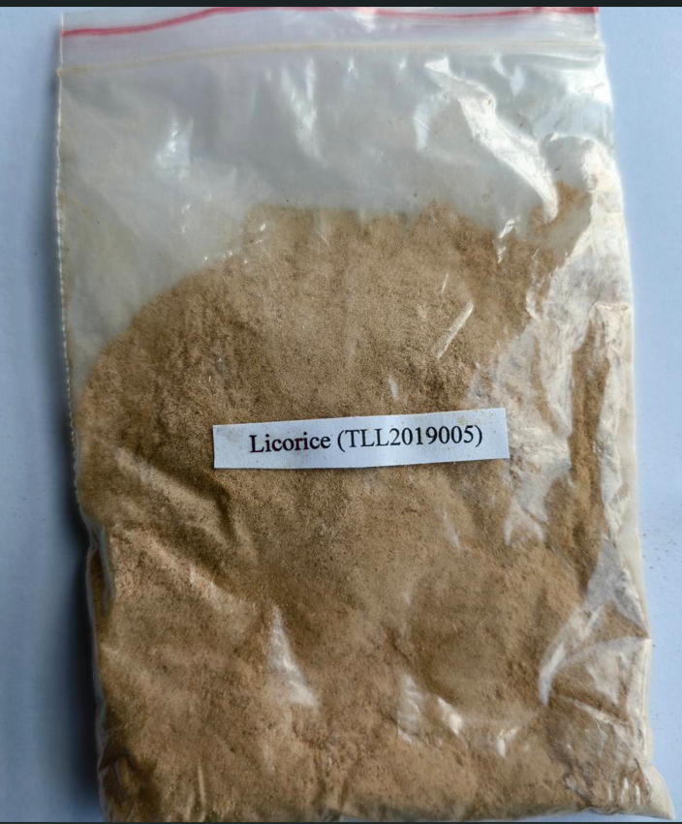
Figure S5 Licorice (TLL2019005)
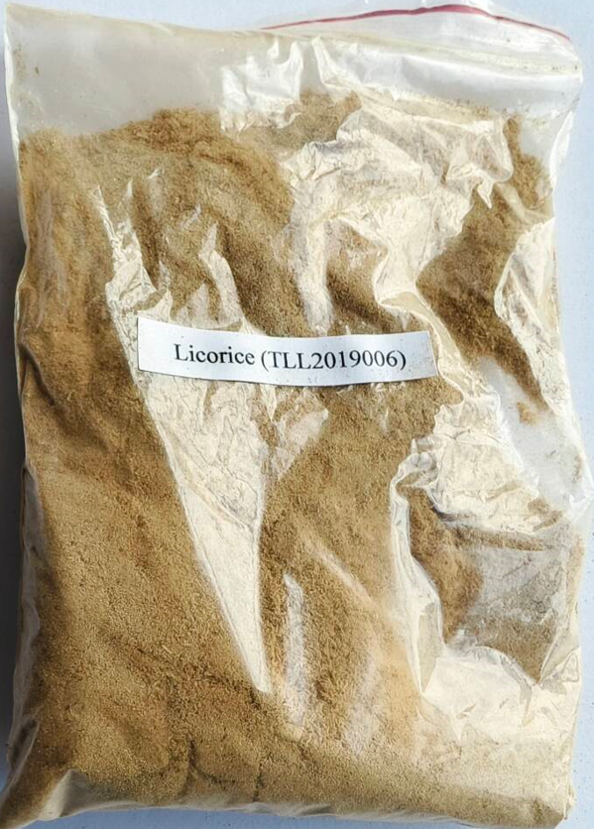
Figure S6 Licorice (TLL2019006)
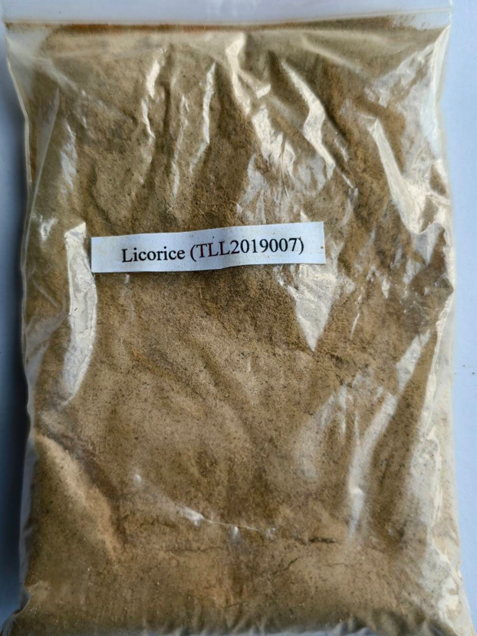
Figure S7 Licorice (TLL2019007)
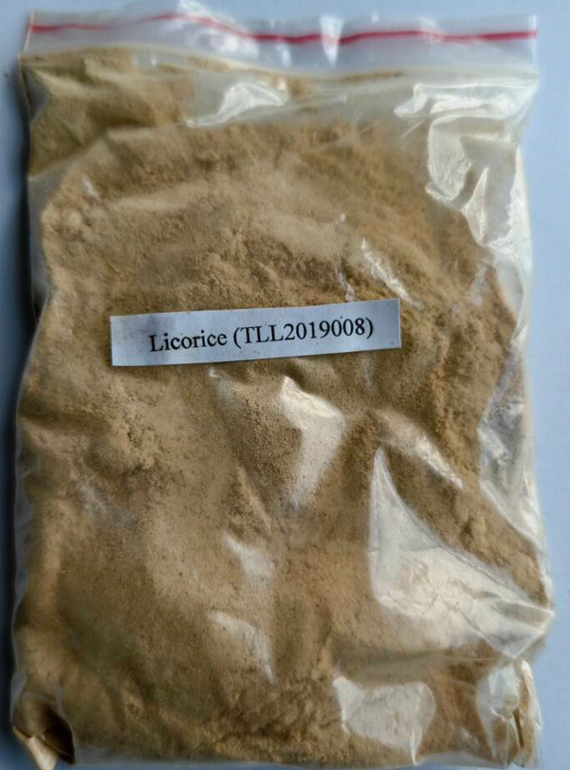
Figure S8 Licorice (TLL2019008)
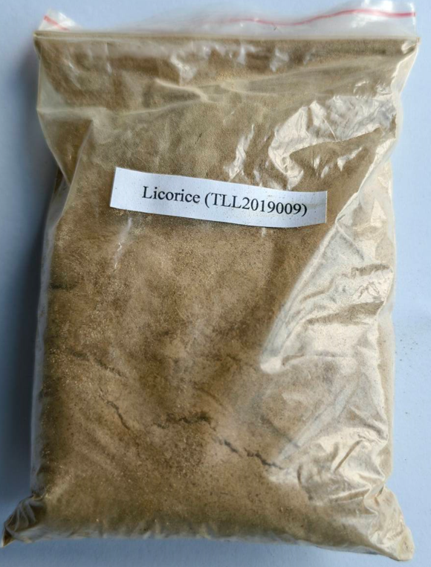
Figure S9 Licorice (TLL2019009)

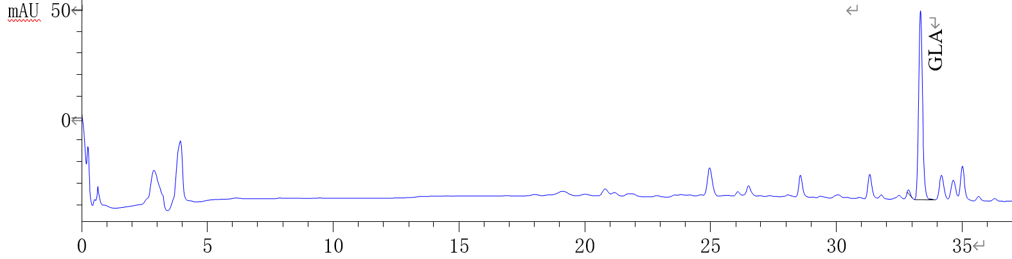
Times/min
Figure S10 Glycyrrhizic acid HPLC chromatogram of licorice in Dongsheng District, Ordos, Inner Mongolia

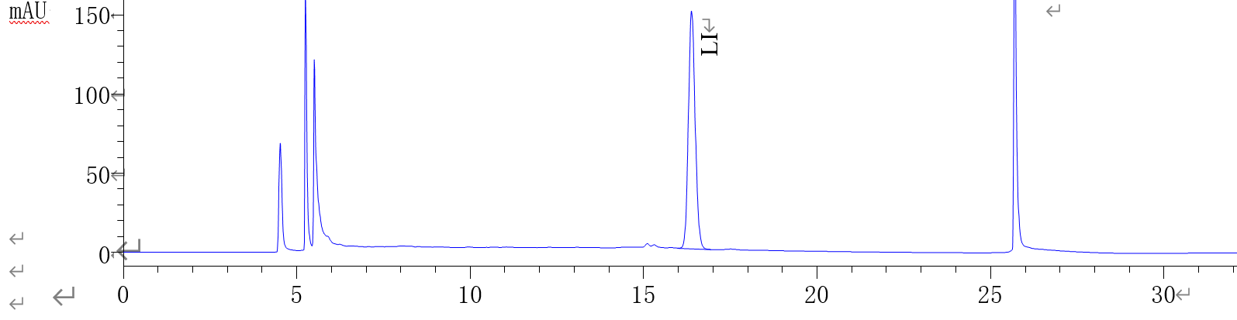
Times/min
Figure S11 Liquiritin HPLC chromatogram of licorice in Dongsheng District, Ordos, Inner Mongolia

Table S1(a) Thermogravimetric analysis data of licorice in Dongsheng District, Ordos, Inner Mongolia
Curve | Peak | Temperature range/℃ | Weight loss/% | Peak area/J/g | The fastest temperature of  weightlessness/℃
TG,DTG | Peak 1 | 36.3-146.5 | 3.34 | — | 119.5
TG,DTG | Peak 2 | 146.5-394.3 | 42.29 | — | 310.2
DTA | Peak 1 | 41.0-151.2 | — | 154.6 | —
DTA | Peak 2 | 367.8-444.6 | — | 14.56 | —

Table S1(b) Thermogravimetric analysis data of licorice in the Hohhot Huimin area, Inner Mongolia
Curve | Peak | Temperature range/℃ | Weight loss/% | Peak area/J/g | The fastest temperature  of weightlessness/℃
TG,DTG | Peak 1 | 182.3-429.7 | 52.23 | — | 312.7
DTA | Peak 1 | 44.4-155.0 | — | 129.5 | —

Table S1(c) Thermogravimetric analysis data of licorice in Guyang County, Baotou, Inner Mongolia
Curve | Peak | Temperature range/℃ | Weight loss/% | Peak area/J/g | The fastest temperature  of weightlessness/℃
TG,DTG | Peak 1 | 41.3-147.6 | 3.02 | — | 108.5
TG,DTG | Peak 2 | 147.6-407.4 | 50.49 | — | 308.7
DTA | Peak 1 | 40.8-146.7 | — | 91.57 | —

Table S1(d) Thermogravimetric analysis data of licorice in Linhe District, Bayanzhuoer city, Xinjiang
Curve | Peak | Temperature range/℃ | Weight loss/% | Peak area/J/g | The fastest temperature  of weightlessness/℃
TG,DTG | Peak 1 | 49.3-153.8 | 6.10 | — | 85.6
TG,DTG | Peak 2 | 153.8-397.6 | 50.31 | — | 305.0
DTA | Peak 1 | 34.7-166.5 | — | 260.7

Table S1(e) Thermogravimetric analysis data of licorice in the Kashgar Prefecture, Xinjiang
Curve | Peak | Temperature range/℃ | Weight loss/% | Peak area/J/g | The fastest temperature  of weightlessness/℃
TG,DTG | Peak 1 | 45.4-150.7 | 3.22 | — | 108.9
TG,DTG | Peak 2 | 150.7-397.6 | 49.57 | — | 309.6
DTA | Peak 1 | 36.4-158.2 | — | 167.5 | —

Table S1(f) Thermogravimetric analysis data of licorice in Yili Yining County, Xinjiang
Curve | Peak | Temperature range/℃ | Weight loss/% | Peak area/J/g | The fastest temperature  of weightlessness/℃
TG,DTG | Peak 1 | 44.8-162.6 | 8.61 | — | 95.5
TG,DTG | Peak 2 | 162.6-390.6 | 50.16 | — | 312.7
DTA | Peak 1 | 34.4-177.7 | — | 287.70 | —
DTA | Peak 2 | 251.5-367.4 | — | 96.00 | —

Table S2 The optimal wavelengths and correlation coefﬁcients (R) and limits of detection for elements
Element | MDL/μg/ml | MQL/μg/ml | Analyzing Wavelength/nm | Correlation coefficient
Al | 0.000921 | 0.003071 | 309.271 | 0.999303
As | 0.002302 | 0.007675 | 189.042 | 0.999474
Ba | 0.000024 | 0.00008 | 455.403 | 0.998483
Cd | 0.000204 | 0.000681 | 228.802 | 0.999558
Co | 0.00024 | 0.000801 | 228.616 | 0.999557
Cr | 0.000219 | 0.000732 | 283.563 | 0.998963
Cu | 0.000228 | 0.00076 | 324.754 | 0.999732
Fe | 0.000277 | 0.000923 | 259.94 | 0.999591
Hg | 0.000675 | 0.002251 | 184.95 | 0.999367
K | 0.000275 | 0.000916 | 766.49 | 0.999192
Li | 0.000006 | 0.000021 | 670.784 | 0.999971
Mg | 0.000008 | 0.000025 | 279.553 | 0.998777
Mn | 0.000041 | 0.000136 | 257.61 | 0.99909
Na | 0.000071 | 0.000235 | 588.995 | 0.999004
Ni | 0.000276 | 0.00092 | 221.647 | 0.999545
Pb | 0.00124 | 0.004132 | 220.353 | 0.999602
Sc | 0.000033 | 0.00011 | 361.384 | 0.99967
Sr | 0.000007 | 0.000024 | 407.771 | 0.999617
Zn | 0.000109 | 0.000364 | 213.856 | 0.999954

Table S3 Determination results of the combustion heat, fat, ash, trace element, amino acid, crude fiber, glycyrrhizic acid (GLA) and liquiritin (LI) contents of 6 licorice (n=3, RSD% < 2%)

Variable | Dongsheng District, Ordos, Inner Mongolia | Hohhot Huimin District, Inner Mongolia | Guyang County, Baotou, Inner Mongolia | Linhe District, Bayanzhuoer City, Xinjiang | Kashgar Prefecture, Xinjiang | Yining County, Yili, Xinjiang
Q_{Vaverage}/(J/g) | 12819.9491±523.1583 | 11613.5313±542.1803 | 13005.7032±335.7333 | 13839.0507±534.1375 | 850.6997±37.8469 | 38072.9327±358.0853
Ash/% | 4.2157±0.0748 | 4.5456±0.1715 | 3.9306±0.1508 | 6.2108±0.1797 | 0.0749±0.0749 | 0.1059±0.1059
Fat /% | 0.8977±0.0391 | 1.3038±0.0208 | 0.9190±0.0352 | 0.4044±0.0118 | 0.5861±0.0119 | 0.3402±0.0163
Crude fiber/% | 39.6205±0.7667 | 27.0813±0.7082 | 17.0439±0.3952 | 26.1338±0.7833 | 27.8562±0.5498 | 42.0327±1.5542
GLA/% | 2.1081±0.0305 | 1.7004±0.0506 | 1.8387±0.0365 | 4.5268±0.0369 | 2.6986±0.0108 | 4.3545±0.0517
LI/% | 0.0760±0.0017 | 0.2875±0.0013 | 0.4382±0.0014 | 0.0882±0.0017 | 0.5529±0.0008 | 0.0590±0.0015
Al | 309.1873±0.0002 | 85.249±0.0017 | 44.2820±0.0026 | 0±0.0005 | 12.4670±0.0006 | 67.8457±0.0000
As | — | — | — | — | — | —
Ba | 5.5212±0.0000 | 6.8608±0.0000 | 7.1797±0.0001 | 3.8424±0.0000 | 3.1718±0.0000 | 4.5820±0.0000
Cd | — | — | — | — | — | —
Co | 0.0883±0.0002 | — | — | — | — | —
Cr | 1.2367±0.000 | 0.5923±0.0001 | — | — | 0.3965±0.0001 | —
Cu | 155.4770±0.0001 | 30.1086±0.0001 | 23.0868±0.0003 | 30.0584±0.0005 | 76.8722±0.0008 | 17.5643±0.0004
Fe | 186.9258±0.0021 | 228.9240±0.0002 | 184.6948±0.0011 | 95.8658±0.0004 | 134.4493±0.0008 | 181.5514±0.002
Hg | — | — | — | — | — | —
K | 5097.1731±0.09 | 5004.9358±0.04 | 5262.2528±0.1000 | 4819.5525±0.109 | 3638.3260±0.017 | 5241.1576±0.04
Li | 0.4417±0.0000 | 0.4442±0.0000 | 0.2580±0.0000 | 0.2432±0.0000 | 0.2643±0.0000 | 0.5225±0.0000
Mg | 1759.7173±0.021 | 1668.3119±0.01 | 1352.1066±0.032 | — | 1519.3833±0.011 | —
Mn | 17.1378±0.0002 | 12.0928±0.0002 | 12.6397±0.0002 | 5.9825±0 | 10.74889±0 | 7.0740±0.0001
Na | 715.9894±0.011 | 706.8115±0.009 | 561.0490±0.002 | 2000.9728±0.025 | 552.4229±0.014 | —
Ni | 344.8763±0.0011 | 57.5025±0.0004 | 52.1926±0.0004 | 71.8385±0.0001 | 182.5551±0.0029 | 31.7926±0.0004
Pb | 6.0071±0.0002 | 4.5903±0.0004 | 3.7833±0.0003 | 1.8482±0.0012 | 5.4185±0.0014 | 2.6929±0.0011
Sc | — | — | — | — | — | —
Sr | 128.3127±0.0017 | 167.9171±0.0012 | 126.6122±0.0012 | 245.3794±0.0056 | 227.7093±0.003 | 271.9051±0.0046
Zn | 883.8339±0.002 | 409.4274±0.0007 | 760.9630±0.002 | 525.2918±0.001 | 943.1718±0.022 | 254.7830±0.0014
CySO₃H | 361.3444±1.3288 | 335.1296±0.1659 | 373.471±1.1021 | 347.3337±0.9379 | 370.5494±0.4393 | 389.0573±0.8811
Asp | 64.7591±1.4019 | 467.614±0.2981 | 68.3954±1.1652 | 1860.9816±1.0501 | 34.9047±0.51 | 87.5588±1.1574
MetSON | 175.6129±0.1667 | 226.2258±0.0853 | 174.4974±0.8024 | 585.955±1.5971 | 2208.1351±0.927 | 207.8463±0.8022
Thr | 115.5396±0.3889 | 70.2294±0.0943 | 283.1043±1.2503 | 3875.4316±1.9369 | 142.9678±0.9554 | 1499.8391±1.5304
Ser | 171.8517±0.2321 | 62.1338±0.2066 | 704.7932±1.8735 | 542.0511±0.5894 | 136.661±1.2342 | 496.3673±0.1739
Glu | 222.9749±0.3903 | 107.7784±0.3708 | 135.7449±1.9495 | 5652.704±0.598 | 487.6537±1.8417 | 616.9847±0.0774
Gly | 435.2353±0.4195 | 806.9148±0.0935 | 2697.7446±0.9497 | 133.3911±0.4382 | 3741.5423±0.1328 | 2789.2454±0.1721
Ala | 310.6853±0.7613 | 35.2279±0.4245 | 719.227±0.4756 | 74.2543±0.5795 | 667.3849±1.3713 | 716.5184±0.3176
(Cys)₂ | 7059.6479±1.2883 | 2304.2734±0.3708 | 5299.049±0.9868 | 730.7852±0.5639 | 2133.1144±0.5122 | 2421.8493±0.3972
Val | 1612.1316±0.1806 | 408.9298±0.0935 | 393.6513±0.5708 | 389.468±0.7887 | 167.0323±0.3147 | 151.4535±0.4599
Met | 105.2685±1.5209 | 824.9622±0.4256 | 85.9779±0.5819 | 341.7424±1.083 | 464.8226±0.5456 | 69.7325±0.3023
Ile | 121.237±1.3076 | 199.214±0.4092 | 339.5505±0.655 | 102.9086±0.6319 | 132.873±0.5863 | 243.1833±0.6084
Leu | 583.1367±0.409 | 64.2884±0.4489 | 592.2845±0.7244 | 58.1109±0.1522 | 96.9012±1.2435 | 578.7265±0.8357
Tyr | 326.6614±1.6892 | 113.7711±0.8856 | 347.3383±0.7623 | 127.8517±0.7547 | 121.5866±0.9531 | 421.8904±0.8772
Phe | 82.8596±0.3789 | 126.1675±1.2619 | 121.8453±1.1987 | 613.2743±0.3371 | 61.9848±1.0704 | 127.227±1.3614
His | 365.1165±0.4211 | 256.1982±0.1374 | 232.3893±1.5041 | 101.7067±0.7203 | 1210.8338±0.1649 | 220.4473±1.691
Lys | 389.5102±0.1571 | 1476.3973±0.1168 | 290.4287±0.4511 | 60.2514±1.317 | 82.1605±0.3818 | 306.5047±0.3493
NH₄ | 68.2698±0.1862 | 15.9979±0.3255 | 169.6553±0.5187 | 678.677±0.1985 | 1604.2173±0.6332 | 90.4579±0.386
Arg | 15749.0442±0.2728 | 1404.1016±0.6333 | 453.6245±0.4362 | 4166.3199±1.5 | 4533.3647±0.4068 | 9258.3157±0.4724
Pro | 243.278±0.1773 | 5692.4087±1.0928 | 9577.0842±0.6826 | 1050.0365±0.8199 | 1693.8612±1.1158 | —

