Supplymentary figure
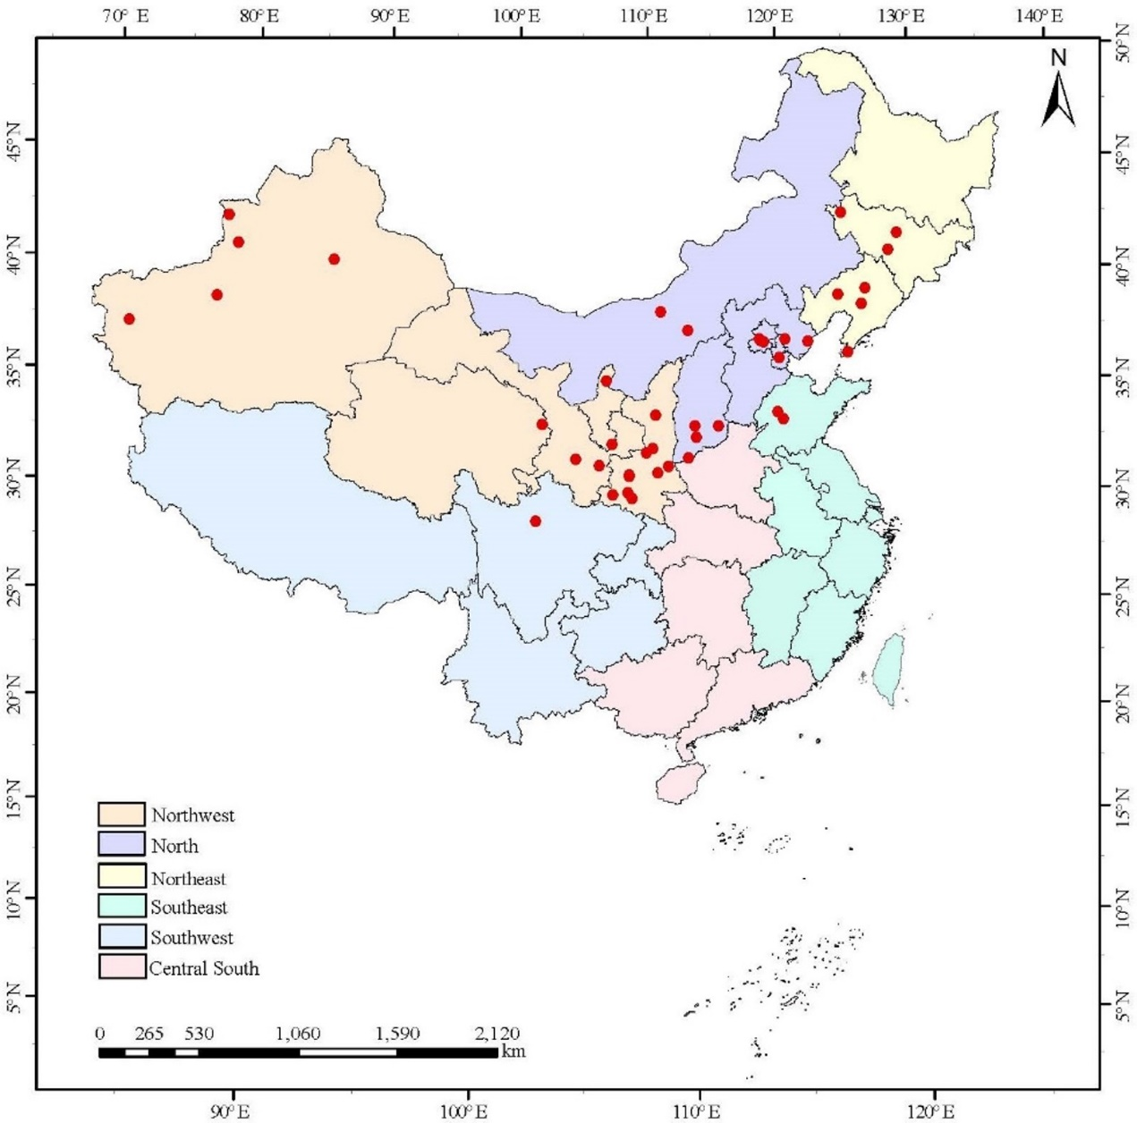
Fig. S1 Distribution map of P. tomentosa population. The red dots represent the distribution locations of 42 populations.
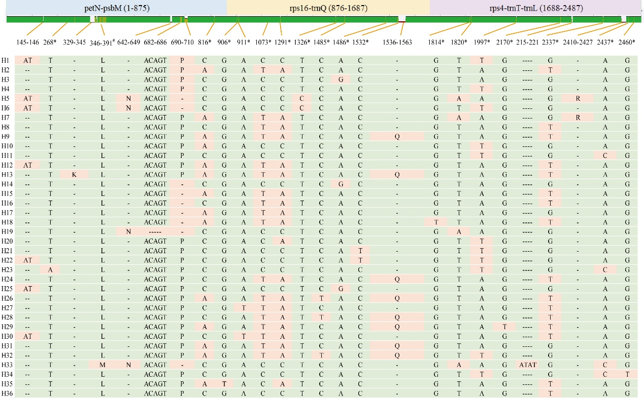
Fig. S2 Variable sites of 36 haplotypes from P. tomentosa based on cpDNA sequences. K: ATAATGGGTATAATAAA; L: ATAATGGG--TATAATAAAATAATCTTTTTGTTAGCATTCCGACGA; M: TCGTCGGAATGCTAACAAAAAGATTATTTTATTA--TACCCATTAT; N: AATAACAG; P: AAAATAAAAAGT; Q: AACGATAAAAAAAGATAGATAAAAAAGA; R: ATATATTTTAATTTTTTT. *, #: segregating sites excluding gaps. #: containing 22 segregating (polymorphic) sites.
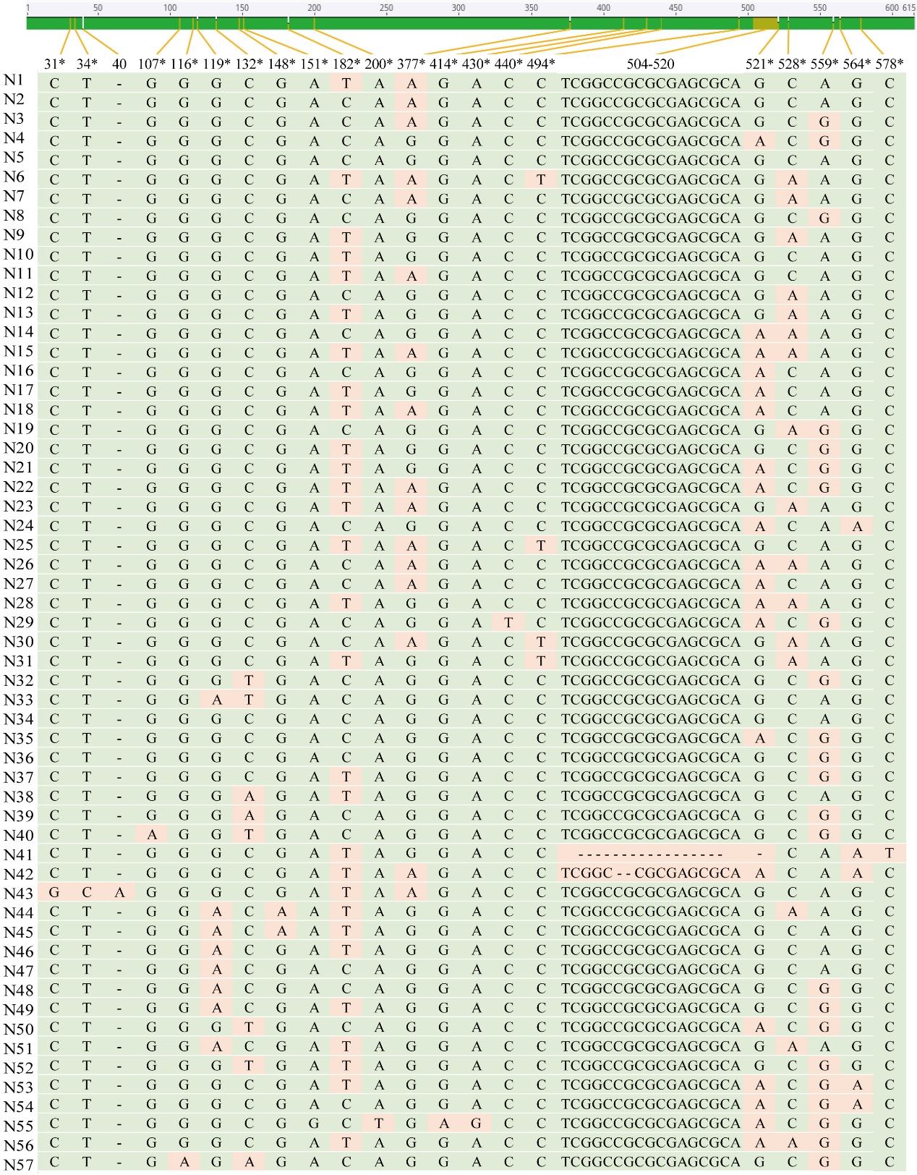
Fig. S3 Variable sites of 57 haplotypes from P. tomentosa based on ITS sequences. *: segregating sites excluding gaps.

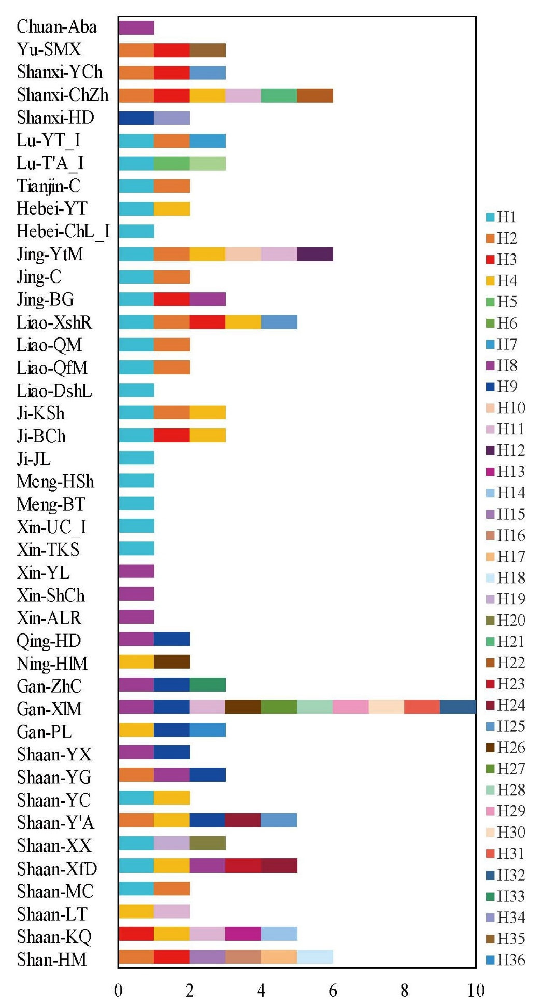
Fig. S4 Haplotype composition of each P. tomentosa population.
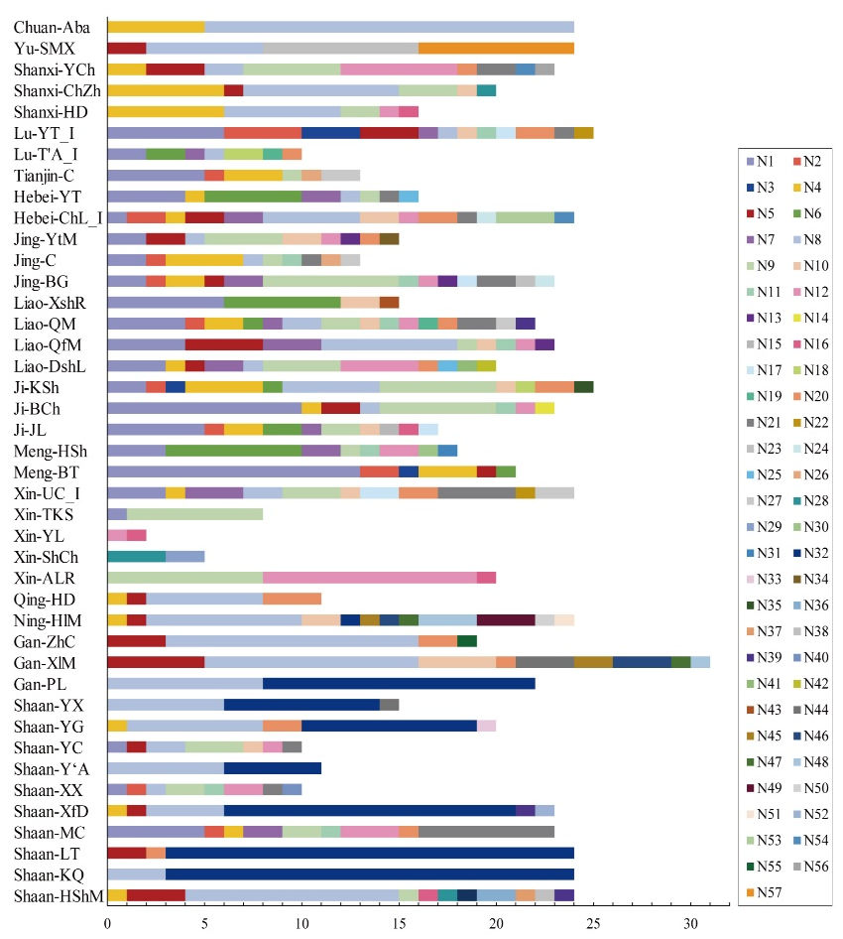
Fig. S5 The ITS haplotype composition of P. tomentosa populations in different provinces.

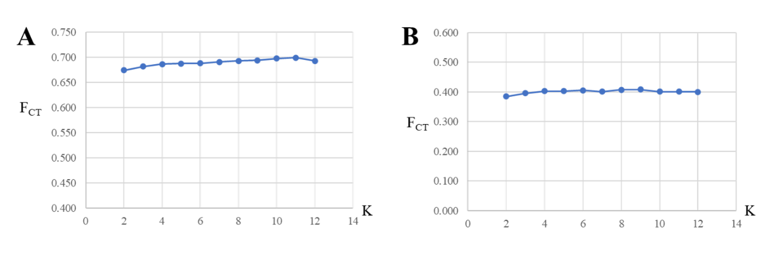
Fig. S6 F_{CT} values from the spatial analyses of molecular variance (SAMOVA) for K = 2–12 groups using cpDNA (A) and ITS (B) data.

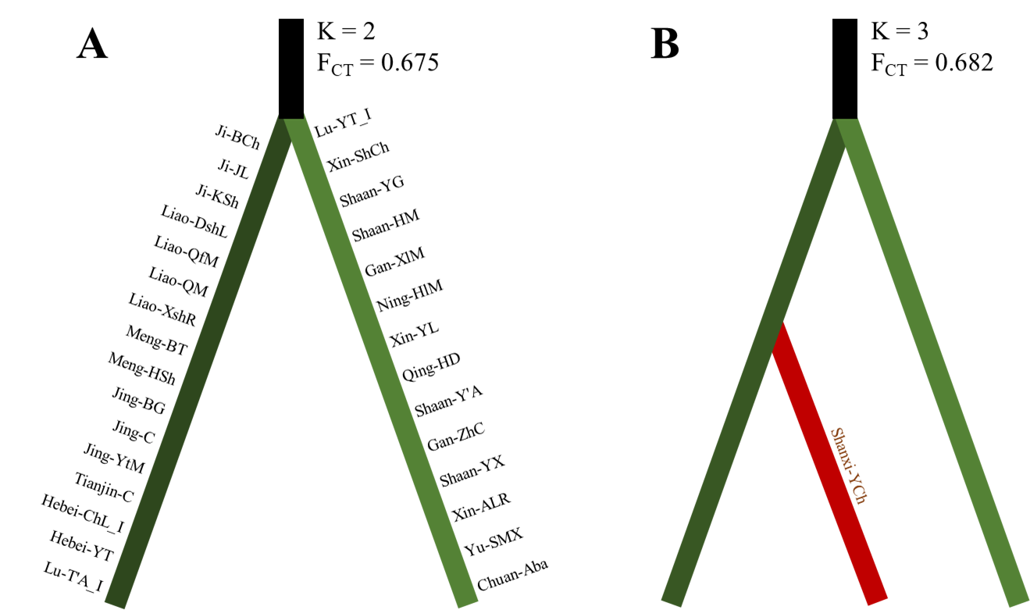
Fig. S7 Results of the spatial analysis of molecular variance (SAMOVA) showing the clustering of populations into K=2 to 3 groups based on cpDNA data.
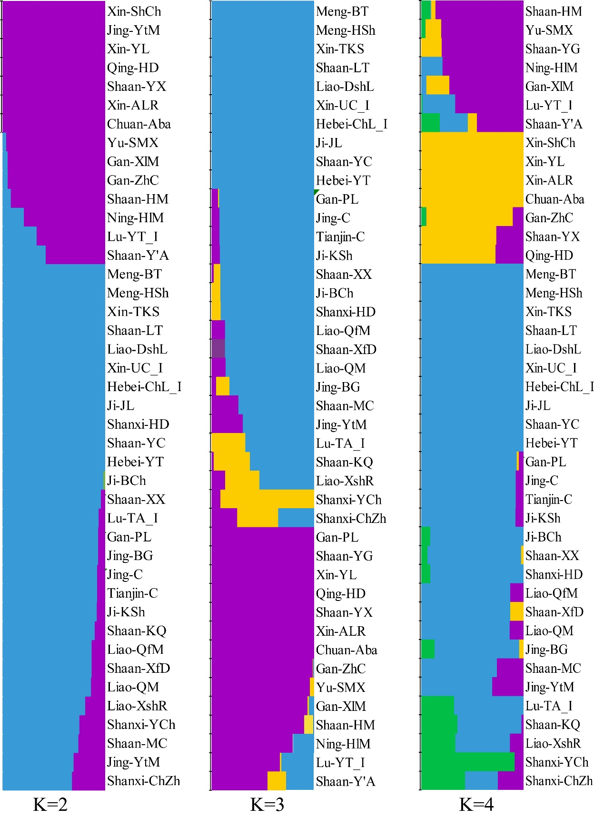
Fig. S8 Histogram of the structure for 42 P. tomentosa populations at K = 2, 3 and 4 based on ITS variable sites.

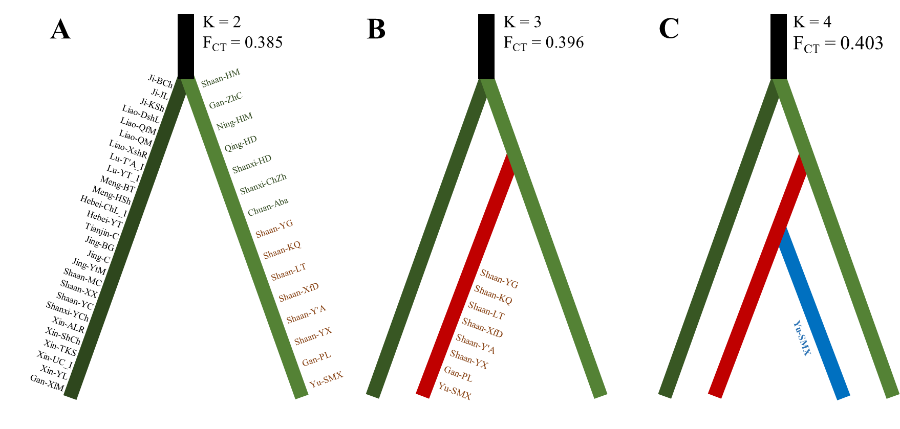
Fig. S9 Results of the spatial analysis of molecular variance (SAMOVA) showing the clustering of populations into K=2 to 3 groups based on ITS data.

