Supplementary materials

Genomic divergence, introgression and KASP fingerprinting panel development in five cultivar groups of sweet osmanthus

Chen Gaoª, Wenxin Maª, Jingchao Yang^{b}, Shuqing Li^{b}, Jinling Huang^{c,d}, Jianfen Wei^{e}, Kaiming Zhangª, Peng Guo^{b}, Yihan Wang^{b*}, Fude Shang^{b*}

Affiliations
ª College of Landscape Architecture, Henan Agricultural University, Zhengzhou, 450002 China
^{b} College of Life Sciences, Henan Engineering Research Center for Osmanthus Germplasm Innovation and Resource Utilization, Henan Agricultural University, Zhengzhou 450046, China
^{c} Department of Biology, East Carolina University, Greenville, NC, 27858 USA
^{d} State Key Laboratory of Crop Stress Adaptation and Improvement, School of Life Sciences, Henan University, Kaifeng 475004, China
^{e} Hangzhou Landscaping Incorporated, Hangzhou 310020, China

Correspondence
Yihan Wang (yihanwang@vip.163.com); Fude Shang (shangfude@henau.edu.cn)

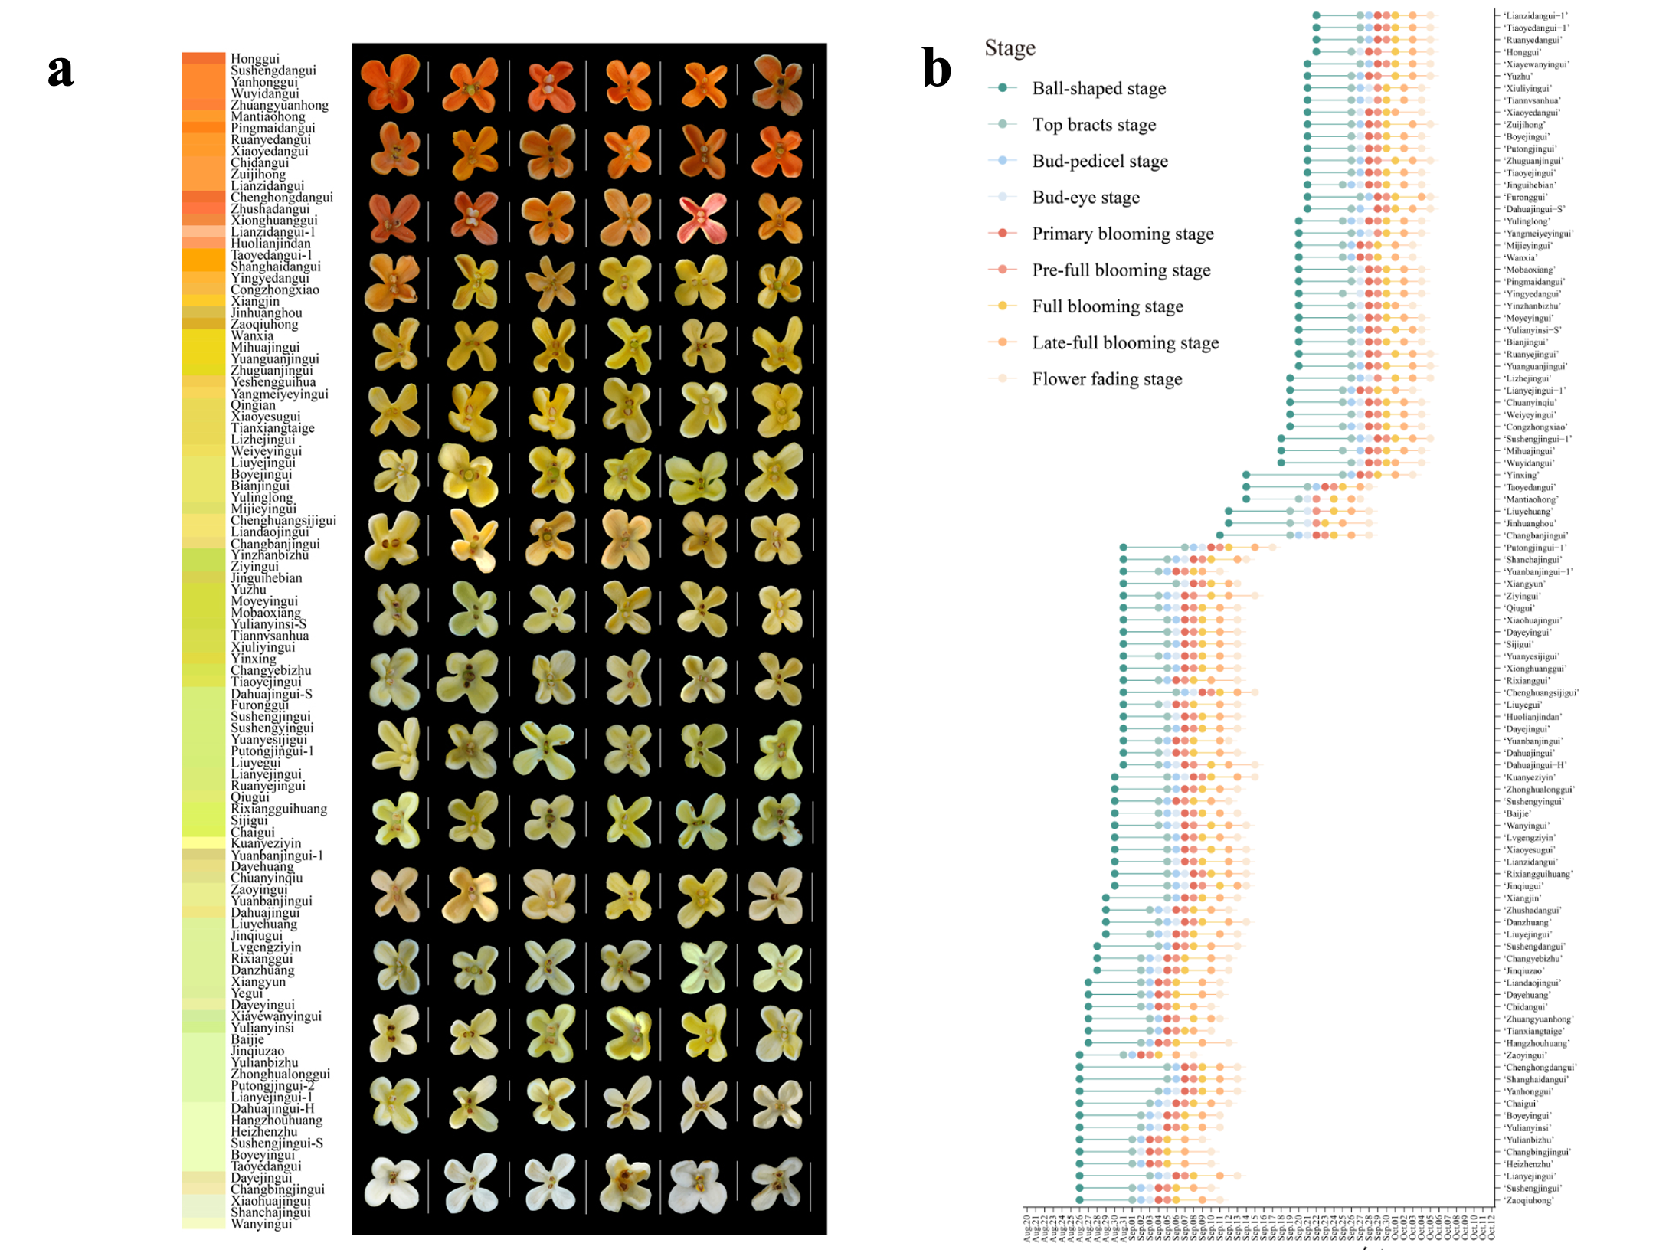
Fig S1. Diversity of petal color (a) and blooming phenology (b) observed in sweet osmanthus cultivars from the National Germplasm Bank in 2024. Petal color was assessed using the Royal Horticultural Society (RHS) Color Chart. Blooming phenology was classified according to Yang (2011).

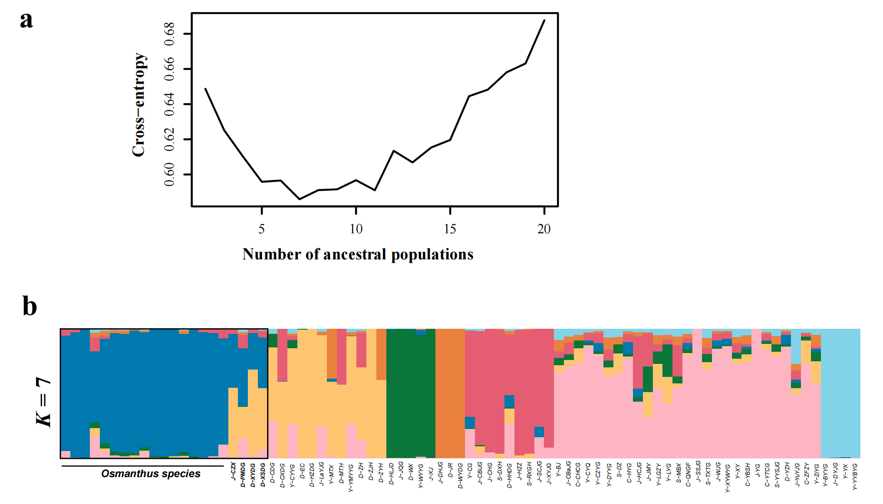
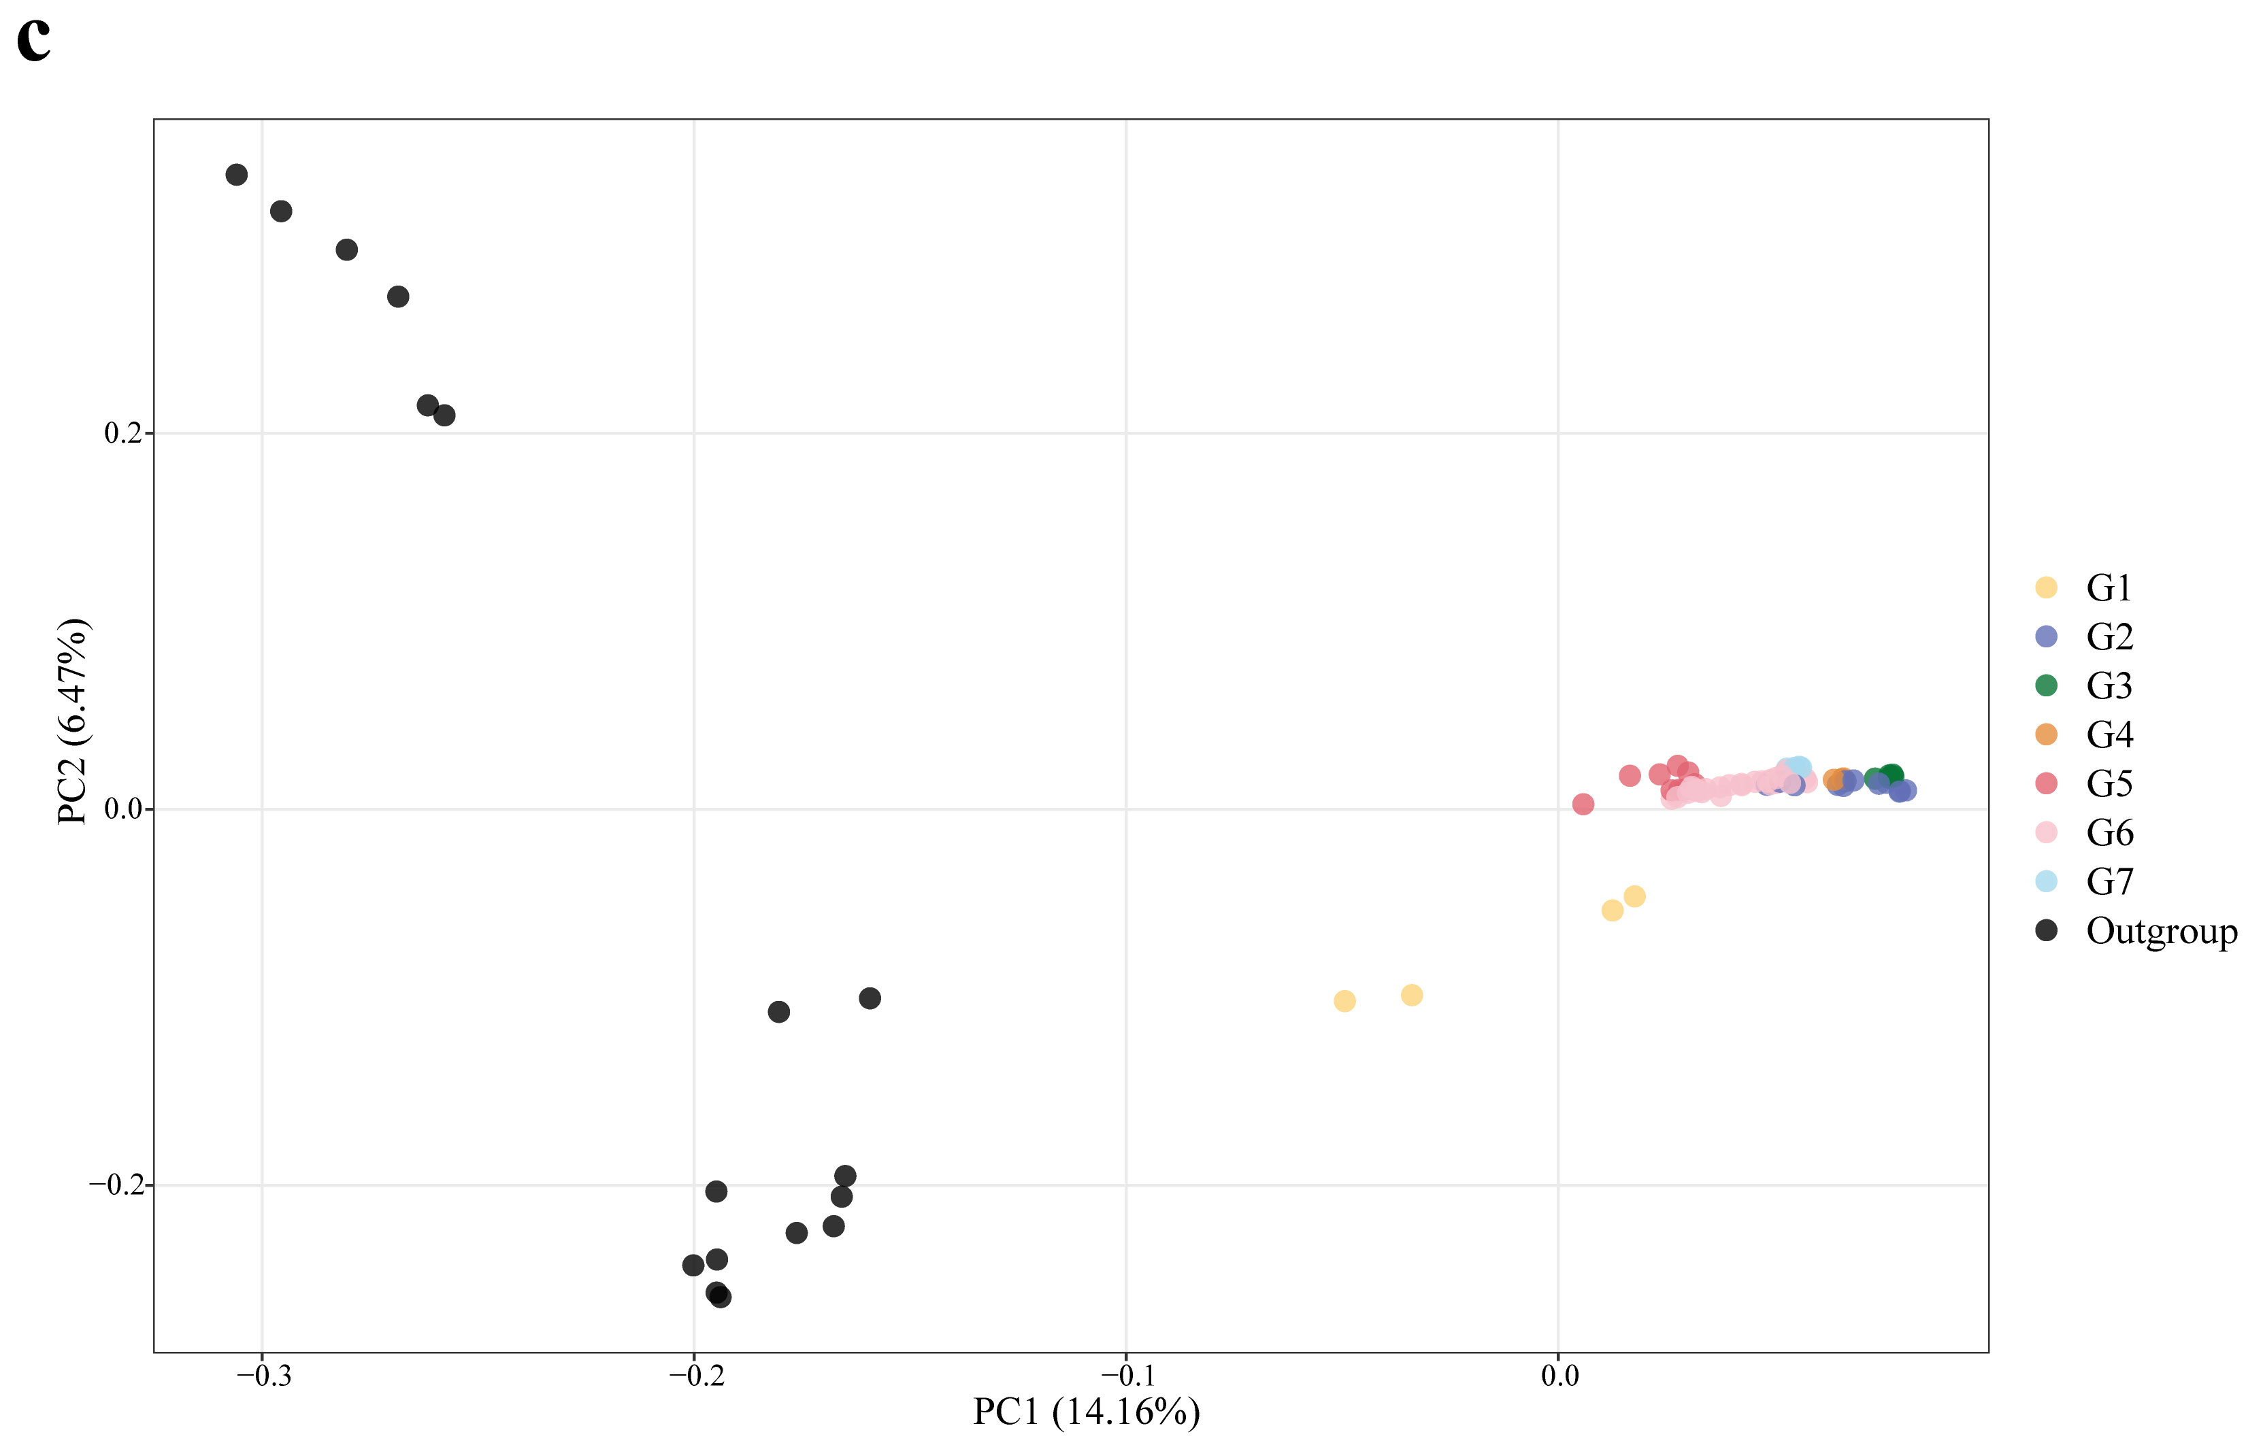

Fig S2. Clustering analysis of sequenced O. fragrans accessions and outgroup. (a) Mean cross-entropy of sNMF analysis across different K values. (b) sNMF analysis results for K = 7. Each individual is represented by a vertical bar that represents the proportion of ancestry of its genome into K clusters. The black outline highlights pedigree contributions of outgroup to G1 cultivars. (c) Principal component analysis of sequenced O. fragrans accessions and the outgroup species.

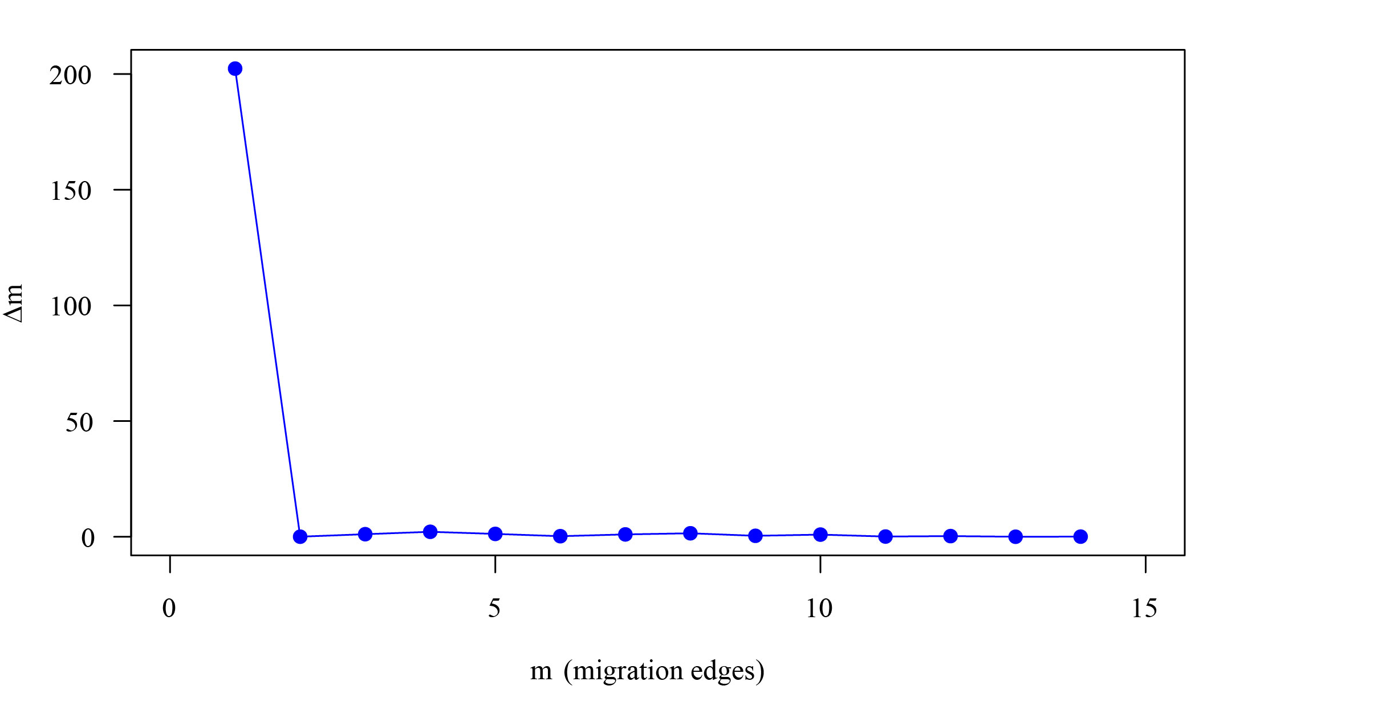
Fig S3. Distribution of ∆m inferred by OptM in TreeMix analysis.
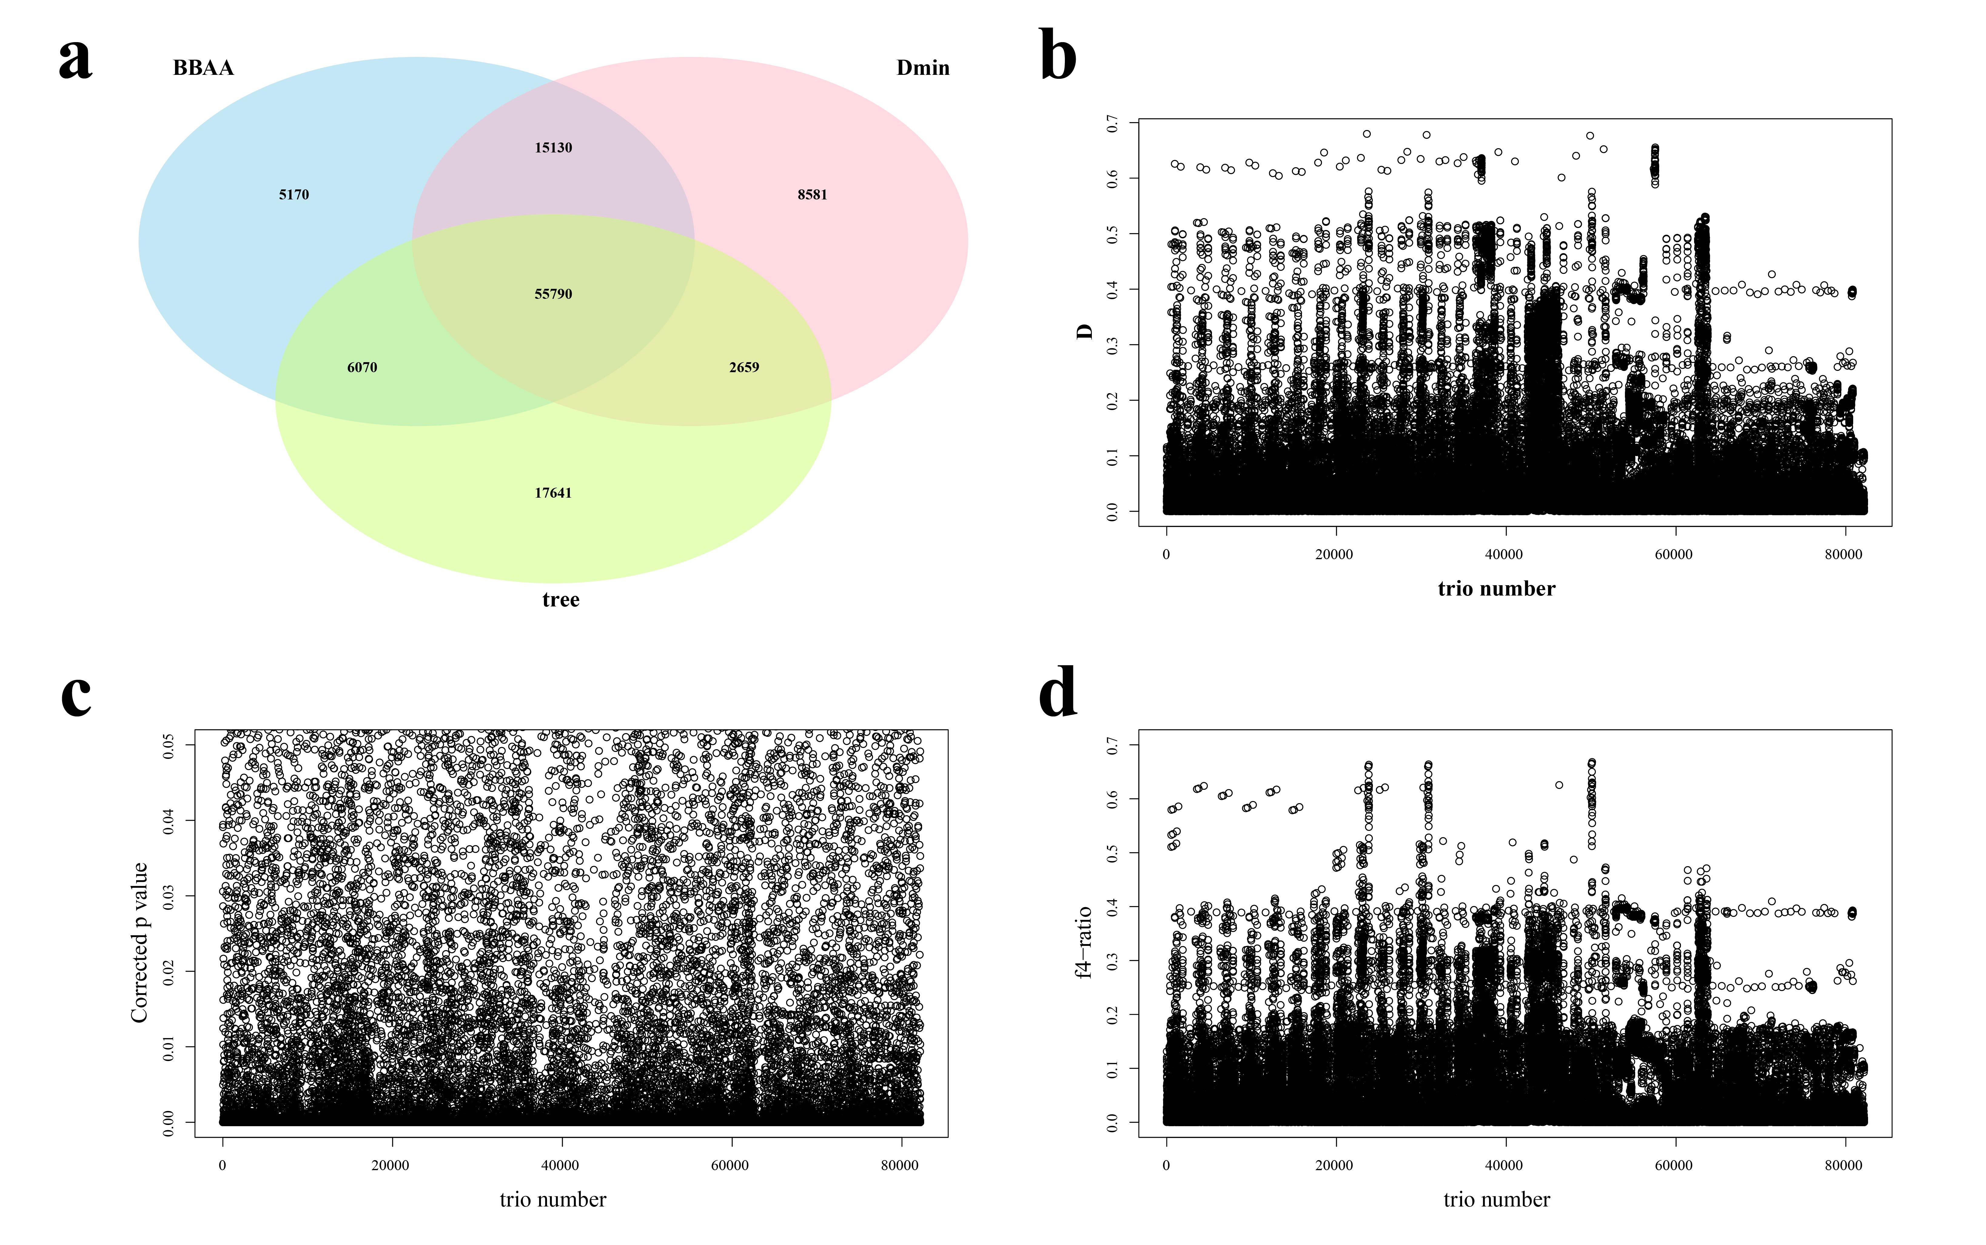
Fig S4. Population relationship clustering results and their statistical distribution based on analysis using Dsuite software. (a) Venn diagram represents three different species relationship clustering methods (BBAA, Dmin, and Tree) calculated by Dsuite software, among which there are 55,790 identical subtrees. (b) Distribution of D-statistical values. (c) Distribution of significant (P < 0.05) D-statistics. (d) Distribution of f₄-statistical values.
Fig S5. Whole-genome scatter plot showing the distribution of f_{dM} values for four G1 cultivars calculated using Dsuite D-statistics. The f_{dM} values valued from 0 to 1.
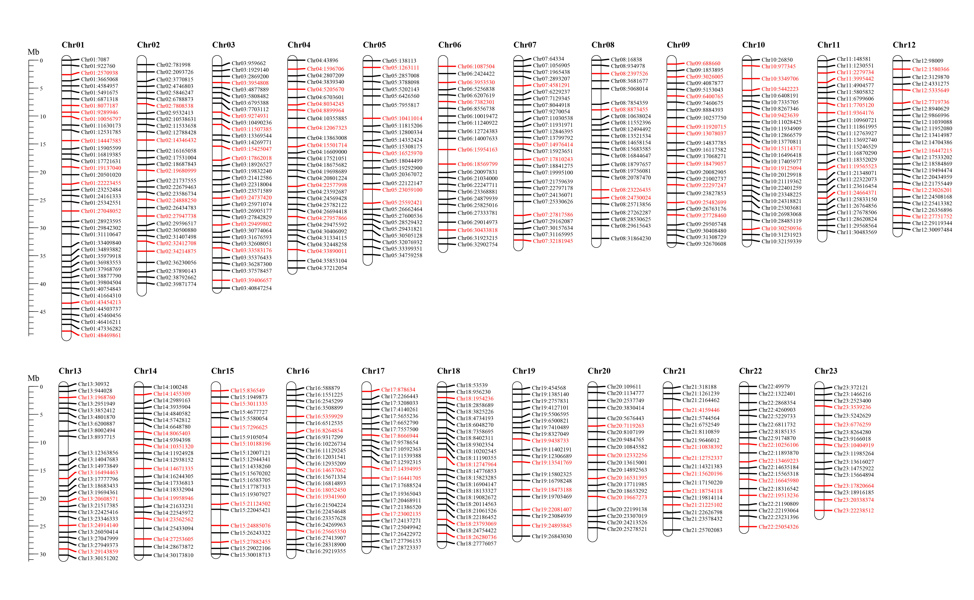
Fig S6. Distributions of all KASP markers among sweet osmanthus chromosomes. The black and red horizontal lines perpendicular to a chromosome represent the markers included in the preliminary KASP panel, and red lines represent core KASP markers retained through a phenotyping-based DUS testing.
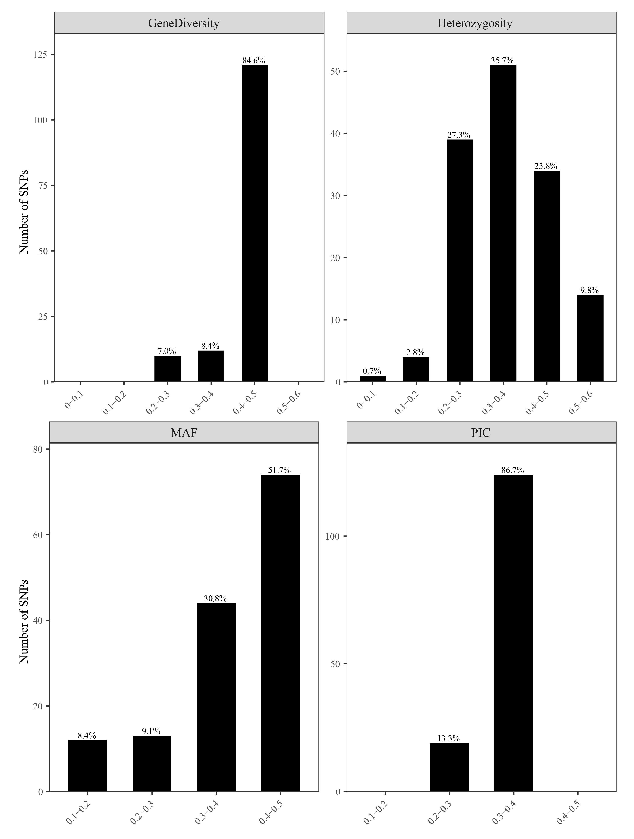
Fig S7. Polymorphism information content (PIC), observed heterozygosity, Minor allele frequency (MAF), and gene diversity index for the 143 core SNP loci across 165 sweet osmanthus cultivars.

Fig S8. Representative KASP labeled fluorescence detection results. Each color code in the plots presents one of three genotypes: homozygote of allele 1 (red), homozygote of allele 2 (blue), heterozygote (green), and negative control (NTC) (yellow).

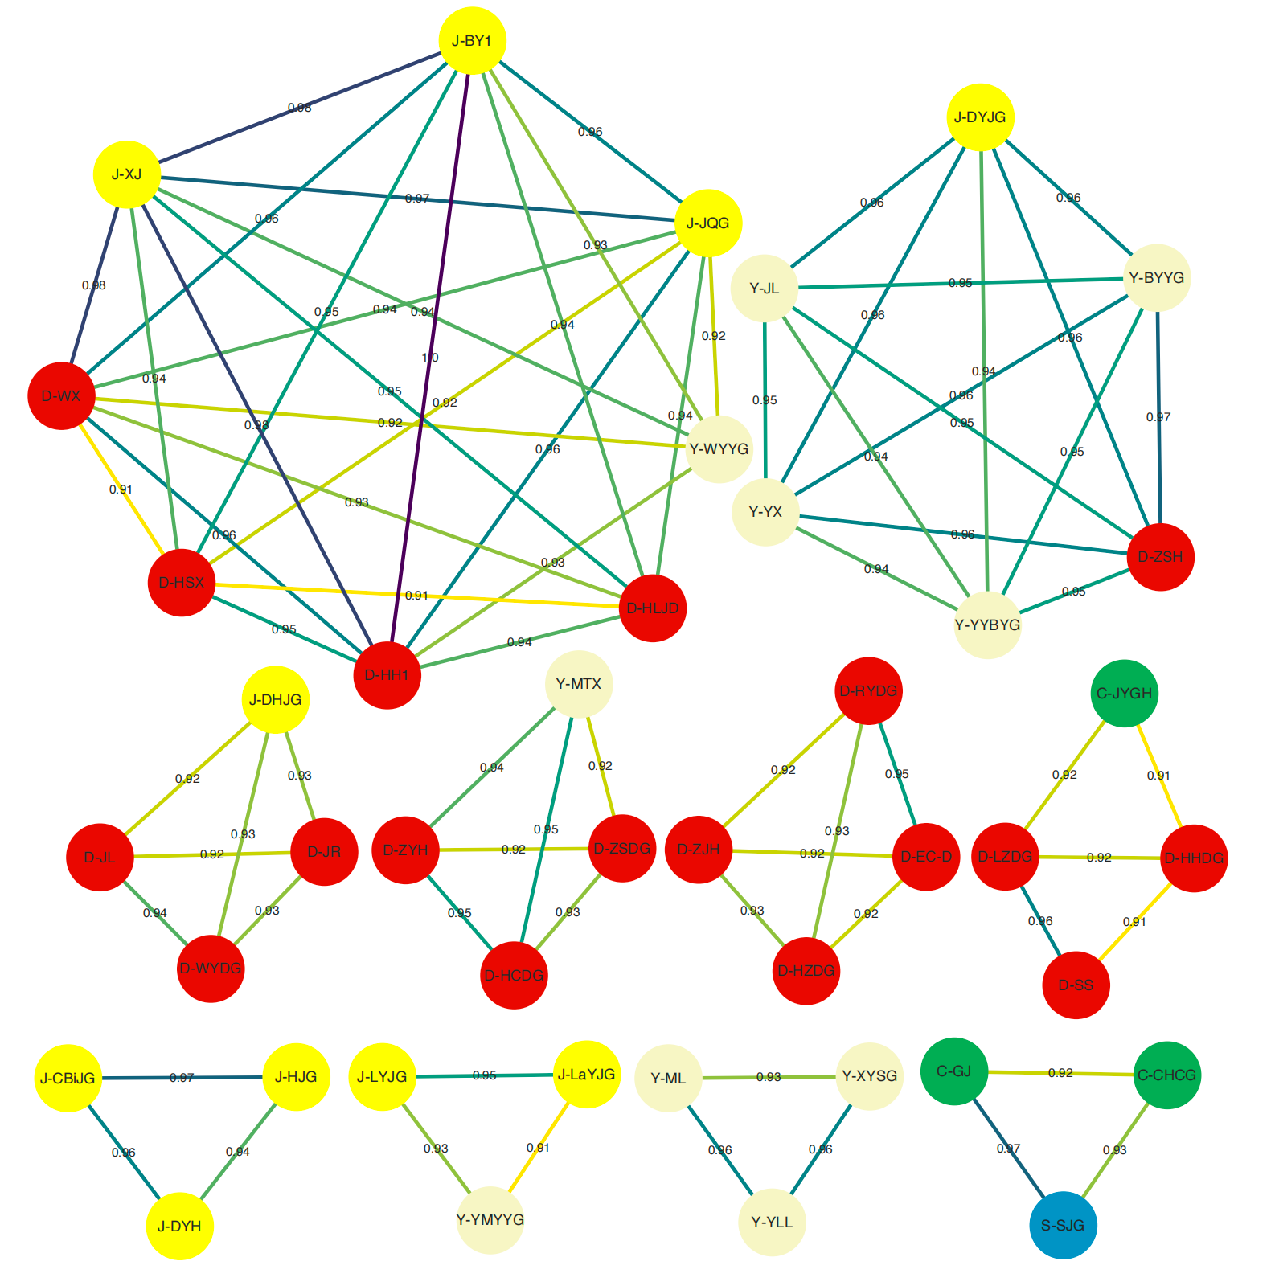
Fig S9. Genetic similarity network among cultivars with genetic similarity coefficients > 0.9. The genetic similarity coefficients were calculated based on core KASP markers. The color of circles marked different cultivar groups: Albus (light yellow), Asiaticus (blue), Aurantiacus group (red), Caiyegui group (yellow) and Luteus group (yellow).

