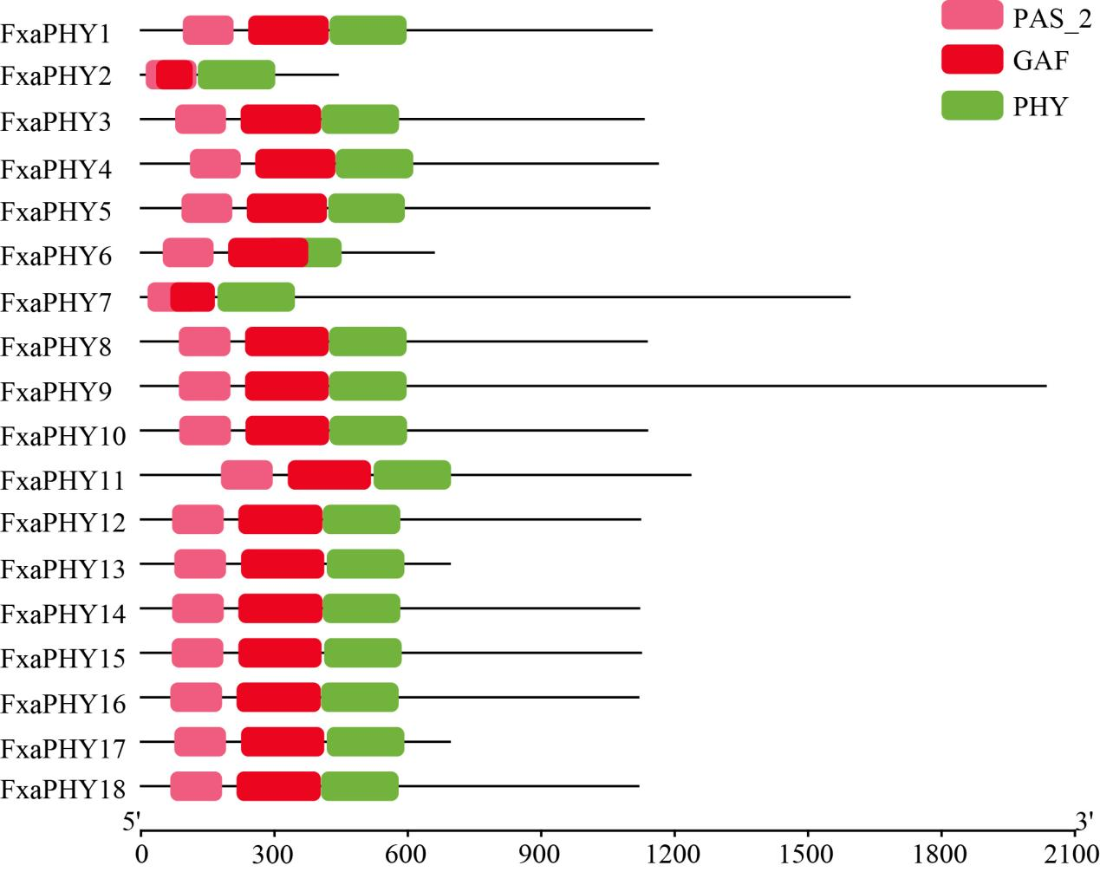
Supplementary Fig. S1 Characteristic phytochrome domains.

