Appendix

Table S1 Comparison of bootstrap support values(BS) between gene-partitioned and unpartitioned maximum likelihood (ML) analyses.
Node | BS (Partitioned) | BS (Unpartitioned) | ΔBS
(Amana + Erythronium) | 98 | 98 | 0
Erythronium crown | 98 | 98 | 0
Eurasia clade | 100 | 100 | 0
ENA clade | 100 | 100 | 0
WNA clade | 100 | 100 | 0
ENA + Eurasia clade | 62 | 56 | 6
WNA (excl. E. grandiflorum) | 87 | 91 | 4

Table S2 Sensitivity analysis of divergence-time estimates comparing primary and alternative root-age prior settings
Node | Primary |  | Alternative |  | HPD overlap (%)
Node | mean (Ma) | 95% HPD (Ma) | mean (Ma) | 95% HPD (Ma) | HPD overlap (%)
Family Liliaceae | 68.5 | 45.0–88.4 | 64.0 | 46.7–80.6 | 78.2
Crown Erythronium | 16.7 | 9.3–26.4 | 23.4 | 13.1–37.5 | 47.0
Eurasian clade | 8.7 | 3.7–18.0 | 13.4 | 4.8–24.0 | 65.1
Eastern North America | 5.8 | 1.1–13.4 | 4.8 | 1.5–9.2 | 62.8
Western North America | 3.4 | 1.1–9.3 | 7.3 | 1.8–17.7 | 45.3
HPD overlap (%) was calculated as the ratio of the intersection length to the union length of the two 95% HPD intervals

Table S3 Summary of plastome assembly quality and validation metrics.
Species | Plastome length (bp) | Mean depth (×) | Depth range (×) | Breadth of coverage (%) | Reads mapped to plastome (%)
Erythronium albidum | 151,599 | 323.5 | 36–487 | 100 | 1.15
Erythronium californicum | 149,438 | 86.8 | 23–244 | 100 | 0.93
Erythronium caucasicum | 151,312 | 114.2 | 18–409 | 100 | 1.26
Erythronium citrinum | 150,695 | 202.3 | 20–752 | 100 | 0.77
Erythronium dens-canis | 151,370 | 284.1 | 130–402 | 100 | 1.07
Erythronium grandiflorum | 150,647 | 182.7 | 79–280 | 100 | 2
Erythronium japonicum | 151,827 | 674.7 | 332–951 | 100 | 3.84
Erythronium multiscapideum | 150,727 | 179.4 | 18–368 | 100 | 1.45
Erythronium revolutum | 150,651 | 632.7 | 126–841 | 100 | 2.49
Erythronium tuolumnense | 150,770 | 59.8 | 3–148 | 100 | 0.5
Erythronium americanum | 151,114 | 149.2 | 28–230 | 100 | 0.85

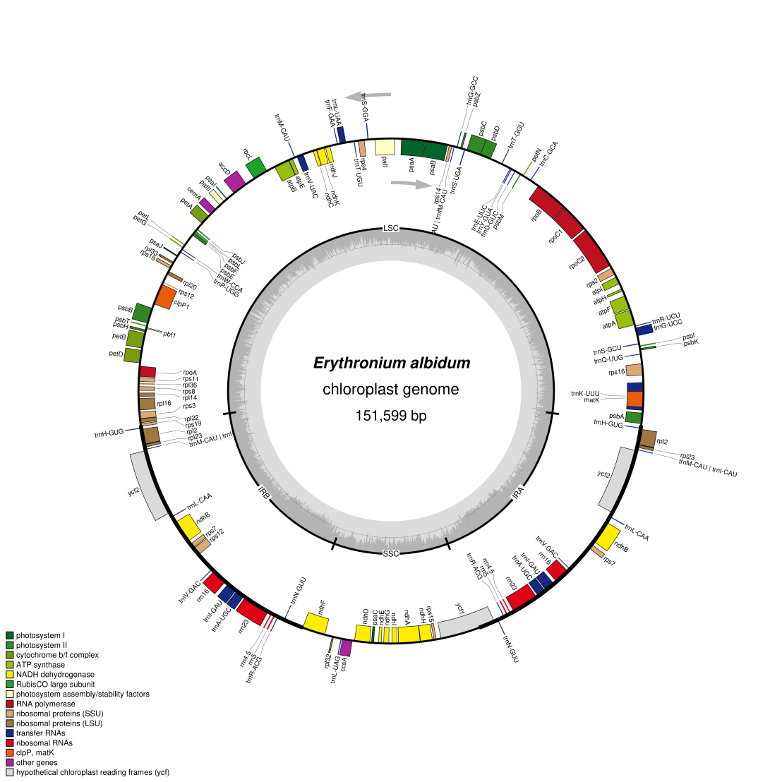
Figure S1 Representative plastome map of E. albidum.
Genes are color-coded by functional group. The transcription of genes occurs in a clockwise direction for those positioned on the inner side of the circular map and in a counterclockwise direction for those on the outer side. The GC content is depicted by a central gray circle.
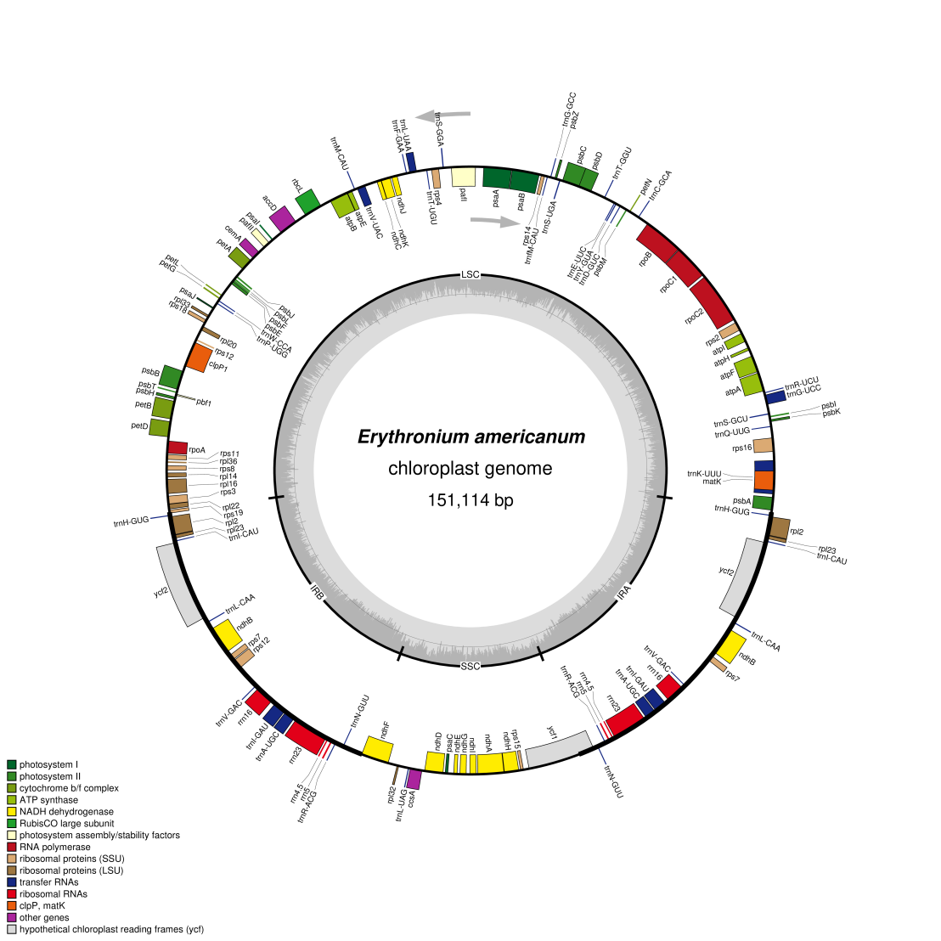
Figure S2 Representative plastome map of E. americanum.
Genes are color-coded by functional group. The transcription of genes occurs in a clockwise direction for those positioned on the inner side of the circular map and in a counterclockwise direction for those on the outer side. The GC content is depicted by a central gray circle.
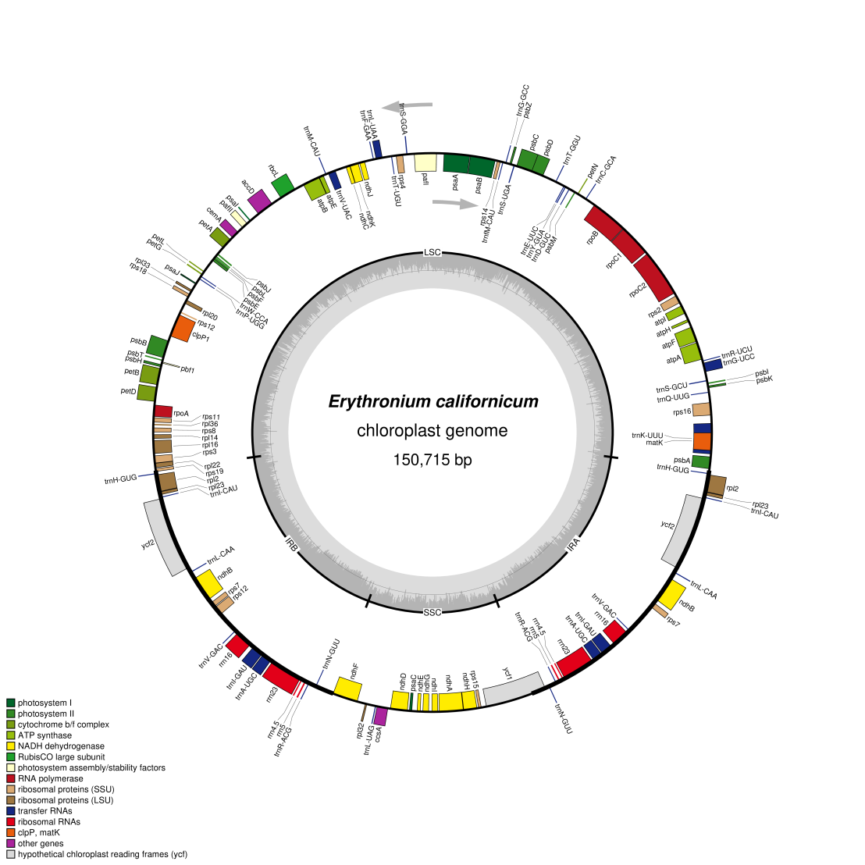
Figure S3 Representative plastome map of E. californicum.
Genes are color-coded by functional group. The transcription of genes occurs in a clockwise direction for those positioned on the inner side of the circular map and in a counterclockwise direction for those on the outer side. The GC content is depicted by a central gray circle.
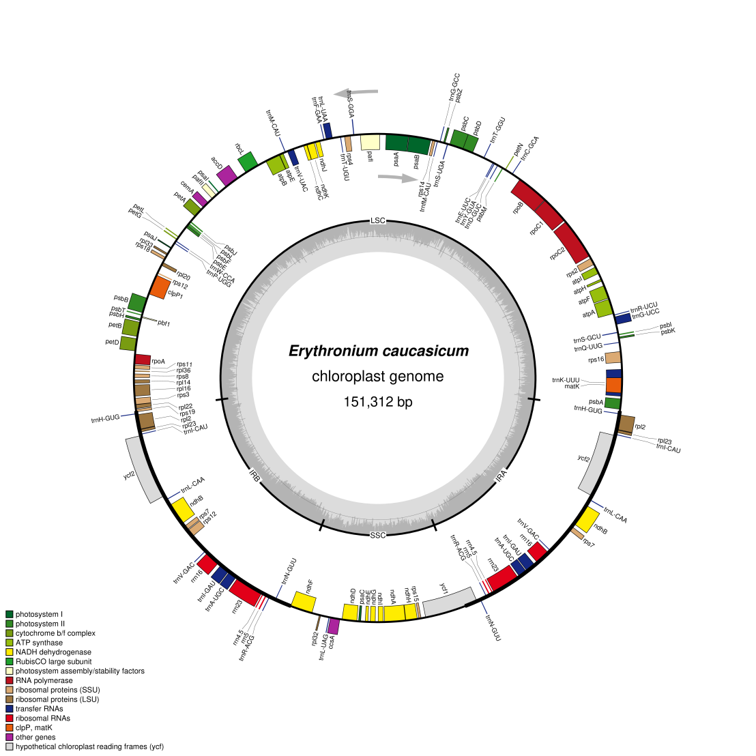
Figure S4 Representative plastome map of E. caucasicum.
Genes are color-coded by functional group. The transcription of genes occurs in a clockwise direction for those positioned on the inner side of the circular map and in a counterclockwise direction for those on the outer side. The GC content is depicted by a central gray circle.
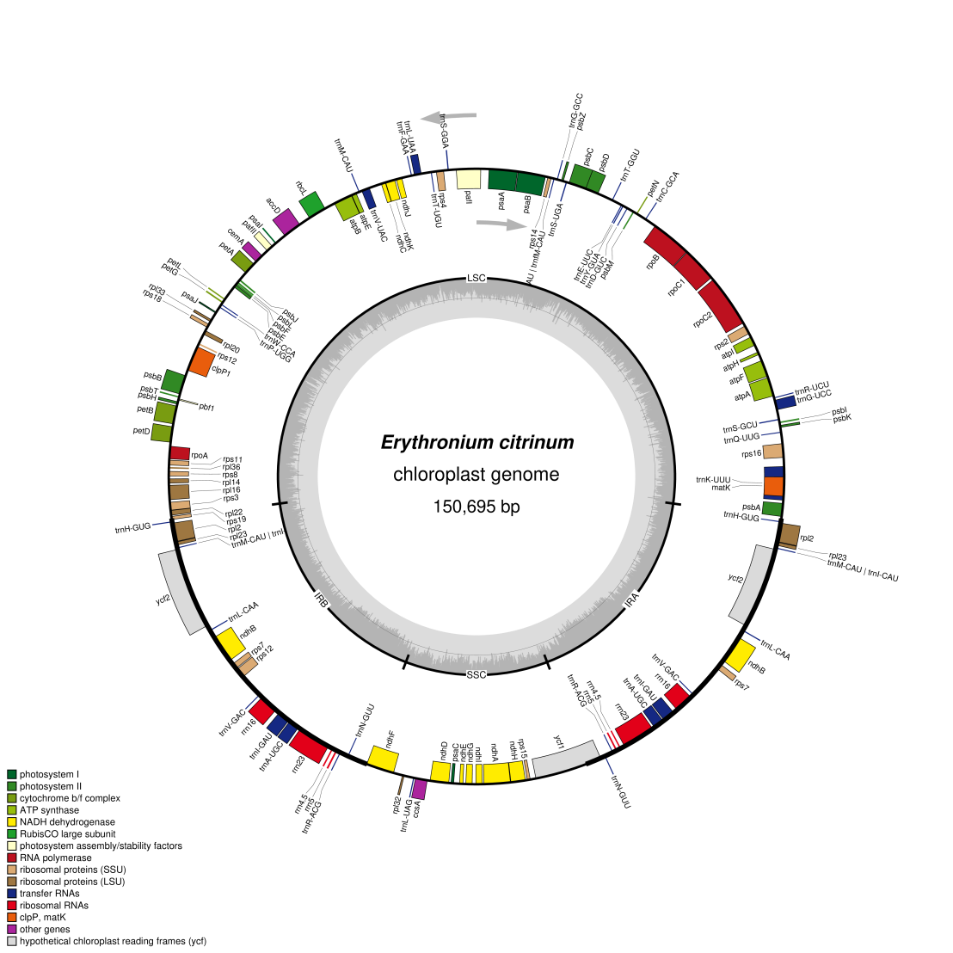
Figure S5 Representative plastome map of E. citrinum.
Genes are color-coded by functional group. The transcription of genes occurs in a clockwise direction for those positioned on the inner side of the circular map and in a counterclockwise direction for those on the outer side. The GC content is depicted by a central gray circle.
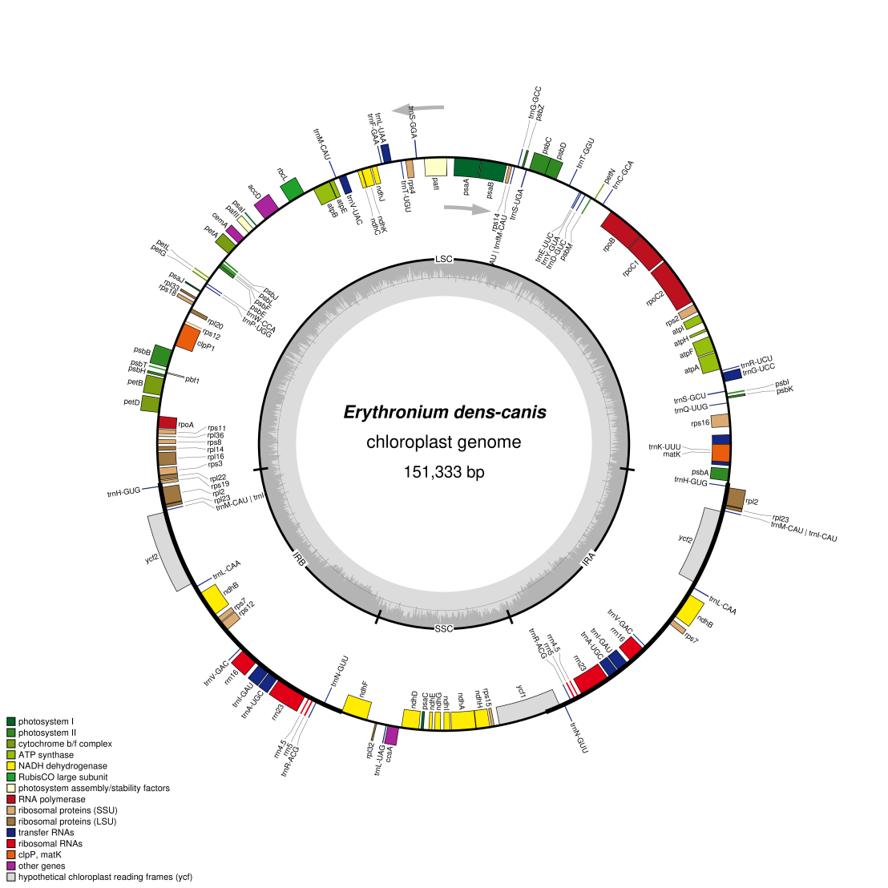
Figure S6 Representative plastome map of E. dens-canis.
Genes are color-coded by functional group. The transcription of genes occurs in a clockwise direction for those positioned on the inner side of the circular map and in a counterclockwise direction for those on the outer side. The GC content is depicted by a central gray circle.
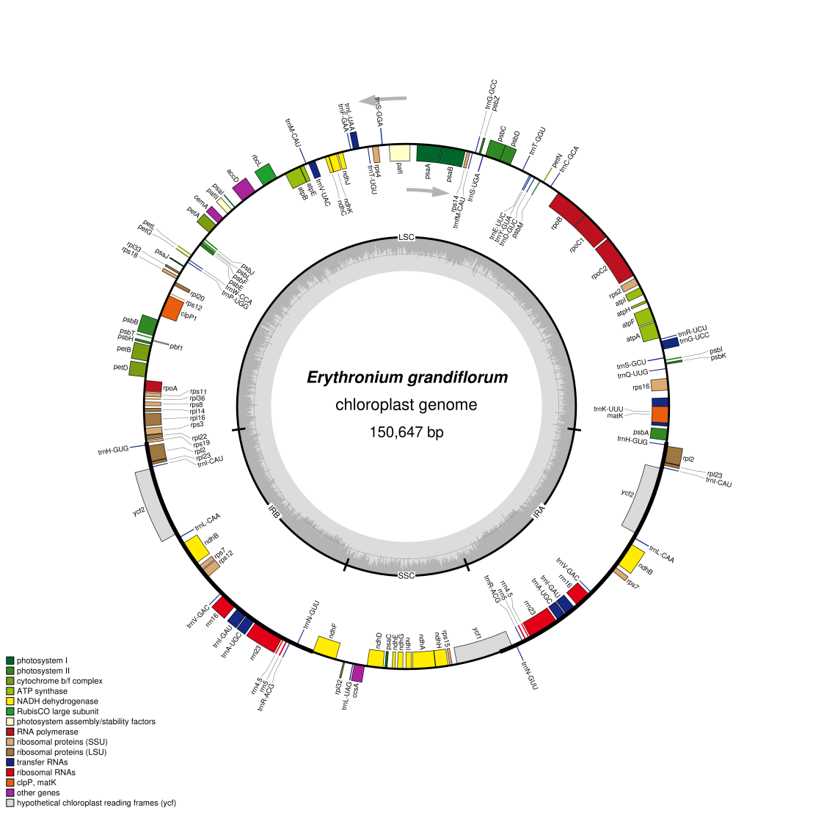
Figure S7 Representative plastome map of E. grandiflorum.
Genes are color-coded by functional group. The transcription of genes occurs in a clockwise direction for those positioned on the inner side of the circular map and in a counterclockwise direction for those on the outer side. The GC content is depicted by a central gray circle.
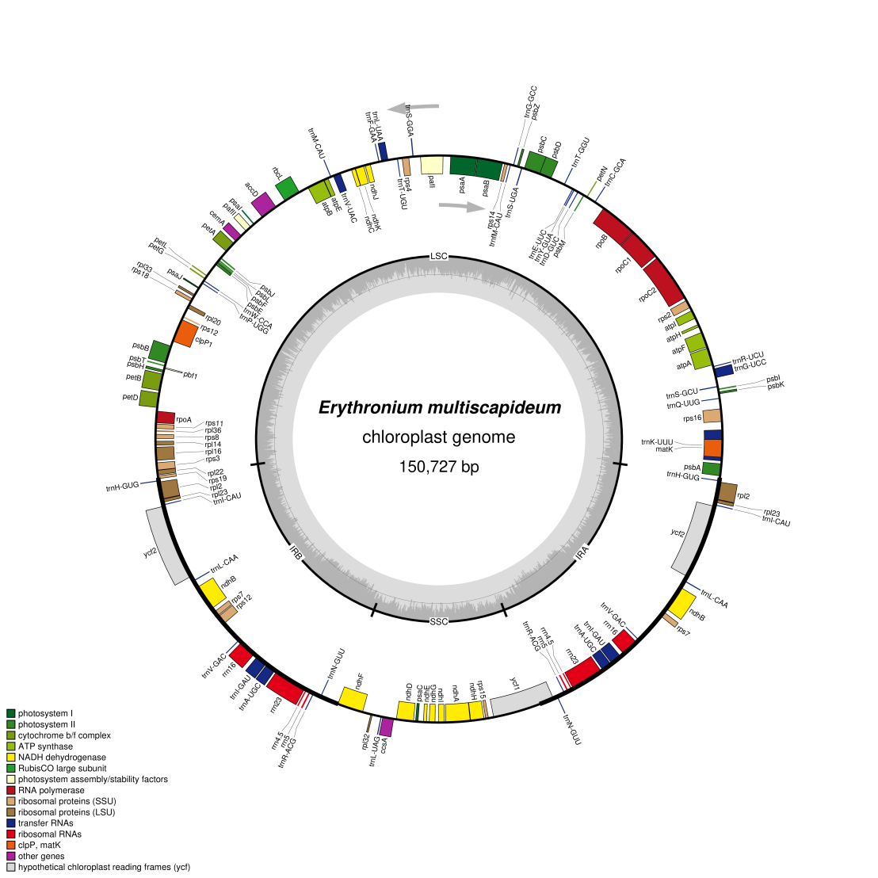
Figure S8 Representative plastome map of E. multiscapideum.
Genes are color-coded by functional group. The transcription of genes occurs in a clockwise direction for those positioned on the inner side of the circular map and in a counterclockwise direction for those on the outer side. The GC content is depicted by a central gray circle.
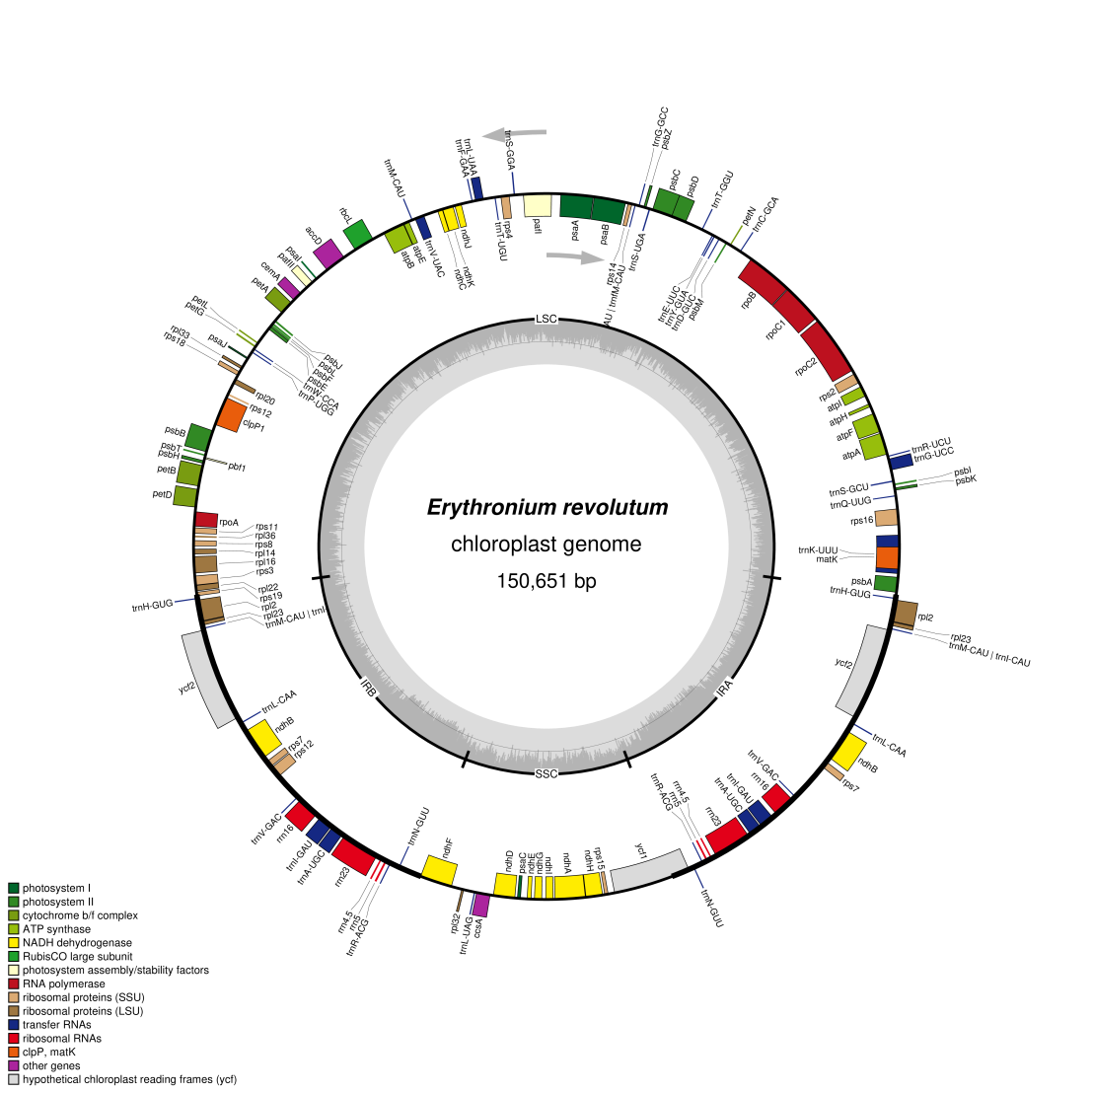
Figure S9 Representative plastome map of E. revolutum.
Genes are color-coded by functional group. The transcription of genes occurs in a clockwise direction for those positioned on the inner side of the circular map and in a counterclockwise direction for those on the outer side. The GC content is depicted by a central gray circle.
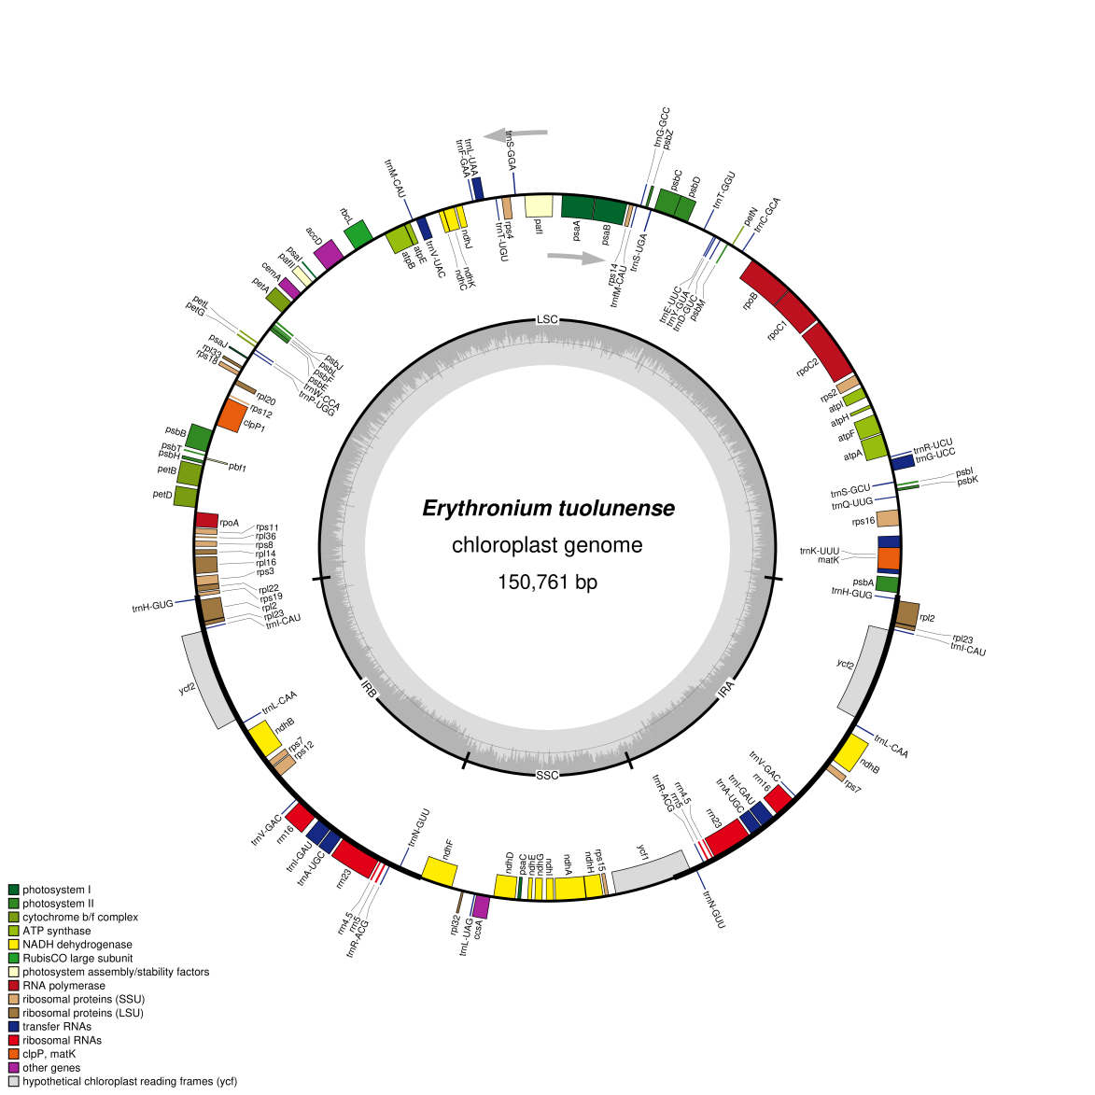
Figure S10 Representative plastome map of E. tuolumnense.
Genes are color-coded by functional group. The transcription of genes occurs in a clockwise direction for those positioned on the inner side of the circular map and in a counterclockwise direction for those on the outer side. The GC content is depicted by a central gray circle.
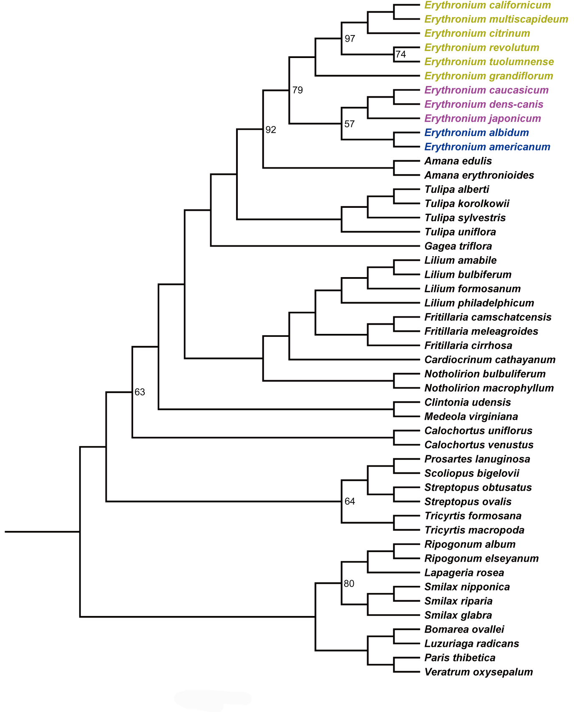
Figure S11 The Maximum Parsimony bootstrap consensus tree of 48 taxa inferred from 78 CDS. Numbers above the node indicate maximum parsimony bootstrap support values (MP-BS). Only support under MP-BS = 100% is shown.

