Microbial Volatile Organic Compounds (mVOCs) from Rhizobacterium RL-WG62 Mediate Salt Tolerance in Brassica napus by Reprogramming Transcriptome

Yanyan Wang^{a, b}, Lihua Tanª, Jie Chenª, Hongle Wangª, Hanqiao Hu^{a, b}, Chunyu Zhang^{c}, Lei Ren^{a, b, *}
a College of Coastal Agricultural Sciences, Guangdong Ocean University, Zhanjiang 524088, China
b South China Branch of National Saline-Alkali Tolerant Rice Technology Innovation Center, Zhanjiang 524088, China
c College of Plant Science and Technology, Huazhong Agricultural University, Wuhan, 430070,China.

*Correspondence:
Lei Ren, College of Coastal Agricultural Sciences, Guangdong Ocean University, Zhanjiang 524088, China. e-mail address: renlei@gdou.edu.cn

Table S1 List of qRT-PCR Primers

Gene name | Forward primer (F) | Reverse primer (R)
BnaA02G0418200ZS | AAGCGAGTGCATCATCGTG | TAAACATCCTTTCCATCGCCCTT
BnaA03G0277000ZS | AGCAAACCAAGACCAACCCT | TTTCTGCTGCCGTTCTTCCT
BnaA02G0383800ZS | TCAAGAACTCGGGATTGAGCCC | CTTTGTGTTAGAACCCGTTGGCTTA
BnaC02G0513900ZS | GGAAGAAGCTGGTGAGGAGT | CTTCTCCCAGGGCTGTCTTT
BnaC02G0556300ZS | TCTAGCTCGGAGGATGATGGG | ATGGCCTGGCAACTTTTCC
BnaC01G0147400ZS | AGACCGTGCTAACGTGGG | TCTCCAGCTAAGACCAGTCCAT
BnaA05G0383800ZS | AGAGGGGGCTTACGAGACC | CTCCGGACAAACTGTCTTTAACTTT
BnaC04G0066000ZS | CCAAGAAGGGTGAGACCGTT | GTCCCATCTGCTGATATCCTTCAC
BnaC04G0036100ZS | ATGAAGAGTCTTACCATTTGGGCTA | CCTCAAACTTTATGGAAGCAACAGAG
BnaA08G0081400ZS | CTCAAGAGTTTGCCGAAAACGAAC | GGTTCACCTCTTCCTCTCTCGA
Bnactin7 | TGTTCCCTGGAATTGCTGACCGTA | TGCGACCACCTTGATCTTCATGCT

Table S2 Information on mVOCs potentially with salt tolerance-promoting functions released by strain RL-WG62

Serial Number | mVOCs | Molecular Formula | CAS No. | Retention Time (min) | Peak Area
1 | 1, 3-Pentadiene | C₅H₈ | 504-60-9 | 8.812 | 176647
2 | Methyl thiolacetate | C₃H₆OS | 1534-08-3 | 19.585 | 289069
3 | Acetic acid, butyl ester | CH3CO₂(CH2)3CH3 | 123-86-4 | 24.619 | 30533
4 | 2, 4-Dithiapentane | CH3SCH2SCH3 | 1618-26-4 | 27.97 | 34274
5 | Dimethyl trisulfide | C₂H₆S₃ | 3658-80-8 | 30.727 | 92726
6 | 2, 2, 4-Trimethyl-1, 3-pentanediol diisobutyrate | C₁₆H₃₀O₄ | 6846-50-0 | 33.25 | 45673
7 | 2-Butanone | C2H5COCH3 | 78-93-3 | 13.652 | 90069
8 | Hexadecane | CH3(CH2)14CH3 | 544-76-3 | 35.719 | 29310
9 | Decane, 2, 6, 7-trimethyl- | C13H28 | 62108-25-2 | 34.834 | 38323
10 | Heptadecane | CH₃(CH₂)₁₅CH₃ | 629-78-7 | 35.71 | 17415
11 | Octane, 1-bromo- | C₈H₁₇Br | 111-83-1 | 35.669 | 99448
12 | Isoprene | C₅H₈ | 78-79-5 | 8.798 | 93118
13 | 1-Tridecene | C₁₃H₂₆ | 2437-56-1 | 34.548 | 17603
14 | 2-Pentanone, 3-methyl- | C2H5COCH3 | 565-61-7 | 13.717 | 46304
15 | Nonane, 2, 3-dimethyl- | C₁₁H₂₄ | 2884-06-2 | 31.511 | 37168

Table S3 RNA-seq sequencing and alignment statistics

Sample | Total_Reads | Clean_Reads | Q30 (%) | Total_Mapped | Multiple_Mapped | Uniquely_Mapped
CK1_0_1 | 51936140 |  | 95.83 | 48149684 (94.53%) | 2448619 (5.09%) | 45701065 (94.91%)
CK1_0_2 | 41353322 | 40504314 | 95.59 | 38286301 (94.52%) | 1938379 (5.06%) | 36347922 (94.94%)
CK1_0_3 | 40648170 | 39896876 | 96.01 | 37742680 (94.60%) | 1929699 (5.11%) | 35812981 (94.89%)
T1_0_1 | 41230192 | 40423002 | 95.68 | 38284660 (94.71%) | 1992416 (5.20%) | 36292244 (94.80%)
T1_0_2 | 46374054 | 45372636 | 95.45 | 42977191 (94.72%) | 2212439 (5.15%) | 40764752 (94.85%)
T1_0_3 | 45144508 | 44339744 | 95.99 | 42054997 (94.85%) | 2191819 (5.21%) | 39863178 (94.79%)
CK1_2_1 | 36472490 | 35800330 | 95.71 | 33872114 (94.61%) | 1774133 (5.24%) | 32097981 (94.76%)
CK1_2_2 | 42137634 | 41349750 | 95.72 | 39136510 (94.65%) | 2053460 (5.25%) | 37083050 (94.75%)
CK1_2_3 | 47949836 | 46966040 | 95.67 | 44450611 (94.64%) | 2346745 (5.28%) | 42103866 (94.72%)
T1_2_1 | 38850164 | 38086700 | 95.84 | 36196184 (95.04%) | 1734044 (4.79%) | 34462140 (95.21%)
T1_2_2 | 46681614 | 45691180 | 95.54 | 43443096 (95.08%) | 2177552 (5.01%) | 41265544 (94.99%)
T1_2_3 | 55240718 | 54085018 | 95.64 | 51423291 (95.08%) | 2568928 (5.00%) | 48854363 (95.00%)
CK3_0_1 | 64064818 | 62778756 | 95.57 | 59615733 (94.96%) | 3070774 (5.15%) | 56544959 (94.85%)
CK3_0_2 | 45327492 | 44410540 | 95.52 | 42171286 (94.96%) | 2173710 (5.15%) | 39997576 (94.85%)
CK3_0_3 | 42086662 | 41282852 | 95.71 | 39221797 (95.01%) | 1997475 (5.09%) | 37224322 (94.91%)
T3_0_1 | 47393152 | 46404816 | 95.57 | 44078955 (94.99%) | 2206031 (5.00%) | 41872924 (95.00%)
T3_0_2 | 48178800 | 47237662 | 95.81 | 44908258 (95.07%) | 2258822 (5.03%) | 42649436 (94.97%)
T3_0_3 | 42796786 | 41931802 | 95.69 | 39831980 (94.99%) | 2019272 (5.07%) | 37812708 (94.93%)
CK3_2_1 | 41810176 | 40940832 | 95.62 | 39080598 (95.46%) | 2008311 (5.14%) | 37072287 (94.86%)
CK3_2_2 | 38037780 | 37242536 | 95.40 | 35562783 (95.49%) | 1765226 (4.96%) | 33797557 (95.04%)
CK3_2_3 | 45052580 | 44110280 | 95.44 | 42100378 (95.44%) | 2171525 (5.16%) | 39928853 (94.84%)
T3_2_1 | 38014164 | 37249372 | 95.13 | 35456268 (95.19%) | 1874778 (5.29%) | 33581490 (94.71%)
T3_2_2 | 43374992 | 42457020 | 94.99 | 40411651 (95.18%) | 2152625 (5.33%) | 38259026 (94.67%)
T3_2_3 | 44004772 | 42949514 | 94.59 | 40863823 (95.14%) | 2177172 (5.33%) | 38686651 (94.67%)

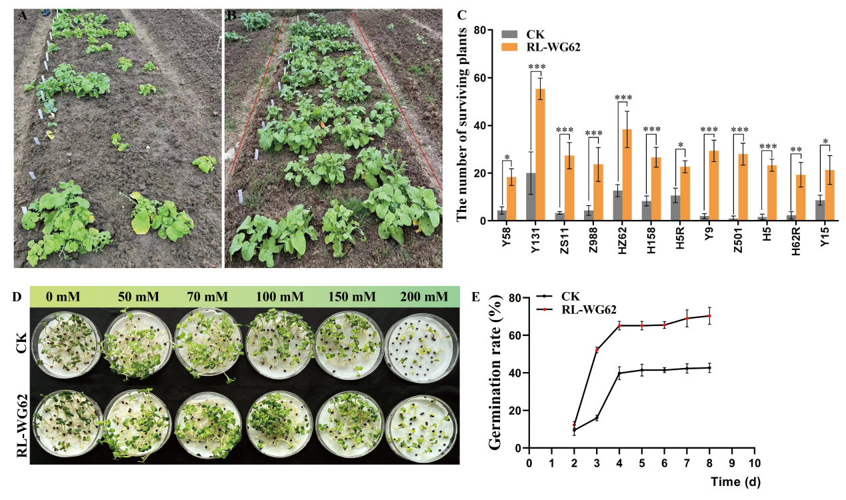

Fig.S1 Effects of strain RL-WG62 on rapeseed seed germination under salt stress. (A) and (B) respectively show seedlings of 12 Brassica napus materials grown in saline soil after their seeds were treated with water (control, CK) and RL-WG62 bacterial suspension; (C) corresponds to the statistical results of the seedling surviving rate for each variety. (D) Phenotypes of rapeseed germination on day 8 under different salt concentrations; (E) Statistical analysis of germination rates at 200 mM NaCl. CK: control group treated with water; RL-WG62: treatment group soaked with bacterial suspension.

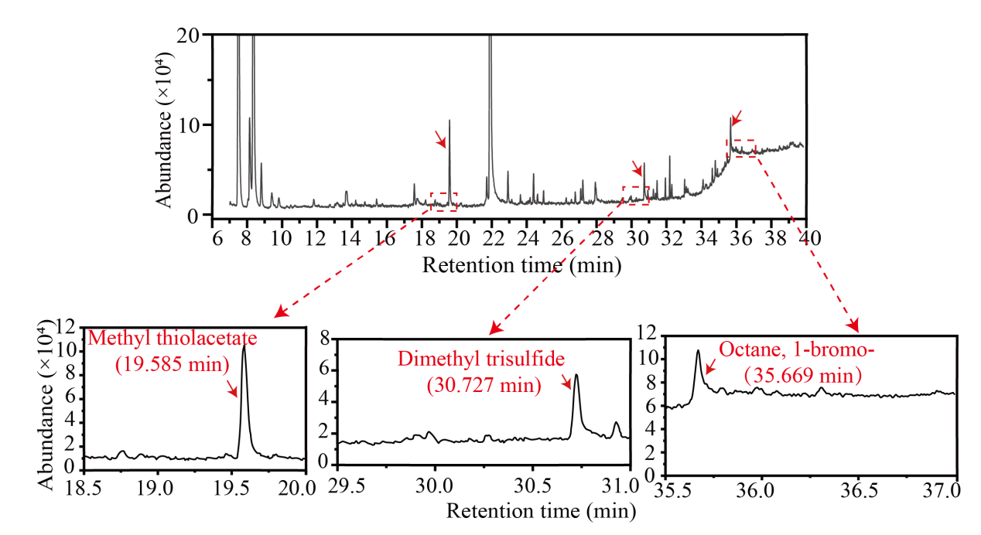
Fig.S2 Gas chromatography-mass spectrometry (GC-MS) analysis of mVOCs

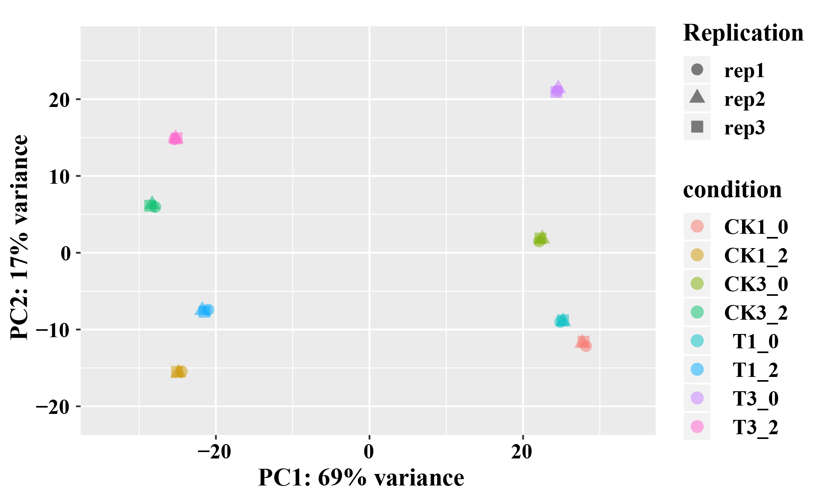
Fig. S3 Principal component analysis plot of samples. The X-axis represents the first principal component (PC1), and the Y-axis represents the second principal component (PC2). In the plot, different shapes correspond to different samples, while different colors indicate different groups.

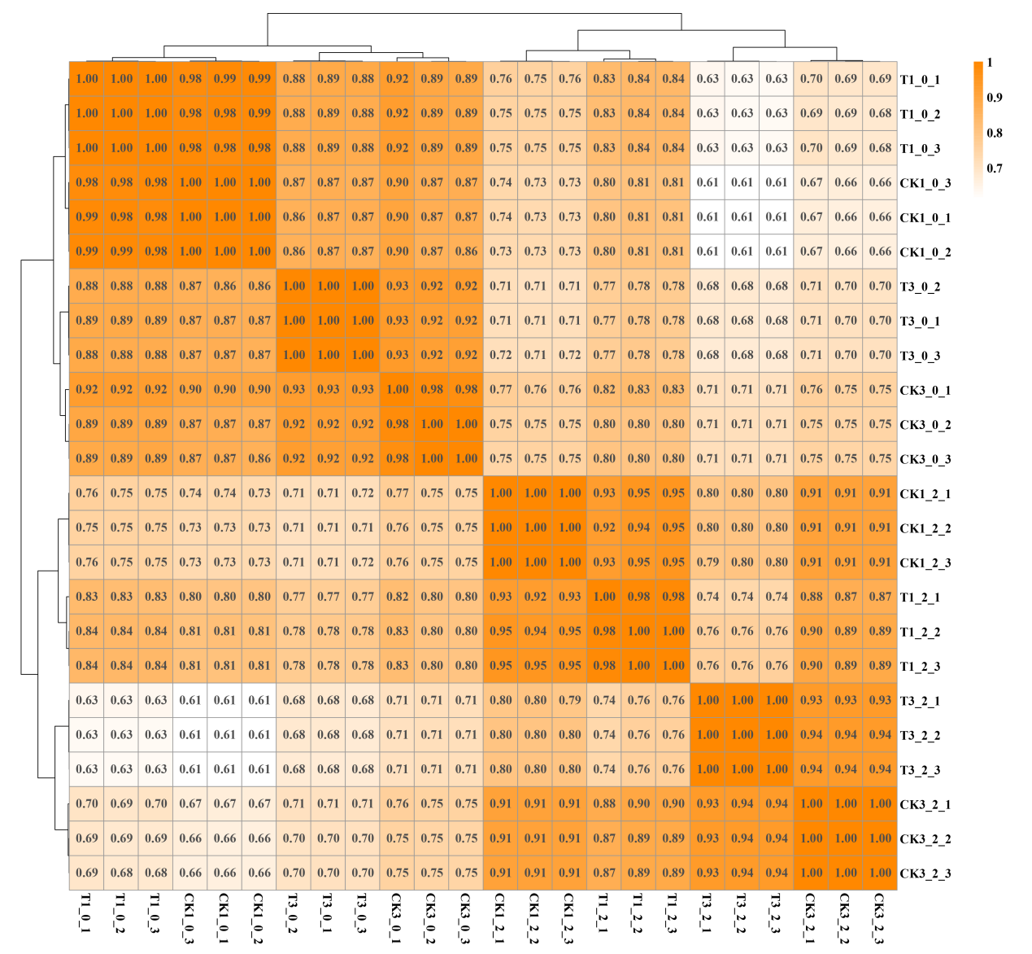
Fig.S4 Correlation diagram between samples. The left and top sides of the figure display sample clustering, while the right and bottom sides indicate sample names. Squares of different colors represent the strength of correlation between two samples, with the numerical values denoting correlation coefficients. A coefficient between 0.8 to 1 indicates a very strong correlation. If the correlation coefficient between biological replicates falls below 0.8, it suggests relatively low similarity among the samples.

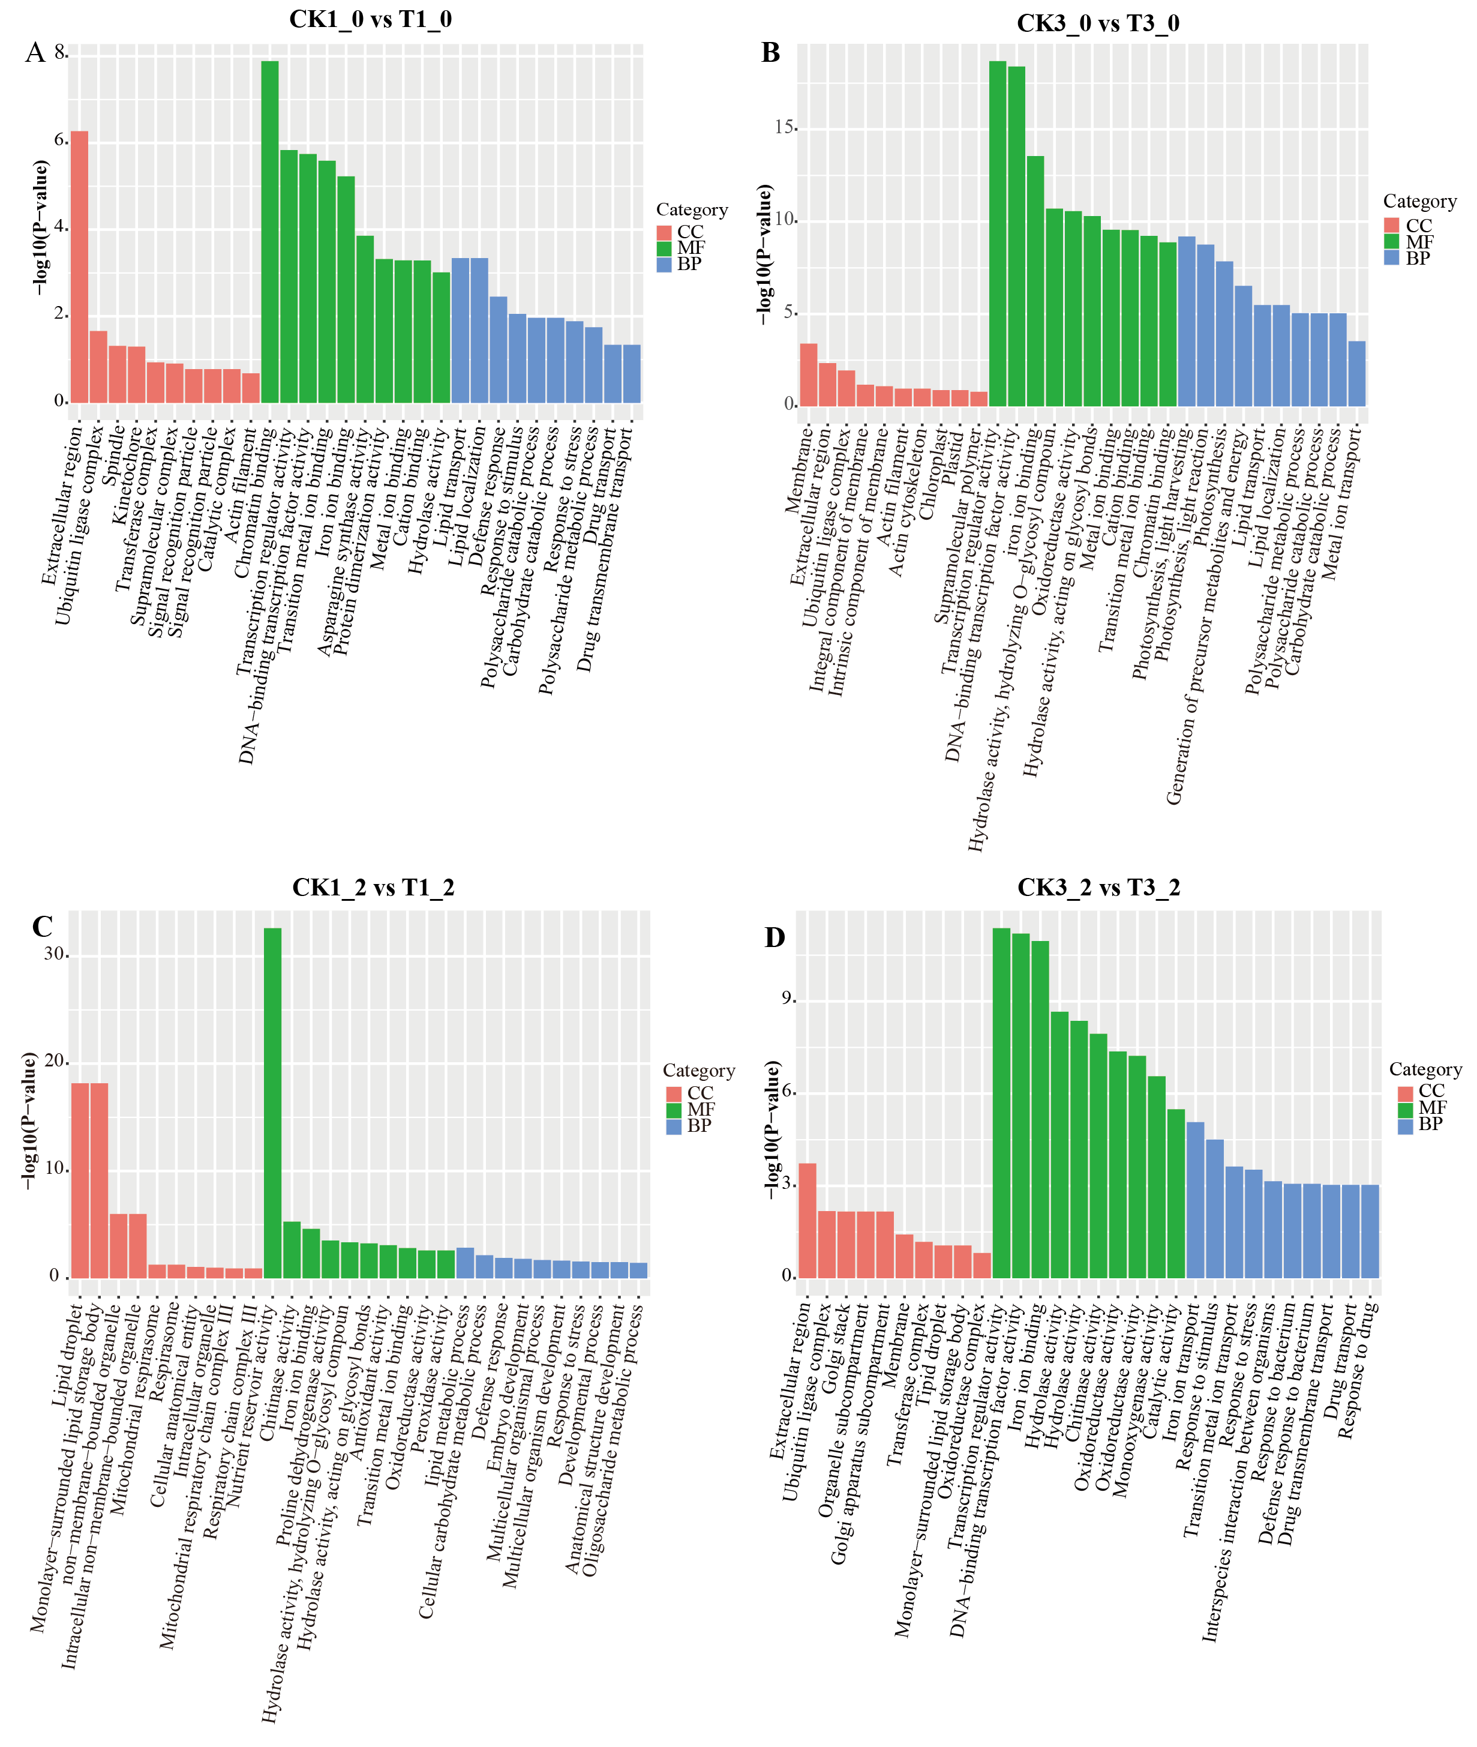
Fig. S5 GO enrichment classifications of DEGs

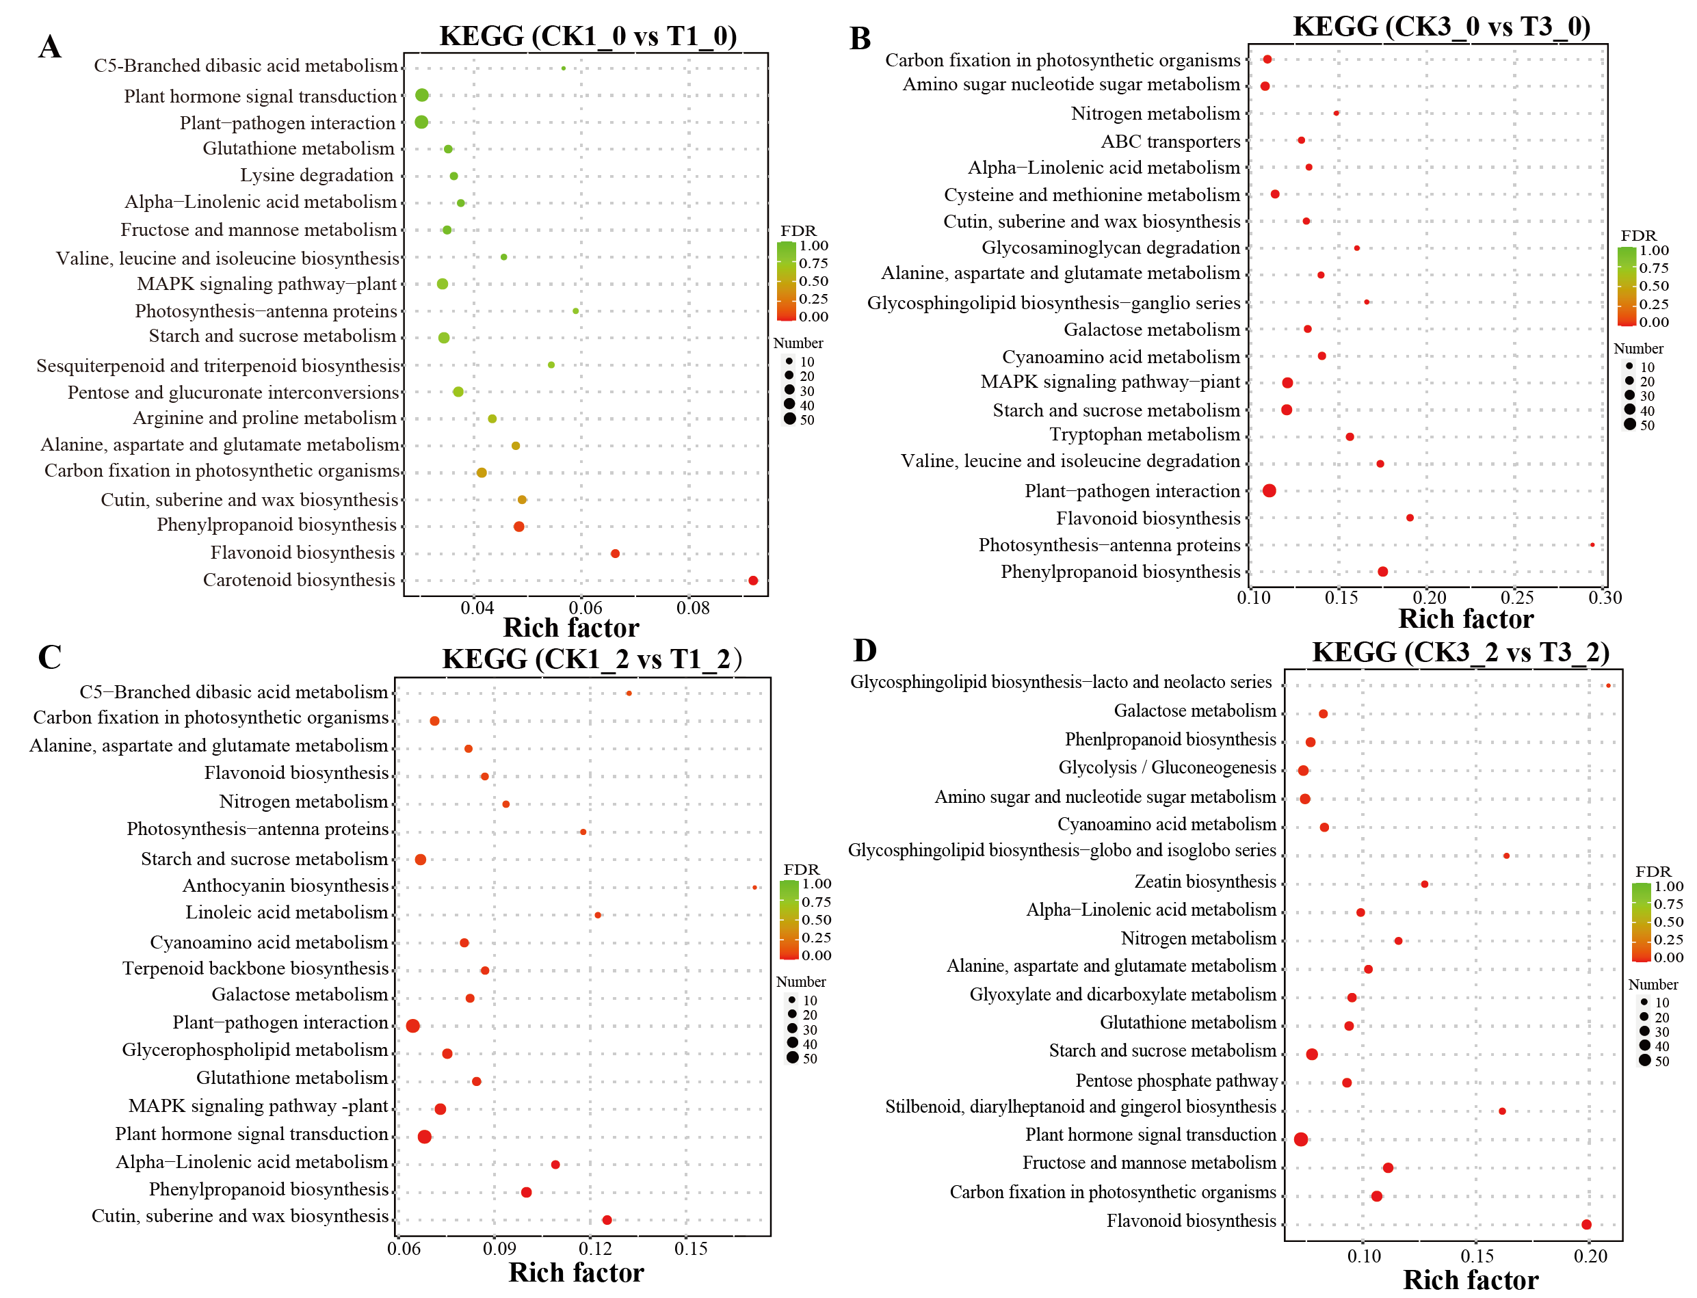
Fig. S6 KEGG enrichment classifications of DEGs

