Supplementary Information
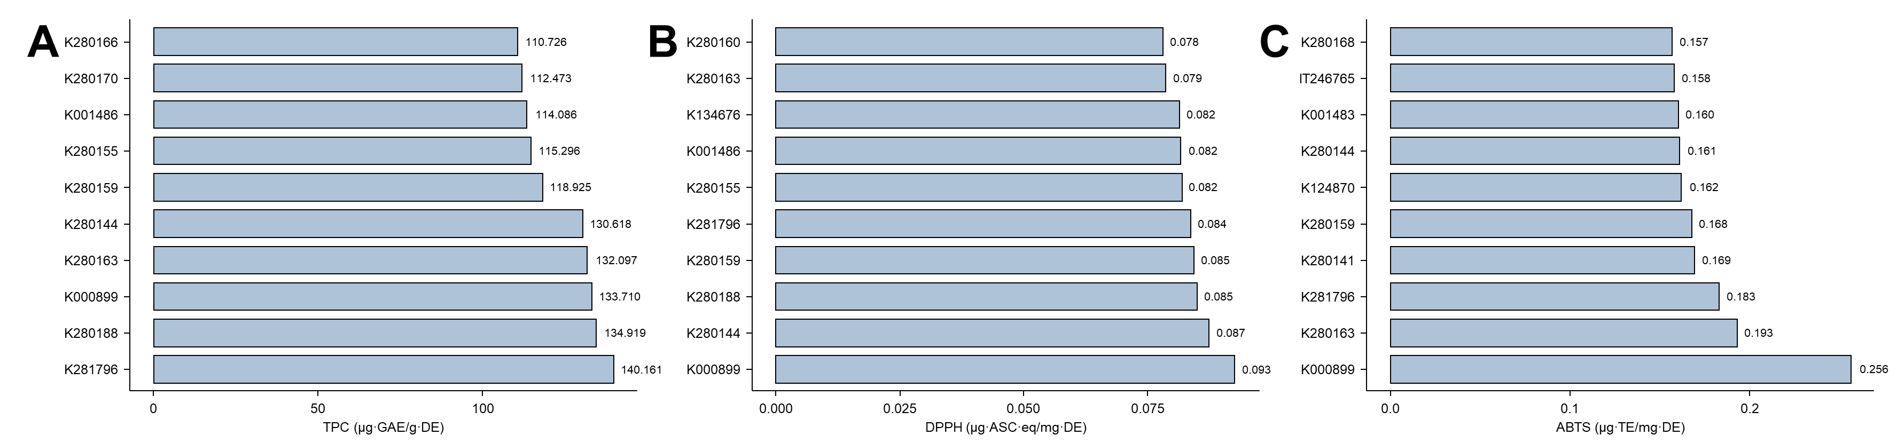
Fig. S1. Top-performing accessions for antioxidant indices. Bar plots showing the top 10 Agastache accessions ranked for (A) total phenolic content (TPC), (B) DPPH scavenging activity, and (C) ABTS scavenging activity. Error bars represent standard deviations based on replicate measurements.

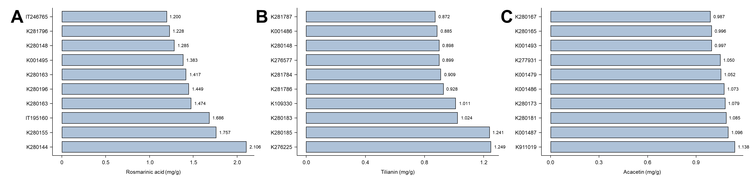
Fig. S2. Top-performing accessions for secondary metabolites. Bar plots showing the top 10 Agastache accessions ranked by content of (A) rosmarinic acid (RA), (B) tilianin (Til), and (C) acacetin (AC). Error bars indicate standard deviations across replicates.

Table S1. List of Agastache accessions used in this study and their origin
No. | Accession | Species | Origin
1 | 175074 | Agastache rugosa | Korea, South
2 | 183182 | Agastache rugosa | Korea, South
3 | 195160 | Agastache rugosa | Korea, South
4 | 195226 | Agastache rugosa | Korea, South
5 | 196720 | Agastache rugosa | Korea, South
6 | 209893 | Agastache rugosa | Korea, South
7 | 209894 | Agastache rugosa | Korea, South
8 | 246764 | Agastache rugosa | Korea, South
9 | 246765 | Agastache rugosa | Korea, South
10 | 246766 | Agastache rugosa | Korea, South
11 | 807260 | Agastache rugosa | Korea, South
12 | 911019 | Agastache rugosa | Korea, South
13 | K000899 | Agastache cana | Exotic, Canada
14 | K000909 | Agastache foeniculum | Exotic, Canada
15 | K001011 | Agastache rugosa | Exotic, Canada
16 | K001475 | Agastache rugosa | Korea, South
17 | K001476 | Agastache rugosa | Korea, South
18 | K001477 | Agastache rugosa | Korea, South
19 | K001478 | Agastache rugosa | Korea, South
20 | K001479 | Agastache rugosa | Korea, South
21 | K001480 | Agastache rugosa | Korea, South
22 | K001481 | Agastache rugosa | Korea, South
23 | K001482 | Agastache rugosa | Korea, South
24 | K001483 | Agastache rugosa | Korea, South
25 | K001484 | Agastache rugosa | Korea, South
26 | K001485 | Agastache rugosa | Korea, South
27 | K001486 | Agastache rugosa | Korea, South
28 | K001487 | Agastache rugosa | Korea, South
29 | K001488 | Agastache rugosa | Korea, South
30 | K001489 | Agastache rugosa | Korea, South
31 | K001490 | Agastache rugosa | Korea, South
32 | K001491 | Agastache rugosa | Korea, South
33 | K001492 | Agastache rugosa | Korea, South
34 | K001493 | Agastache rugosa | Korea, South
35 | K001494 | Agastache rugosa | Korea, South
36 | K001495 | Agastache rugosa | Korea, South
37 | K024673 | Agastache rugosa | Exotic, China
38 | K026440 | Agastache rugosa | Korea, South
39 | K040600 | Agastache rugosa | Korea, South
40 | K044870 | Agastache rugosa | Exotic, Russia
41 | K109330 | Agastache rugosa | Korea, South
42 | K109639 | Agastache rugosa | Korea, South
43 | K124859 | Agastache rugosa | Korea, South
44 | K124860 | Agastache rugosa | Korea, South
45 | K124862 | Agastache rugosa | Korea, South
46 | K124863 | Agastache rugosa | Korea, South
47 | K124865 | Agastache rugosa | Korea, South
48 | K124866 | Agastache rugosa | Korea, South
49 | K124868 | Agastache rugosa | Korea, South
50 | K124869 | Agastache rugosa | Korea, South
51 | K124870 | Agastache rugosa | Korea, South
52 | K124871 | Agastache rugosa | Korea, South
53 | K134675 | Agastache rugosa | Korea, South
54 | K134676 | Agastache rugosa | Korea, South
55 | K134677 | Agastache rugosa | Korea, South
56 | K136422 | Agastache rugosa | Exotic, East Asia
57 | K144963 | Agastache rugosa | Korea, South
58 | K144964 | Agastache rugosa | Korea, South
59 | K144965 | Agastache rugosa | Korea, South
60 | K144966 | Agastache rugosa | Korea, South
61 | K144967 | Agastache rugosa | Korea, South
62 | K144968 | Agastache rugosa | Korea, South
63 | K146120 | Agastache rugosa | Exotic, Russia
64 | K146200 | Agastache rugosa | Exotic, Russia
65 | K153751 | Agastache rugosa | Korea, North
66 | K160463 | Agastache rugosa | Korea, South
67 | K204298 | Agastache rugosa | Korea, South
68 | K209521 | Agastache rugosa | Korea, South
69 | K264504 | Agastache rugosa | Korea, South
70 | K273577 | Agastache rugosa | Korea, South
71 | K274699 | Agastache rugosa | Korea, North
72 | K276225 | Agastache rugosa | Korea, South
73 | K276577 | Agastache rugosa | Korea, South
74 | K277931 | Agastache rugosa | Korea, South
75 | K280141 | Agastache rugosa | Korea, South
76 | K280142 | Agastache rugosa | Korea, South
77 | K280143 | Agastache rugosa | Korea, South
78 | K280144 | Agastache rugosa | Korea, South
79 | K280145 | Agastache rugosa | Korea, South
80 | K280146 | Agastache rugosa | Korea, South
81 | K280147 | Agastache rugosa | Korea, South
82 | K280148 | Agastache rugosa | Korea, South
83 | K280149 | Agastache rugosa | Korea, South
84 | K280150 | Agastache rugosa | Korea, South
85 | K280151 | Agastache rugosa | Korea, South
86 | K280152 | Agastache rugosa | Korea, South
87 | K280153 | Agastache rugosa | Korea, South
88 | K280154 | Agastache rugosa | Korea, South
89 | K280155 | Agastache rugosa | Korea, South
90 | K280156 | Agastache rugosa | Korea, South
91 | K280157 | Agastache rugosa | Korea, South
92 | K280158 | Agastache rugosa | Korea, South
93 | K280159 | Agastache rugosa | Korea, South
94 | K280160 | Agastache rugosa | Korea, South
95 | K280161 | Agastache rugosa | Korea, South
96 | K280162 | Agastache rugosa | Korea, South
97 | K280163 | Agastache rugosa | Korea, South
98 | K280164 | Agastache rugosa | Korea, South
99 | K280165 | Agastache rugosa | Korea, South
100 | K280166 | Agastache rugosa | Korea, South
101 | K280167 | Agastache rugosa | Korea, South
102 | K280168 | Agastache rugosa | Korea, South
103 | K280169 | Agastache rugosa | Korea, South
104 | K280170 | Agastache rugosa | Korea, South
105 | K280171 | Agastache rugosa | Korea, South
106 | K280172 | Agastache rugosa | Korea, South
107 | K280173 | Agastache rugosa | Korea, South
108 | K280174 | Agastache rugosa | Korea, South
109 | K280175 | Agastache rugosa | Korea, South
110 | K280176 | Agastache rugosa | Korea, South
111 | K280177 | Agastache rugosa | Korea, South
112 | K280178 | Agastache rugosa | Korea, South
113 | K280179 | Agastache rugosa | Korea, South
114 | K280180 | Agastache rugosa | Korea, South
115 | K280181 | Agastache rugosa | Korea, South
116 | K280182 | Agastache rugosa | Korea, South
117 | K280183 | Agastache rugosa | Korea, South
118 | K280184 | Agastache rugosa | Korea, South
119 | K280185 | Agastache rugosa | Korea, South
120 | K280186 | Agastache rugosa | Korea, South
121 | K280187 | Agastache rugosa | Korea, South
122 | K280188 | Agastache rugosa | Korea, South
123 | K280189 | Agastache rugosa | Korea, South
124 | K280190 | Agastache rugosa | Korea, South
125 | K280191 | Agastache rugosa | Korea, South
126 | K280192 | Agastache rugosa | Korea, South
127 | K280193 | Agastache rugosa | Korea, South
128 | K280194 | Agastache rugosa | Korea, South
129 | K280195 | Agastache rugosa | Korea, South
130 | K280196 | Agastache rugosa | Korea, South
131 | K280197 | Agastache rugosa | Korea, South
132 | K280198 | Agastache rugosa | Korea, South
133 | K280199 | Agastache rugosa | Korea, South
134 | K280200 | Agastache rugosa | Korea, South
135 | K280201 | Agastache rugosa | Korea, South
136 | K280202 | Agastache rugosa | Korea, South
137 | K280203 | Agastache rugosa | Korea, South
138 | K281783 | Agastache rugosa | Exotic, United States
139 | K281784 | Agastache rugosa | Exotic, United States
140 | K281786 | Agastache rugosa | Exotic, Canada
141 | K281787 | Agastache rugosa | Exotic, Poland
142 | K281788 | Agastache rugosa | Exotic, Netherlands
143 | K281789 | Agastache rugosa | Exotic, Netherlands
144 | K281790 | Agastache rugosa | Korea, South
145 | K281791 | Agastache rugosa | Exotic, Finland
146 | K281792 | Agastache rugosa | Exotic, Finland
147 | K281793 | Agastache rugosa | Exotic, Russia
148 | K281794 | Agastache rugosa | Exotic, Russia
149 | K281795 | Agastache rugosa | Exotic, Netherlands
150 | K281796 | Agastache rugosa | Exotic, Russia

Table S2. Variance inflation factor (VIF) diagnostics for the multiple regression model used to assess DTF-related trait associations
Variable | VIF
TPC | 2.72
ABTS | 1.45
DPPH | 2.14
RA | 1.64
Til | 1.38
AC | 2.10
PH | 4.34
NB | 5.17
LL | 2.20
LW | 2.68
IL | 1.51
NI | 1.41

