Supplementary figures
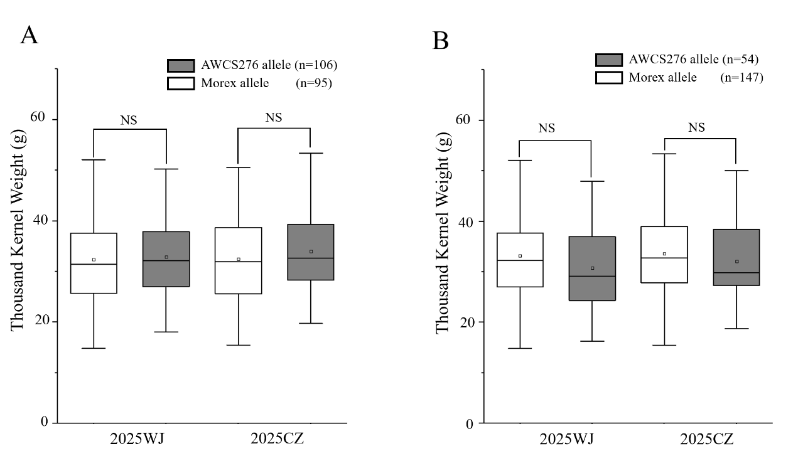
Fig S1. The effect of tiller angle QTL on the thousand kernel weight. (A) Box plot of QTA.cdac-2H.1 effect in MA population grouped by flanking marker. AWCS276 allele and Morex allele indicate lines with and without the positive allele, respectively. (B) Box plot of QTA.cdac-5H effect in MA population grouped by flanking marker. AWCS276 allele and Morex allele indicate lines with and without the positive allele, respectively. NS indicate no significant differences.

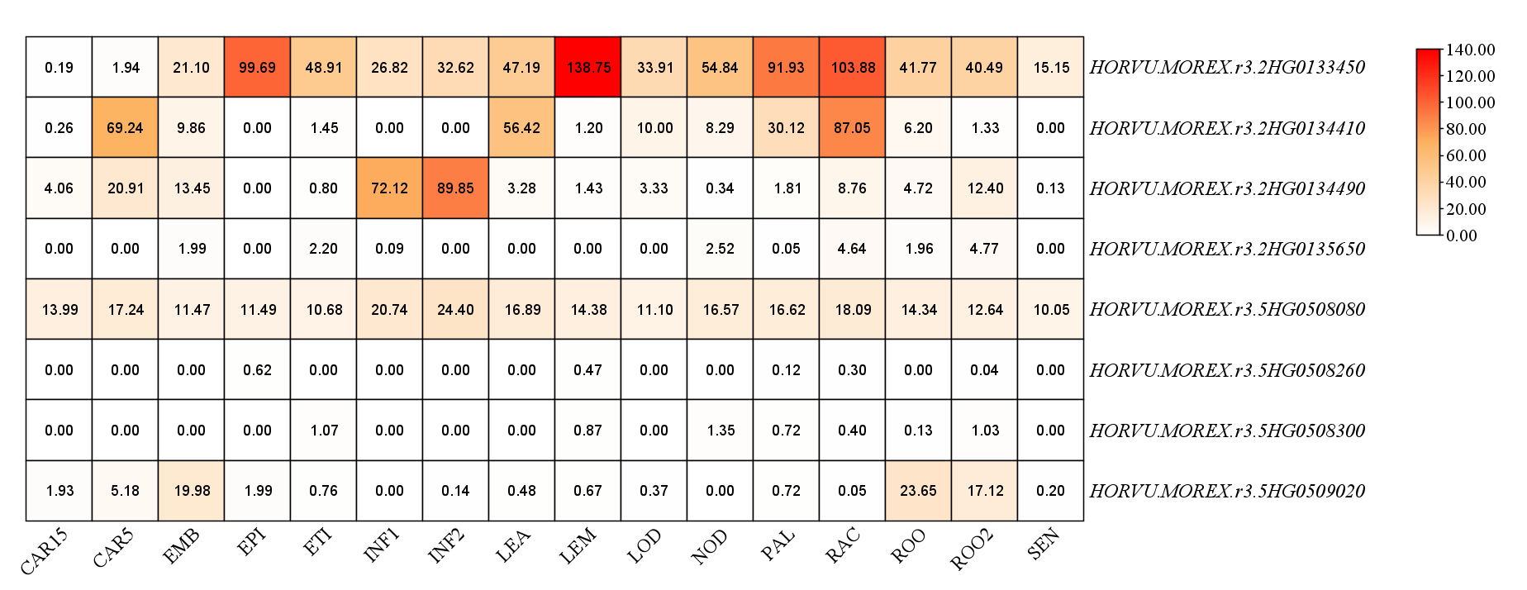
Fig S2. The gene expression in various tissues in eight candidate genes from the BarleyExpDB. CAR15, Grain of 15DPA. CAR5, Grain of 5DPA. EMB, Embryos. EPI, Epidermis. ETI, Etiolated. INF1, Young Inflorescences. INF2, Inflorescences. LEA, Shoot from the seedlings. LEM, Lemma six weeks PA. LOD, Lodicule. NOD, Developing tillers. PAL, Palea. RAC, Rachi. ROO, Root of four weeks. ROO2, Roots from the seeding. SEN, Senescing leaf.

