B
A
C
A
C
B

Fig.S1 Gene structures and motif analysis of VuMYB proteins in cowpea. Among them, (A) is 1R-VuMYB, (B) is 2R-VuMYB, (C) is 3R-VuMYB.

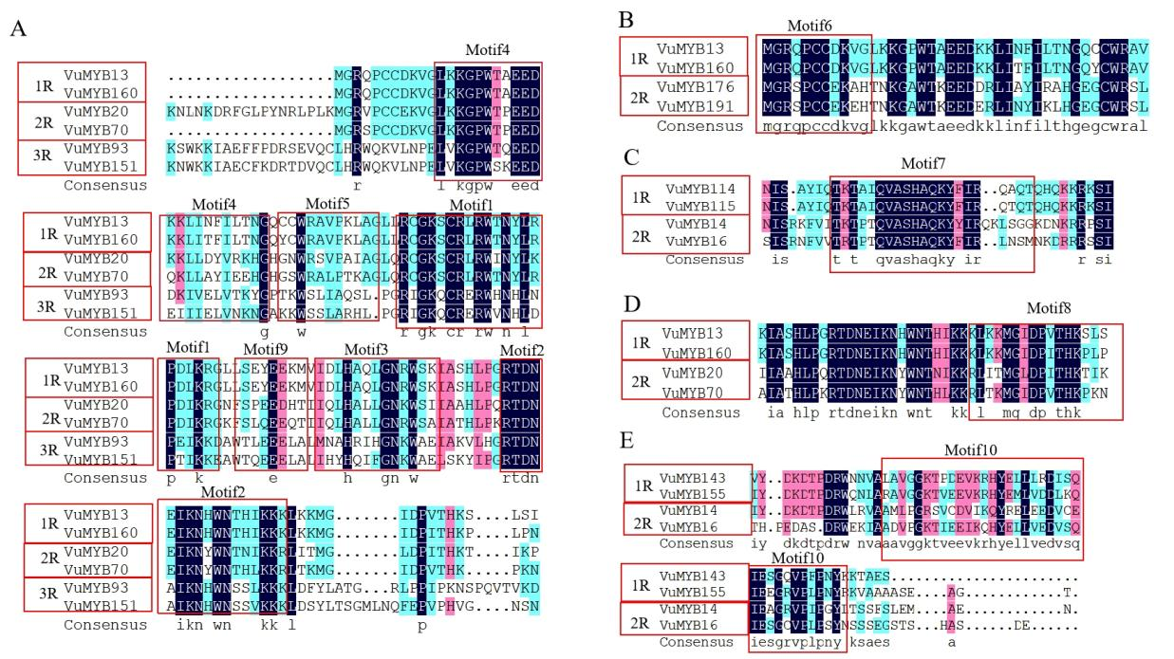
Fig.S2 Motif analysis of 1R-VuMYB, 2R-VuMYB and 3R-VuMYB proteins in cowpea. (A) The common motif for the 1R-VuMYB, 2R-VuMYB, and 3R-VuMYB proteins in cowpea. (B-E)The specific motifs of the 1R-VuMYB and 2R-VuMYB proteins in cowpea, including motif6 (B), motif7 (C), motif8 (D) and motif10 (E).

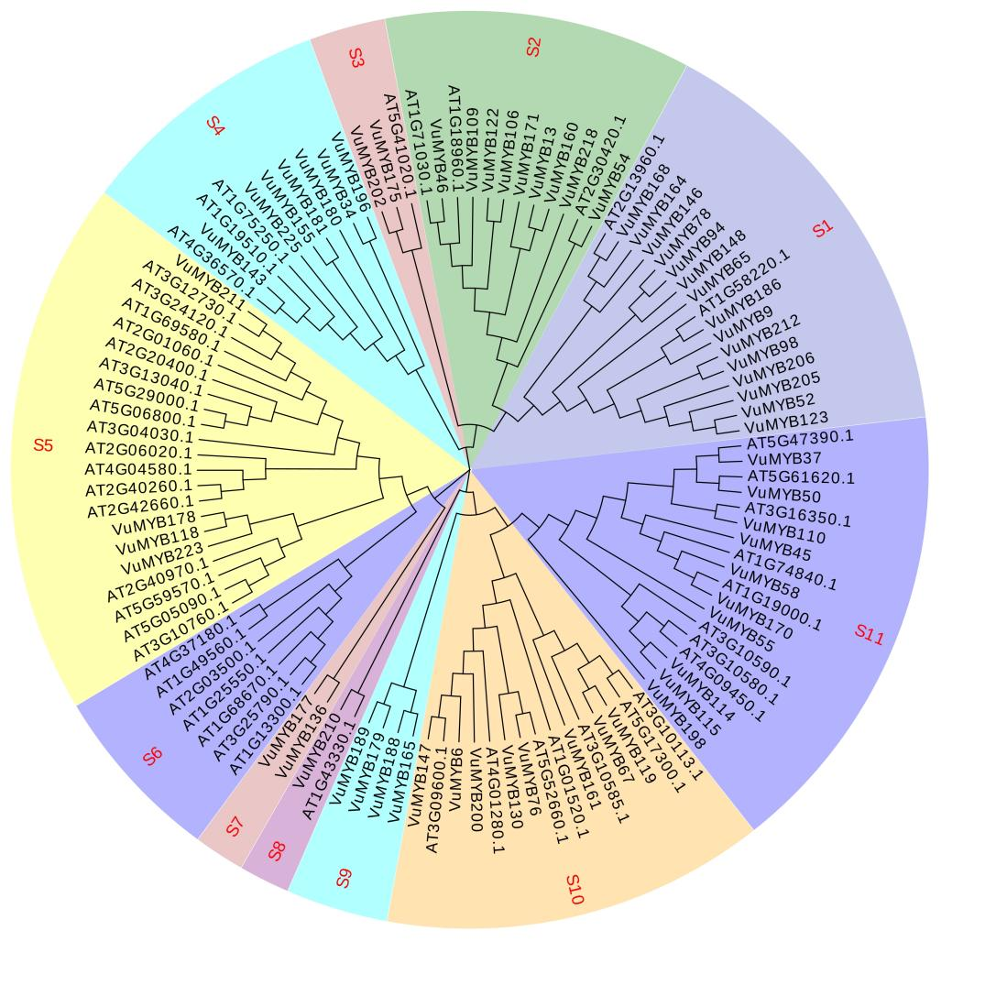
Fig.S3 Phylogenetic analysis of 1R-VuMYB proteins in Arabidopsis thaliana and cowpea.

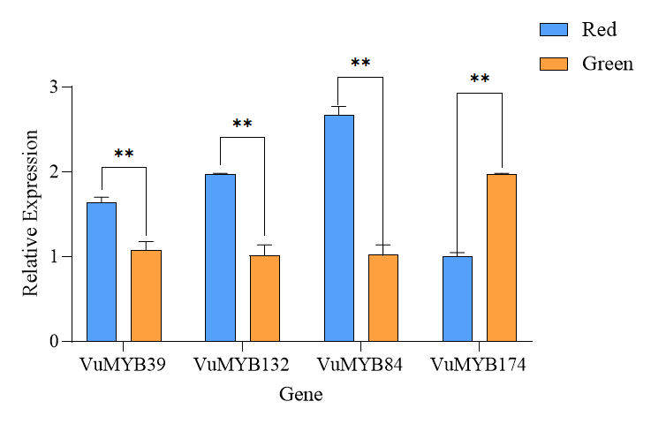
Figure S4. qRT-PCR analysis of VuMYB39, VuMYB132, VuMYB84 and VuMYB174 in red pod and green pod materials. Red for red pod materials, green for green pod materials. Expression levels were determined by qRT-PCR using 3 biological and 3 technical replicates. The data is presented as mean±standard deviation, with values in the control group set to 1 (Student’s t-test: ** P < 0.01).

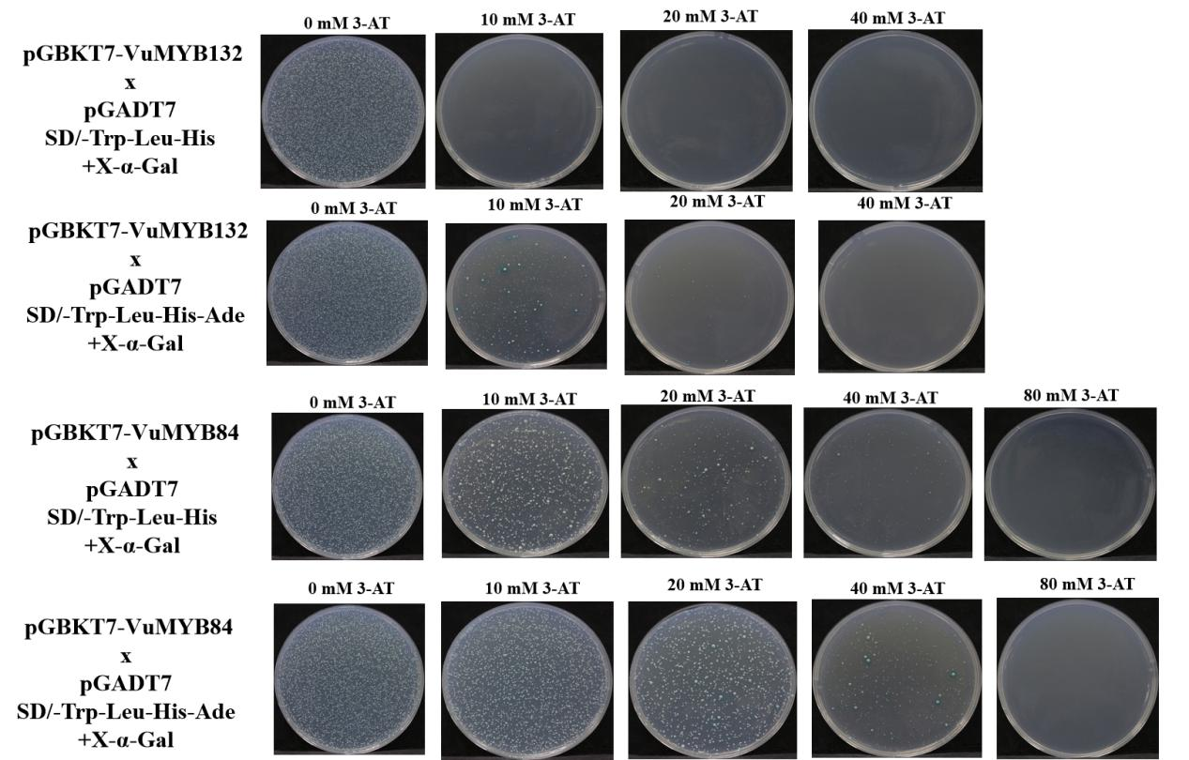

Fig.S5 The inhibition results of VuMYB84 and VuMYB132 protein autoactivation by different concentrations of 3-AT.

