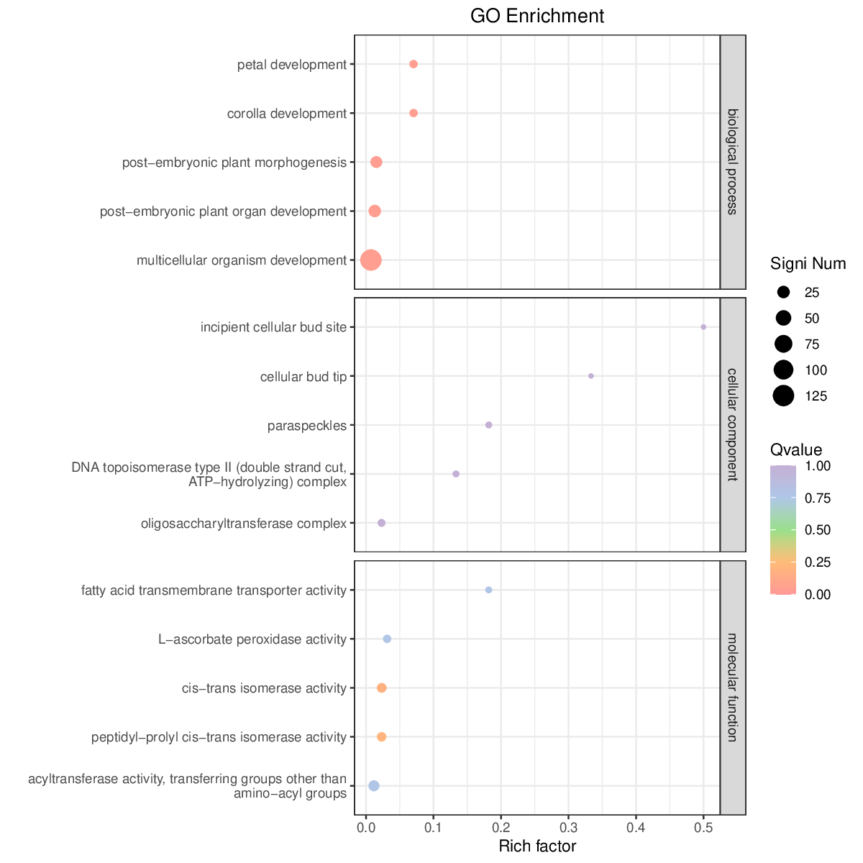
Supplementary Figure S2. Scatter plot of significantly enriched functions. The y-axis shows functional annotation terms, and the x-axis shows the Rich factor for each term. The color of the points represents the Q‑value: smaller Q‑values are indicated by colors closer to red. The size of each point reflects the number of differentially expressed genes (DEGs) associated with the corresponding function.

