Fig. S1 Tanshinone Biosynthetic Pathway

Fig. S2 Above-ground characteristics of the experimental materials
(A) Above-ground phenotypic traits of G97. (B) Above-ground phenotypic traits of G353. (C) Above-ground phenotypic traits of G210. (D) Above-ground phenotypic traits of G161. (E) Above-ground phenotypic traits of G392.

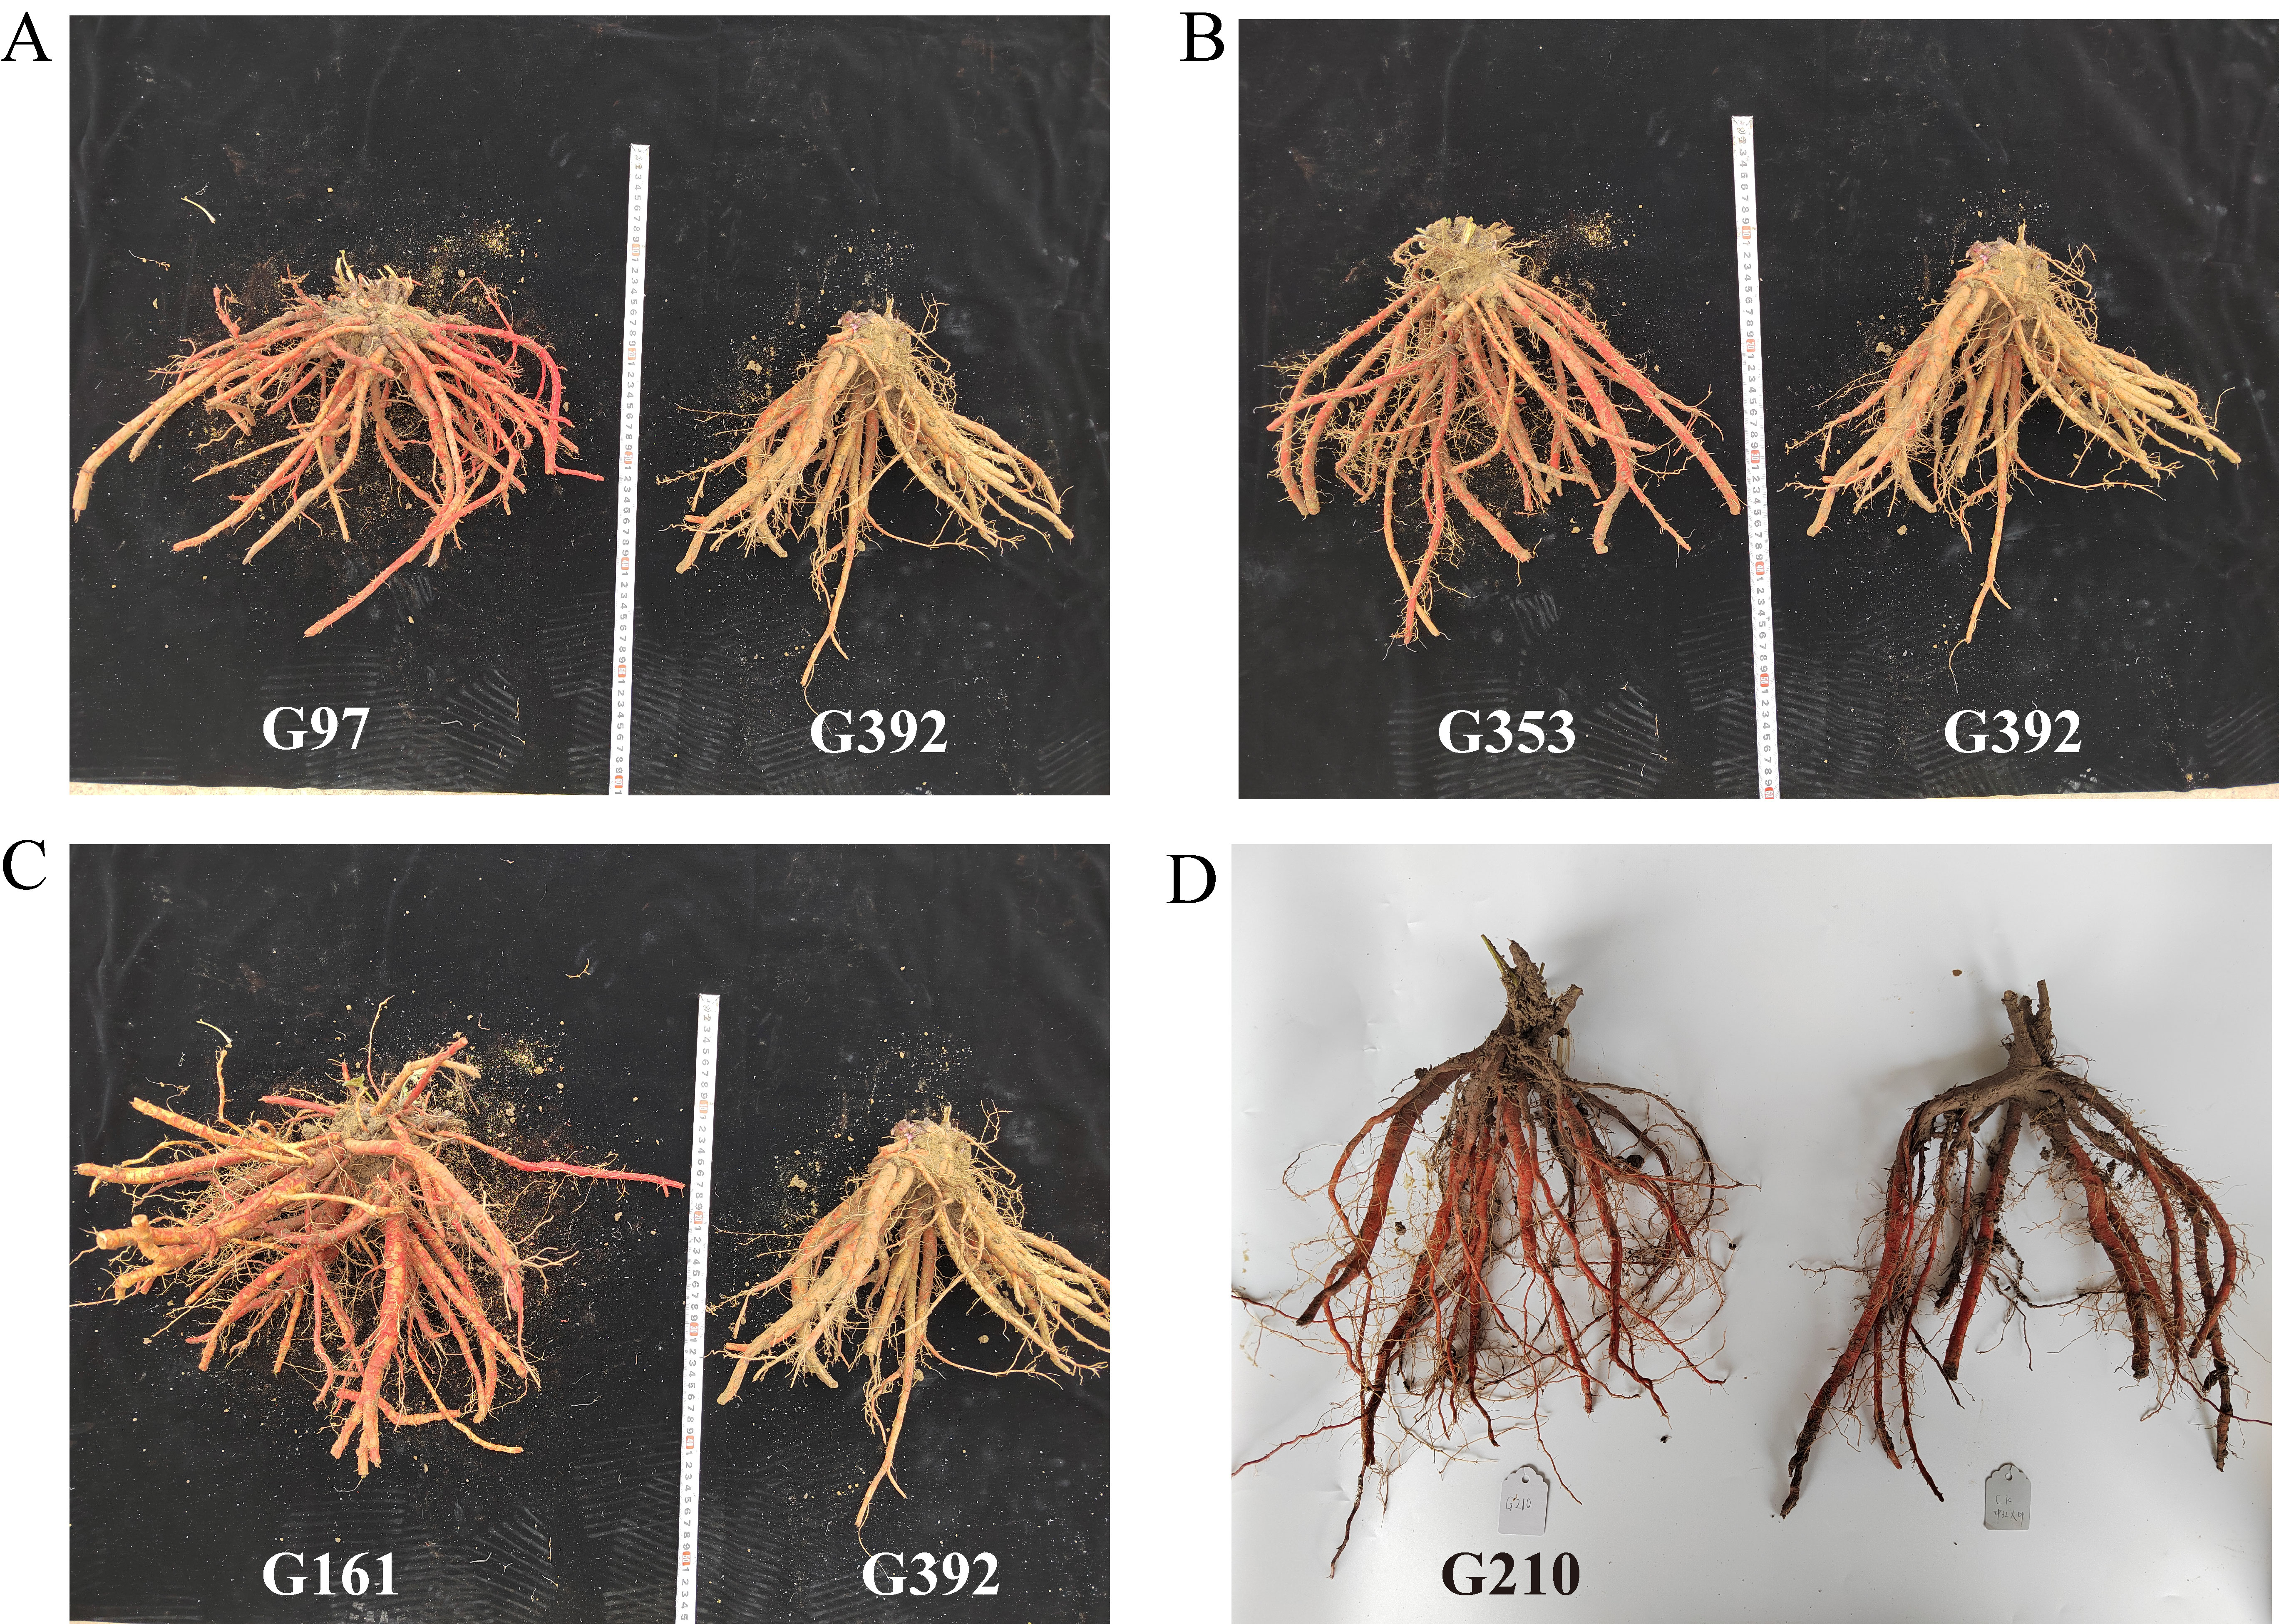
Fig. S3 Root phenotypic traits of the experimental materials
(A) Comparison of root phenotypic traits between G97 and G392. (B) Comparison of root phenotypic traits between G353 and G392. (C) Comparison of root phenotypic traits between G161 and G392. (D) Root phenotypic traits of G210.

Table S1. Gradient elution conditions
Time (min) | Mobile Phase A (%) | Mobile Phase B (%)
0~6 | 61 | 39
6~20 | 61→90 | 39→10
20~20.5 | 90→61 | 10→39
20.5~25 | 61 | 39

Table S2. RT-qPCR primer
Gene | Forward primer | Reverse primer
SmActin | 5’- AGGAACCACCGATCCAGACA-3’ | 5’- GGTGCCCTGAGGTCCTGTT-3’
SmGAPDH | 5’- CCACCGTCCACTCCATCACT-3’ | 5’- TGGGAACTCGGAACGACATAC-3’
SmHMGR3 | 5’-CTTCGTCCAGTCCATCATCATCC-3’ | 5’-CGTCGGTAACCTCAATCTTCTCAA-3’
SmMK | 5’-CAGAGCGCCTGGGAAAATCA-3’ | 5’-TGCATCGTCGTTATCCTCGG-3’
SmDXS1 | 5’-GGAGAAGGGCTTGCCTGAAT-3’ | 5’-GCAACAGCCATTCCAAGTCC-3’
SmDXS2 | 5’-CCGGCGGCCATTTGAGC-3’ | 5’-TTTGTGCGGATACGCCTGG-3’
SmCYP76AK1 | 5’-CTGCTGGAGTTGGTGCAGAA-3’ | 5’-CCTGCGATGATTATGTCCACAAAG-3’
SmbHLH87 | 5’- GTGATTAATTCGTCGTCTTCCAACA-3’ | 5’- TCTTCCTCTTCGGCTTCTCCAT-3’
SmbHLH139 | 5’- GCAGCATTATGGCGAACCTTC-3’ | 5’- GTGATCGGGCAGCATGTTGA-3’
SmUPBEAT1 | 5’- TTTACCAAGAAACCGCCGACTAC-3’ | 5’- GTGGGATTGGCTTGGCTGAAA-3’

Fig. S4 The chromatographic profiles for the quantitative analysis of tanshinones are presented in Fig. S4 of the PDF file.
Fig. S5 Principal component analysis (PCA) of transcriptomic and metabolomic data.
(A) PCA score plot of transcriptome profiles. (B) PCA score plot of metabolome profiles. QC: quality control samples.

