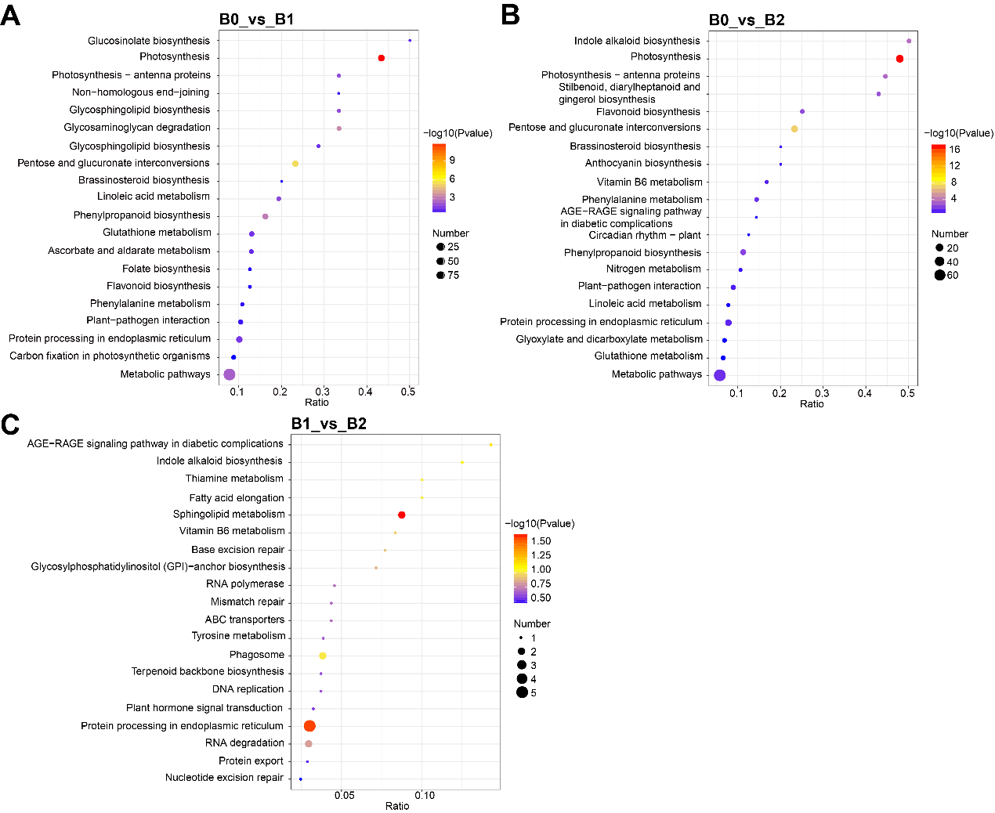
Fig. S1. KEGG enrichment analyses of DEPs across the three groups. KEGG enrichment analysis of DEPs identified in B0_vs_B1 (A), B0_vs_B2 (B), and B1_vs_B2 (C).
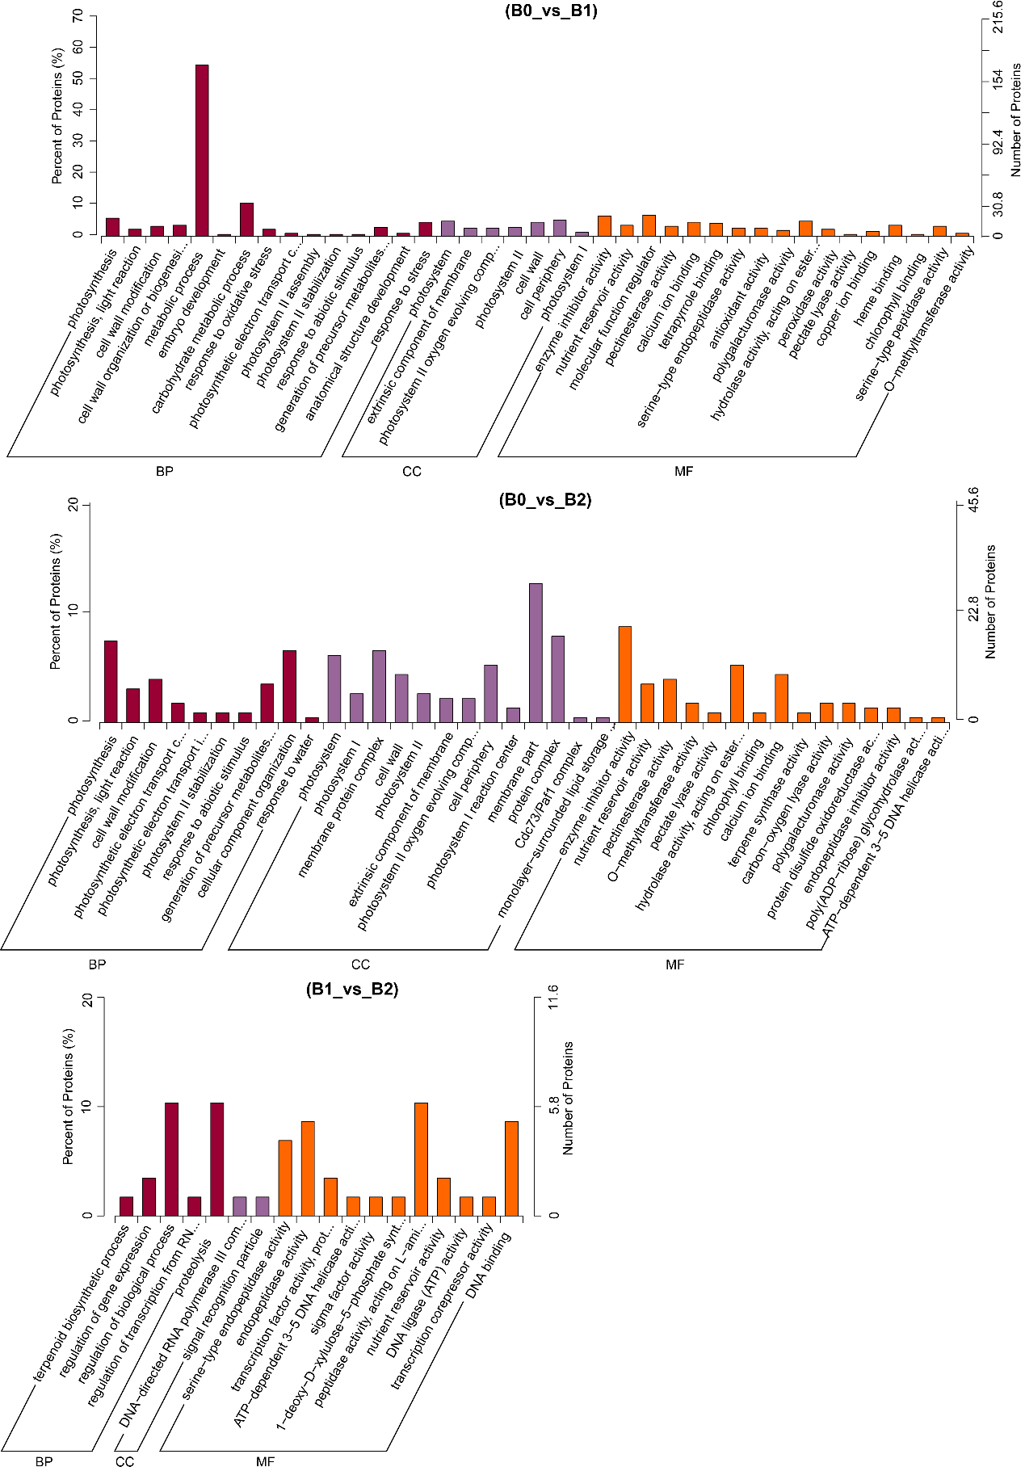
Fig. S2. GO enrichment analysis of DEPs identified in B0_vs_B1, B0_vs_B2, and B1_vs_B2.

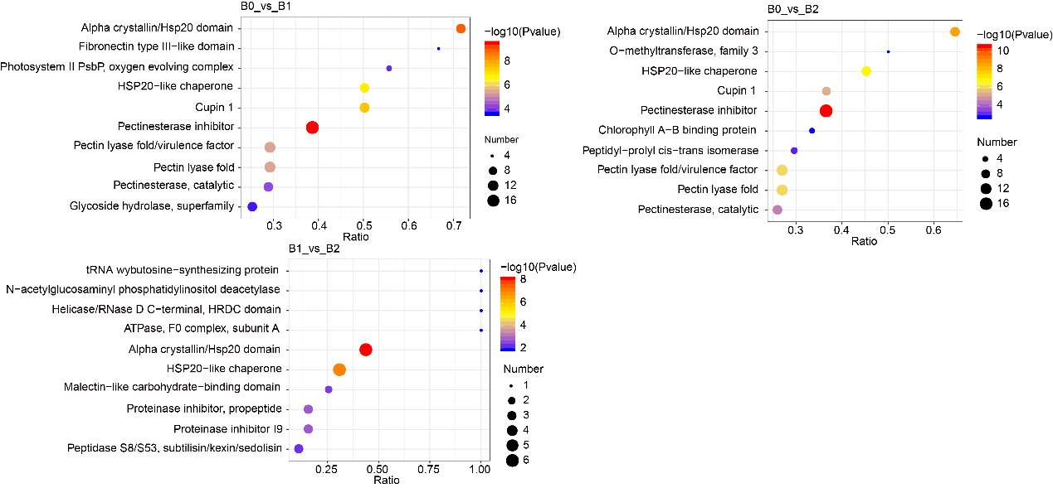
Fig. S3. Domain enrichment analysis was performed based on the results of differential analysis for the B0_vs_B1, B0_vs_B2, and B1_vs_B2 treatment groups. The x-axis represents the ratio of the number of differentially expressed proteins within a given domain to the total number of identified proteins, and the color of the dots indicates the p-value, with smaller values indicating higher reliability and stronger statistical significance.

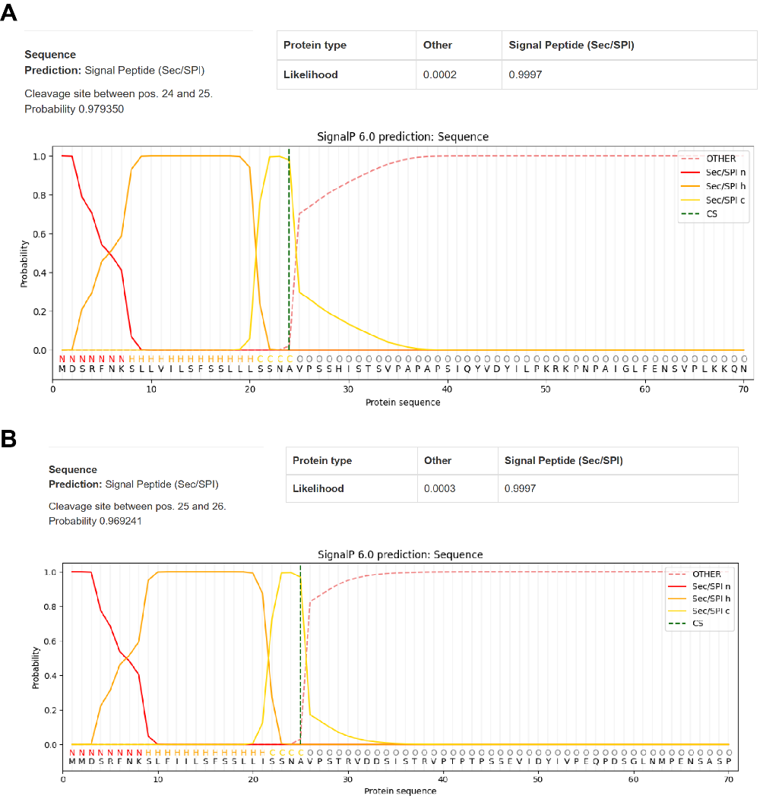
Fig. S4. Signal peptides of MsPMEI14 and MsPMEI15 were predicted using SignalP 6.0. (A) prediction result for the MsPMEI14 signal peptide, indicating a signal peptide cleavage site between amino acids 24 and 25 with a probability of 0.9997. (B) prediction result for the MsPMEI15 signal peptide, indicating a signal peptide cleavage site between amino acids 25 and 26 with a probability of 0.9997.

