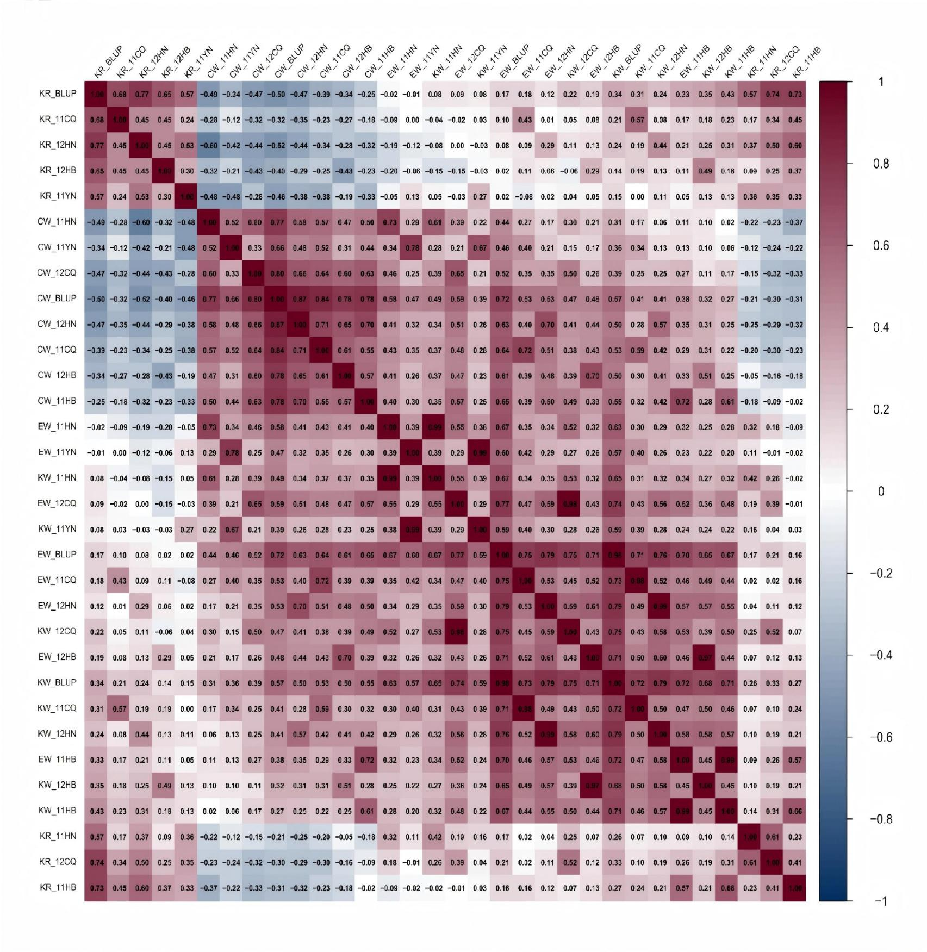
Figure S1. Correlation matrix showing pairwise relationships among ear weight (EW), cob weight (CW), kernel weight (KW) and kernel rate (KR) across seven environments and their best linear unbiased predictions (BLUPs).

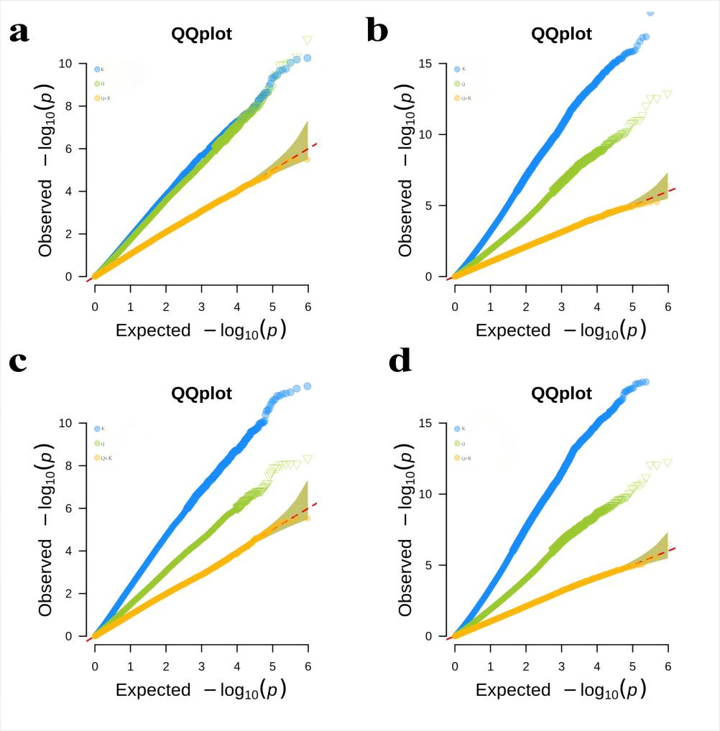
Figure S2. Evaluation of GWAS models using quantile-quantile (Q-Q) plots for four traits based on BLUP values. (a) Q-Q plots for CW under Q, K, and Q+K models. (b) Q-Q plots for EW under the three models. (c) Q-Q plots for KR under the three models. (d) Q-Q plots for KW under the three models. The x-axis represents expected -log₁₀(P) values and the y-axis shows observed -log₁₀(P) values. Deviation from the diagonal line indicates the extent of model miscalibration, with the Q+K model showing optimal performance across all traits.

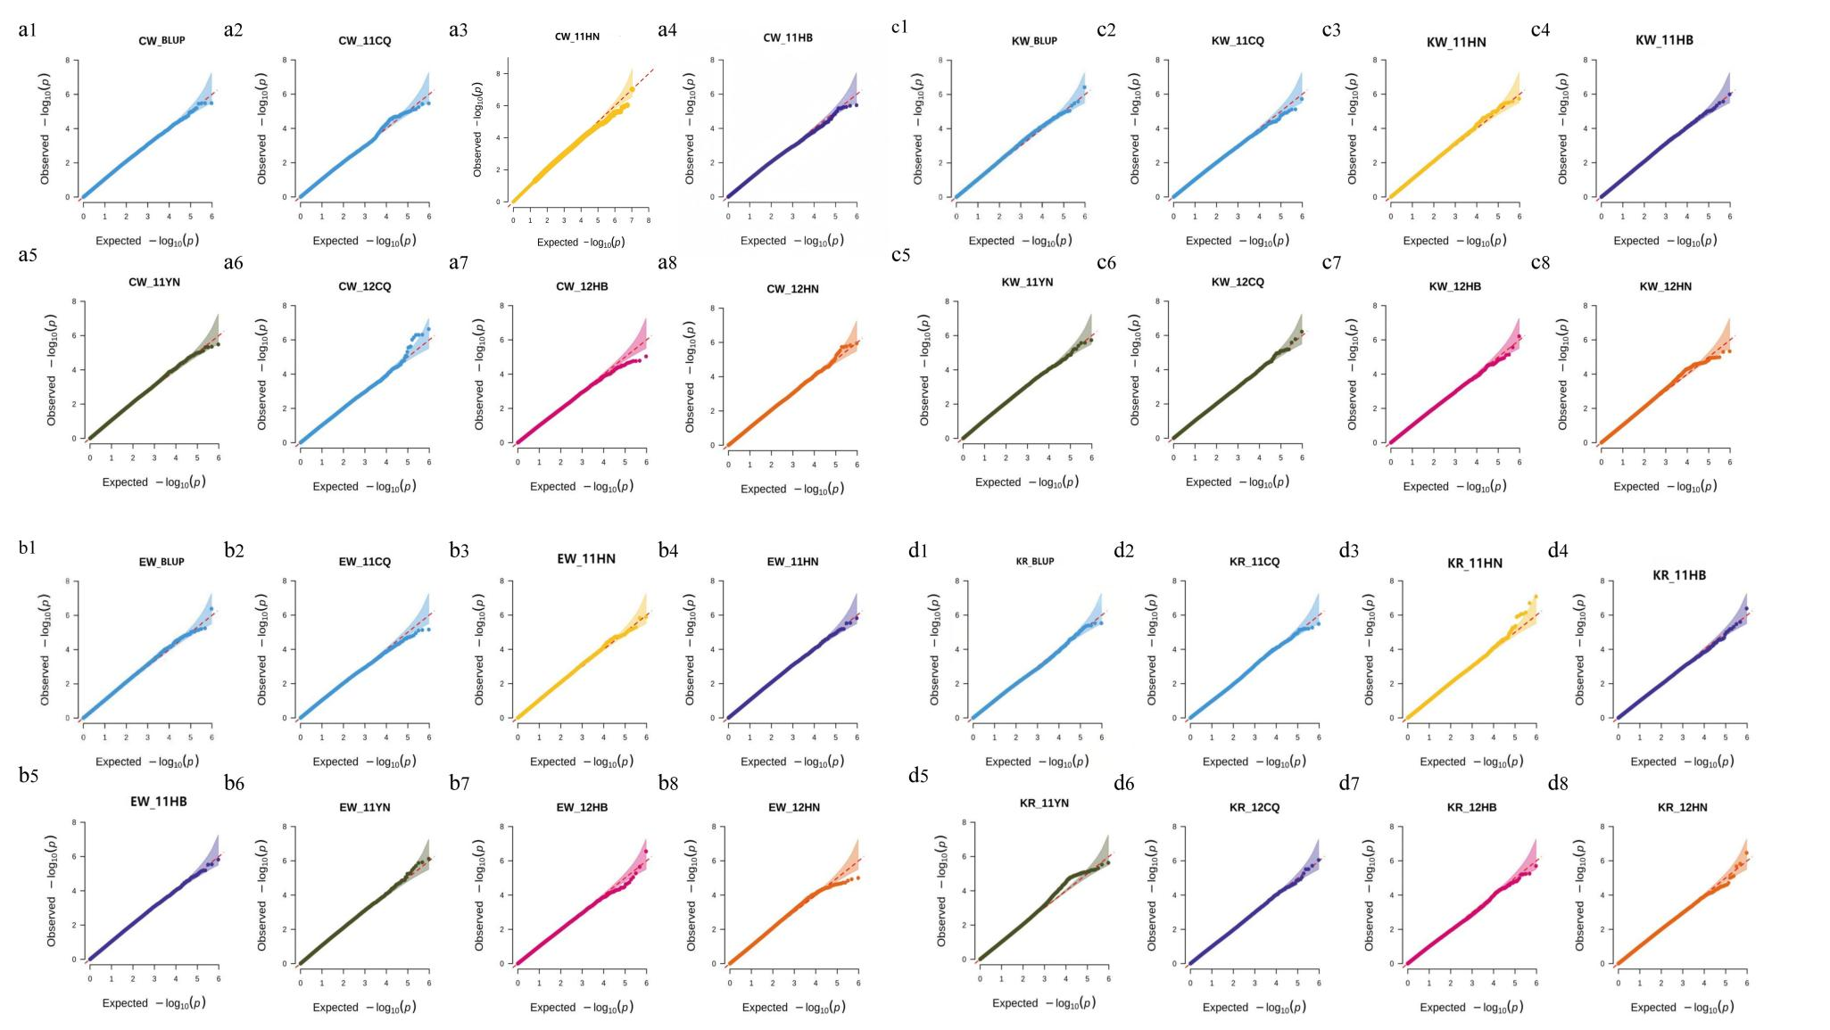
Figure S3. Quantile-quantile (Q-Q) plots of four yield-related traits under Q+K model across seven environments and BLUP values. (a-d) Q-Q plots for CW, EW, KW and KR, respectively. Within each subfigure, panel 1 shows the results based on BLUP values and panel 2-8 represent the seven individual environments (11CQ, 11HN, 11HB, 11YN, 12CQ, 12HB, 12HN). The x-axis represents the expected -log₁₀(P) and the y-axis shows the observed -log₁₀(P). The diagonal line indicates the expected distribution under the null hypothesis, with points closely following the line demonstrating well-controlled false positives.

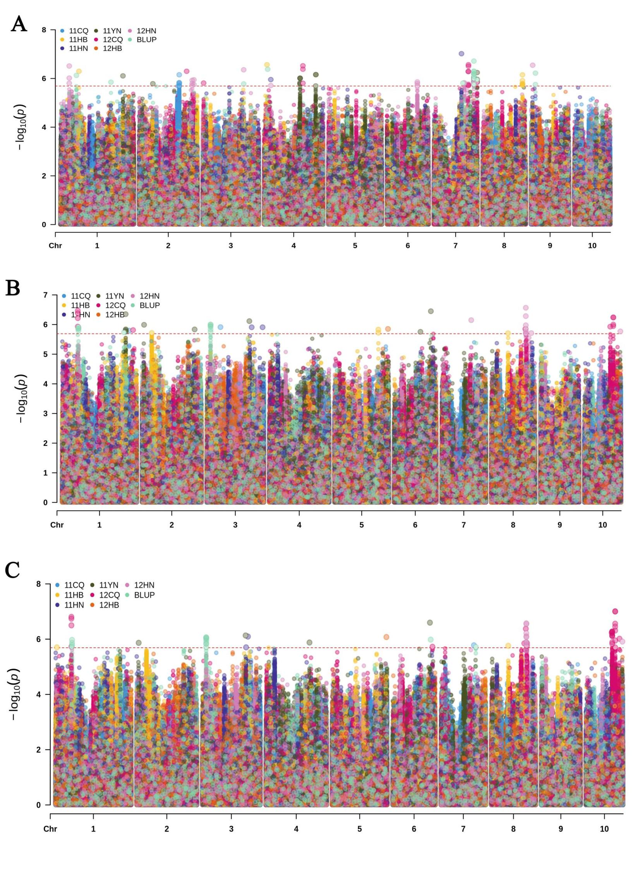
Figure S4. Manhattan plots of genome-wide association signals for three yield-related traits under Q+K model across seven environments and BLUP values. The plots display the distribution of association signals for (A) CW, (B) EW, (C) KW across chromosomes 1 to 10. Each subpanel shows results from seven environments (11CQ, 11HN, 11HB, 11YN, 12CQ, 12HB, 12HN) and BLUP. The horizontal dashed line indicates the genome-wide significance threshold of P = 2.04×10⁻⁶). Peaks above the threshold represent significant associations, with different colors distinguishing the environments.

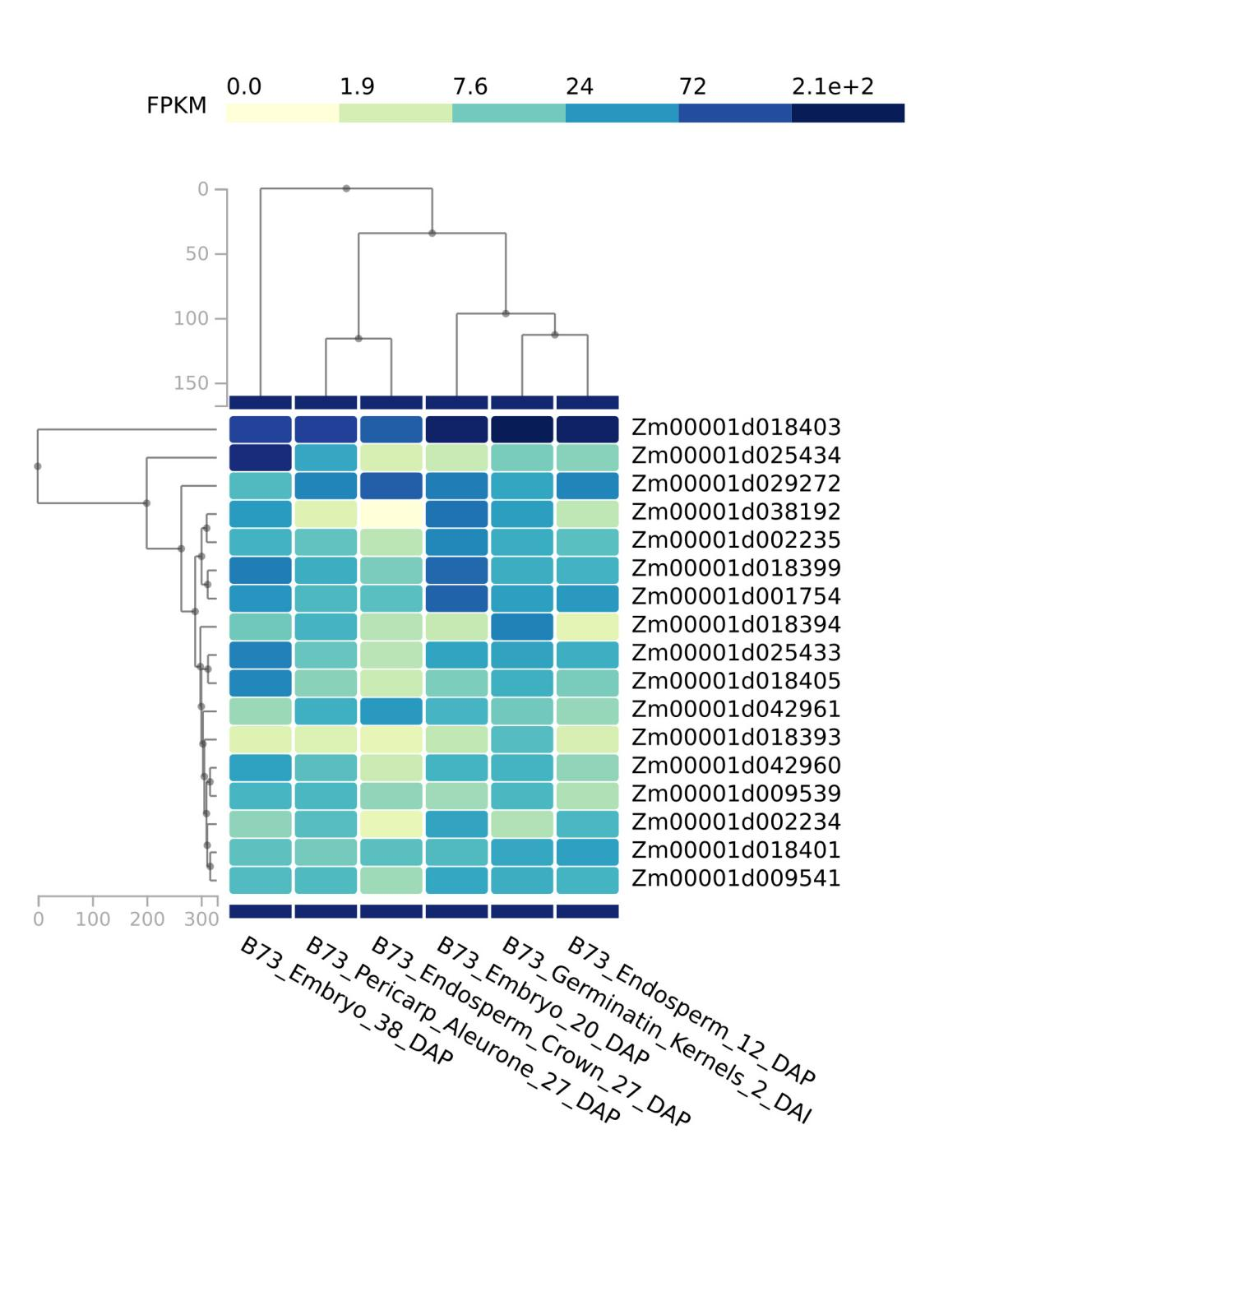
Figure S5. Heatmap of candidate gene expression in kernel development stage.

