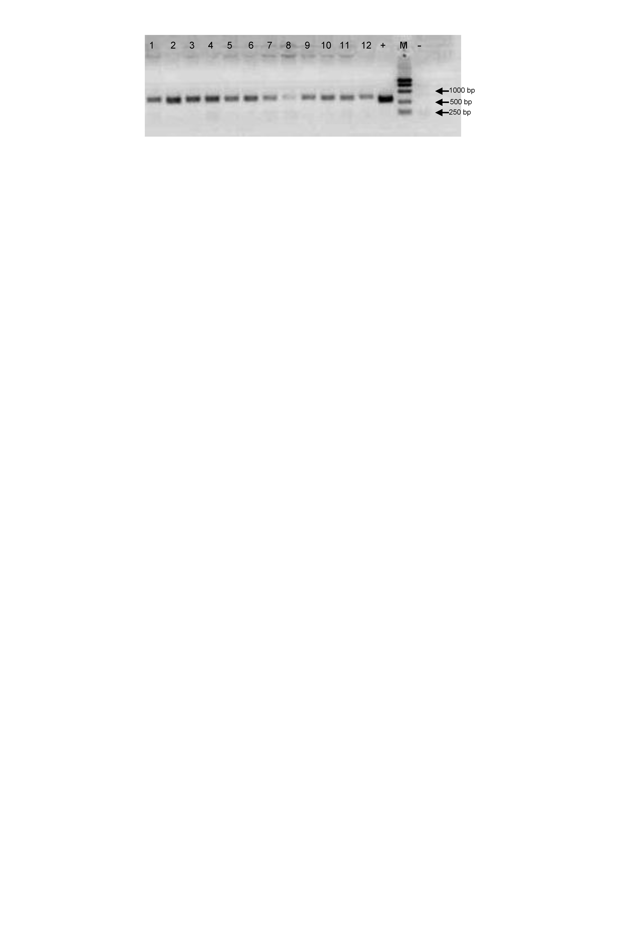
Supplementary Figure 1. PCR-based identification of positive transgenic Arabidopsis. 1–12 represent independent transgenic Arabidopsis lines. “+”indicates the positive control, “−” indicates the negative control, and “M” represents the DNA marker.

