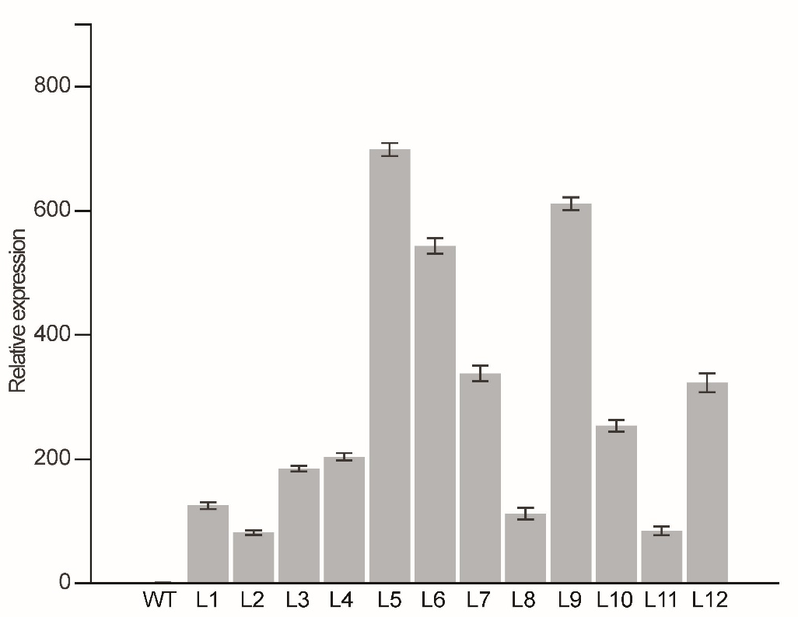
Supplementary Figure 2. Relative expression level of GpNAC68 in leaves of transgenic Arabidopsis. L1 to L12 indicate independent transgenic lines, while “WT” represents the wild-type control.

