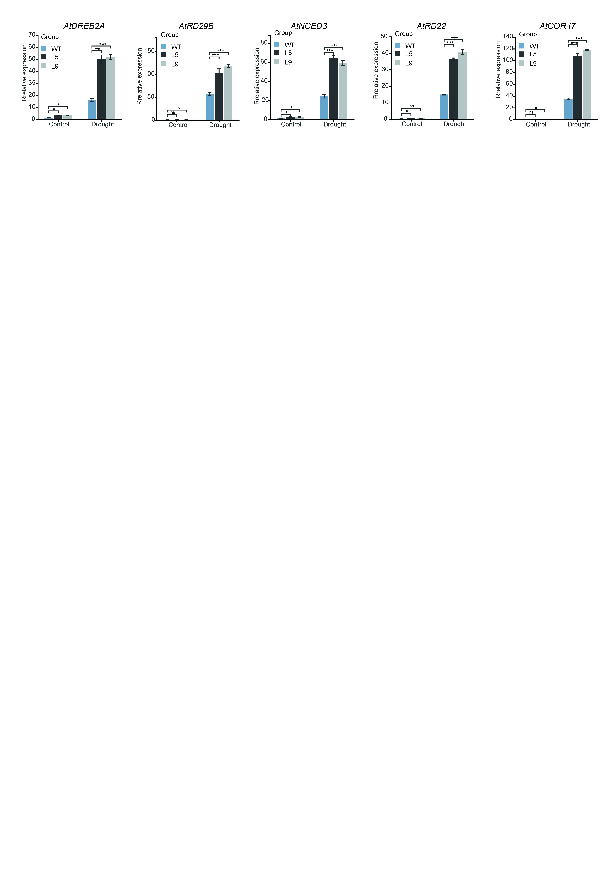
Supplementary Figure 3. Upregulation of drought-responsive genes in GpNAC68-OE plants. Transcript abundance of drought‑related marker genes in WT and GpNAC68-OE lines, quantified by RT-qPCR. Data are presented as means ± SD (n=3). Significance levels: *p < 0.05, * *p < 0.01, and ***p < 0.001.

