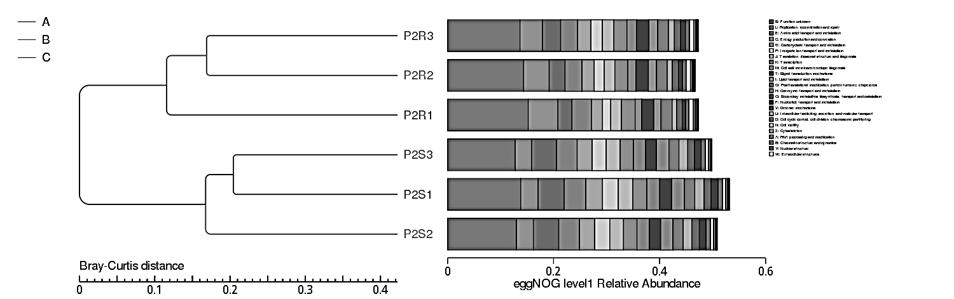
Figure S1. Bray–Curtis dendrogram of Abutilon fruticosum rhizospheric (R1–R3) and bulk soil (S1–S3) microbiomes, constructed from clusters of orthologous group functional categories (A–Z), illustrating functional divergence among the samples.
Figure S2. Computationally inferred counts of gene queries assigned to clusters of orthologous groups (COGs) and partitioned into functional classes A–Z for rhizosphere (R) and bulk (S) soil microbiomes associated with Abutilon fruticosum, with green shading denoting functional categories that are disproportionately enriched in the A. fruticosum soil. Detailed data are provided in Table S3.

Figure S3. Abundance of gene queries based on clusters of orthologous groups (COGs) categorized by functional classifications (A–Z) between samples from the rhizosphere (R) and bulk (S) soil microbiomes associated with Abutilon fruticosum. Detailed data are provided in Table S4.
Figure S4. Relative abundance based on clusters of orthologous groups (COGs) categorized by functional classifications (A–Z) between samples from the rhizosphere (R) and bulk (S) soil microbiomes associated with Abutilon fruticosum. Detailed data are provided in Table S4.

Figure S5. The most abundant orthologous group genes (≥ 1000 gene queries) detected across the combined rhizospheric and bulk soil microbiomes of Abutilon fruticosum, with green bars indicating orthologous group genes that are relatively enriched in the rhizosphere compared with bulk soil. Detailed data are provided in Tables S5 and S7.

