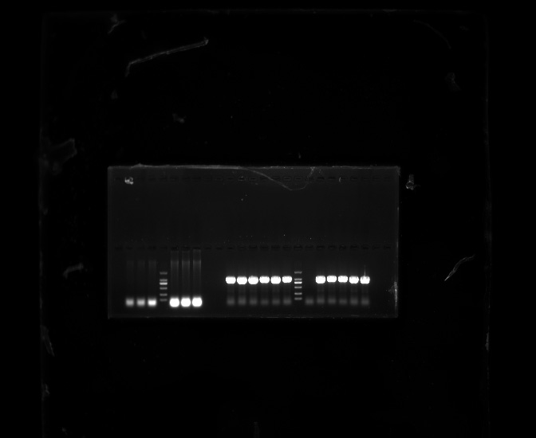
WT IbGGPPS2-OE
#1 #2 #3
Marker
The original version of cropped Supplemental Fig. S5A
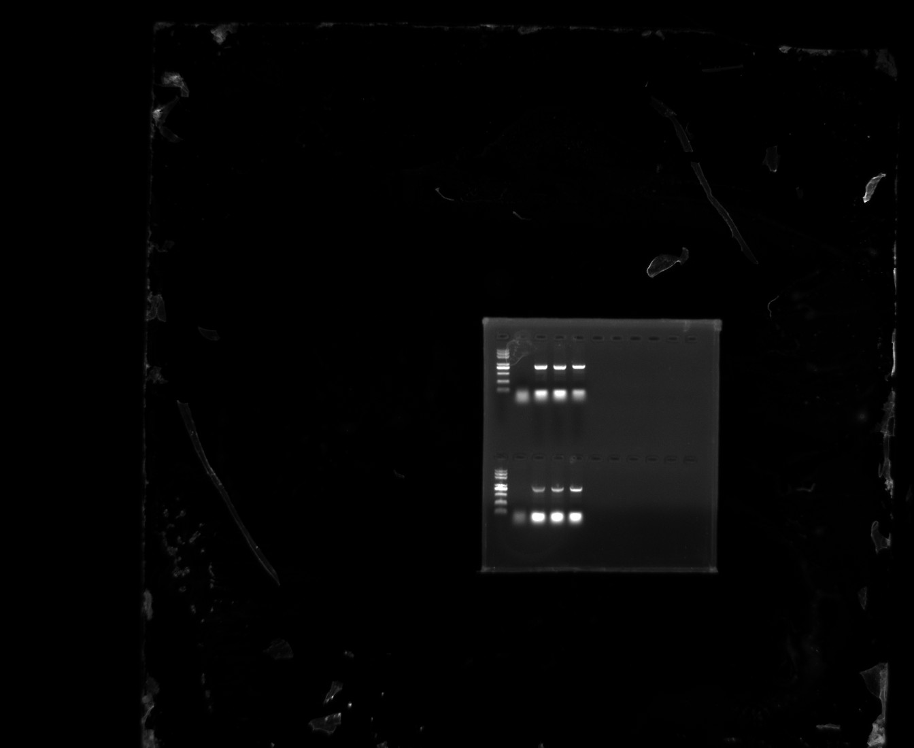
Marker
WT 35S::IbGGPPS2
#1 #2 #3
The original version of cropped Supplemental Fig. S5B

