SUPPORTING INFORMATION
Additional file 2

Phylogenomic and comparative analyses of plastomes in the tribe Marsdenieae (Asclepiadoideae, Apocynaceae): insights into plastome characteristics and generic relationships with emphasis on Asian genera
Rong Chen^{1, 2, 6}, Xin Yao^{1, 2}*, Jin-Yue Li^{1, 6}, Yun-Xue Xiao^{2, 3}, Li-Qiong Chen¹, Hai-Tao Li⁴, Jun-Bo Yang⁵, De-Zhu Li⁵, Wen-Bin Yu^{1, 2, 7, 8}*

1. Center for Integrative Conservation and Yunnan Key Laboratory for the Conservation of Tropical Rainforests and Asian Elephants, Xishuangbanna Tropical Botanical Garden, Chinese Academy of Sciences, Mengla, Yunnan 666303, China
2. Yunnan International Joint Laboratory for the Conservation and Utilization of Tropical Timber Tree Species, Xishuangbanna Tropical Botanical Garden, Chinese Academy of Sciences, Mengla, Yunnan 666303, China
3. Center for Horticulture and Gardening, Xishuangbanna Tropical Botanical Garden, Chinese Academy of Sciences, Mengla, Yunnan 666303, China
4. Yunnan Branch of Institute of Medicinal Plant Development, Chinese Academy of Medical Sciences & Peking Union Medical College, Jinghong, Yunnan 666100, China
5. Plant Germplasm and Genomics Center, Germplasm Bank of Wild Species, Kunming Institute of Botany, Chinese Academy of Sciences, Kunming, Yunnan 650201, China
6. University of Chinese Academy of Sciences, Huairou District, Beijing 101408, China
7. Southeast Asia Biodiversity Research Institute, Chinese Academy of Sciences, Mengla, Yunnan 666303, China
8. Hainan Institute of National Park & Key Laboratory for National Park Protection and Development of Hainan Province, Haikou, Hainan 570203, China

Corresponding authors: Xin Yao (yaoxin@xtbg.ac.cn); Wen-Bin Yu (yuwenbin@xtbg.ac.cn)

Figure S1. Bayesian inference (BI) phylogenetic tree reconstruction of Marsdenieae species based on plastomes. Bayesian posterior probability (BIPP) values are indicated near branches.

Figure S2. Maximum likelihood (ML) phylogenetic tree reconstruction of Marsdenieae species based on 80 PCG sequences. Maximum likelihood bootstrap support (MLBS) values are indicated near branches.

Figure S3. Bayesian inference (BI) phylogenetic tree reconstruction of Marsdenieae species based on 80 PCG sequences. Bayesian posterior probability (BIPP) values are indicated near branches.

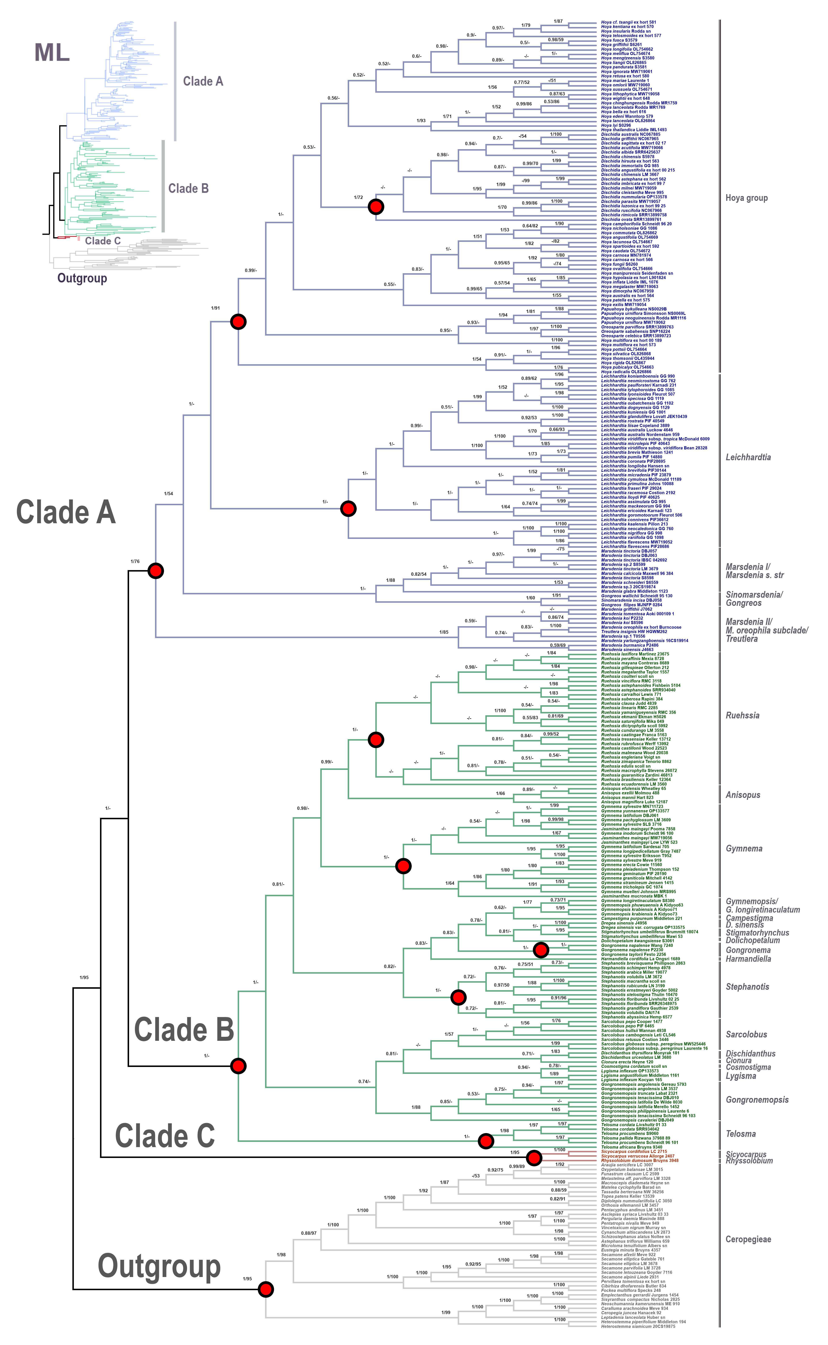

Figure S4. Phylogenetic relationships of Marsdenieae inferred using Maximum Likelihood (ML) and Bayesian Inference (BI) based on the concatenated plastid dataset (trnT-L intron, trnL-F intergenic spacer, rps16 intron, and psbA-trnH intergenic spacer). Values near branches indicate the percentage of posterior probabilities (PP) followed by bootstrap values (BS). Nodes receiving PP < 0.5 and BS < 50% are omitted. The red dots mark the nodes constrained during phylogenetic inference.

Figure S5. Phylogenetic relationships of Marsdenieae inferred using Maximum Likelihood (ML) and Bayesian Inference (BI) based on the nrITS dataset. Values near branches indicate the percentage of posterior probabilities (PP) followed by bootstrap values (BS). Nodes receiving PP < 0.5 and BS < 50% are omitted.

Figure S6. Numbers of different complex repeat types detected in the 72 Marsdenieae plastomes.

Figure S7. The classification and repetition numbers of simple repeat sequences (SSRs) detected in the 72 Marsdenieae plastomes.
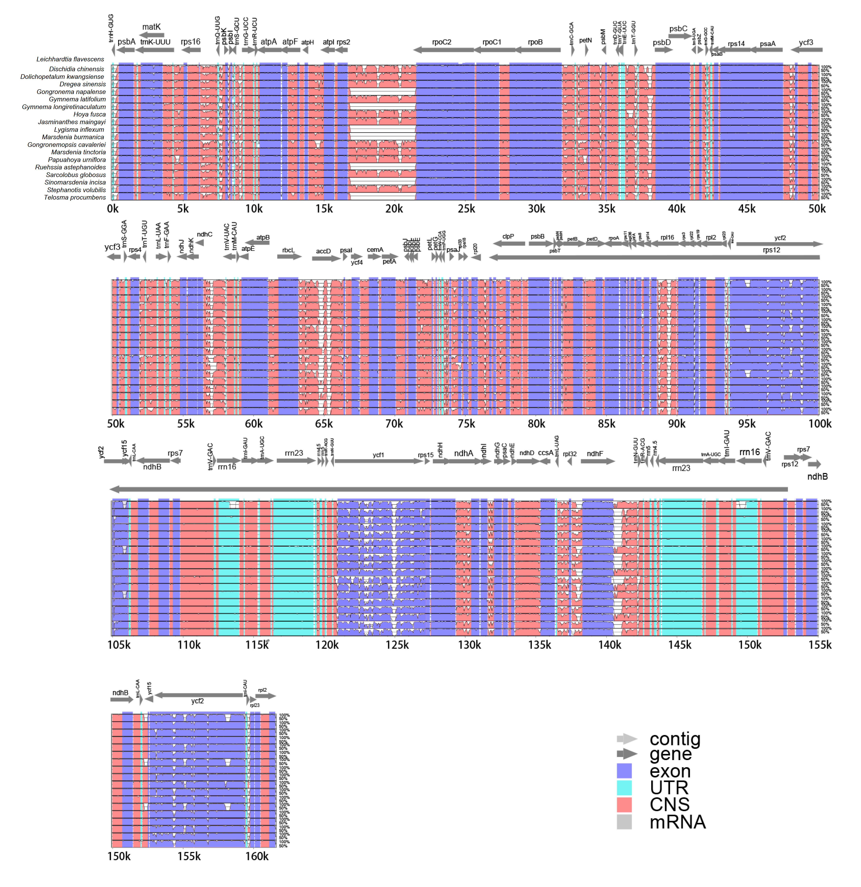

Figure S8. Complete plastome comparison of the 19 species of Marsdenieae. The x-axis represents aligned base sequences, and the y-axis indicates percentage identity (50%−100%). The purple bars, blue bars, and red bars represent exons, RNA genes, and regions of non-coding sequence, respectively.

