Appendix
Appendix A
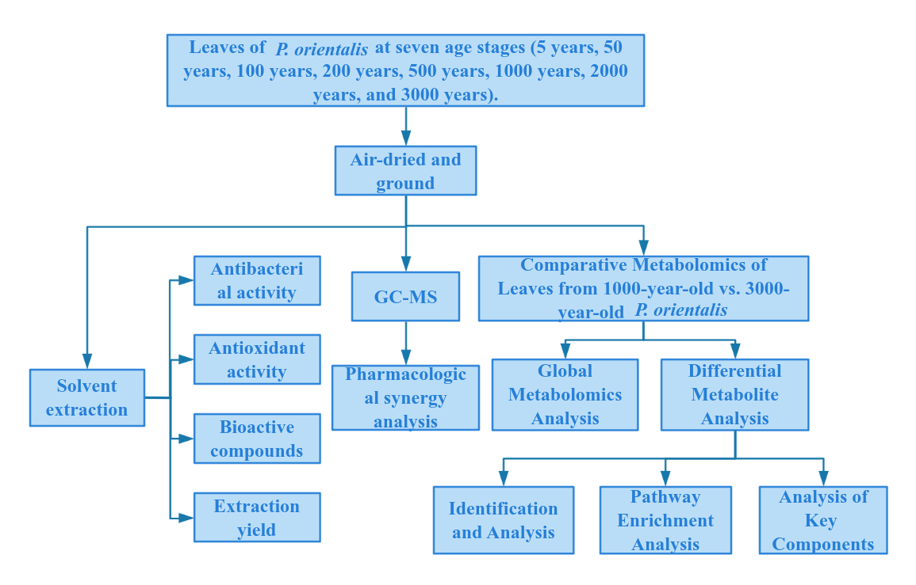
Fig. A1.Experimental and analytical workflow

a  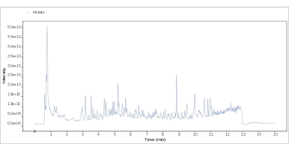 | b  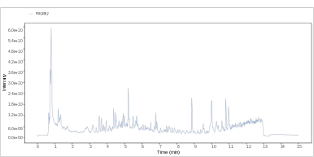 | c  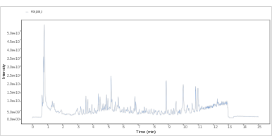
d  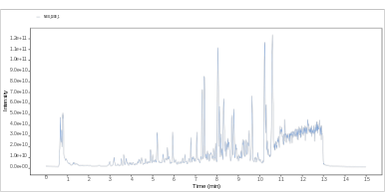 | e  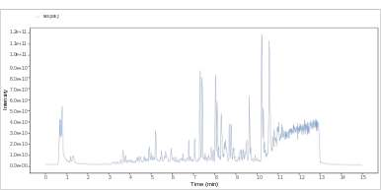 | f  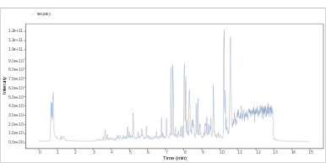
g  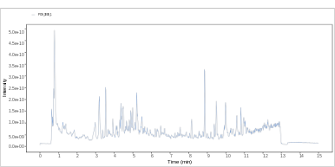 | h  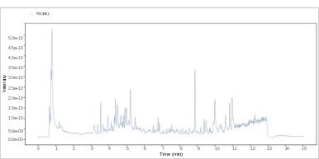 | i  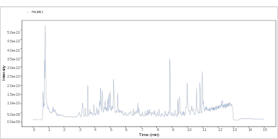
j  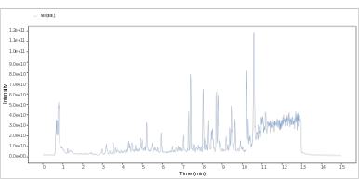 | k  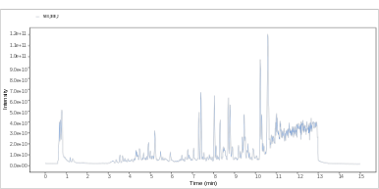 | l  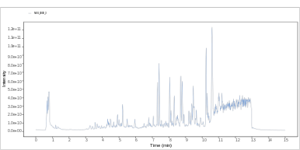
Fig. A2.Total ion chromatograms (TICs) of P. orientalis leaf extracts from 1000- and 3000-year-old trees acquired in positive and negative ion modes (n = 3). Fig. A2a–c show the TICs of the 1000-year-old group in positive ion mode (ESI+); Fig. A2d-2f show the TICs of the 1000-year-old group in negative ion mode (ESI−); Fig. A2g-2i show the TICs of the 3000-year-old group in positive ion mode (ESI+); Fig. A2j-2l show the TICs of the 3000-year-old group in negative ion mode (ESI−).
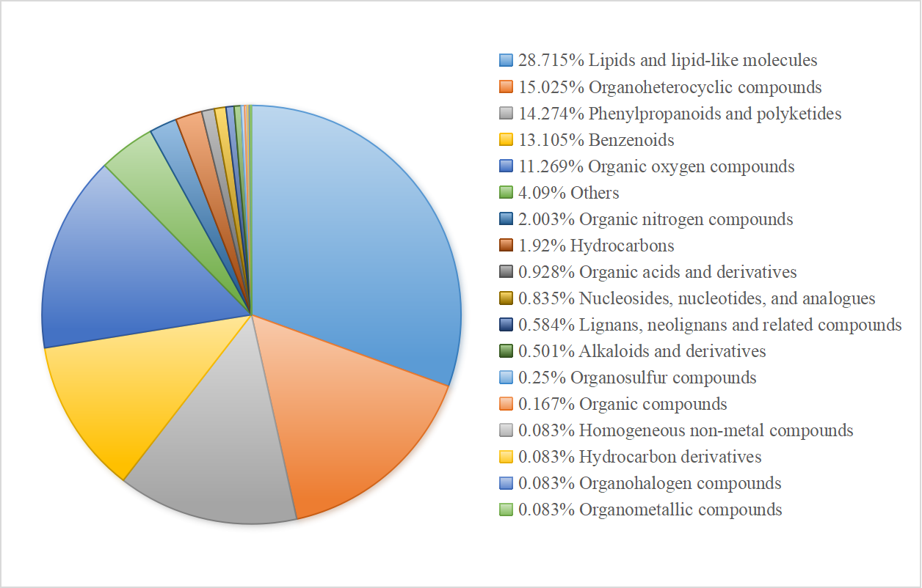
Fig. A3. Pie chart of metabolite classification and relative abundance.

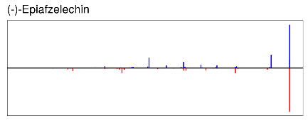 | 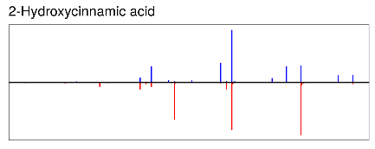 | 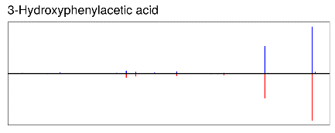
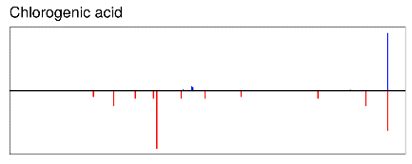 | 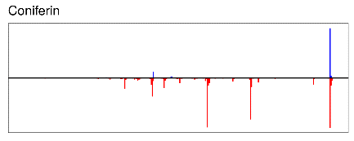 | 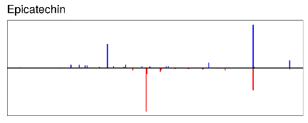
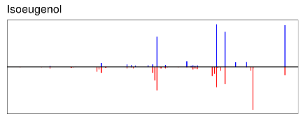 | 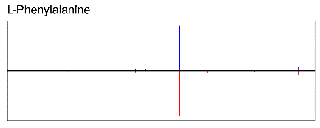 | 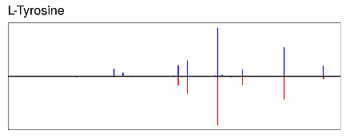
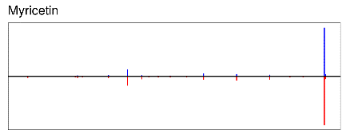 | 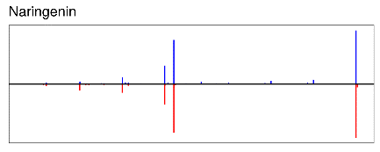 | 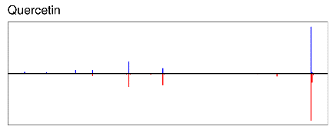
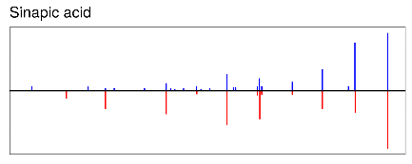 | 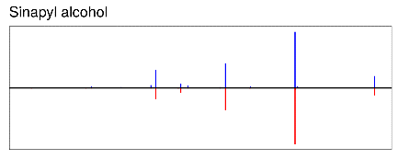 | 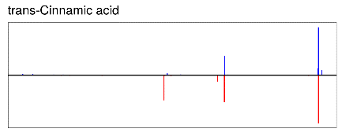
Fig. A4. Representative MS/MS mirror plots of key putatively annotated metabolites discussed in the manuscript. The upper spectra represent the experimental MS/MS spectra acquired from P. orientalis leaf extracts, whereas the lower spectra represent the matched reference spectra from the MS/MS database. These annotations were based on MS/MS spectral matching and are therefore reported as putative annotations unless confirmed by authentic standards.

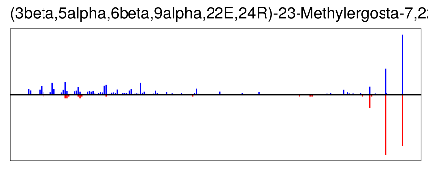 | 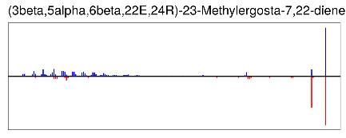 | 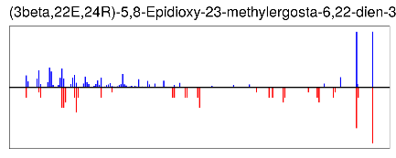
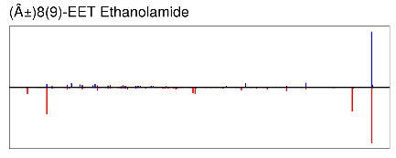 | 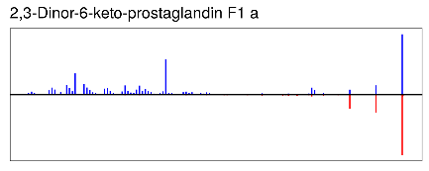 | 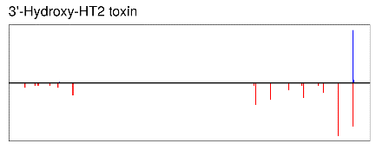
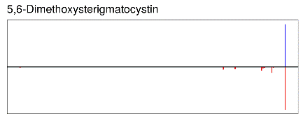 | 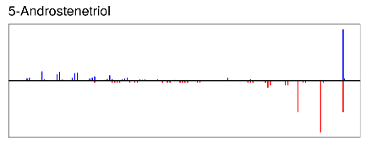 | 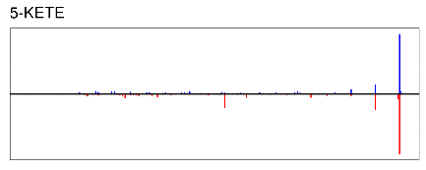
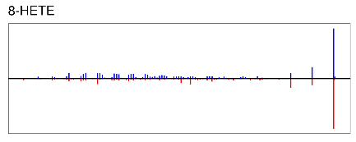 | 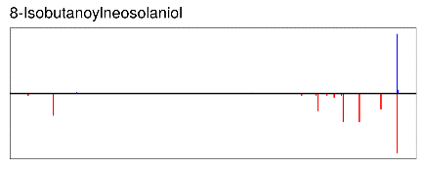 | 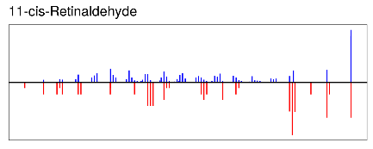
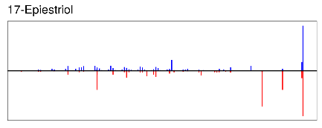 | 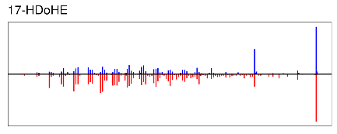 | 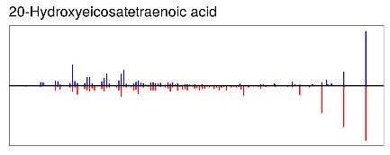
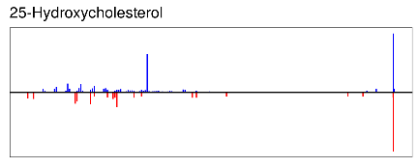 | 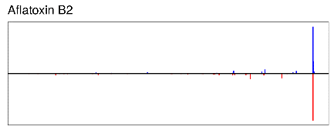 | 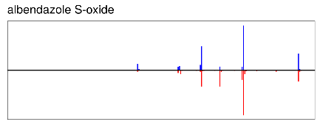
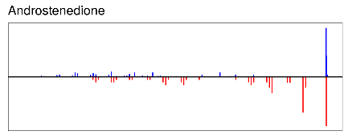 | 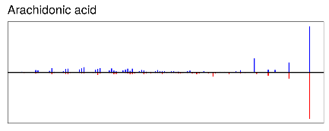 | 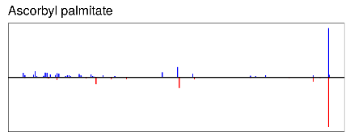
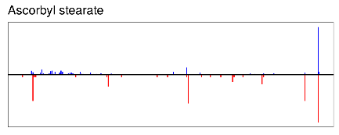 | 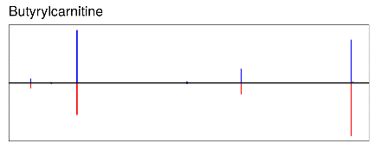 | 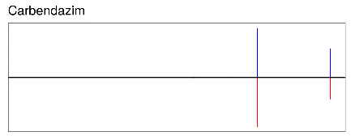
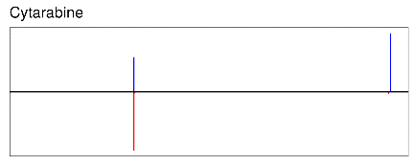 | 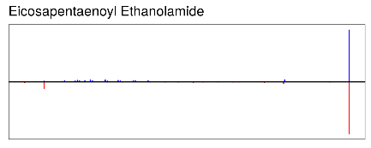 | 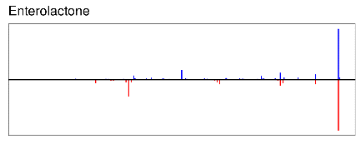
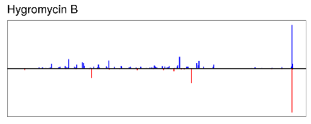 | 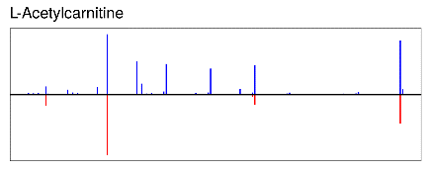 | 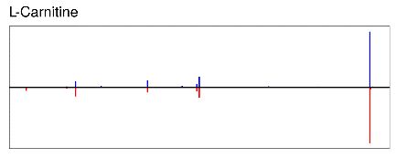
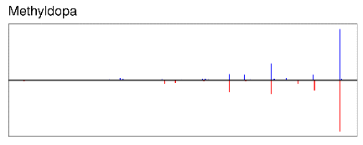 | 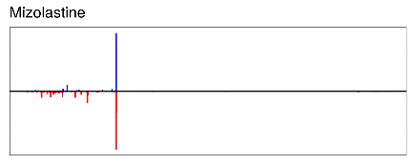 | 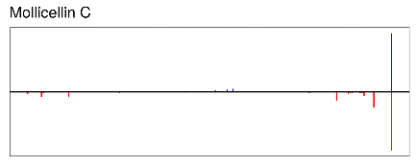
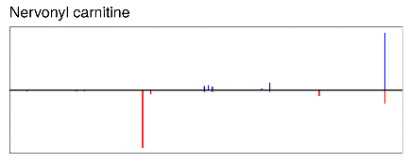 | 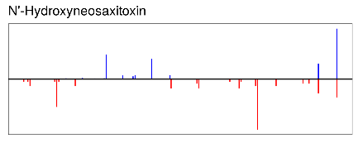 | 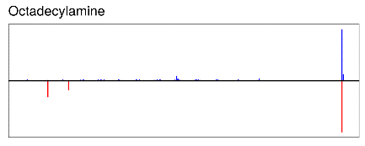
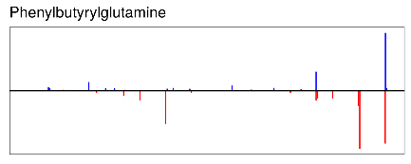 | 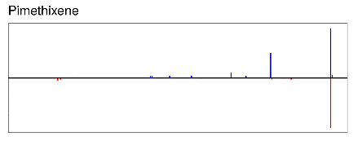 | 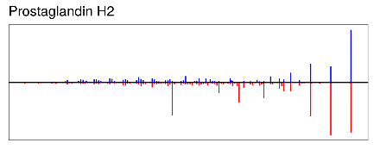
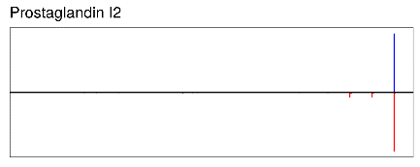 | 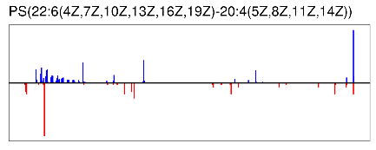 | 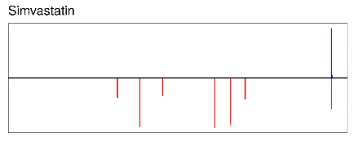
Fig. A5. Representative MS/MS mirror plots of biologically questionable database annotations excluded after manual curation. The upper spectra represent experimental MS/MS spectra acquired from P. orientalis leaf extracts, whereas the lower spectra represent matched database spectra. Although these features showed database MS/MS matches to compounds such as simvastatin, cytarabine, carbendazim, mizolastine, aflatoxin B2, albendazole S-oxide, and methyldopa, these annotations were considered biologically implausible as endogenous metabolites of P. orientalis leaves. Therefore, they were excluded from the curated differential metabolite list and were not used for pathway analysis or biological interpretation.

a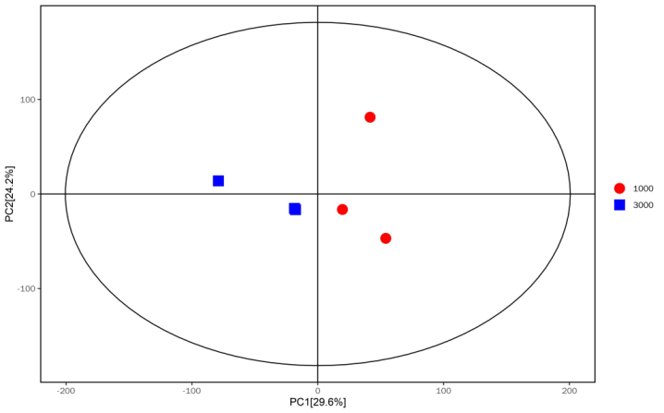 | b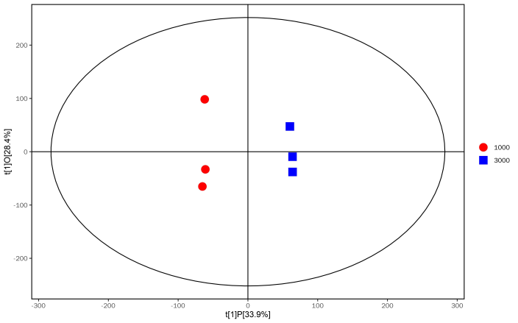
Fig. A6. PCA score scatter plot (a) and OPLS-DA model score scatter plot (b) of the samples

Appendix B
(1)

Curated list of putatively annotated differential metabolites in P. orientalis leaves based on MS/MS spectral matching in positive ion mode.
NO. | Compounds | rt | mz | Fold Change | MS2 Score | MS2 Adduct | MS2 ppm
 | 1-dodecanoyl-glycero-3-phosphate | 483.2855 | 355.1872453 | 0.587597684 | 0.999980923 | [M+H]1+ | 3.87373824453968
 | Musanolone F | 182.719 | 319.0992364 | 1.79954736 | 0.999971077 | [M+H]1+ | 8.42237776891627
 | Physalin E | 290.088 | 545.1990495 | 1.697052815 | 0.999949 | [M+H]1+ | 5.41675980990063
 | Pinusolide | 571.028 | 369.2018213 | 0.788211312 | 0.999911308 | [M+Na]1+ | 3.60324923691055
 | Lucidone C | 594.45 | 405.2603228 | 0.378263979 | 0.999760154 | [M+H]1+ | 8.48455563592375
 | Ginkgolide C | 275.9215 | 441.1352948 | 0.039835603 | 0.999483923 | [M+H]1+ | 7.0583899457193
 | 3'-Hydroxy-T2-triol | 288.0105 | 399.1972875 | 0.818075926 | 0.999460308 | [M+H]1+ | 8.43038392473039
 | Gibberellin A32 | 303.7455 | 379.1358913 | 0.434870543 | 0.998566462 | [M+H]1+ | 9.13945254974407
 | Nicotinic acid | 47.8061 | 124.0393838 | 0.687693472 | 0.998510308 | [M+H]1+ | 0.515429991630059
 | Dimethyl 3-methoxy-4-oxo-5-(8,11,14-pentadecatrienyl)-2-hexenedioate | 483.418 | 421.2558775 | 0.211642134 | 0.998285154 | [M+H]1+ | 8.34749693303316
 | (5alpha,6beta,14alpha,20R,22R)-5,6,14,20,27-Pentahydroxy-1-oxowith-24-enolide | 395.044 | 507.290984 | 5.981238364 | 0.997532538 | [M+H]1+ | 5.93830811676154
 | 2-Acetylfuran | 299.1915 | 111.0442406 | 1.659663267 | 0.996555615 | [M+H]1+ | 0.624374107482442
 | 2,3-Dihydro-2,3-dihydroxy-9-phenyl-1H-phenalen-1-one | 77.42685 | 291.1040483 | 1.572430542 | 0.996218231 | [M+H]1+ | 9.59657501902542
 | Lucidenic acid M | 599.1845 | 463.3006959 | 1.591948185 | 0.995893462 | [M+H]1+ | 7.70617506918291
 | (2R,3R)-2,3-Butanediol | 187.248 | 73.06524853 | 2.095637594 | 0.994917462 | [M+H-H2O]1+ | 1.80039335709728
 | Tangeritin | 274.7315 | 395.1095886 | 1.44383986 | 0.994618 | [M+Na]1+ | 1.7999728320475
 | L-Leucine | 87.0791 | 132.1019297 | 1.759270012 | 0.994370846 | [M+H]1+ | 0.898254258812336
 | Formononetin 7-O-glucuronide | 315.281 | 445.1088105 | 2.190582007 | 0.993351538 | [M+H]1+ | 7.81874413801243
 | Hydrojuglone glucoside | 219.375 | 339.1062116 | 0.369252353 | 0.993205462 | [M+H]1+ | 3.17127668034075
 | Proline betaine | 47.9392 | 144.1017233 | 1.552325378 | 0.988545846 | [M+H]1+ | 0.987757730290646
 | Piperochromanoic acid | 435.8225 | 357.2028535 | 1.797953963 | 0.988367846 | [M+H]1+ | 9.68601995715072
 | p-Mentha-1,3,5,8-tetraene | 315.852 | 133.1010006 | 1.759502459 | 0.987900385 | [M+H]1+ | NA
 | Cosmosiin | 314.76 | 433.1114464 | 1.859034578 | 0.987752615 | [M+H]1+ | 2.33336935639008
 | Quercetin 3-galactoside | 322.4705 | 465.1017951 | 1.891322424 | 0.985283154 | [M+H]1+ | 2.55890045215297
 | 3',4'-Di-O-methylquercetin | 195.686 | 331.0776186 | 2.014649937 | 0.984630538 | [M+H]1+ | 9.42434737571895
 | Myricetin 3-galactoside | 279.856 | 481.0976198 | 3.118194735 | 0.983081 | [M+H]1+ | 2.41945251757386
 | 5,7-dihydroxy-2-(4-methoxyphenyl)-4H-chromen-4-one | 358.799 | 285.0745769 | 2.918325969 | 0.979992154 | [M+H]1+ | 3.03593016493853
 | Phenylacetaldehyde | 178.809 | 121.0647813 | 0.532834491 | 0.978858615 | [M+H]1+ | 0.199594283628692
 | 4-Acetyl-2(3H)-benzoxazolone | 206.038 | 178.0496291 | 6.34172073 | 0.977239154 | [M+H]1+ | 0.858307097642504
 | (2E,4E,6Z)-2,4,6-Decatrienoic acid dehydropiperidide | 559.66 | 232.1690405 | 4.672779309 | 0.975801231 | [M+H]1+ | 1.60445840045138
 | Acetylsalvipisone | 423.7645 | 355.1872013 | 1.474234453 | 0.975561 | [M+H]1+ | 9.84045701204941
 | Citrulline | 43.6191 | 176.102927 | 0.146718438 | 0.975109154 | [M+H]1+ | 0.965278657615334
 | Edultin | 331.113 | 387.143271 | 1.602973153 | 0.975019154 | [M+H]1+ | 8.15458818746685
 | Piperenol A | 257.941 | 385.125008 | 8.936994389 | 0.974110692 | [M+H]1+ | 8.14075551889133
 | Pyrrolidonecarboxylic acid | 43.2908 | 130.0497447 | 1.53392143 | 0.973661462 | [M+H]1+ | 0.233075908623469
 | 2-(Phenylethenyl)-1,3-dioxolane | 314.501 | 177.0906594 | 2.303537274 | 0.973409615 | [M+H]1+ | 0.889922348594913
 | Garcimangosone B | 316.005 | 409.1617257 | 2.050611676 | 0.970303385 | [M+H]1+ | 8.72706860849447
 | Xanthotoxol arabinoside | 183.934 | 335.0735981 | 1.793626063 | 0.970227385 | [M+H]1+ | 9.43495714512637
 | Isorhamnetin | 331.128 | 317.0647607 | 1.508004205 | 0.970113692 | [M+H]1+ | 3.21346987886979
 | 2'-Hydroxyacetophenone | 246.918 | 137.0594352 | 1.458144541 | 0.961739923 | [M+H]1+ | 1.72487531423849
 | Gentisate aldehyde | 222.9855 | 139.0387474 | 1.673280903 | 0.959555462 | [M+H]1+ | 0.928190576000081
 | Sinapyl alcohol | 246.055 | 193.0858174 | 2.569032193 | 0.958463385 | [M+H-H2O]1+ | 2.87665753577573
 | Cynaroside A | 332.693 | 445.2037448 | 3.346242521 | 0.950724385 | [M+H]1+ | 7.966697341
 | p-Mentha-1,8-dien-7-ol | 290.936 | 135.1167334 | 1.684906619 | 0.950674615 | [M+H-H2O]1+ | 5.65216768878205
 | Fructose 6-phosphate | 84.17215 | 261.0364661 | 0.545521847 | 0.949780077 | [M+H]1+ | 2.2288137876188
 | Trifolirhizin | 358.9795 | 447.1271696 | 2.921010341 | 0.947717 | [M+H]1+ | 3.06997391459519
 | 1-deoxy-1-(N6-lysino)-D-fructose | 37.7166 | 134.0448221 | 0.637394288 | 0.947452615 | [M+H]1+ | 0.514264373082074
 | Galbanic acid | 499.301 | 399.2130409 | 0.580090911 | 0.941448769 | [M+H]1+ | 8.22422976417802
 | (Â±)-Tryptophan | 222.306 | 205.0969627 | 1.756614133 | 0.939502385 | [M+H]1+ | 1.46063561415171
 | Lupiwighteone hydrate 7-glucoside | 267.498 | 519.1840411 | 1.80633407 | 0.938695846 | [M+H]1+ | 6.23828436171125
 | Myricetin 3-arabinoside | 288.009 | 451.0869569 | 2.109269093 | 0.936117308 | [M+H]1+ | 2.63483467245199
 | Kaempferol 3-O-arabinoside | 326.526 | 419.0964068 | 1.542823136 | 0.928113308 | [M+H]1+ | 2.591559383
 | Pectachol | 535.046 | 443.2392436 | 0.507543269 | 0.927809615 | [M+H]1+ | 8.13783989291067
 | 4-Pyridoxic acid | 192.683 | 184.0604283 | 2.001418035 | 0.926643923 | [M+H]1+ | 0.478895027522693
 | 6-Methylcoumarin | 275.968 | 161.0594159 | 1.56563975 | 0.925693154 | [M+H]1+ | 1.67149102285814
 | Methyl phenylacetate | 201.522 | 151.075106 | 1.616089633 | 0.922091154 | [M+H]1+ | 1.12553405776116
 | Benzaldehyde | 200.718 | 107.0492376 | 0.69757204 | 0.921852846 | [M+H]1+ | 1.66864075324177
 | 2,3-Pentanedione | 244.0945 | 101.0599644 | 5.564655594 | 0.921262846 | [M+H]1+ | 1.98117589461299
 | Bilobetin | 445.49 | 553.1125421 | 10.8330841 | 0.920926385 | [M+H]1+ | 1.75648421623266
 | 4-O-Caffeoylshikimic acid | 280.6265 | 337.0879818 | 1.942140997 | 0.919990308 | [M+H]1+ | 9.85252370925297
 | (-)-Menthone | 297.559 | 155.1429048 | 1.522705658 | 0.919692 | [M+H]1+ | 0.916014317567759
 | Calebin A | 278.2665 | 385.1250203 | 1.280370568 | 0.919512 | [M+H]1+ | 8.04589302440402
 | 2-(3,4-dihydroxyphenyl)-5,7-dihydroxy-6-[3,4,5-trihydroxy-6-(hydroxymethyl)oxan-2-yl]-4H-chromen-4-one | 312.806 | 471.0880667 | 0.818616998 | 0.916646846 | [M+Na]1+ | 2.72179989227655
 | Tsibulin 2 | 299.8725 | 183.1376326 | 1.601728586 | 0.915519308 | [M+H]1+ | 1.29381018742819
 | Peonidin 3-lathyroside | 444.3895 | 345.0955369 | 1.595035857 | 0.915465923 | [M+H]1+ | 3.6475212369173
 | Pteroside D | 258.2045 | 411.1978482 | 3.255466964 | 0.915225923 | [M+H]1+ | 0.963308358753377
 | Isobutyric acid | 77.7443 | 89.06007802 | 2.030133232 | 0.914616308 | [M+H]1+ | 3.95224571189502
 | (-)-Epiafzelechin | 325.105 | 275.0907209 | 1.510593519 | 0.912315308 | [M+H]1+ | 2.49361906372301
 | 2,3,4,5-Tetrahydro-6-(5-methyl-2-furanyl)pyridine | 377.701 | 164.1069557 | 0.394710664 | 0.911861462 | [M+H]1+ | 1.48043576570788
 | 1-(2-Methoxy-3,4-methylenedioxyphenyl)-1-propanone | 205.124 | 209.0803795 | 1.493939928 | 0.910500769 | [M+H]1+ | 1.89765071341327
 | Coniferin | 242.247 | 365.1201146 | 1.447837267 | 0.906851 | [M+H]1+ | 8.86398711907519
 | Jaceidin | 219.828 | 361.0888402 | 0.246546494 | 0.903738615 | [M+H]1+ | 8.83500459063753
 | Methyl 2-hydroxybenzoate | 280.595 | 153.0543822 | 2.30498503 | 0.897833462 | [M+H]1+ | 1.69066966566067
 | ar-Artemisene | 725.868 | 271.2413941 | 1.663303246 | 0.897386692 | [M+H]1+ | NA
 | Diosmetin | 318.57 | 301.0701555 | 1.713641514 | 0.894623308 | [M+H]1+ | 2.89911582700846
 | 3-Methyl-2-oxovaleric acid | 268.203 | 113.0598345 | 1.36670507 | 0.894411308 | [M+H-H2O]1+ | 4.63519683692267
 | Methylsyringin | 236.425 | 387.1618271 | 1.56545033 | 0.893387231 | [M+H]1+ | 8.91792664799461
 | (R)-11,12,13-Trinor-1(5),6,9-guaiatrien-8-one | 235.365 | 175.1116301 | 1.38315419 | 0.892325846 | [M+H]1+ | 1.32971130691033
 | 4-Pentenoic acid | 121.267 | 101.0599462 | 1.506152862 | 0.887557692 | [M+H]1+ | 2.10498145945611
 | 2-Acetyl-5-methylfuran | 295.138 | 125.0596483 | 1.477384158 | 0.886739385 | [M+H]1+ | 0.584856550555773
 | Euglobal V | 588.2965 | 455.2764476 | 2.916189063 | 0.882281154 | [M+H]1+ | 7.99088866488594
 | 2,4-Pentadienal | 257.768 | 83.04956759 | 1.855311201 | 0.881340923 | [M+H]1+ | 4.19971337205712
 | 5,6-Dihydro-5-hydroxy-6-methyl-2H-pyran-2-one | 299.1915 | 229.0855324 | 1.678752648 | 0.878222846 | [M+H]1+ | 1.9133017194002
 | Ethyl 2-furanacrylate | 262.784 | 167.0702571 | 2.146166569 | 0.877027846 | [M+H]1+ | 0.895028531200305
 | Naphthalene | 569.498 | 129.0697336 | 1.580423361 | 0.87561 | [M+H]1+ | NA
 | L-Arabitol | 46.34375 | 153.0755106 | 1.780946326 | 0.873015846 | [M+H]1+ | 1.49637468272137
 | 2-Methoxy-4-vinylphenol | 269.448 | 151.0751056 | 2.220976648 | 0.872894692 | [M+H]1+ | 1.25812338556029
 | Benzene | 288.0335 | 79.054597 | 1.37218511 | 0.872851615 | [M+H]1+ | NA
 | Safrole | 279.02 | 163.0752385 | 1.536802202 | 0.870238385 | [M+H]1+ | 1.73729854723142
 | 2-Methylerythritol | 47.97985 | 137.0805486 | 1.897732332 | 0.869687538 | [M+H]1+ | 1.79959029316411
 | 4',5-Dihydroxy-7-methoxy-6-methylflavone | 782.848 | 299.0904545 | 2.384865417 | 0.867684846 | [M+H]1+ | 3.19611962315495
 | Methyl cinnamate | 267.62 | 163.0752581 | 1.732847335 | 0.866472154 | [M+H]1+ | 2.04005204772114
 | 6-(3,4-Methylenedioxyphenyl)-3,5-hexadien-2-one | 299.1915 | 217.0855311 | 1.64428205 | 0.865067769 | [M+H]1+ | 1.70900531721865
 | Cubebinin | 424.748 | 449.2129513 | 0.393740991 | 0.857484462 | [M+H]1+ | 7.91519071742549
 | (R)-Shinanolone | 344.71 | 193.0857356 | 2.981319517 | 0.856612462 | [M+H]1+ | 0.462351785116908
 | 11,12-Dimethylrosmanol | 434.4295 | 375.2133971 | 1.596146673 | 0.855324769 | [M+H]1+ | 8.81144036259136
 | 24,25-Epoxywithanolide D | 592.9195 | 487.2682314 | 2.840391379 | 0.855285692 | [M+H]1+ | 7.62375234336441
 | 2-Methyltetrahydrofuran-3-one | 47.88155 | 101.0599551 | 1.706102163 | 0.848843462 | [M+H]1+ | 1.44457423063957
 | Epinepetalactone | 258.131 | 167.1062456 | 4.253491944 | 0.846573462 | [M+H]1+ | 1.32935694978726
 | Prexanthoperol | 390.5335 | 315.1940644 | 0.750283863 | 0.846151538 | [M+H]1+ | 3.21084635096263
 | Alfalone | 532.2125 | 299.0906538 | 1.754605084 | 0.845507154 | [M+H]1+ | 2.86681443353171
 | (E,E,E)-Sylvatine | 476.147 | 384.251144 | 0.367469477 | 0.836739615 | [M+H]1+ | 8.15472006828405
 | Pisatin | 449.472 | 315.0858162 | 1.521823263 | 0.836590308 | [M+H]1+ | 2.35205080065378
 | 3-Ethylphenol | 260.911 | 123.0805089 | 1.471457966 | 0.834777 | [M+H]1+ | 0.345449353193332
 | gamma-Glutamyltyrosine | 402.937 | 311.1248909 | 0.446352972 | 0.834470692 | [M+H]1+ | 2.88101455252559
 | (1Z,4Z)-1,5-bis(4-hydroxyphenyl)-1,4-pentadiene | 309.72 | 253.1217014 | 0.253390357 | 0.832097 | [M+H]1+ | 2.37317336077294
 | L-Arginine | 43.1319 | 175.1190547 | 2.061712101 | 0.831251 | [M+H]1+ | 1.03345830631007
 | Citrusin E | 218.988 | 373.1481715 | 0.649305207 | 0.829758769 | [M+H]1+ | 3.15155559981621
 | Dehydrovomifoliol | 235.583 | 223.1322355 | 1.357704796 | 0.825983 | [M+H]1+ | 2.00148038735332
 | Ethyl trans-p-methoxycinnamate | 436.123 | 291.1946571 | 1.257905687 | 0.821265 | [M+H]1+ | 3.15489524585356
 | Cis-zeatin | 226.057 | 220.118996 | 0.339418704 | 0.815928923 | [M+H]1+ | 1.83866364076381
 | 2-Hexenyl formate | 272.403 | 129.0908184 | 0.687134147 | 0.815599231 | [M+H]1+ | 0.580163100547721
 | Geijerone | 268.122 | 179.1427086 | 1.35142532 | 0.812941615 | [M+H]1+ | 1.5422550612584
 | Syringic acid | 193.2225 | 199.0601191 | 2.056180011 | 0.811665615 | [M+H]1+ | 0.900180100888957
 | 4-Hydroxychalcone | 309.664 | 225.0908592 | 0.437445839 | 0.811557615 | [M+H]1+ | 1.67216280286206
 | Methyl trans-p-methoxycinnamate | 314.9145 | 193.0829125 | 0.224665812 | 0.805339385 | [M+H]1+ | 2.38433327609455
 | Dopamine | 183.581 | 154.086023 | 0.578100759 | 0.801795077 | [M+H]1+ | 1.58754865283181
 | Lucidenic acid E2 | 439.5375 | 517.2773239 | 0.277849759 | 0.799863308 | [M+H]1+ | 5.59855898799107
 | (E)-3-(2-Methylpropylidene)-1(3H)-isobenzofuranone | 289.575 | 189.0905942 | 1.660656821 | 0.797766615 | [M+H]1+ | 1.35626243880322
 | Methyl (3x,4E,10R)-3,10-dihydroxy-4,11-dodecadiene-6,8-diynoate 10-glucoside | 262.5875 | 397.1456975 | 1.91198684 | 0.796820923 | [M+H]1+ | 8.67849650528629
 | 7-Methoxy-6-methyl-2H-1-benzopyran-2-one | 202.063 | 191.070034 | 1.43624209 | 0.792679538 | [M+H]1+ | 1.1700277269819
 | Aloe emodin w-acetate | 449.2525 | 313.0702232 | 1.864380797 | 0.791960462 | [M+H]1+ | 2.73311728141536
 | Austalide H | 355.7775 | 477.2456974 | 0.608495991 | 0.791068077 | [M+H]1+ | 7.72707035292392
 | Ginkgotoxin | 181.463 | 184.0966114 | 1.695923586 | 0.779824769 | [M+H]1+ | 0.751091743520123
 | Armillaridin | 344.914 | 449.177226 | 5.917008687 | 0.779518154 | [M+H]1+ | 9.98548374243043
 | Tyrosyl-Proline | 341.654 | 279.1331007 | 0.044511248 | 0.779260846 | [M+H]1+ | 3.07473724443751
 | Benzofuran | 219.007 | 119.0490737 | 0.436002908 | 0.774862154 | [M+H]1+ | 0.111963103919838
 | (Z)-3-(1-Butenyl)-1H-2-benzopyran-1-one | 289.533 | 201.0907446 | 2.057305484 | 0.769899462 | [M+H]1+ | 1.01745725496069
 | Gamma-terpinene | 576.109 | 137.1322313 | 0.65335039 | 0.769824769 | [M+H]1+ | NA
 | Curcumin I | 341.654 | 397.1633214 | 2.721609867 | 0.763078231 | [M+H]1+ | 2.89464420365819
 | 8,13-Abietadien-18-al | 563.343 | 287.2356806 | 4.291457901 | 0.758793923 | [M+H]1+ | 3.44794832375389
 | L-Glutamic acid | 44.1466 | 148.060316 | 1.89676061 | 0.758290462 | [M+H]1+ | 1.35635803775677
 | 2-Methyl-1,3-cyclohexadiene | 268.122 | 95.08579705 | 1.380464503 | 0.757766462 | [M+H]1+ | 无
 | (3Z,6Z)-3,6-Nonadienal | 257.007 | 139.1117498 | 3.240622633 | 0.746821 | [M+H]1+ | 1.49827567706679
 | Glycyl-Lysine | 84.5619 | 204.1338557 | 4.193767138 | 0.745281 | [M+H]1+ | 1.5626372020748
 | 2-(Ethoxymethyl)furan | 218.985 | 127.0753853 | 1.371901445 | 0.741930077 | [M+H]1+ | 0.0510198200246037
 | 2-Methylbutanoic acid | 195.982 | 103.0755867 | 1.226394598 | 0.739103462 | [M+H]1+ | 1.55459102528285
 | L-trans-4-Methyl-2-pyrrolidinecarboxylic acid | 794.291 | 130.0862761 | 0.537218441 | 0.738546 | [M+H]1+ | 0.584364260660215
 | Glyceollin IV | 306.723 | 355.1531757 | 2.144373601 | 0.738336 | [M+H]1+ | 3.011967668
 | N-Acetylvanilalanine | 340.9855 | 254.1018111 | 0.28502643 | 0.735159308 | [M+H]1+ | 3.11711334985564
 | PC(18:1(11Z)/14:0) | 635.5385 | 732.5516699 | 4680.678261 | 0.735104923 | [M+H]1+ | 2.18987772520292
 | Indole-3-carboxylic acid | 278.274 | 162.0548465 | 2.310074612 | 0.734649077 | [M+H]1+ | 1.04219992854461
 | 4-(4-Methoxyphenyl)-2-butanone | 235.365 | 179.1066568 | 1.361376567 | 0.732259538 | [M+H]1+ | 0.951240424437029
 | Picrotin | 201.522 | 311.1116223 | 1.775907571 | 0.730141692 | [M+H]1+ | 6.955732093
 | Petunidin 3-glucoside | 311.37 | 479.1181243 | 1.416818186 | 0.729298692 | [M]+ | 1.79766324216718
 | 5-Phenyl-1,3-oxazinane-2,4-dione | 237.453 | 192.0655814 | 3.026632251 | 0.719165 | [M+H]1+ | 0.280520759289571
 | Methyl 4-methoxybenzoate | 179.29 | 167.0702167 | 0.504472923 | 0.718530462 | [M+H]1+ | 1.30269604823963
 | Gancaonin G | 299.168 | 353.1371682 | 1.631097269 | 0.716615462 | [M+H]1+ | 2.91857459462136
 | Cyclodopa glucoside | 206.038 | 358.112428 | 4.367941756 | 0.715824923 | [M+H]1+ | 2.50995827619525
 | (9S,10S)-10-hydroxy-9-(phosphonooxy)octadecanoate | 527.5205 | 397.2368055 | 2.137715192 | 0.712265308 | [M+H]1+ | 3.56328694704329
 | (Â±)-2-Hydroxy-3-(2-hydroxyphenyl)propanoic acid | 91.8072 | 183.0650761 | 0.603357156 | 0.707350615 | [M+H]1+ | 0.978136239931786
 | 2,3-Dehydrosilybin | 364.6125 | 481.1116867 | 1.845353812 | 0.706725615 | [M+H]1+ | 2.214284612
 | Isocyclocalamin | 488.055 | 503.2236193 | 16.77544181 | 0.701531385 | [M+H]1+ | 6.83004699510215
 | Methyl (R)-9-hydroxy-10-undecene-5,7-diynoate glucoside | 257.768 | 369.1504021 | 3.945760373 | 0.701304615 | [M+H]1+ | 9.33832794712313
 | 2-(3,4-dihydroxyphenyl)-5,7-dihydroxy-3-{[3,4,5-trihydroxy-6-(hydroxymethyl)oxan-2-yl]oxy}-4H-chromen-4-one | 298.2065 | 465.1020245 | 6.685657189 | 0.698863154 | [M+H]1+ | 2.23012778968868
 | Glyceollidin II | 299.311 | 341.1376816 | 1.646204711 | 0.698646462 | [M+H]1+ | 3.38485770551938
 | Austrobailignan 7 | 313.626 | 343.1524357 | 3.283804466 | 0.697644308 | [M+H]1+ | 3.31370944282101
 | Salicin | 315.281 | 309.0955697 | 2.408184495 | 0.693601154 | [M+Na]1+ | 5.19985168876218
 | (3xi,6E)-1,7-Diphenyl-6-hepten-3-ol | 440.2725 | 267.1736175 | 0.385240415 | 0.692927923 | [M+H-H2O]1+ | 4.54194636066473
 | 2-Phenylethyl 3-methylbutanoate | 261.539 | 207.1375791 | 1.329766714 | 0.691927615 | [M+H]1+ | 1.57070664826643
 | Mulberranol | 299.168 | 439.1745923 | 1.683873175 | 0.687649846 | [M+H]1+ | 2.79942006069959
 | Geniposidic acid | 264.5775 | 375.1256061 | 3.695566062 | 0.686436231 | [M+H]1+ | 9.24645214596165
 | 8-Ocimenyl acetate | 307.5805 | 195.1379549 | 1.794197987 | 0.683701462 | [M+H]1+ | 0.668640441634864
 | Kinobeon A | 358.892 | 357.1322202 | 1.529230578 | 0.681870077 | [M+H]1+ | 2.36737656078342
 | MG(16:1(9Z)/0:0/0:0) | 550.912 | 329.2674579 | 6.079771783 | 0.681502462 | [M+H]1+ | 3.99972441784559
 | Glicoisoflavanone | 307.355 | 385.163514 | 2.134107125 | 0.681459154 | [M+H]1+ | 2.4519644644612
 | 3-(2-Furanyl)-2-propenal | 225.693 | 123.0441944 | 2.850238136 | 0.680736385 | [M+H]1+ | 0.166014830605395
 | Glycyrin | 299.311 | 383.1485055 | 1.588012028 | 0.678351231 | [M+H]1+ | 3.43161302584797
 | Indole-3-carbinol | 231.814 | 148.0754028 | 1.395613434 | 0.676665538 | [M+H]1+ | 1.47631029585085
 | LysoPA(0:0/18:0) | 588.2105 | 439.2805983 | 3.500440907 | 0.666458231 | [M+H]1+ | 2.7353393753585
 | 7-hydroxy-6-methoxy-3-(4-methoxyphenyl)-4H-chromen-4-one | 635.383 | 299.0904393 | 1.560854328 | 0.666331538 | [M+H]1+ | 3.19410478109231
 | 3-(4-Isopropylphenyl)propanal | 260.911 | 177.127388 | 1.433632859 | 0.661230538 | [M+H]1+ | 1.48844684363533
 | Betonicine | 47.2839 | 160.0964681 | 0.582712322 | 0.656730462 | [M+H]1+ | 2.19710457618374
 | Lepidine C | 269.1785 | 361.1641332 | 2.597131052 | 0.652271231 | [M+H]1+ | 6.08888381006021
 | Distichonic acid B | 210.494 | 295.1139629 | 1.690544415 | 0.650205308 | [M+H]1+ | 3.24818968498646
 | Hericene B | 653.9005 | 583.4345094 | 3.512786981 | 0.648828692 | [M+H]1+ | 2.60673862075614
 | 3,5-Dihydroxybenzoic acid | 91.16545 | 155.0336016 | 1.832263901 | 0.648690538 | [M+H]1+ | 0.921287763558914
 | 8-Epidiosbulbin E acetate | 351.016 | 389.1589472 | 1.372497097 | 0.647570615 | [M+H]1+ | 2.84336665322998
 | Linalyl cinnamate | 391.3315 | 285.1844158 | 0.536236121 | 0.646352385 | [M+H]1+ | 2.96218315244406
 | Icariside B8 | 257.6425 | 389.2168695 | 2.961328917 | 0.641417615 | [M+H]1+ | 2.70569499093948
 | (ent-16betaOH)-16,17-Dihydroxy-9(11)-kauren-19-oic acid | 512.7045 | 335.2202057 | 2.54204974 | 0.640463615 | [M+H]1+ | 4.30705593146884
 | 3-Methoxy-4-hydroxyphenylglycolaldehyde | 259.981 | 183.0651335 | 1.635532805 | 0.633924615 | [M+H]1+ | 0.676161258554879
 | 3-Aminopropionaldehyde | 803.853 | 74.06053261 | 1.868444839 | 0.632117692 | [M+H]1+ | 6.02077709395584
 | (R)-Bitalin A | 337.95 | 219.1014643 | 1.459896364 | 0.626047692 | [M+H]1+ | 2.44340549274519
 | Gancaonin I | 476.393 | 355.1512528 | 0.335416276 | 0.625330692 | [M+H]1+ | 9.45668830657419
 | Pteroside Z | 333.563 | 395.2052071 | 1.13144421 | 0.623625 | [M+H]1+ | 2.12616505360031
 | Furocoumarinic acid glucoside | 217.246 | 367.0990323 | 0.513297423 | 0.622504154 | [M+H]1+ | 8.64731714950733
 | 5-Methoxyseselin | 299.1915 | 259.0962038 | 1.546085471 | 0.620587385 | [M+H]1+ | 2.4967144816672
 | Norecasantalic acid | 452.0345 | 181.1219183 | 1.747127668 | 0.620204 | [M+H]1+ | 1.84166391551369
 | 5,7-Dihydroxy-6,8-dimethylflavanone | 277.8325 | 285.1112024 | 1.351234471 | 0.619969154 | [M+H]1+ | 2.49486010537828
 | 9-Hydroxycalabaxanthone | 299.311 | 409.1641228 | 1.732491972 | 0.618361923 | [M+H]1+ | 2.64576868915473
 | Glyceollidin I | 324.7485 | 341.1375851 | 2.28123623 | 0.618166769 | [M+H]1+ | 3.27745353811249
 | LysoPE(18:1(9Z)/0:0) | 343.353 | 480.3056793 | 0.064949082 | 0.613137462 | [M+H]1+ | 5.47439878180488
 | 1,6-Dihydroxy-3,7-dimethoxy-2-(2-hydroxy-3-methyl-3-butenyl)-8-(3-methyl-2-butenyl)-xanthone | 314.1625 | 441.190103 | 5.494085048 | 0.610331923 | [M+H]1+ | 2.22961705846139
 | 3-Furanmethanol glucoside | 129.581 | 261.0958289 | 2.941955788 | 0.608077692 | [M+H]1+ | 4.95713942528204
 | 2'-Oxoaloesol 7-glucoside | 245.5545 | 395.1308848 | 2.6509164 | 0.607628 | [M+H]1+ | 8.80207197402571
 | 2,4,6-Trimethoxyphenyl acetate | 222.357 | 227.0911088 | 1.777251546 | 0.596674231 | [M+H]1+ | 1.86722025152871
 | Epoxyeremopetasinorol | 261.714 | 225.1480165 | 1.295501159 | 0.596611538 | [M+H]1+ | 1.70084862789614
 | 5-Hexyl-1,4-dioxan-2-one | 286.618 | 187.1327165 | 2.049169332 | 0.596291615 | [M+H]1+ | 0.842281296790089
 | 5-(3',4'-Dihydroxyphenyl)-gamma-valerolactone | 367.929 | 209.0803494 | 1.627500237 | 0.595440846 | [M+H]1+ | 1.81013182671989
 | 2,6-Dimethoxybenzoic acid | 247.734 | 183.065066 | 1.27430287 | 0.593037846 | [M+H]1+ | 0.71052631383265
 | Cymorcin monoglucoside | 258.875 | 329.1586285 | 2.13923061 | 0.592091308 | [M+H]1+ | 3.62269745116292
 | 4-Hydroxy-3-prenylbenzoic acid glucoside | 278.503 | 369.1506046 | 1.233943062 | 0.591326077 | [M+H]1+ | 8.70790506217387
 | Dihydro-3-(1-octenyl)-2,5-furandione | 352.373 | 211.1323514 | 4.360448039 | 0.589256846 | [M+H]1+ | 1.91103603769564
 | 4-Ethyl-2-methoxyphenol | 260.681 | 153.0907995 | 1.428214237 | 0.58594 | [M+H]1+ | 1.23930940614249
 | Picrocrocin | 305.764 | 331.1745249 | 1.596538366 | 0.583577154 | [M+H]1+ | 3.33339941834439
 | (R)-mandelic Acid | 202.063 | 135.0438686 | 1.622902157 | 0.580592077 | [M+H-H2O]1+ | 4.93882248586077
 | DG(14:1(9Z)/20:4(5Z,8Z,11Z,14Z)/0:0) | 756.801 | 587.4664611 | 3.025999429 | 0.577156154 | [M+H]1+ | 2.39942101036449
 | Prolyl-Asparagine | 88.28375 | 230.1130397 | 0.303176556 | 0.576751692 | [M+H]1+ | 1.64243817960322
 | 10-Acetoxytoxol | 299.407 | 277.1061166 | 1.514053645 | 0.575097308 | [M+H]1+ | 2.94428543933314
 | Dihydrocubebin | 356.187 | 359.1479684 | 1.830262188 | 0.568043385 | [M+H]1+ | 2.9856224152412
 | 2-Amino-4-ethoxy-3-hydroxybutanoic acid | 279.417 | 164.0917336 | 1.220621701 | 0.565917154 | [M+H]1+ | 0.802115649688254
 | O-Methylsomniferine | 278.596 | 623.2692796 | 2.296427868 | 0.563541923 | [M+H]1+ | 9.33625776917547
 | L-Iditol | 45.0255 | 183.0863338 | 1.628510742 | 0.556885154 | [M+H]1+ | 0.522655190851801
 | Coriandrone B | 307.832 | 293.1371962 | 2.098126054 | 0.553400615 | [M+H]1+ | 2.52260612143949
 | 4'-Hydroxy-5,7-dimethoxyflavan | 314.1725 | 287.1270562 | 463.0858917 | 0.553006615 | [M+H]1+ | 2.50809104961899
 | Abietinal | 395.072 | 287.2366575 | 3.748336375 | 0.551269462 | [M+H]1+ | 3.08761221665759
 | (R)-2-Feruloyl-1-(4-Hydroxyphenyl)-1,2-ethanediol | 240.558 | 331.1165304 | 1.98353011 | 0.550169154 | [M+H]1+ | 3.04755651848099
 | Aurochrome | 694.9255 | 569.4392812 | 3.564003286 | 0.550049846 | [M+H]1+ | 7.84764509230886
 | DG(16:1(9Z)/20:4(8Z,11Z,14Z,17Z)/0:0) | 752.748 | 615.4954866 | 1.873248886 | 0.548953538 | [M+H]1+ | 3.18066309635334
 | 1-eicosanoyl-glycero-3-phosphate | 569.272 | 467.314981 | 7.506904505 | 0.548373538 | [M+H]1+ | 2.57599486594204
 | Montecristin | 648.506 | 575.5023284 | 0.771738262 | 0.548178615 | [M+H]1+ | 1.68407994149253
 | Zapotin | 221.415 | 343.1167272 | 1.907406649 | 0.545625692 | [M+H]1+ | 3.11812806046656
 | Methyl 7-epi-12-hydroxyjasmonate glucoside | 235.365 | 403.1947313 | 1.356803605 | 0.540685077 | [M+H]1+ | 3.10815918261267
 | Methyl (2E,6Z)-dodecadienoate | 315.954 | 211.1690652 | 3.796095659 | 0.536136846 | [M+H]1+ | 1.50752041236347
 | 2-(2-Hydroxy-4-methylphenyl)-3-pentanone | 235.347 | 193.1223164 | 1.389284337 | 0.535633923 | [M+H]1+ | 1.12551072300967
 | 3-Ethenyl-4-hydroxy-2,5-dimethylhex-5-en-2-yl acetate | 403.009 | 213.1479416 | 0.351970173 | 0.531455769 | [M+H]1+ | 2.01044548527762
 | Hericene C | 724.6825 | 585.4497712 | 2.68275979 | 0.520383538 | [M+H]1+ | 1.99418451771065
 | N-(gamma-Glutamyl)ethanolamine | 46.6942 | 191.1024301 | 9.20799888 | 0.520246692 | [M+H]1+ | 1.0335337099261
 | (Â±)-threo-1-(p-Hydroxyphenyl)propylene glycol 4'-glucoside | 234.549 | 331.136008 | 1.342146175 | 0.514251923 | [M+H]1+ | 9.79082129744208
 | Edulinine | 343.26 | 292.1533993 | 0.265696042 | 0.513078615 | [M+H]1+ | 3.37876584570893
 | Isocaproic acid | 225.294 | 117.0909802 | 1.691672461 | 0.510331077 | [M+H]1+ | 1.00029774269314
 | 2,3-Dihydroxy-2-methylbutanoic acid | 46.6923 | 135.0649584 | 1.631650127 | 0.507696154 | [M+H]1+ | 0.511141933529793
 | 3-Hydroxy-beta-ionone | 316.005 | 209.153461 | 1.841639942 | 0.506686385 | [M+H]1+ | 1.73989170635138
 | Prolylglycine | 123.884 | 173.0921326 | 3.240990996 | 0.494344615 | [M+H]1+ | 0.520234291551918
 | Gingerenone C | 300.805 | 327.1576517 | 1.617419755 | 0.488063538 | [M+H]1+ | 3.12247081099442
 | Histidinyl-Hydroxyproline | 47.8061 | 269.1224047 | 1.766770455 | 0.487375308 | [M+H]1+ | 8.08542425786155
 | Moracin M | 269.446 | 243.0650191 | 1.407074005 | 0.481022231 | [M+H]1+ | 2.09851036882179
 | N-Methyl-1-deoxynojirimycin | 695.833 | 178.1083504 | 0.420998059 | 0.480083077 | [M+H]1+ | 6.08883270133996
 | 7-Hydroxyenterolactone | 339.8575 | 315.1218663 | 4.260387952 | 0.468821923 | [M+H]1+ | 2.25820697937371
 | 8-Hydroxy-4'-methoxypinoresinol | 299.1915 | 389.1590404 | 1.671717034 | 0.468625154 | [M+H]1+ | 2.67222977384531
 | Methionyl-Methionine | 200.853 | 281.0986068 | 0.266558663 | 0.462814 | [M+H]1+ | 8.77463574586516
 | 1-O-Feruloylglucose | 217.515 | 357.1163924 | 1.909245933 | 0.459762077 | [M+H]1+ | 2.66609703806749
 | trans-Grandmarin | 201.566 | 293.1009464 | 1.683960756 | 0.445963154 | [M+H]1+ | 2.68623251138005
 | 1-(5-Acetyl-2-hydroxyphenyl)-3-methyl-1-butanone | 314.178 | 221.1167955 | 3.615223216 | 0.429002769 | [M+H]1+ | 1.20824804395156
 | (3S,7E,9S)-9-Hydroxy-4,7-megastigmadien-3-one 9-glucoside | 316.005 | 371.2053337 | 1.992001407 | 0.427218077 | [M+H]1+ | 2.64513650893947
 | 2-(Arabinosylamino)-3-(glucosylamino)propanenitrile | 81.05625 | 380.1648899 | 0.001951649 | 0.402662538 | [M+H]1+ | 2.38919719154427
 | 9-Hydroxy-4-(3,7-dimethyl-2,6-octadienyloxy)-psoralen | 330.159 | 369.1691298 | 2.044801113 | 0.395895615 | [M+H]1+ | 3.13084111666582
 | Divanillyltetrahydrofuran ferulate | 307.353 | 521.2163715 | 1.728650063 | 0.385687615 | [M+H]1+ | 1.27788492127649
 | 1-Isothiocyanato-8-(methylthio)octane | 47.5644 | 218.1076344 | 0.526179378 | 0.383617077 | [M+H]1+ | 5.8920060277922
 | Hispolone | 227.547 | 221.080649 | 1.750409306 | 0.376206615 | [M+H]1+ | 1.60199280385963
 | threo-Syringoylglycerol | 244.3175 | 245.101151 | 5.081620491 | 0.369304846 | [M+H]1+ | 2.14826408700308
 | Isolubimin | 270.968 | 237.184743 | 1.698413501 | 0.352039538 | [M+H]1+ | 1.83159993337456
All differential metabolites listed in Appendix B1 were annotated from positive-ion-mode data (ESI+). NA indicates that the precursor mass error was not available.

(2)
Chemical Composition and Relative Content of P. orientalis Leaves
Substance | 5-Year-Old Trees | 50-Year-Old Trees | 200-Year-Old Trees | 500-Year-Old Trees | 1000-Year-Old Trees | 2000-Year-Old Trees | 3000-Year-Old Trees
(-)-α-Bourbonene | 0.09±0.01 | 0.06±0.05 | 0 | 0.10±0.02 | 0.09±0.02 | 0.22±0.12 | 0.13±0.03
(1R)-2,6,6-Trimethylbicyclo[3.1.1]hept-2-ene | 0.45±0.01 | 0.39±0.14 | 0.59±0.22 | 0.34±0.17 | 0.38±0.12 | 0.66±0.15 | 0.34±0.22
(3E,5Z)-1,3,5-Undecatriene | 0.18±0.30 | 1.68±2.91 | 3.72±3.26 | 0 | 0 | 0 | 0
(E)-α-Farnesene | 0.51±0.01 | 0.21±0.02 | 0 | 0.14±0.24 | 0 | 0.15±0.13 | 0.37±0.18
α-Copaene | 0.05±0.15 | 0.05±0.09 | 0 | 0.02±0.02 | 0 | 0 | 0
τ-Cadinol | 0.31±0.03 | 0.05±0.08 | 0 | 0 | 0 | 0 | 0
(Z,E)-3,7,11-Trimethyl-1,3,6,10-dodecatetraene | 0.23±0.01 | 0.07±0.06 | 0.37±0.07 | 0 | 0.02±0.04 | 0 | 0.09±0.15
1,3,8-p-Menthatriene | 0 | 0.01±0.01 | 0.03±0.03 | 0 | 0 | 0 | 0
[S-(R,S)]-5-(1,5-Dimethyl-4-hexenyl)-2-methyl-1,3-cyclohexadiene | 0 | 0.01±0.006 | 0.21±0.19 | 0.24±0.21 | 1.76±0.86 | 0.21±0.18 | 0
[S-(E,E)]-1-Methyl-5-methylene-8-(1-methylethyl)-1,6-cyclodecadiene | 0.30±0.03 | 0.14±0.13 | 0.16±0.28 | 0.12±0.21 | 0.13±0.01 | 0.28±0.12 | 0.26±0.10
3,7-Dimethyl-1,6-octadien-3-ol | 1.39±0.82 | 0.58±0.23 | 1.22±0.20 | 0.93±0.08 | 0.47±0.02 | 0.54±0.53 | 0.99±0.53
3,7-Dimethyl-1,6-octadien-3-yl 2-aminobenzoate | 0 | 0.20±0.35 | 0.20±0.61 | 0.44±0.05 | 0.28±0.24 | 0.29±0.38 | 0.34±0.35
1-Heptatriacontanol | 0.18±0.04 | 0.06±0.06 | 0.56±0.23 | 0.11±0.04 | 0.03±0.02 | 0.06±0.10 | 0
1-Hydroxy-1,7-dimethyl-4-isopropyl-2,7-cyclodecadiene | 0 | 0 | 0 | 0 | 0 | 0.14±0.24 | 0.08±0.13
[1R-[1α(R*),2α,4aα,8aα]]-α-Ethyldecahydro-2-hydroxy-α,2,5,5,8a-pentamethyl-1-naphthalenepropanol | 0 | 0 | 0.10±0.09 | 0.14±0.12 | 0.90±0.50 | 0.04±0.07 | 0
1-Octen-3-ol | 0 | 0.06±0.10 | 0.06±0.11 | 0 | 0.33±0.06 | 0 | 0
[3R-(3α,3aα,7α,8aα)]-Octahydro-3,8,8-trimethyl-6-methylene-1H-3a,7-methanoazulene | 0 | 0.06±0.06 | 0.20±0.01 | 0.22±0.01 | 0.09±0.08 | 0.05±0.09 | 0.14±0.14
(R)-2,4a,5,6,7,8-Hexahydro-3,5,5,9-tetramethyl-1H-benzocycloheptene | 0.26±0.23 | 0.11±0.19 | 0.22±0.02 | 0.11±0.19 | 0.45±0.21 | 0.22±0.20 | 0.20±0.20
[1aR-(1aα,4α,4aα,7α,7aα,7bα)]-Decahydro-1,1,4,7-tetramethyl-1H-cycloprop[e]azulen-4-ol | 0.01±0.01 | 0.01±0.02 | 0.02±0.02 | 0.03±0.03 | 0.01±0.01 | 0.06±0.10 | 0.14±0.25
Methyl (E,Z)-2,4-decadienoate | 0.29±0.01 | 0.19±0.02 | 0.09±0.08 | 0.14±0.12 | 0.09±0.08 | 0.14±0.14 | 0.19±0.09
 | 0.43±0.37 | 0.29±0.25 | 0.25±0.22 | 1.75±0.39 | 0.50±0.14 | 0.55±0.95 | 0.50±0.47
E,E-2,6-Dimethyl-1,3,5,7-octatetraene | 0.59±0.51 | 0.96±0.02 | 1.67±0.10 | 1.11±0.06 | 0.58±0.03 | 1.02±0.14 | 0.78±0.68
(Z)-3,7-Dimethyl-2,6-octadien-1-ol | 0.27±0.010 | 0.03±0.06 | 0.03±0.05 | 0.02±0.03 | 0.03±0.05 | 0 | 0.03±0.06
(E)-3,7-Dimethyl-2,6-octadienal | 7.78±0.09 | 9.15±0.50 | 6.50±0.54 | 11.23±1.31 | 11.44±0.80 | 9.82±0.68 | 9.41±3.57
(Z)-3,7-Dimethyl-2,6-octadienal | 0.02±0.04 | 0 | 0 | 0.03±0.02 | 0.02±0.02 | 0 | 0
Methyl 3,7-dimethyl-2,6-octadienoate | 1.08±0.04 | 0.45±0.47 | 1.87±0.13 | 0.18±0.02 | 0.10±0.00 | 0.79±0.57 | 0.26±0.10
trans-1-Methyl-4-(1-methylethyl)-2-cyclohexen-1-ol | 0.06±0.05 | 0.03±0.52 | 0.03±0.03 | 0 | 0.02±0.02 | 0 | 0
[s-(Z,Z)]-α,α,4,8-Tetramethyl-3,7-cyclodecadiene-1-methanol | 2.64±2.25 | 3.73±0.46 | 0.13±0.18 | 1.15±1.63 | 2.12±1.62 | 2.65±2.00 | 2.11±1.64
3-Carene | 0 | 0 | 0.16±0.14 | 0 | 0 | 0.09±0.16 | 0
(R)-4-Methyl-1-(1-methylethyl)-3-cyclohexen-1-ol | 1.36±0.04 | 1.30±0.30 | 0.91±0.10 | 3.47±0.25 | 0.96±0.19 | 2.69±1.33 | 1.80±1.47
α,α,4-Trimethyl-3-cyclohexene-1-methanol acetate | 0.03±0.05 | 0 | 0 | 0 | 0 | 0 | 0.05±0.09
5-Methyl-2-(1-methylvinyl)-4-hexen-1-yl acetate | 0.19±0.02 | 0 | 0 | 0 | 0 | 0 | 0
6-Epishyobunol | 0.13±0.23 | 0.70±0.07 | 0 | 0.67±0.05 | 0.45±0.37 | 0.63±0.12 | 0.38±0.38
α,α,4-Trimethylbenzenemethanol | 0.02±0.03 | 0.12±0.10 | 0.05±0.05 | 0.55±0.12 | 0.16±0.14 | 0.35±0.19 | 0.25±0.27
(1S-endo)-1,7,7-Trimethylbicyclo[2.2.1]hept-2-yl acetate | 0 | 0 | 0 | 0.17±0.16 | 0.16±0.14 | 0.16±0.28 | 0
(1R)-2,2-Dimethyl-3-methylenebicyclo[2.2.1]heptane | 0.05±0.04 | 0 | 0.28±0.41 | 0 | 0 | 0 | 0
4-Methyl-1-(1-methylethyl)bicyclo[3.1.0]hex-2-ene | 10.35±0.26 | 9.68±1.86 | 13.86±2.29 | 8.01±2.14 | 9.22±1.67 | 13.05±3.15 | 7.20±4.72
(1α,2β,5α)-2-Methyl-5-(1-methylethyl)bicyclo[3.1.0]hexan-2-ol | 0 | 0.01±0.01 | 0.03±0.02 | 0.02±0.02 | 0 | 0.07±0.13 | 0
4-Methylene-1-(1-methylethyl)bicyclo[3.1.0]hexane | 0 | 0 | 1.31±0.45 | 0.88±0.07 | 0.51±0.02 | 0.48±0.14 | 1.33±0.60
2,6-Dimethyl-6-(4-methyl-3-pentenyl)bicyclo[3.1.1]hept-2-ene | 0 | 0.03±0.05 | 0.28±0.08 | 0.09±0.16 | 0 | 0.16±0.28 | 0.34±0.37
[1S-(1α,2β,5α)]-4,6,6-Trimethylbicyclo[3.1.1]hept-3-en-2-ol | 0.01±0.01 | 0.01±0.01 | 0.05±0.04 | 0.02±0.02 | 0.02±0.02 | 0 | 0
Bornyl acetate | 0.40±0.01 | 0.62±0.25 | 0.25±0.10 | 0.62±0.11 | 1.29±0.12 | 0.56±0.35 | 0.69±0.46
Caryophyllene | 1.21±2.10 | 0.06±0.10 | 2.66±2.08 | 2.11±1.68 | 1.38±2.05 | 1.28±2.21 | 1.05±1.81
Caryophyllene oxide | 0 | 0 | 0.11±0.09 | 0 | 0 | 0 | 0
Cedrene | 0.15±0.02 | 0.34±0.30 | 0 | 0 | 0.15±0.26 | 0.12±0.21 | 0
Cedrol | 2.89±0.15 | 5.51±1.54 | 2.04±0.76 | 2.63±1.21 | 3.51±1.28 | 4.15±2.5 | 3.63±3.17
4-Methylene-1-methyl-2-(2-methyl-1-propen-1-yl)-1-vinylcycloheptane | 0.61±0.02 | 0 | 0 | 0 | 0 | 0 | 0.28±0.49
1-Vinyl-1-methyl-2,4-bis(1-methylvinyl)cyclohexane | 0 | 0 | 0 | 0.16±0.14 | 0 | 0.12±0.12 | 0.06±0.10
[1S-(1α,2β,4β)]-1-Vinyl-1-methyl-2,4-bis(1-methylvinyl)cyclohexane | 0.02±0 | 0.11±0.09 | 0.13±0.12 | 0.21±0.02 | 0.03±0.04 | 0.09±0.15 | 0.15±0.13
cis-1-Methyl-4-(1-methylvinyl)cyclohexanol | 0.45±0.39 | 0.33±0.28 | 0.93±0.07 | 0.48±0.01 | 0.27±0.02 | 0.49±0.18 | 0.33±0.29
Dodecamethylcyclohexasiloxane | 0 | 0 | 0.32±0.03 | 0.08±0.14 | 0.05±0.09 | 0.05±0.09 | 0
1-Methyl-4-(1-methylethylidene)cyclohexene | 0 | 0.01±0.01 | 0.02±0.02 | 0.02±0.02 | 0.02±0.02 | 0 | 0
1-Methyl-5-(1-methylvinyl)cyclohexene | 0.15±0.13 | 0.06±0.11 | 0.03±0.03 | 0.06±0.11 | 0.11±0.19 | 0.09±0.16 | 0
[S-(R,S)]-3-(1,5-Dimethyl-4-hexenyl)-6-methylenecyclohexene | 9.63±0.13 | 9.65±0.54 | 7.80±0.74 | 11.95±1.14 | 12.88±0.88 | 9.80±1.64 | 10.33±2.48
3-Acetoxy-4-(1-hydroxy-1-methylethyl)-1-methylcyclohexene | 0.25±0.53 | 0.19±0.32 | 0 | 0 | 0 | 0 | 0.06±0.11
(3R-trans)-4-Vinyl-4-methyl-3-(1-methylvinyl)-1-(1-methylethyl)cyclohexene | 0.04±0.01 | 0.03±0.03 | 0 | 0.03±0.03 | 0.04±0.04 | 0 | 0
4-Methyl-3-(1-methylethylidene)cyclohexene | 12.35±0.20 | 12.70±0.58 | 9.87±0.73 | 14.13±1.36 | 16.68±1.10 | 11.94±1.70 | 12.80±2.13
Ethyl 4-methylcyclooctanecarboxylate | 0.15±0.02 | 0.37±0.10 | 0.26±0.04 | 0.41±0.03 | 0.37±0.08 | 0.75±0.66 | 0.45±0.16
D-Limonene | 0.09±0.01 | 0.22±0.02 | 0.05±0.04 | 0.11±0.01 | 0.12±0.01 | 0.05±0.81 | 0.07±0.13
Diepi-α-cedrene | 0.13±0.07 | 3.48±0.04 | 3.98±0.23 | 4.77±0.02 | 2.17±0.15 | 2.72±3.13 | 3.03±2.63
Epicubebol | 0 | 0.08±0.13 | 0.34±0.30 | 0.26±0.23 | 0 | 0 | 0
Geraniol | 0 | 0 | 0.04±0.07 | 0.31±0.27 | 2.01±0.28 | 0.30±0.51 | 0
Geranyl acetate | 7.68±0.32 | 5.79±1.11 | 9.16±0.89 | 5.25±0.38 | 3.21±0.29 | 5.16±1.73 | 4.35±1.79
Cubebol | 0.10±0.18 | 0.66±0.57 | 0.26±0.22 | 1.06±0.06 | 0.58±0.05 | 0.30±0.53 | 0.75±0.66
Humulene | 0.12±0.15 | 0.02±0.04 | 0.13±0.22 | 0 | 0.04±0.08 | 0 | 0
L-α-Terpineol | 0 | 0 | 0.20±0.02 | 0.23±0.11 | 0.18±0.02 | 0 | 0
[1S-cis]-1,2,3,5,6,8a-Hexahydro-4,7-dimethyl-1-(1-methylethyl)naphthalene | 0 | 0 | 0.15±0.04 | 0.01±0.01 | 0.37±0.33 | 0.25±0.43 | 0.18±0.20
1,2,4a,5,6,8a-Hexahydro-4,7-dimethyl-1-(1-methylethyl)naphthalene | 2.82±0.13 | 2.30±0.45 | 0 | 0 | 0 | 1.39±1.21 | 1.21±2.09
[4aR-(4aα,7α,8aβ)]-Decahydro-4a-methyl-1-methylene-7-(1-methylvinyl)naphthalene | 0 | 0.15±0.14 | 0 | 0 | 0 | 0 | 0.15±0.13
[1S-(1α,4β,5α)]-1,8-Dimethyl-4-(1-methylvinyl)spiro[4.5]dec-7-ene | 0 | 0 | 0 | 0 | 0 | 0 | 0.54±0.66
4-Terpinenol | 0.01±0.01 | 0.14±0.04 | 0.06±0.05 | 0.45±0.14 | 0.15±0.05 | 0.26±0.15 | 0.11±0.11
Ylangene | 0.23±0.35 | 0.16±0.16 | 0.09±0.16 | 0.36±0.60 | 0 | 0.45±0.40 | 0
cis-Thujopsene | 0.12±0.01 | 0.05±0.05 | 0.10±0.09 | 0.02±0.04 | 0.03±0.03 | 0 | 0
cis-β-Farnesene | 20.21±0.31 | 4.31±4.03 | 2.79±4.83 | 6.85±2.21 | 3.59±3.30 | 5.59±5.07 | 10.35±9.05
trans-3-Caren-2-ol | 0.17±0.29 | 0.47±0.08 | 0.42±0.47 | 0.38±0.28 | 0.05±0.05 | 0.08±0.14 | 0.06±0.10
α-Cadinol | 0.02±0.04 | 0.07±0.12 | 0 | 0 | 0.05±0.08 | 0.04±0.06 | 0.03±0.05
α-Guaiene | 0.37±0.32 | 0 | 0 | 0 | 0 | 0 | 0
α-Ylangene | 2.92±9.99 | 15.00±2.60 | 13.10±1.28 | 3.86±1.05 | 6.80±0.90 | 8.37±3.67 | 10.59±6.29
α-Pinene | 0 | 0 | 0.03±0.03 | 0 | 0 | 0.05±0.09 | 0
α-Terpineol | 0.01±0.02 | 0.33±0.23 | 0.20±0.03 | 0.32±0.03 | 0.12±0.01 | 0.24±0.22 | 0.15±0.14
α-Bisabolol | 0 | 0.01±0.01 | 0.08±0.02 | 0 | 0.01±0.01 | 0 | 0
β-Myrcene | 0.94±0.03 | 0.26±0.07 | 0.23±0.21 | 0.30±0.10 | 0.18±0.17 | 0.36±0.08 | 0.48±0.14
β-Ocimene | 0 | 0.53±0.92 | 2.60±0.56 | 4.57±0.85 | 6.27±0.78 | 1.98±2.09 | 2.49±2.32
β-Phellandrene | 2.22±0.12 | 1.44±0.41 | 1.36±0.43 | 1.64±0.64 | 2.46±0.63 | 1.64±0.49 | 1.88±0.27
β-Pinene | 0.64±0.03 | 0.89±0.08 | 0.38±0.06 | 0.36±0.04 | 0.35±0.02 | 0.32±0.17 | 0.50±0.06
β-Curcumene | 0.17±0.01 | 0.37±0.08 | 0.17±0.03 | 0.27±0.02 | 0.27±0.03 | 0.30±0.15 | 0.25±0.22
γ-Elemene | 0 | 0.07±0.12 | 0 | 0.33±0.57 | 0.19±0.16 | 0.10±0.17 | 0
γ-Ylangene | 0.03±0 | 0.02±0.02 | 0.01±0.01 | 0.15±0.13 | 0.02±0.04 | 0.05±0.09 | 0

