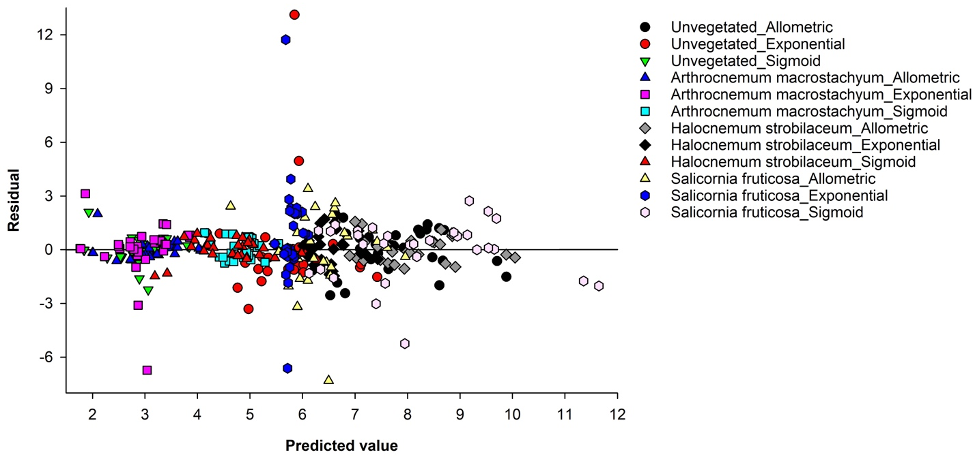
Fig. S1 Model uncertainty (predicted vs. residuals) for volumetric soil organic carbon density (SOC_{v}; kg C/m³) using three mathematical models across salt marshes with different plant species along the deltaic coast of Egypt.

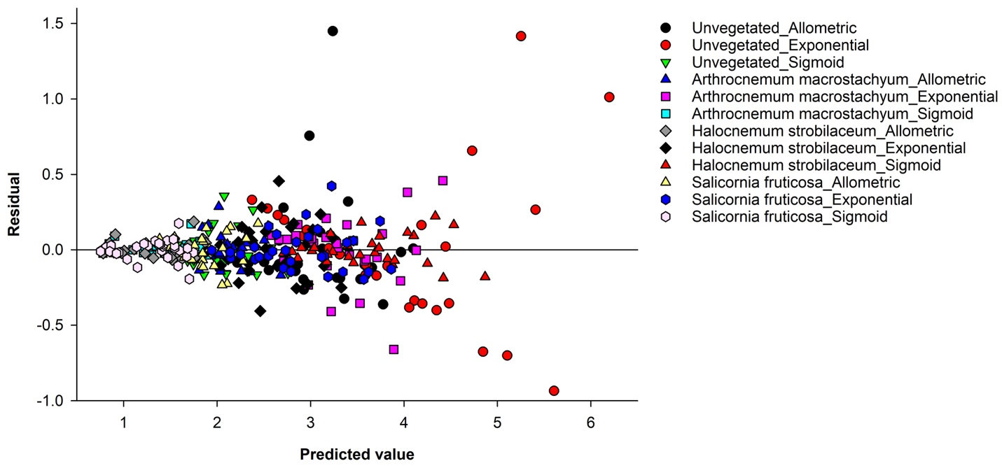
Fig. S2 Model uncertainty (predicted vs. residuals) for cumulative soil organic carbon stock (SOC_{c}; kg C/m²) using three mathematical models across salt marshes with different plant species along the deltaic coast of Egypt.

