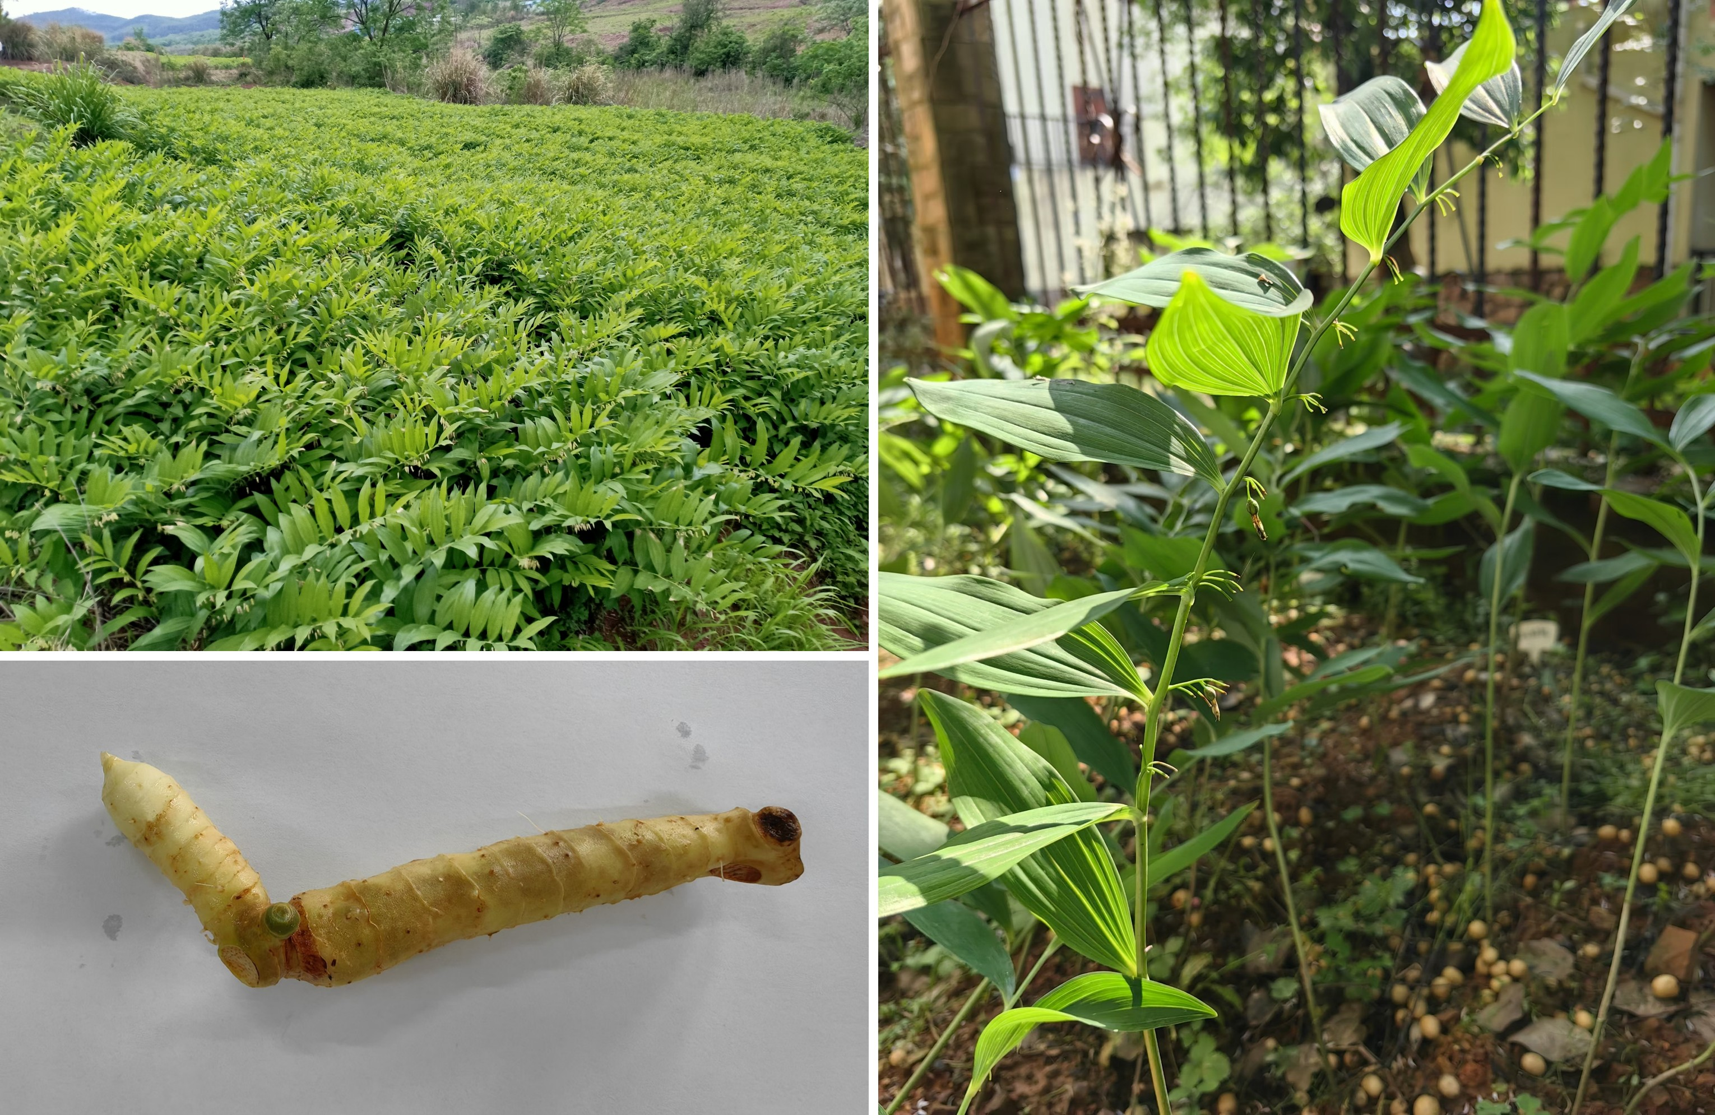
Fig. S1 The plant morphology of P. odoratum.

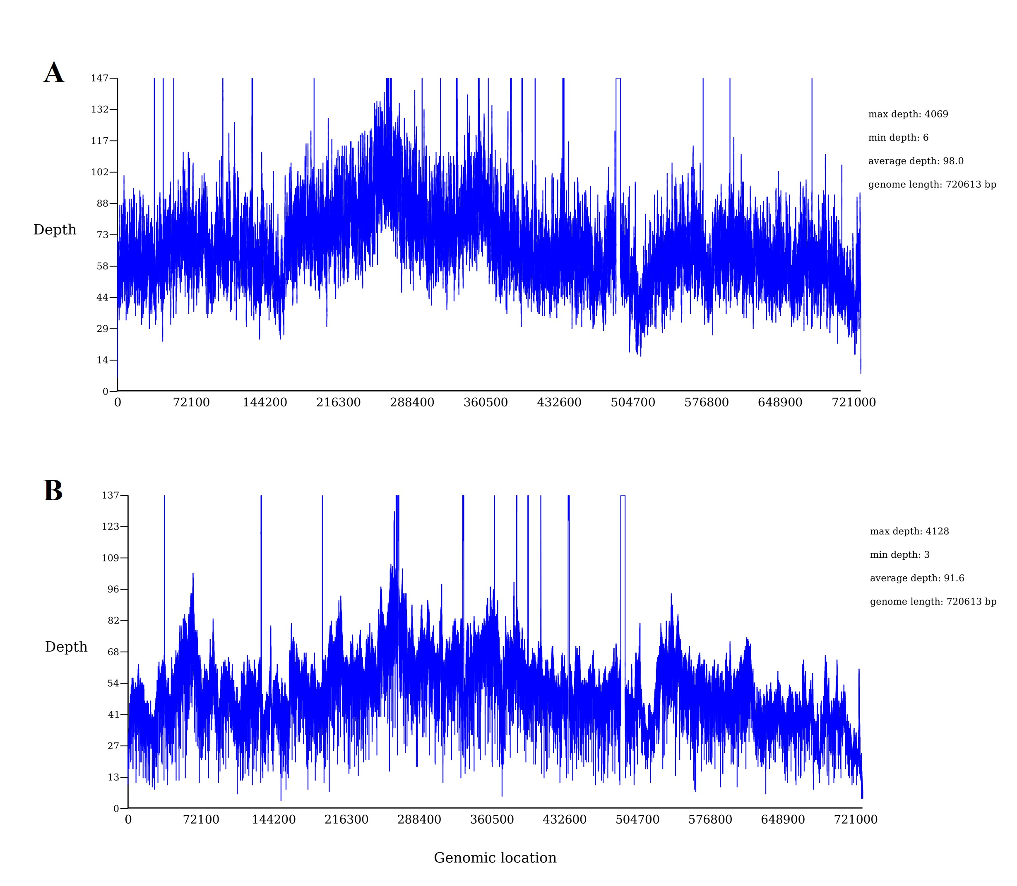
Fig. S2 The mapping results of the mitogenome sequence of P. odoratum. (A, B) Sequencing depth of coverage based on Illumina short-reads and Nanopore long-reads, respectively. The X-axis showed the positions along the mitogenome, and the Y-axis showed the coverage depth.

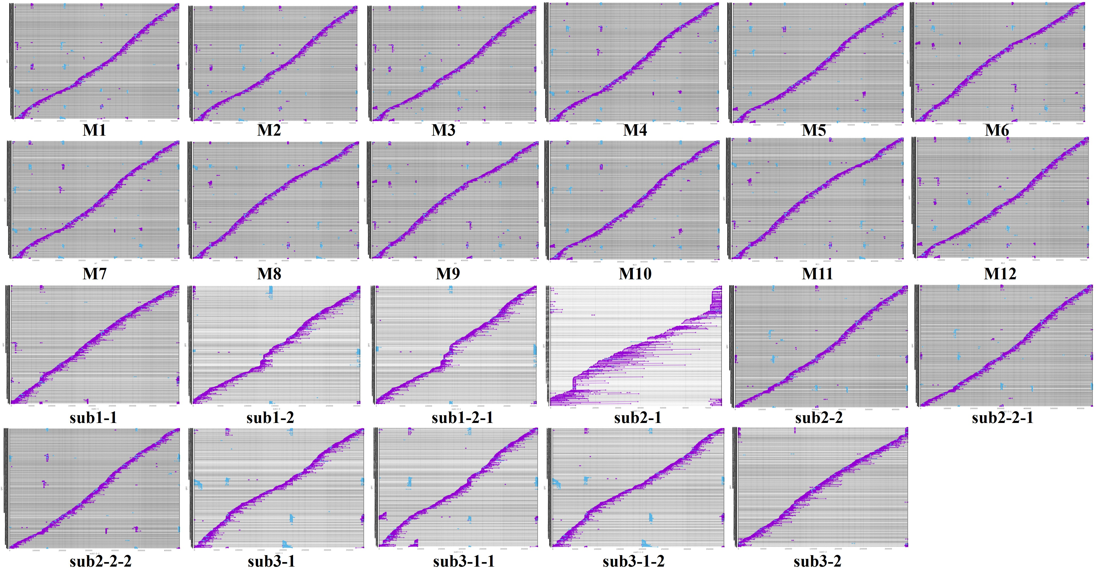
Fig. S3 The read re-mapping analysis of all configurations. The X-axis showed the positions along the mitogenome, and the Y-axis showed query reads.

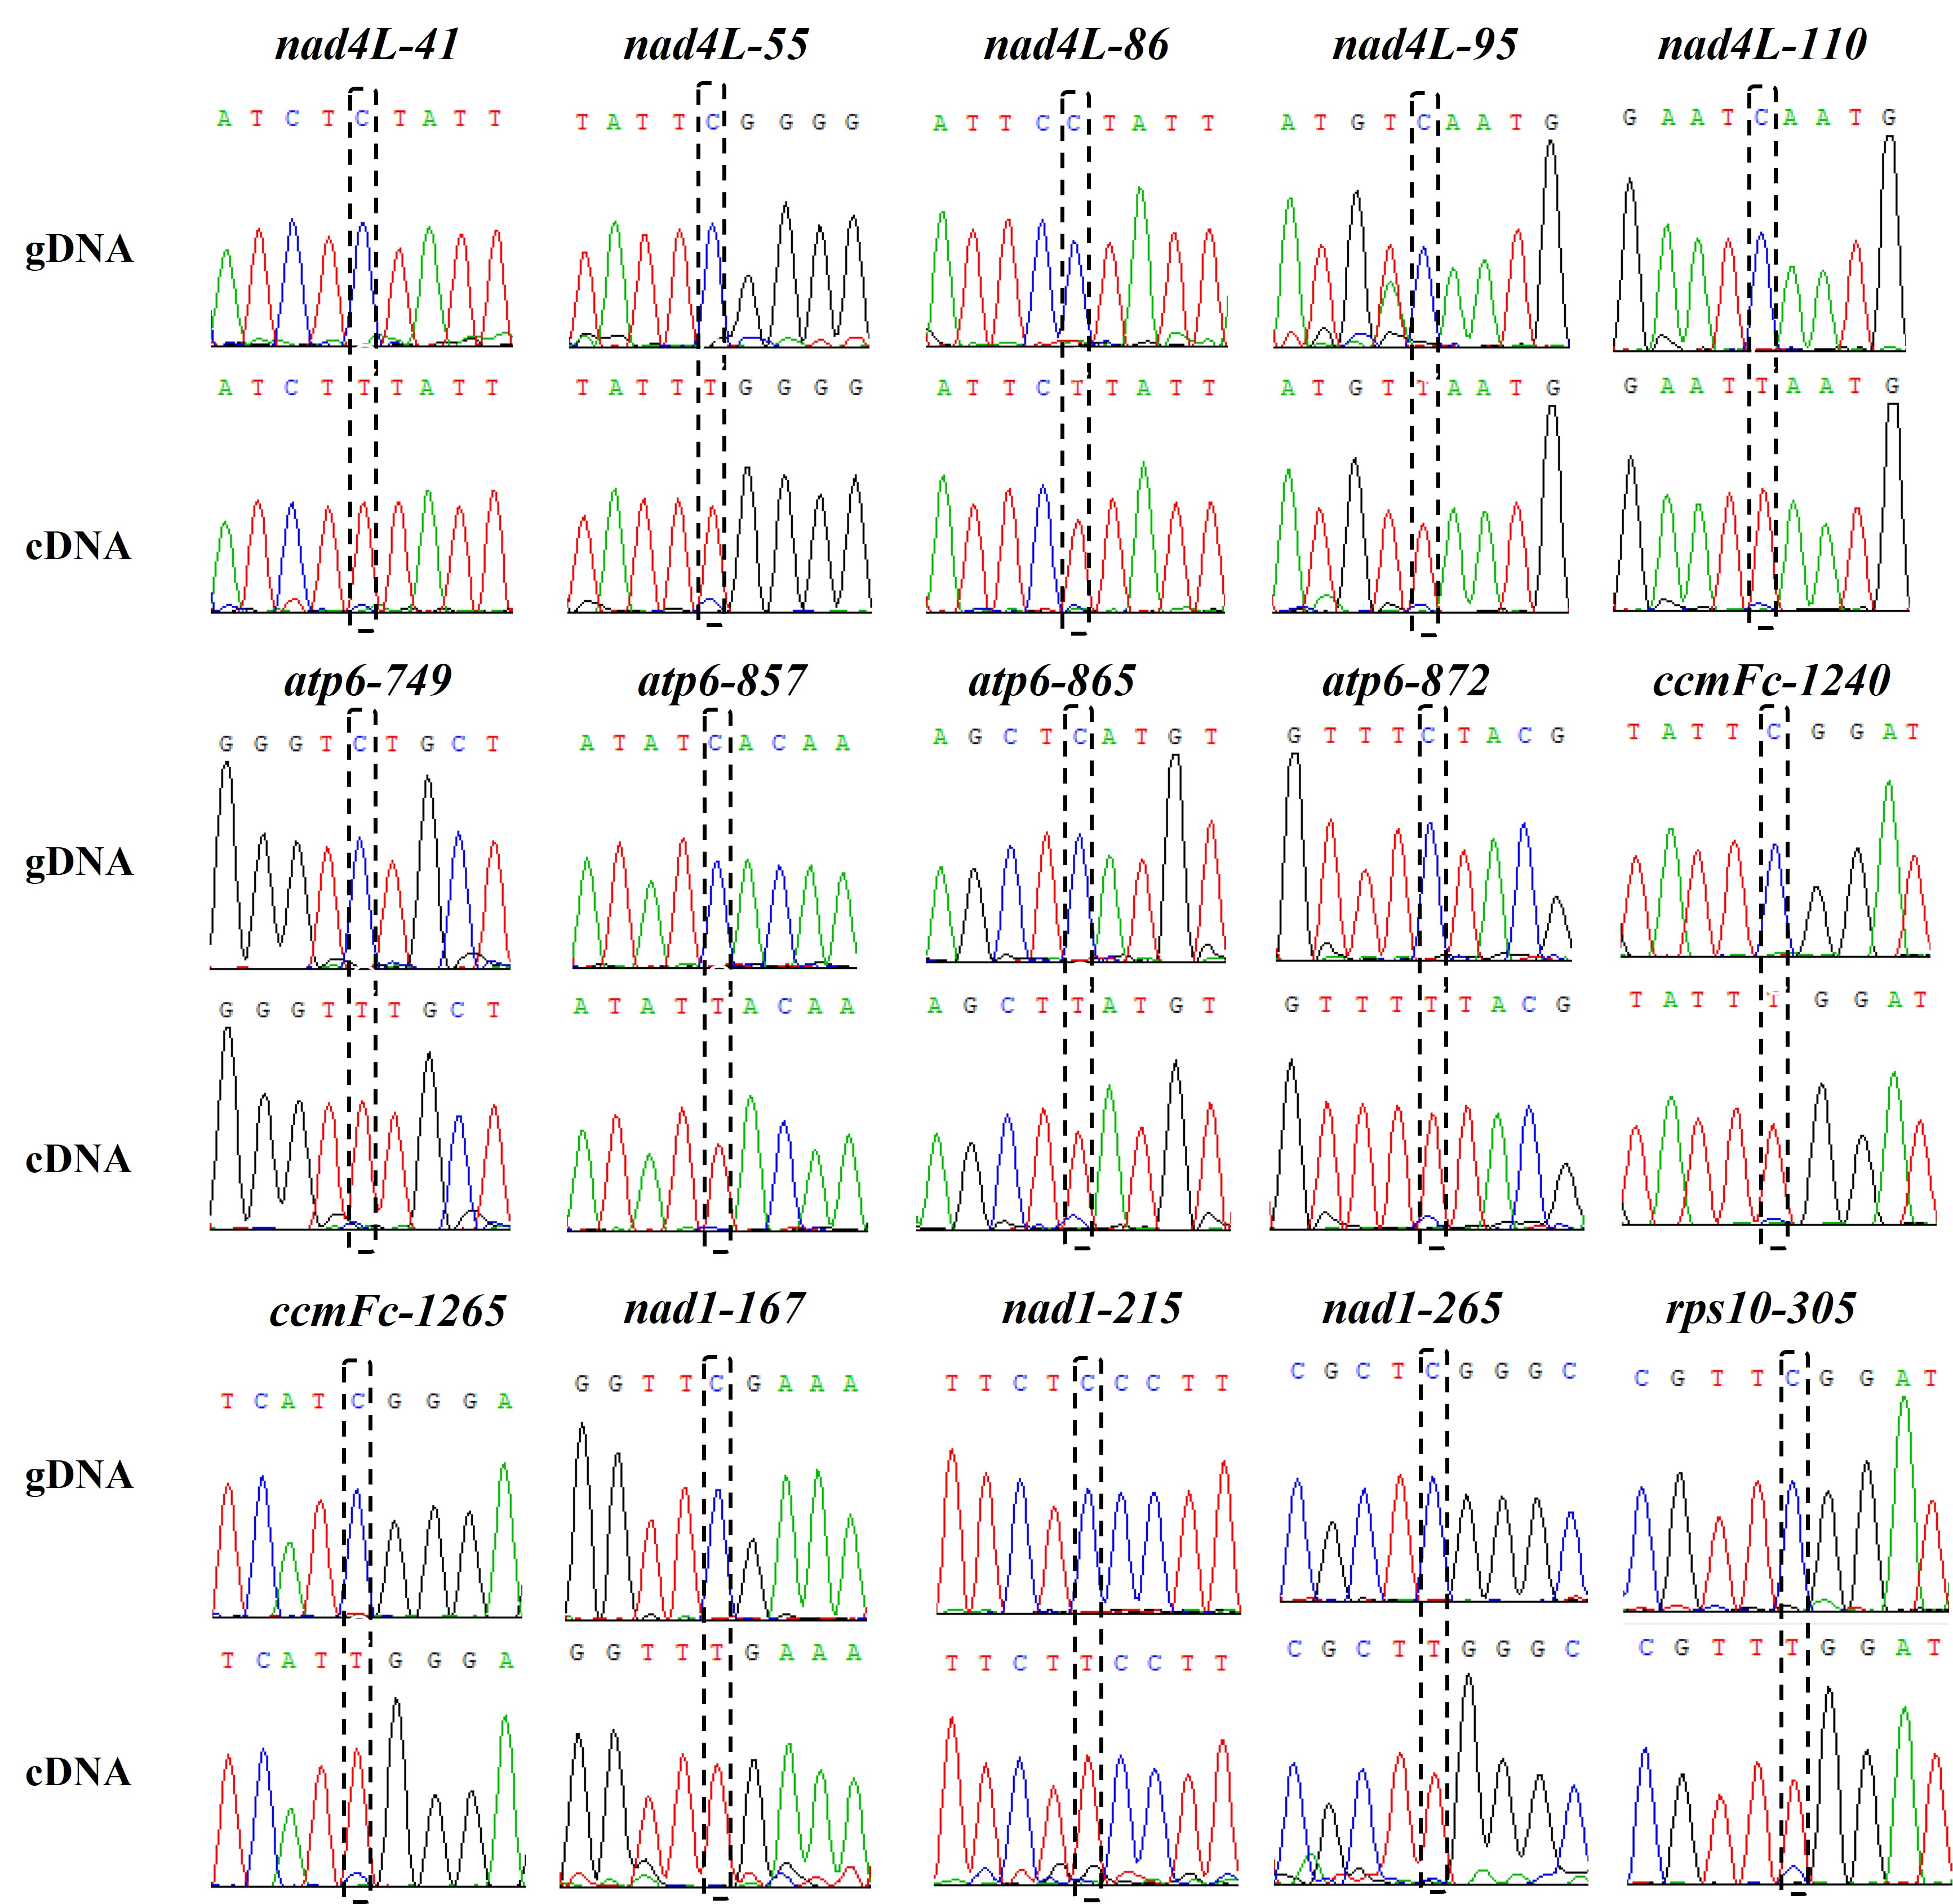
Fig. S4 Validation of additional fifteen RNA editing sites.

Fig. S5 The composition of PCGs in mitogenomes of the selected species.

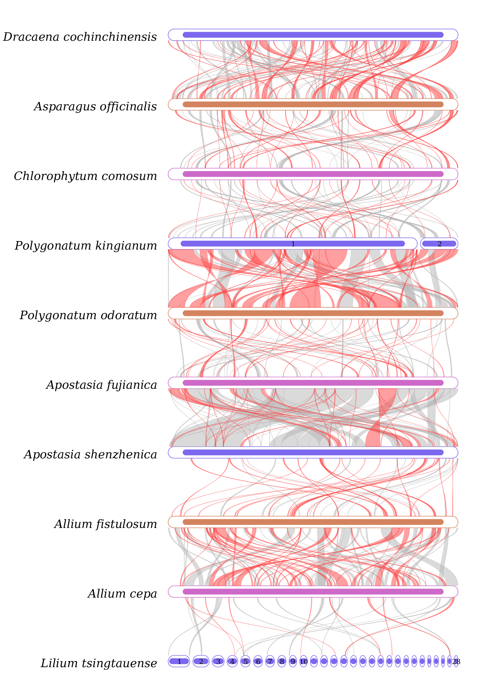
Fig. S6 Collinearity analysis. The red curved areas indicated regions that inversions occurred and the gray areas indicate regions with good homology.
Fig. S7 PCR products of the start and stop codons’ editing sites. M: Marker (bp); Lane 1-3: nad1, with cDNA, gDNA and ddH₂O as templets respectively; Lane 4-6: nad4L, with cDNA, gDNA and ddH₂O as templets respectively; Lane 7-9: ccmFc, with cDNA, gDNA and ddH₂O as templets respectively; Lane 10-12: atp6, with cDNA, gDNA and ddH₂O as templets respectively; Lane 13-15: atp9, with cDNA, ddH₂O and gDNA as templets respectively; Lane 16-18: rps10, with cDNA, gDNA and ddH₂O as templets respectively.

