Table S4. Putative motifs identified from HaKCS proteins using MEME. The sequence logos were generated using WebLogo.
Motif name | Sequence logo
Motif 1 | 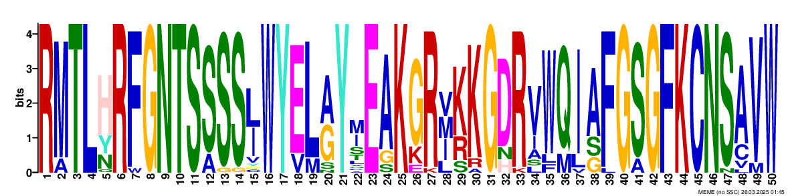  RMTLHRFGNTSSSSJWYELAYMEAKGRVKKGDRVWQIAFGSGFKCNSAVW
Motif 2 | 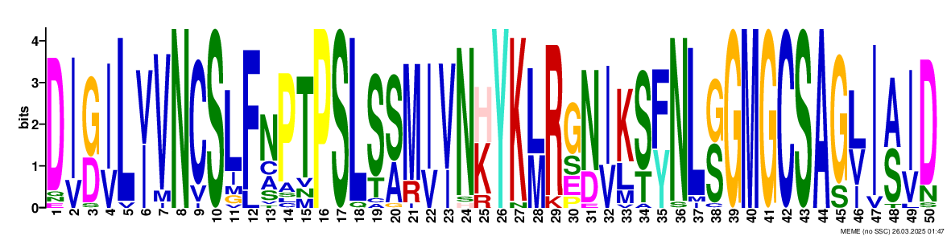  DIGILVVNCSLFNPTPSLSSMIVNHYKLRGNIKSFNLGGMGCSAGLIAID
Motif 3 | 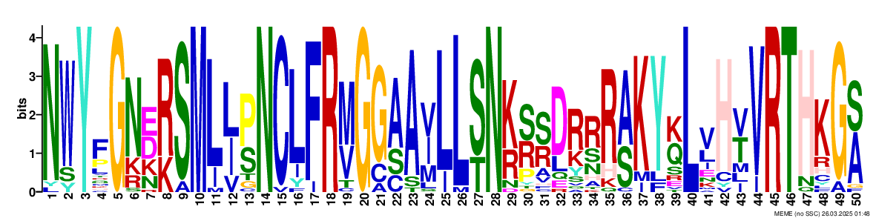  NWYFGNERSMLJPNCLFRMGGAAVLLSNKSSDRRRAKYKLVHVVRTHKGA
Motif 4 | 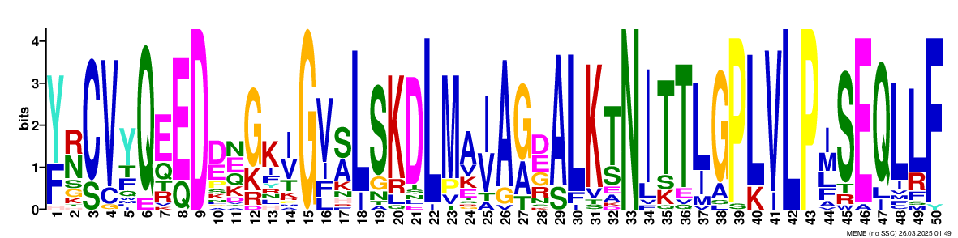  YNCVYQEEDDEGKIGVSLSKDLMAIAGDALKTNITTLGPLVLPISEQLLF
Motif 5 | 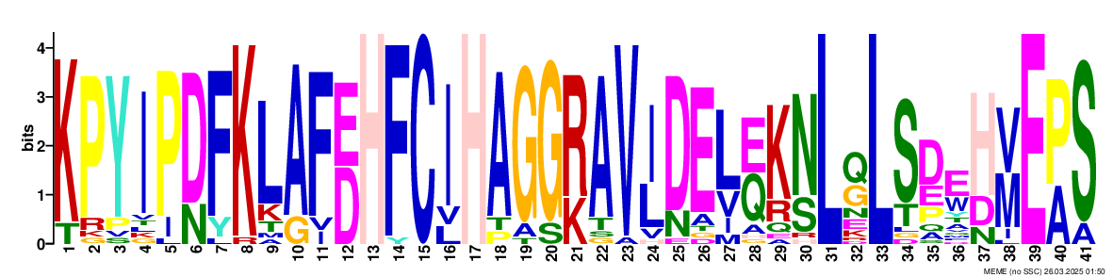  KPYIPDFKLAFEHFCIHAGGRAVIDELZKNLQLSDEHVEPS
Motif 6 | 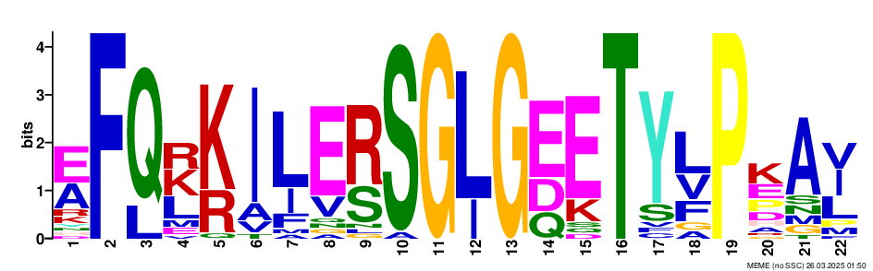  EFQKKILERSGLGEETYLPKAI
Motif 7 | 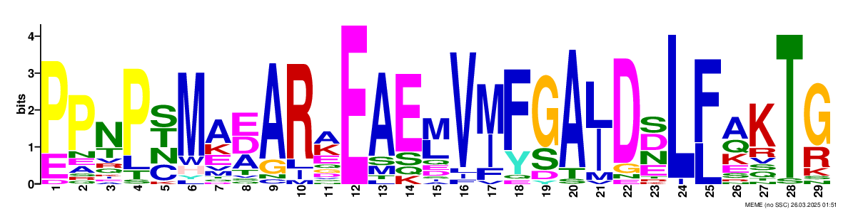  PPNPSMAEARAEAEMVMFGAJDDLFAKTG
Motif 8 | 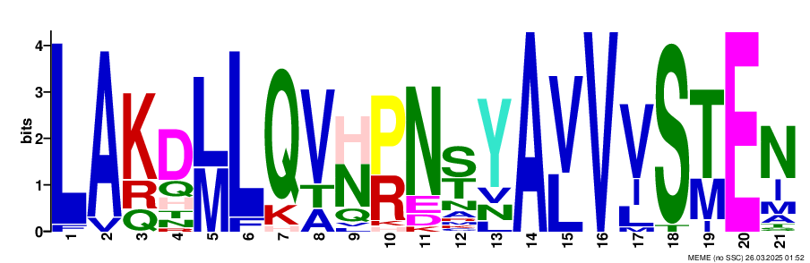  LAKDLLQVHPNSYAVVVSTEN
Motif 9 | 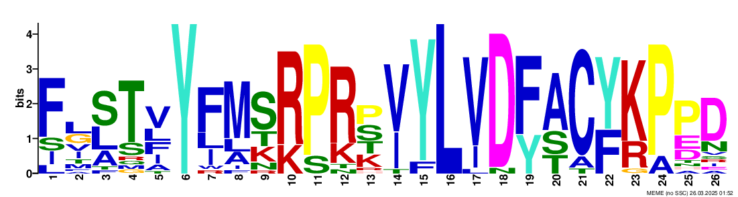  FLSTVYFMSRPRPVYLVDFACYKPPD
Motif 10 | 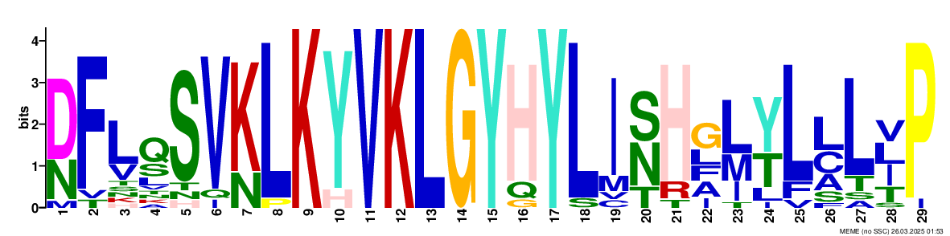  DFLQSVKLKYVKLGYHYLISHGLYLLLVP

