Supplementary Data:

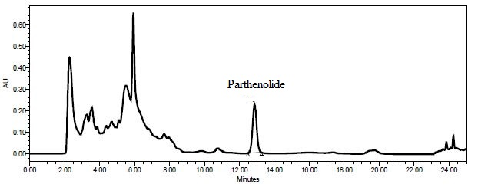
Fig. S1 Chromatogram of Parthenolide of sample R-F (Red-Flower).

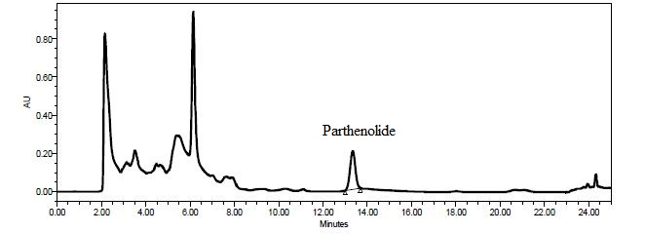

Fig. S2 Chromatogram of Parthenolide of sample B-F (Blue-Flower).

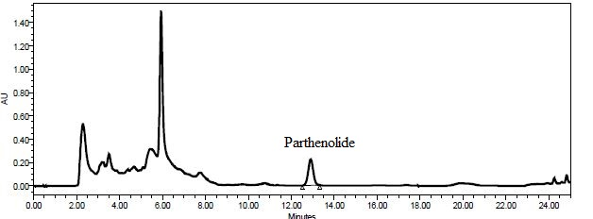

Fig. S3 Chromatogram of Parthenolide of sample W-G (White -Flower).

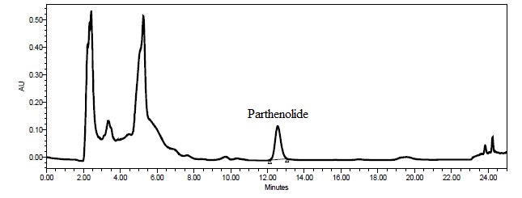
Fig. S4 Chromatogram of Parthenolide of sample 50R:50B-F (50Red:50Blue -Flower).

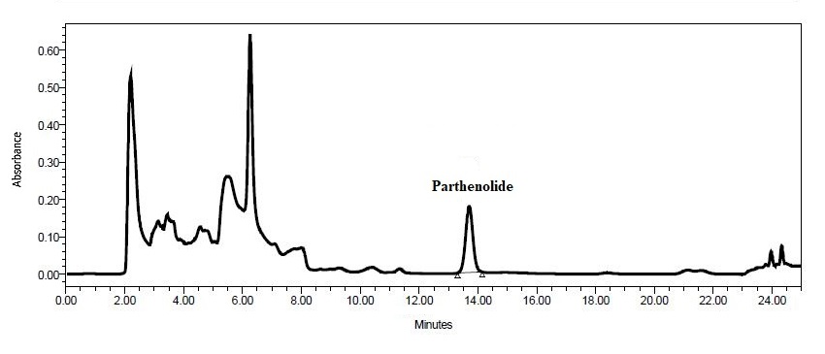
Fig. S5 Chromatogram of Parthenolide of sample 50R:50W-F (50Red -50White -Flower).

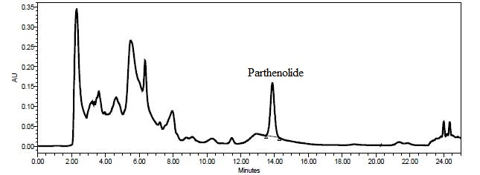
Fig. S6 Chromatogram of Parthenolide of sample C-F (Control-Flower).

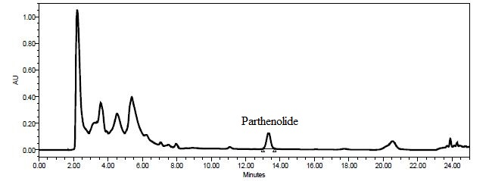
Fig.S7 Chromatogram of Parthenolide of sample R-L (Red- Leaf).

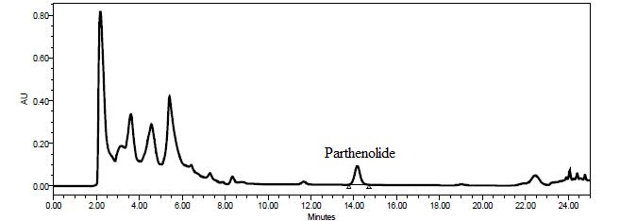

Fig. S8 Chromatogram of Parthenolide of sample B-L (Blue- Leaf).

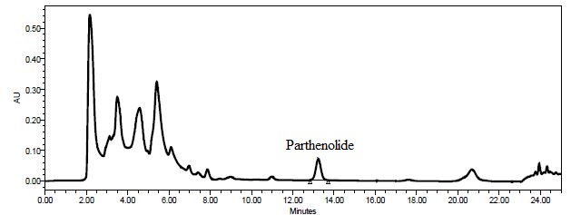

Fig.S9 Chromatogram of Parthenolide of sample W-L (White - Leaf).

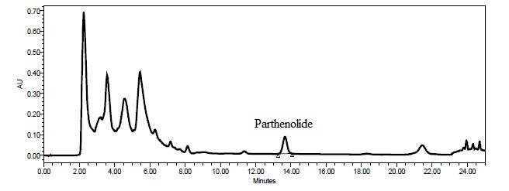
Fig. S10 Chromatogram of Parthenolide of sample 50R:50B-L (50Red:50Blue - Leaf).

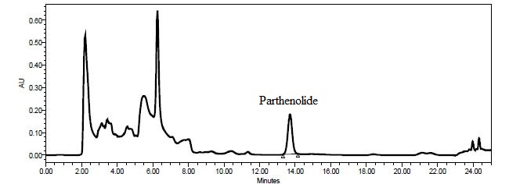

Fig. S11 Chromatogram of Parthenolide of sample 50R:50W-L (50Red -50White - Leaf).

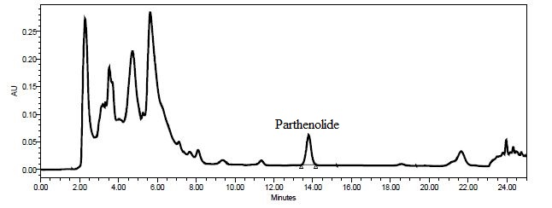

Fig. S12 Chromatogram of Parthenolide of sample C -L (Control-Leaf).

