Table S1 Demographic (size) structure of seven survey sites of seven survey sites
Tree height (m) | Individual number
Tree height (m) | ND | JH | LP | TD | JZ | TBC | CB
0~1.3 | 13 | 529 | 0 | 1 | 36 | 53 | 0
1.3~2.5 | 17 | 276 | 0 | 17 | 5 | 28 | 0
2.5~5 | 8 | 148 | 0 | 1 | 0 | 4 | 0
>5 | 12 | 67 | 1 | 8 | 4 | 1 | 10
JH, LP, ND, TBC, JZ, TD, and CB refer to the Jianhe, Liping, Nandan, Tangbaocun, Jingzhou, Tongdao, and Chengbu populations, respectively.

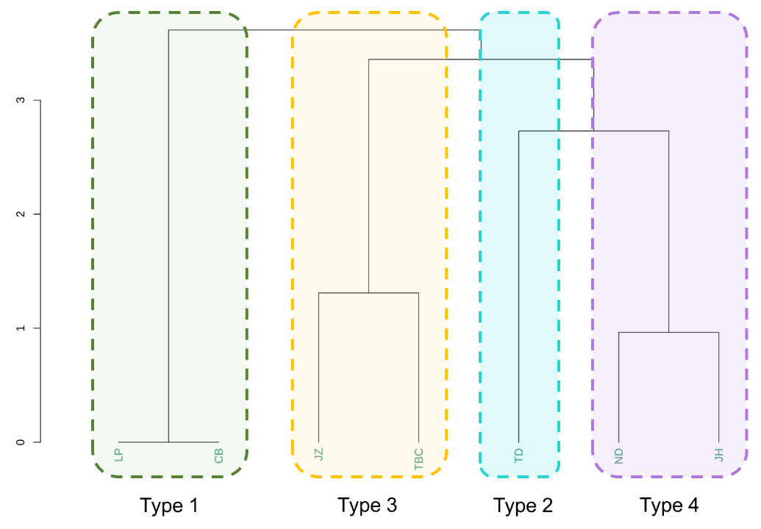
Figure S1 Clustering analysis based on the Ormosia microphylla population age structure. In the picture, JH, LP, ND, TBC, JZ, TD, and CB refer to the Jianhe, Liping, Nandan, Tangbaocun, Jingzhou, Tongdao, and Chengbu populations, respectively.

Table S2 Sample allocation for genome resequencing
Population | Province | Genetic cluster | Number of resequenced individuals
ND | Guangxi | GX | 26
JH | Guizhou | HG | 3
LP | Guizhou | HG | 1
JZ | Hunan | HG | 1
TBC | Hunan | HG | 21
TD | Hunan | HN | 9
CB | Hunan | HN | 1
Total | / | / | 62

Table S3 ADMIXTURE cross-validation error and log-likelihood values
K | CV error | Log-likelihood
2 | 0.66365 | -1798604245
3 | 0.72103 | -1757439293
4 | 0.76594 | -1714844939
5 | 0.82855 | -1678337578
6 | 0.89925 | -1648904123
7 | 0.98741 | -1622659977
8 | 1.04953 | -1586688111
9 | 1.13129 | -1556588492
10 | 1.21993 | -1534082547

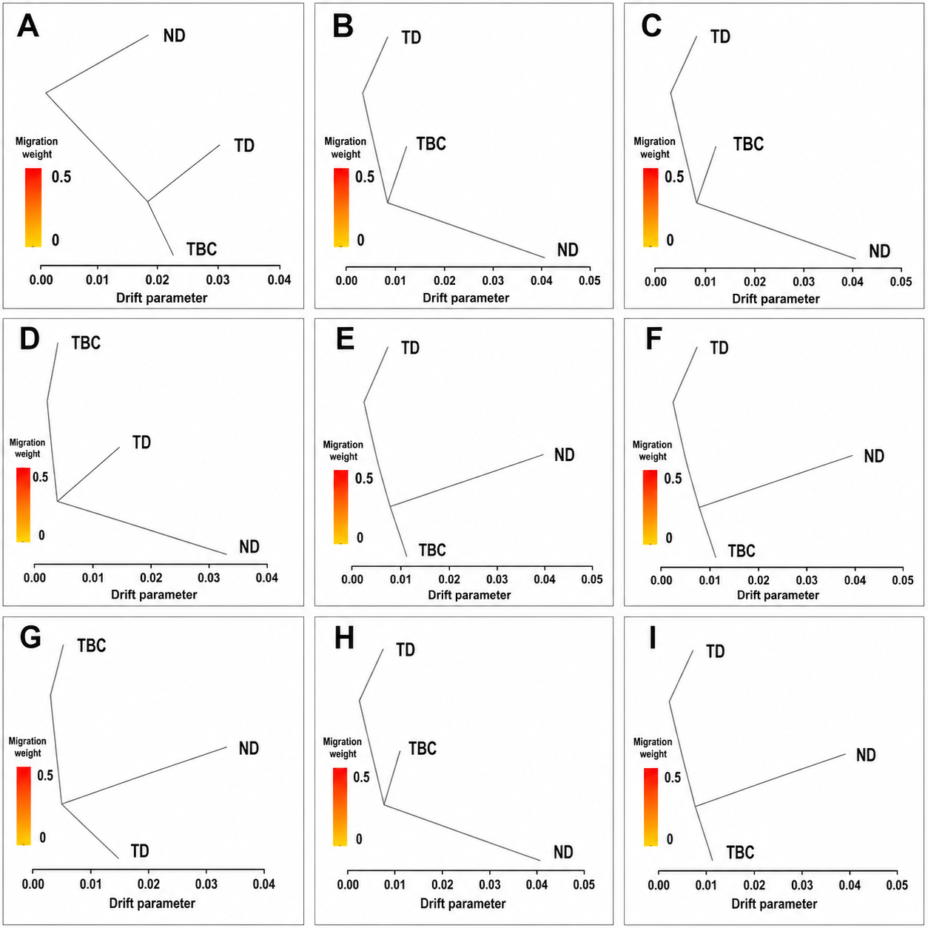
Figure S2 Gene flow between the GX, HG, and HN genetic clusters of Ormosia microphylla.

Table S4 Per-sample sequencing quality statistics for the 62 resequenced individuals
Sample | Population | Genetic cluster | Clean reads | Clean bases (Gb) | Q20 (%) | Q30 (%) | GC (%)
CB | CB | HN | 200,271,696 | 29.38 | 97.826 | 92.521 | 36.888
JH-1 | JH | HG | 158,752,918 | 23.64 | 95.941 | 88.663 | 35.841
JH-2 | JH | HG | 163,680,204 | 24.36 | 96.076 | 89.126 | 35.948
JH-3 | JH | HG | 191,993,664 | 28.57 | 96.061 | 89.018 | 35.951
JZ | JZ | HG | 194,230,428 | 28.36 | 97.864 | 92.661 | 36.670
LP | LP | HG | 198,904,970 | 29.16 | 97.900 | 92.776 | 36.405
ND-1 | ND | GX | 126,581,212 | 18.78 | 97.752 | 92.201 | 35.823
ND-10 | ND | GX | 180,521,312 | 26.75 | 97.520 | 91.376 | 35.479
ND-11 | ND | GX | 200,947,042 | 29.71 | 97.439 | 91.165 | 36.079
ND-12 | ND | GX | 185,359,428 | 27.48 | 97.494 | 91.273 | 35.893
ND-13 | ND | GX | 184,310,936 | 27.34 | 97.536 | 91.457 | 35.719
ND-14 | ND | GX | 169,015,210 | 25.04 | 97.338 | 90.762 | 35.813
ND-15 | ND | GX | 166,659,180 | 24.67 | 97.387 | 90.915 | 35.712
ND-16 | ND | GX | 211,833,662 | 31.38 | 97.613 | 91.694 | 35.719
ND-17 | ND | GX | 169,258,880 | 25.11 | 97.325 | 90.743 | 35.707
ND-18 | ND | GX | 164,270,670 | 24.35 | 97.095 | 89.946 | 35.314
ND-19 | ND | GX | 141,832,138 | 21.00 | 97.050 | 89.890 | 35.737
ND-2 | ND | GX | 171,144,782 | 25.24 | 97.591 | 91.640 | 35.888
ND-20 | ND | GX | 185,125,224 | 27.51 | 97.389 | 90.905 | 35.229
ND-21 | ND | GX | 146,147,138 | 21.71 | 97.317 | 90.755 | 35.461
ND-22 | ND | GX | 145,333,246 | 21.54 | 97.112 | 90.062 | 35.655
ND-23 | ND | GX | 187,796,424 | 27.68 | 97.520 | 91.436 | 36.830
ND-24 | ND | GX | 210,314,932 | 31.22 | 97.335 | 90.733 | 35.863
ND-25 | ND | GX | 277,720,166 | 40.11 | 98.944 | 95.131 | 36.971
ND-26 | ND | GX | 145,348,772 | 21.51 | 97.489 | 91.296 | 36.217
ND-3 | ND | GX | 184,184,648 | 27.26 | 98.656 | 95.108 | 36.048
ND-4 | ND | GX | 256,480,252 | 37.96 | 97.594 | 91.622 | 36.103
ND-5 | ND | GX | 209,246,438 | 30.95 | 97.607 | 91.735 | 35.916
ND-6 | ND | GX | 177,737,828 | 26.31 | 97.421 | 91.074 | 35.778
ND-7 | ND | GX | 150,786,718 | 22.24 | 97.323 | 90.720 | 35.530
ND-8 | ND | GX | 178,507,004 | 26.53 | 97.382 | 90.865 | 35.314
ND-9 | ND | GX | 157,240,732 | 23.34 | 97.146 | 90.204 | 35.068
TBC-1 | TBC | HG | 163,913,652 | 24.27 | 96.279 | 89.688 | 36.784
TBC-10 | TBC | HG | 165,246,644 | 24.53 | 96.300 | 89.769 | 36.959
TBC-11 | TBC | HG | 215,736,650 | 31.98 | 96.254 | 89.626 | 36.412
TBC-12 | TBC | HG | 189,300,324 | 28.11 | 96.194 | 89.471 | 36.653
TBC-13 | TBC | HG | 178,430,048 | 26.53 | 96.081 | 89.121 | 36.512
TBC-14 | TBC | HG | 207,643,986 | 30.73 | 96.343 | 89.888 | 36.958
TBC-15 | TBC | HG | 172,853,236 | 25.66 | 96.100 | 89.176 | 36.295
TBC-16 | TBC | HG | 178,761,118 | 26.46 | 96.321 | 89.824 | 36.784
TBC-17 | TBC | HG | 241,709,656 | 35.55 | 97.775 | 92.610 | 36.650
TBC-18 | TBC | HG | 267,338,820 | 39.15 | 97.587 | 91.977 | 36.344
TBC-19 | TBC | HG | 189,305,736 | 27.76 | 97.796 | 92.414 | 36.974
TBC-2 | TBC | HG | 215,466,994 | 31.94 | 96.316 | 89.815 | 36.536
TBC-20 | TBC | HG | 205,062,428 | 30.27 | 97.717 | 92.166 | 36.936
TBC-21 | TBC | HG | 197,918,182 | 29.14 | 97.704 | 92.040 | 36.803
TBC-3 | TBC | HG | 137,471,892 | 20.45 | 95.838 | 88.446 | 35.578
TBC-4 | TBC | HG | 192,041,946 | 28.54 | 96.095 | 89.132 | 36.013
TBC-5 | TBC | HG | 166,896,556 | 24.76 | 96.280 | 89.708 | 36.454
TBC-6 | TBC | HG | 189,880,832 | 28.18 | 96.165 | 89.359 | 36.480
TBC-7 | TBC | HG | 155,623,374 | 23.15 | 96.164 | 89.332 | 35.930
TBC-8 | TBC | HG | 216,583,166 | 32.12 | 96.360 | 89.969 | 36.859
TBC-9 | TBC | HG | 174,379,034 | 25.79 | 96.351 | 89.932 | 36.829
TD-1 | TD | HN | 189,641,928 | 27.64 | 97.821 | 92.495 | 36.886
TD-2 | TD | HN | 197,373,256 | 29.11 | 97.580 | 91.618 | 36.174
TD-3 | TD | HN | 214,048,332 | 31.21 | 97.790 | 92.395 | 36.861
TD-4 | TD | HN | 183,567,476 | 27.05 | 97.691 | 92.046 | 36.666
TD-5 | TD | HN | 168,648,138 | 24.84 | 97.496 | 91.352 | 36.250
TD-6 | TD | HN | 161,287,462 | 23.66 | 97.581 | 91.593 | 36.451
TD-7 | TD | HN | 195,003,674 | 28.61 | 97.835 | 92.535 | 36.691
TD-8 | TD | HN | 186,503,924 | 27.54 | 97.626 | 91.776 | 36.561
TD-9 | TD | HN | 150,860,220 | 22.15 | 98.000 | 93.107 | 37.013

Table S5 Per-sample mapping-depth and reference-coverage statistics for the 62 resequenced individuals
Sample | Population | Genetic cluster | Mapped (%) | Properly mapped (%) | Depth (x) | Coverage 1x (%) | Coverage 5x (%) | Coverage 10x (%)
CB | CB | HN | 98.670 | 76.120 | 9.899 | 44.830 | 30.410 | 23.180
JH-1 | JH | HG | 98.660 | 73.350 | 7.963 | 44.880 | 29.600 | 21.460
JH-2 | JH | HG | 98.660 | 73.590 | 8.194 | 44.960 | 29.620 | 21.620
JH-3 | JH | HG | 98.620 | 73.300 | 9.600 | 46.160 | 31.190 | 23.830
JZ | JZ | HG | 98.980 | 76.800 | 9.558 | 44.820 | 30.430 | 23.190
LP | LP | HG | 98.940 | 75.930 | 9.833 | 45.150 | 30.930 | 23.810
ND-1 | ND | GX | 98.530 | 72.040 | 6.316 | 42.800 | 27.580 | 18.200
ND-10 | ND | GX | 98.640 | 72.300 | 9.058 | 45.210 | 31.020 | 23.630
ND-11 | ND | GX | 98.740 | 73.220 | 10.013 | 45.720 | 31.400 | 24.270
ND-12 | ND | GX | 98.820 | 72.890 | 9.281 | 45.430 | 31.130 | 23.810
ND-13 | ND | GX | 98.740 | 72.460 | 9.225 | 45.330 | 31.090 | 23.740
ND-14 | ND | GX | 98.740 | 73.740 | 8.473 | 44.620 | 30.120 | 22.380
ND-15 | ND | GX | 98.820 | 73.410 | 8.356 | 44.430 | 29.950 | 22.250
ND-16 | ND | GX | 98.790 | 73.870 | 10.599 | 45.800 | 32.080 | 25.320
ND-17 | ND | GX | 98.760 | 72.850 | 8.494 | 44.720 | 30.260 | 22.580
ND-18 | ND | GX | 98.690 | 73.380 | 8.202 | 44.470 | 30.330 | 22.590
ND-19 | ND | GX | 98.630 | 73.600 | 7.081 | 43.300 | 28.310 | 19.470
ND-2 | ND | GX | 98.770 | 73.430 | 8.541 | 44.650 | 30.120 | 22.490
ND-20 | ND | GX | 98.700 | 72.180 | 9.315 | 45.420 | 31.380 | 24.270
ND-21 | ND | GX | 98.630 | 71.310 | 7.334 | 43.970 | 29.230 | 20.680
ND-22 | ND | GX | 98.640 | 72.600 | 7.272 | 43.740 | 28.950 | 20.230
ND-23 | ND | GX | 98.870 | 75.070 | 9.350 | 44.710 | 30.140 | 22.780
ND-24 | ND | GX | 98.690 | 72.380 | 10.517 | 46.070 | 31.960 | 25.010
ND-25 | ND | GX | 98.860 | 73.930 | 13.560 | 47.340 | 33.300 | 26.610
ND-26 | ND | GX | 98.610 | 72.910 | 7.271 | 43.400 | 28.170 | 19.690
ND-3 | ND | GX | 98.700 | 75.150 | 8.764 | 44.520 | 30.550 | 23.010
ND-4 | ND | GX | 98.760 | 72.850 | 12.801 | 47.230 | 33.330 | 26.760
ND-5 | ND | GX | 98.760 | 73.010 | 10.423 | 46.130 | 31.960 | 24.980
ND-6 | ND | GX | 98.800 | 73.180 | 8.897 | 44.860 | 30.370 | 22.970
ND-7 | ND | GX | 98.740 | 73.240 | 7.541 | 43.930 | 29.280 | 21.040
ND-8 | ND | GX | 98.820 | 73.190 | 8.975 | 44.990 | 30.970 | 23.710
ND-9 | ND | GX | 98.690 | 72.090 | 7.887 | 44.410 | 30.060 | 22.140
TBC-1 | TBC | HG | 98.820 | 75.700 | 8.171 | 44.170 | 28.780 | 20.980
TBC-10 | TBC | HG | 98.750 | 74.450 | 8.251 | 44.370 | 28.800 | 21.050
TBC-11 | TBC | HG | 98.760 | 74.930 | 10.725 | 46.620 | 31.860 | 24.820
TBC-12 | TBC | HG | 98.700 | 75.080 | 9.418 | 45.550 | 30.360 | 22.950
TBC-13 | TBC | HG | 98.680 | 73.740 | 8.897 | 45.390 | 30.170 | 22.600
TBC-14 | TBC | HG | 98.800 | 76.150 | 10.302 | 45.840 | 30.920 | 23.740
TBC-15 | TBC | HG | 98.690 | 74.400 | 8.631 | 45.110 | 29.810 | 22.120
TBC-16 | TBC | HG | 98.630 | 75.190 | 8.885 | 44.860 | 29.510 | 21.950
TBC-17 | TBC | HG | 98.900 | 74.970 | 11.972 | 46.300 | 32.170 | 25.430
TBC-18 | TBC | HG | 98.890 | 74.680 | 13.236 | 47.310 | 33.400 | 26.830
TBC-19 | TBC | HG | 98.860 | 74.900 | 9.382 | 44.520 | 29.730 | 22.480
TBC-2 | TBC | HG | 98.730 | 74.690 | 10.716 | 46.550 | 31.680 | 24.620
TBC-20 | TBC | HG | 98.970 | 75.120 | 10.196 | 45.130 | 30.690 | 23.600
TBC-21 | TBC | HG | 98.930 | 75.450 | 9.858 | 44.920 | 30.480 | 23.320
TBC-3 | TBC | HG | 98.740 | 75.040 | 6.881 | 43.460 | 27.890 | 19.140
TBC-4 | TBC | HG | 98.690 | 74.140 | 9.592 | 46.060 | 31.140 | 23.830
TBC-5 | TBC | HG | 98.790 | 74.930 | 8.339 | 44.750 | 29.420 | 21.580
TBC-6 | TBC | HG | 98.700 | 74.570 | 9.434 | 45.760 | 30.760 | 23.400
TBC-7 | TBC | HG | 98.680 | 74.060 | 7.804 | 44.580 | 29.190 | 21.160
TBC-8 | TBC | HG | 98.750 | 75.220 | 10.745 | 46.260 | 31.350 | 24.300
TBC-9 | TBC | HG | 98.760 | 75.580 | 8.656 | 44.640 | 29.290 | 21.650
TD-1 | TD | HN | 98.970 | 76.200 | 9.384 | 44.450 | 29.790 | 22.470
TD-2 | TD | HN | 98.920 | 74.420 | 9.816 | 45.230 | 31.020 | 23.890
TD-3 | TD | HN | 98.920 | 75.080 | 10.568 | 45.440 | 30.930 | 23.880
TD-4 | TD | HN | 98.890 | 74.020 | 9.151 | 44.660 | 29.910 | 22.500
TD-5 | TD | HN | 98.910 | 74.810 | 8.427 | 44.040 | 29.340 | 21.700
TD-6 | TD | HN | 98.820 | 74.070 | 8.044 | 43.970 | 28.920 | 20.860
TD-7 | TD | HN | 98.950 | 76.390 | 9.683 | 44.740 | 30.300 | 23.050
TD-8 | TD | HN | 98.880 | 74.300 | 9.341 | 44.630 | 29.960 | 22.660
TD-9 | TD | HN | 98.920 | 75.560 | 7.460 | 42.750 | 27.640 | 19.590

Table S6 Variant calling and filtering summary for the resequencing dataset
Metric | Value
Reference genome | Ormosia henryi
Reference genome total length | 2,639,023,864 bp
Reference genome N50 | 338,397,820 bp
Reference genome GC content | 35.879%
Filtered SNPs | 63,597,066
Filtered INDELs | 11,340,745
Ti/Tv | 2.639
Biallelic sites | 74,937,811
Sites with missing rate <= 0.2 | 84,634,226 (99.93%)
Sites with MAF > 0.05 | 44,625,714 (52.69%)
Downstream filtered SNP file | All.filtered.maf0.05.miss0.2.biallelic.rm.indel.vcf

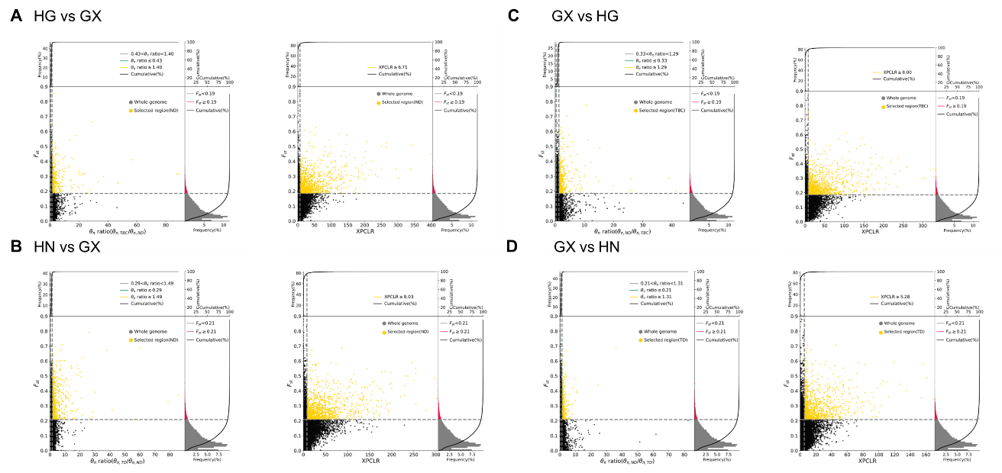
Figure S3 Genomic regions with a selective sweep. Screening of selected genes using HG (A) and HN (B) populations, respectively, with the GX population as the background population; Screening of selected genes using the GX population, respectively, with HG (C) and HN (D) populations.

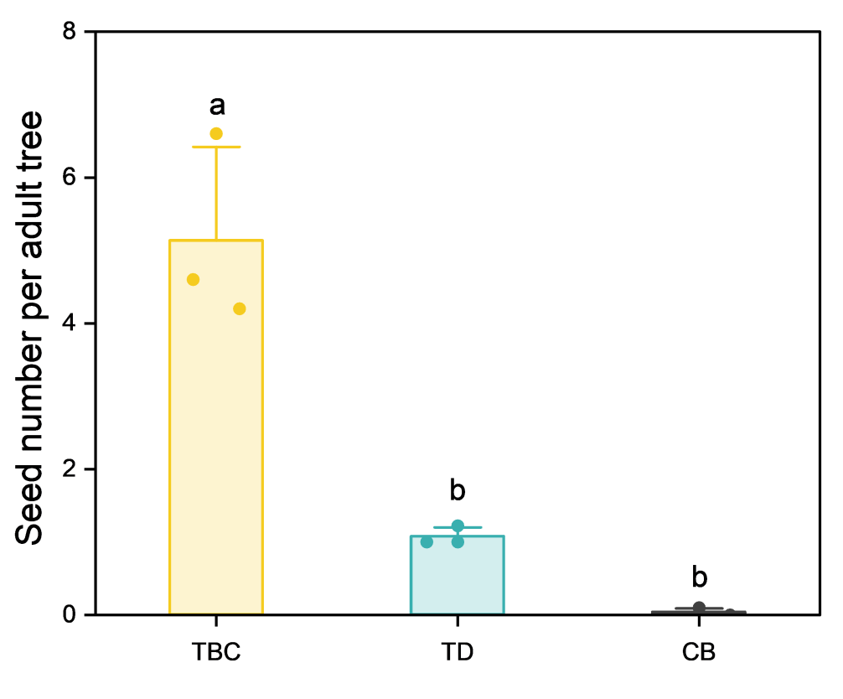
Figure S4 Seed number of a single Ormosia microphylla adult and old tree (with heights > 2.5 m) individual. TD, CB, and TBC refer to the Tongdao, Chengbu, and Tangbaocun populations, respectively. Different letters represent significant differences at p<0.05.

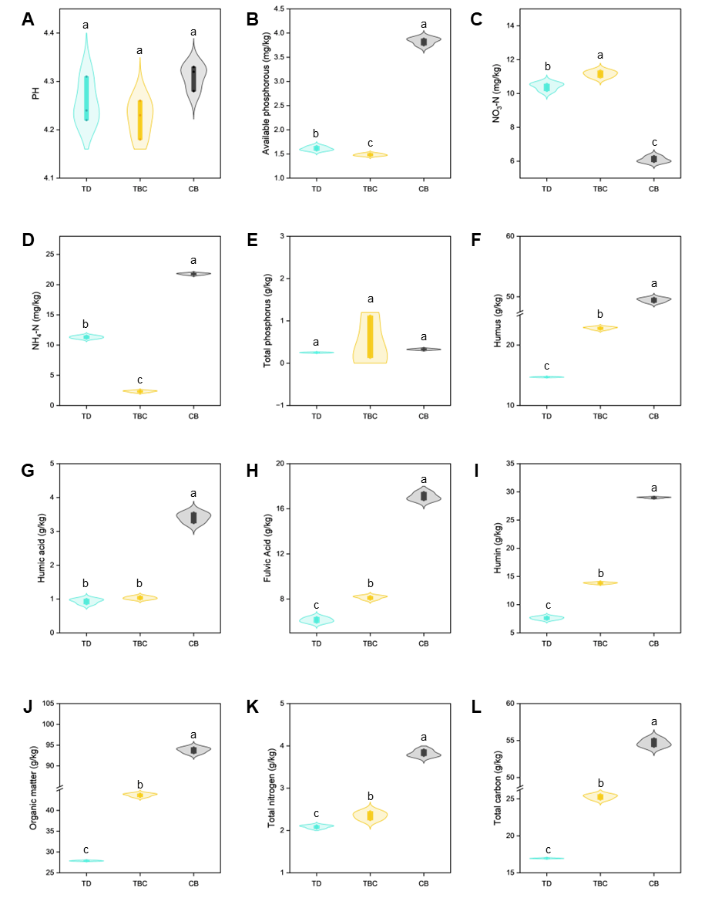
Figure S5 Soil nutrient composition of representative Ormosia microphylla populations. TD, CB, and TBC refer to the Tongdao, Chengbu, and Tangbaocun populations, respectively. Different letters represent significant differences at p<0.05.

Table S7 Investigated bird species.
Order | Family | Species
Galliformes | Phasianidae | Bambusicola thoracica
Galliformes | Phasianidae | Lophura nycthemera
Podicipediformes | Podicipedidae | Tachybaptus ruficollis
Columbiformes | Columbidae | Streptopelia orientalis
Columbiformes | Columbidae | Streptopelia chinensis
Pelecaniformes | Ardeidae | Ardeola bacchus
Piciformes | Capitonidae | Psilopogon faber
Piciformes | Picidae | Blythipicus pyrrhotis
Passeriformes | Vireonidae | Erpornis zantholeuca
Passeriformes | Campephagidae | Pericrocotus solaris
Passeriformes | Laniidae | Lanius schach
Passeriformes | Corvidae | Garrulus glandarius
Passeriformes | Corvidae | Urocissa erythrorhyncha
Passeriformes | Corvidae | Dendrocitta formosae
Passeriformes | Corvidae | Corvus macrorhynchos
Passeriformes | Paridae | Pardaliparus venustulus
Passeriformes | Paridae | Parus cinereus
Passeriformes | Hirundinidae | Hirundo rustica
Passeriformes | Hirundinidae | Cecropis daurica
Passeriformes | Pycnonotidae | Spizixos semitorques
Passeriformes | Pycnonotidae | Pycnonotus xanthorrhous
Passeriformes | Pycnonotidae | Pycnonotus sinensis
Passeriformes | Pycnonotidae | Ixos mcclellandii
Passeriformes | Pycnonotidae | Hemixos castanonotus
Passeriformes | Phylloscopidae | Phylloscopus inornatus
Passeriformes | Cettiidae | Abroscopus albogularis
Passeriformes | Cettiidae | Horornis fortipes
Passeriformes | Aegithalidae | Aegithalos concinnus
Passeriformes | Sylviidae | Sinosuthora webbianus
Passeriformes | Sylviidae | Psittiparus gularis
Passeriformes | Zosteropidae | Yuhina castaniceps
Passeriformes | Timaliidae | Erythrogenys gravivox
Passeriformes | Timaliidae | Erythrogenys swinhoei
Passeriformes | Timaliidae | Pomatorhinus ruficollis
Passeriformes | Timaliidae | Cyanoderma ruficeps
Passeriformes | Pellorneidae | Alcippe morrisonia
Passeriformes | Leiothrichidae | Garrulax canorus
Passeriformes | Leiothrichidae | Garrulax perspicillatus
Passeriformes | Leiothrichidae | Garrulax pectoralis
Passeriformes | Leiothrichidae | Garrulax sannio
Passeriformes | Leiothrichidae | Leiothrix lutea
Passeriformes | Muscicapidae | Tarsiger cyanurus
Passeriformes | Muscicapidae | Phoenicurus auroreus
Passeriformes | Muscicapidae | Rhyacornis fuliginosus
Passeriformes | Muscicapidae | Enicurus schistaceus
Passeriformes | Muscicapidae | Enicurus leschenaulti
Passeriformes | Estrildidae | Lonchura striata
Passeriformes | Estrildidae | Lonchura punctulata
Passeriformes | Passeridae | Passer montanus
Passeriformes | Motacillidae | Motacilla cinerea
Passeriformes | Motacillidae | Motacilla alba
Passeriformes | Motacillidae | Anthus hodgsoni
Passeriformes | Paridae | Fringilla montifringilla
Passeriformes | Paridae | Chloris sinica
Passeriformes | Emberizidae | Emberiza pusilla
Passeriformes | Emberizidae | Emberiza spodocephala

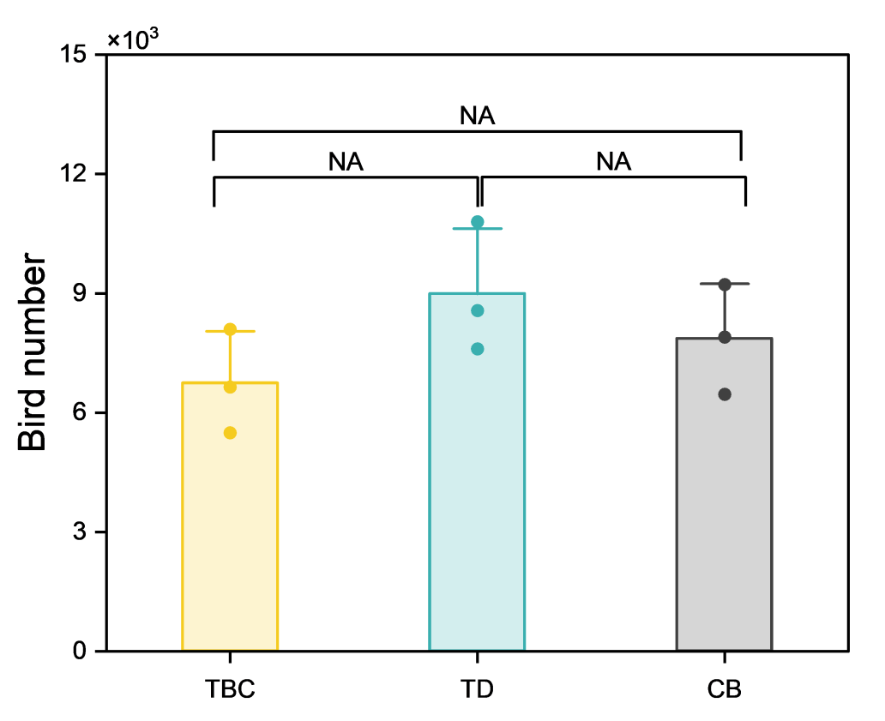
Figure S6 Number of bird individuals investigated in representative Ormosia microphylla populations. TD, CB, and TBC refer to the Tongdao, Chengbu, and Tangbaocun populations, respectively. Different letters represent significant differences at p<0.05.

Table S8 Evidence map linking genetic clusters, demographic status, and environmental observations
Cluster | Populations | Demographic pattern | Genomic signal | Environmental or disturbance observation | Conservation implication
GX | ND | Relatively stable age structure | Low pi; selected pathways enriched in fatty acid and linoleic acid metabolism | Representative soil, bird, and stump data not measured for ND in the current ecological subset | Priority in situ protection and a separate ex situ conservation line
HG | JH, LP, JZ, TBC | Mixed patterns; TBC and JZ dominated by saplings, LP represented by a single old individual | Low pi; enrichment of cutin, suberin, and wax biosynthesis in comparisons involving HG | TBC showed comparatively favorable soil conditions among the representative sites | Protect regeneration sites, monitor seedling survival, and preserve HG material separately
HN | TD, CB | TD is dominated by young trees; CB lacks young individuals | Low pi; enrichment of phenylpropanoid biosynthesis-related pathways in comparisons involving HN | TD showed stronger logging disturbance and lower bird diversity than TBC/CB in the representative-site survey | Strengthen logging control and maintain seed-disperser habitat
JH, LP, ND, TBC, JZ, TD, and CB refer to the Jianhe, Liping, Nandan, Tangbaocun, Jingzhou, Tongdao, and Chengbu populations, respectively.

Table S9 Selected site-level Spearman correlations
Variable 1 | Variable 2 | rho | p value | n
Bird Shannon index | Seeds per adult tree | -0.50 | 0.667 | 3
Stump count | Adult + old trees | 0.50 | 0.667 | 3
Stump count | Seeds per adult tree | -0.50 | 0.667 | 3
Bird Shannon index | Saplings + young trees | -0.50 | 0.667 | 3
Bird abundance | Seeds per adult tree | -0.50 | 0.667 | 3

Table S10 Multi-factor standardized indices for representative populations
Site | Disturbance pressure | Biotic support | Reproductive output | Regeneration status | Mature-tree availability
TBC | 0.50 | 0.65 | 1.00 | 1.00 | 0.00
TD | 0.00 | 0.33 | 0.18 | 0.47 | 0.80
CB | 1.00 | 0.78 | 0.00 | 0.00 | 1.00
TD, CB, and TBC refer to the Tongdao, Chengbu, and Tangbaocun populations

Table S11 Principal component loadings of standardized ecological and demographic variables
PC1 | PC2 | Variable | label
0.295546 | 0.619763 | Disturbance pressure | Logging pressure
0.170825 | 0.692219 | Biotic support | Bird/habitat support
-0.52867 | 0.264754 | Reproductive output | Reproductive output
-0.56661 | 0.046595 | Regeneration status | Natural recruitment
0.531916 | -0.25389 | Mature tree availability | Age structure

