SatRNA-mediated exacerbation of disease symptoms in plants reduces virus transmission potential by aphids

Barbara Wrzesińska-Krupa¹, Patryk Frąckowiak¹, Marta Budziszewska¹, Przemysław Strażyński², Aleksandra Obrępalska-Stęplowska¹

¹ Institute of Plant Protection – National Research Institute, Department of Molecular Biology and Biotechnology, Władysława Węgorka 20, 60-318 Poznań, Poland
² Institute of Plant Protection – National Research Institute, Department of Entomology and Agricultural Pests, Władysława Węgorka 20, 60-318 Poznań, Poland

* Corresponding author: Aleksandra Obrępalska-Stęplowska, Władysława Węgorka 20 street, 60-318 Poznań (Poland), tel: (+48) 61 864 9145; e-mail: olaob@o2.pl or ao.steplowska@iorpib.poznan.pl

Additional File 1

Protocol S1 Virus and satRNA presence verification in the infected plants by reverse transcription polymerase chain reaction (RT-PCR){Wrzesińska, 2016 #168}
To verify the cucumoviruses and satRNAs presence in the agroinfiltrated plants at 9 dpi, 1 cm in diameter leaf fragments were collected for the analysis. Total RNA was extracted using 500 μL of TRI Reagent Solution (Thermo Fisher Scientific, Waltham, MA, USA) followed by precipitation with 2-propanol and washing with 70% ethanol. The air-dried precipitate was suspended in nuclease-free water. The quantity and quality of the RNA were estimated in a DS-11 Series Spectrophotometer (DeNovix, Wilmington, DE, USA). One μg of RNA was reverse transcribed using RevertAid Reverse Transcriptase (Thermo Fisher Scientific) with a random hexamer primer (EURx, Gdańsk, Poland) according to the manufacturer’s instructions. The PCR reaction mixture (10 μL) contained 1× DreamTaq Green PCR Master Mix (Thermo Fisher Scientific), 0.5 μM forward primer, 0.5 μM reverse primer, and 1 μL of cDNA. To verify PSV and satRNA-P presence, PSVCP1 and PSVCP2 primers, and PSVsat1 and PSVsat2 primers were used, respectively (Table S1). Whereas, for CMV as well as non-nc- and nc-satRNAs detection, CMVcpF and CMVcpR primers, and CMVsatF and CMVsatR primers were used, respectively (Table S1).

Table S1 Primers used in this study for the detection of fragments corresponding to coat proteins (CPs) genes and the fragments of satRNAs (satRNAs) sequences of peanut stunt virus (PSV) and cucumber mosaic virus (CMV) using reverse transcription polymerase chain reaction (RT-PCR)
Primer name | Primer sequence (5’→3’) | Annealing temperature | Function
PSVCP | 1: TACCTTTTGGGTTCAATTCC | 45°C | Detection of PSV coat protein sequence [1]
PSVCP | 2: GACTGACCATTTTAGCCG | 45°C | Detection of PSV coat protein sequence [1]
PSVsat | 1: CACTGTAATGGTGATGCGACAG | 55°C | Detection of PSV satRNA-P sequence
PSVsat | 2: CGGTACAGCAGTCCTGATAG | 55°C | Detection of PSV satRNA-P sequence
CMVcp | F: ATGGACAAATCTGAATCAACCAGT | 60°C | Detection of CMV coat protein sequence
CMVcp | R: TCAGACTGGGAGCACTCCA | 60°C | Detection of CMV coat protein sequence
CMVsat | F: GTTTTGTTTGATGGAGAATT | 52.7°C | Detection of CMV non-nc- and nc-satRNAs sequences
CMVsat | R: GGGTCCTGTAGAGGAATGATAG | 52.7°C | Detection of CMV non-nc- and nc-satRNAs sequences

Table S2 Primers used in this study for the synthesis of agroinfectious clones
Primer name | Primer sequence (5’→3’) | Function
PSVg1F | ATTTCATTTGGAGAGGGTTTTATCACGAGCGTACGG | Forward primer, for amplification of PSV-G RNA1; sequence essential for recombination with 5´ end of binary vector is underlined
PSVp2F | ATTTCATTTGGAGAGGGTTTTATCAAGAGCGTACGG | Forward primer, for amplification of PSV-G RNA2; sequence essential for recombination with 5´ end of binary vector is underlined [2]
PSVp3F | ATTTCATTTGGAGAGGGTTTTACCAACCAGGAATCTG | Forward primer, for amplification of PSV-G RNA3; sequence essential for recombination with 5´ end of binary vector is underlined [2]
PSVp123R | GATGCCATGCCGACCCTGGTCTCCTTATGGAACCCTC | Common reverse primer, for cDNA synthesis and amplification of PSV-G RNA1 and RNA3; sequence essential for recombination with 3´ end of binary vector is underlined [2]
PSVg2R | GATGCCATGCCGACCCTGGTCTCCTATGGAAACCCTC | Reverse primer, for cDNA synthesis and amplification of PSV-G RNA2; sequence essential for recombination with 3´ end of binary vector is underlined
CMVnonNCsatF | ATTTCATTTGGAGAGGGTTTTGTTTGTTAGAGAATT | Forward primer, for amplification of CMV non-necrogenic satRNA; sequence essential for recombination with 5´ end of binary vector is underlined
CMVnonNCsatR | GATGCCATGCCGACCCGGGTCCTGTAGAGGAATGTGTA | Reverse primer, for amplification of CMV non-necrogenic satRNA; sequence essential for recombination with 3´ end of binary vector is underlined
CMVNCsatF | ATTTCATTTGGAGAGGGTTTTGTTTGATGGAGAATT | Forward primer, for amplification of CMV necrogenic satRNA; sequence essential for recombination with 5´ end of binary vector is underlined
CMVNCsatR | GATGCCATGCCGACCCGGGTCCTGTAGAGGAATGATAG | Reverse primer, for amplification of CMV necrogenic satRNA; sequence essential for recombination with 3´ end of binary vector is underlined

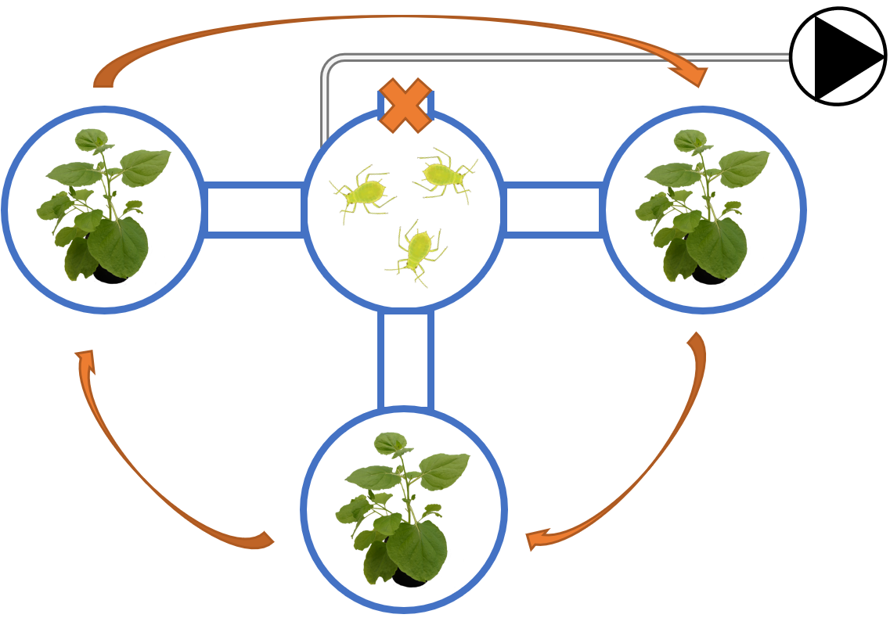
Figure S1 Schematic representation of the olfactometer. The arrows indicate the direction of the rotation of side jars. The  sign stands for the air pump. Aphid image was obtained from TogoTV

Table S3 Primers used in this study for the quantification of peanut stunt virus (PSV) and cucumber mosaic virus (CMV) genomic strands, and their satRNAs by quantitative real-time PCR (RT-qPCR) and digital droplet (ddPCR)
Primer name | Primer sequence (5’→3’) | Annealing temperature | Function
PSVq1 | F: CTTCTGCCCTCGTTGATAAAG | 57°C | Detection of PSV RNA1 in qPCR/ddPCR [3]
PSVq1 | R: CATACCGATTTCGAATCACTTC | 57°C | Detection of PSV RNA1 in qPCR/ddPCR [3]
PSVq2a | F: CTTCTAGGTATCCCCGTAAG | 60°C | Detection of PSV RNA2 in qPCR/ddPCR [3]
PSVq2a | R: CAAGCACATTGATACCCTATC | 60°C | Detection of PSV RNA2 in qPCR/ddPCR [3]
PSVq3a | F: CTAGTCGGACTTTAACACAAC | 56°C | Detection of PSV RNA3 in qPCR/ddPCR [3]
PSVq3a | R: ACGCTCATATATCCCTTAGAC | 56°C | Detection of PSV RNA3 in qPCR/ddPCR [3]
PARNA | 1: GGGAGGGCGGGCGTTCGTAGTG | 60°C | Detection of PSV satRNA-P in qPCR/ddPCR [3]
PARNA | 2: GCCGTGGCCTTTCGTGGTC | 60°C | Detection of PSV satRNA-P in qPCR/ddPCR [3]
CMVq1 | F: GGAGAGGAATGGGACGTGATATC | 60°C | Detection of CMV RNA1 in qPCR/ddPCR [4]
CMVq1 | R: CAAAATCTTCCCATCGGTAACAG | 60°C | Detection of CMV RNA1 in qPCR/ddPCR [4]
CMVq2a | F: ATGAGCTCCTTGTCGCTTTTG | 60°C | Detection of CMV RNA2 in qPCR/ddPCR [4]
CMVq2a | R: TTATTAAACGCAGGGCACCAT | 60°C | Detection of CMV RNA2 in qPCR/ddPCR [4]
CMVq3a | 1: CACGGTCGTATTGCTTCCTT | 60°C | Detection of CMV RNA3 in qPCR/ddPCR
CMVq3a | 2: GAAACGCATTGCCCATCTAT | 60°C | Detection of CMV RNA3 in qPCR/ddPCR
CMVqsat | F: GCGAGCTATGTCCGCTACTC | 60°C | Detection of CMV non-nc- and nc-satRNAs in qPCR/ddPCR
CMVqsat | R: GACATTCACGGAGATCAGCA | 60°C | Detection of CMV non-nc- and nc-satRNAs in qPCR/ddPCR

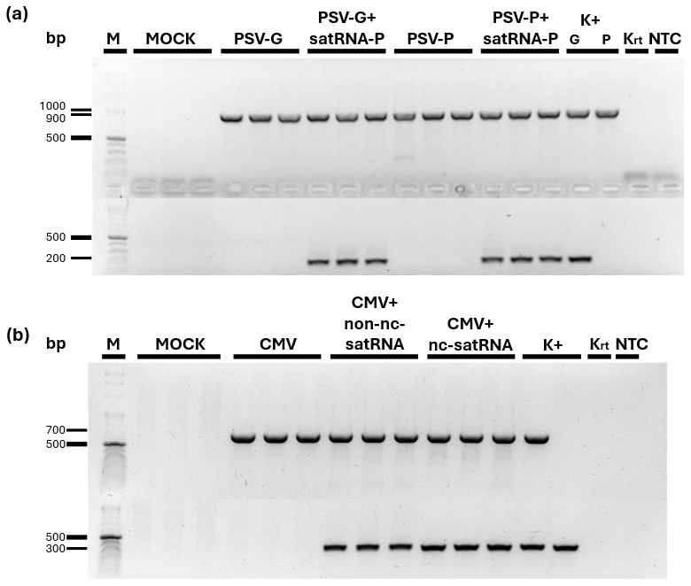
Figure S2 Peanut stunt virus (PSV) (a) and cucumber mosaic virus (CMV) (b) coat protein (upper row) and satellite RNAs (satRNAs) (lower row) sequences identification in the agroinfiltrated Nicotiana benthamiana plants. M – molecular mass marker, K+ – positive controls [plasmids with sequences corresponding to individual RNA strands: in (a) for PSV, PSV-G and PSV-P RNA3 (upper row), and satRNA-P (lower row); in (b) for CMV, CMV RNA3 (upper row), and non-necrogenic satRNA (non-nc-satRNA) and necrogenic satRNA (nc-satRNA), respectively (lower row)]; Krt – reverse transcription negative control (without RNA template); NTC – no cDNA template contro
REFERENCES

1. Obrępalska-Stęplowska A, Budziszewska M, Pospieszny H. Complete nucleotide sequence of a Polish strain of Peanut stunt virus (PSV-P) that is related to but not a typical member of subgroup I. Acta Biochim Pol. 2008;55:731-9.
2. Wrzesińska B, Wieczorek P, Obrępalska-Stęplowska A. Recombination-based generation of the agroinfectious clones of Peanut stunt virus. J Virol Methods. 2016;237:179-86.
3. Obrępalska-Stęplowska A, Renaut J, Planchon S, Przybylska A, Wieczorek P, Barylski J, et al. Effect of temperature on the pathogenesis, accumulation of viral and satellite RNAs and on plant proteome in peanut stunt virus and satellite RNA-infected plants. Front Plant Sci. 2015;6:903.
4. Feng J-L, Chen S-N, Tang X-S, Ding X-F, Du Z-Y, Chen J-S. Quantitative determination of cucumber mosaic virus genome RNAs in virions by real-time reverse transcription-polymerase chain reaction. Acta Biochimica et Biophysica Sinica. 2006;38(10):669-76.

