Supporting information

Elucidating the Biochemical Properties of Limonene Synthase from Agastache rugosa

Sun-Yong Jung^{1,†}, Yeon-Ju Jeong^{2,†}, Min-Ju Seo⁴, Jiyeun Yi⁵, Bong Hyun Sung^{5,}*, and Soo-Jin Yeom^{1,3,4,}*

Table S1. Strain, plasmids and oligonucleotides used in this study.
Enzyme | Origin | Vector | Oligonucleotide (5’ → 3’)
MsLS | Mentha spicata | pET-28a | (F) AGCAGCGGCCTGGTGCCGCGCGGCAGCCATATGGCCCTGAAAGTATTGAGCGTAGCTACG  (R) ATCTCAGTGGTGGTGGTGGTGGTGCTCGAGTTAGGCGAATGGTTCGAACAGAGTACGAGT
ArLS | Agastache rugosa | pET-28a | (F) AGCAGCGGCCTGGTGCCGCGCGGCAGCCATATGGCTCTCAAAATGACTAGCGTCGTAATG  (R) ATCTCAGTGGTGGTGGTGGTGGTGCTCGAGTCACGCAAAAGGCTGGAACAAGCATGCGGC
Variants | Oligonucleotide (5’ → 3’)
D366A | (F) – CTTATAACAGTCATGGCTGATATTTACGATG  (R) – GACATCGTAAATATCAGCCATGACTGTTATAAG
D370A | (F) – GGATGATATTTACGCTGTCTATGGTACC  (R) – GGTACCATAGACAGCGTAAATATCATCC
D510A | (F) – CTACTGCGCCTTGCTGCTGATTTAGGAACCTCC  (R) – GGAGGTTCCTAAATCAGCAGCAAGGCGCAGTAG
T514A | (F) – GCTGATGATTTAGGAGCCTCCGTTGAAG  (R) – CAACGGAGGCTCCTAAATCATCAGCAAGG
D523A | (F) – GGTGAGCAGAGGTGCCGTGCCAAAATCAATAC  (R) – GTATTGATTTTGGCACGGCACCTCTGCTCACC
R329A | (F) – GAAGCTCCCGTTCGCGGCGGATAGGCTTATAGAGAG  (R) – CTCTCTATAAGCCTATCCGCCGCGAACGGGAGCTTC
S335A | (F) – GAGGGATAGGCTTATAGAGGCCTACTTCTGGAGTACAGGG  (R) – CCCTGTACTCCAGAAGTAGGCCTCTATAAGCCTATCCCTC
W338A | (F) – GCTTATAGAGAGCTACTTCGCGAGTACAGGGATGGTAGAG  (R) – CTCTACCATCCCTGTACTCGCGAAGTAGCTCTCTATAAGC
I359A | (F) – CGCAAGGATAATTATGGCCAAAGTTGCCGCTCTTATAACAGTCATGGATG  (R) – CATCCATGACTGTTATAAGAGCGGCAACTTTGGCCATAATTATCCTTGCG
I362A | (F) – GGCCAAAGTTATCGCTCTTGCAACAGTCATGGATGATA  (R) – TATCATCCATGACTGTTGCAAGAGCGATAACTTTGG
T363A | (F) – GTTATCGCTCTTATAGCAGTCATGGATGATATTTAC  (R) – CATCCATGACTGCTATAAGAGCGATAACTTTGG
Y441A | (F) – GCAGAGAACGCTCTGATGGAGTCAAAATGG  (R) – GACTCCATCAGAGCGTTCTCTGCTTGATCCACC
V467A | (F) – GAACTCGTGGATATCAGCCAGTGGGCCTTGTG  (R) – CACAAGGCCCACTGGCTGATATCCACGAGTTC
V472A | (F) – CAGTCAGTGGGCCTTGTGCTCTAACCCATG  (R) – CATGGGTTAGAGCACAAGGCCCACTGACTGATATCC
R507A | (F) – GGTCCTCGTACCTACTGGCCCTTGCTGATGATTTAG  (R) – CTAAATCATCAGCAAGGGCCAGTAGGTACGAGGACC
K526A | (F) – GCAGAGGTGACGTGCCAGCATCAATACAGTGC  (R) – GCACTGTATTGATGCTGGCACGTCACCTCTGC
Y587A | (F) – GAATGGCGCAGTTTATGGCTCACTATGGAGATGGCC  (R) – GGCCATCTCCATAGTGAGCCATAAACTGCGCCATTC
H593A | (F) – GTATCACTATGGAGATGGCGCTGGCACACAACACCC  (R) – GGGTGTTGTGTGCCAGCGCCATCTCCATAGTGATAC
S466A | (F) – GGAGAACTCGTGGATAGCAGTCAGTGGGCC  (R) – GGCCCACTGACTGCTATCCACGAGTTCTCC

Table S2. Conserved residues in the active- site residues of limonene synthases associated with stereoselectivity. The four residues that constitute the hydrophobic pocket in limonene synthase were selected because of their differing compositions in MsLS and ArLS.
Enzyme | Major limonene enantiomer | Residue no.
Enzyme | Major limonene enantiomer | 335 | 359 | 467 | 472
ArLS | R | S | I | V | V
LaLS | R | S | I | V | I
StLS | R | S | I | V | V
ClLS | R | S | I | I | I
MsLS | S | C | N | I | M
PfLS | S | C | N | I | M
AgLS | S | Y | C | S | A
PaLS | S | Y | C | S | A

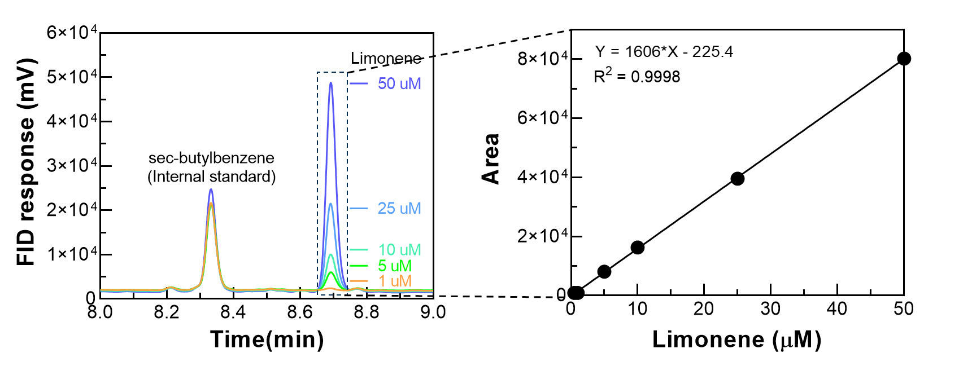
Figure S1. Standard curve of limonene quantification using GC–FID. Chromatogram of sec-butylbenzene as internal standard and limonene, predicted product acquired by GC–FID analysis. Limonene standard was prepared at concentrations of 1, 5, 10, 25, and 50 μM, and a standard curve was generated in GraphPad Prism 8.0 (GraphPad Software, USA) to quantify the product amount.

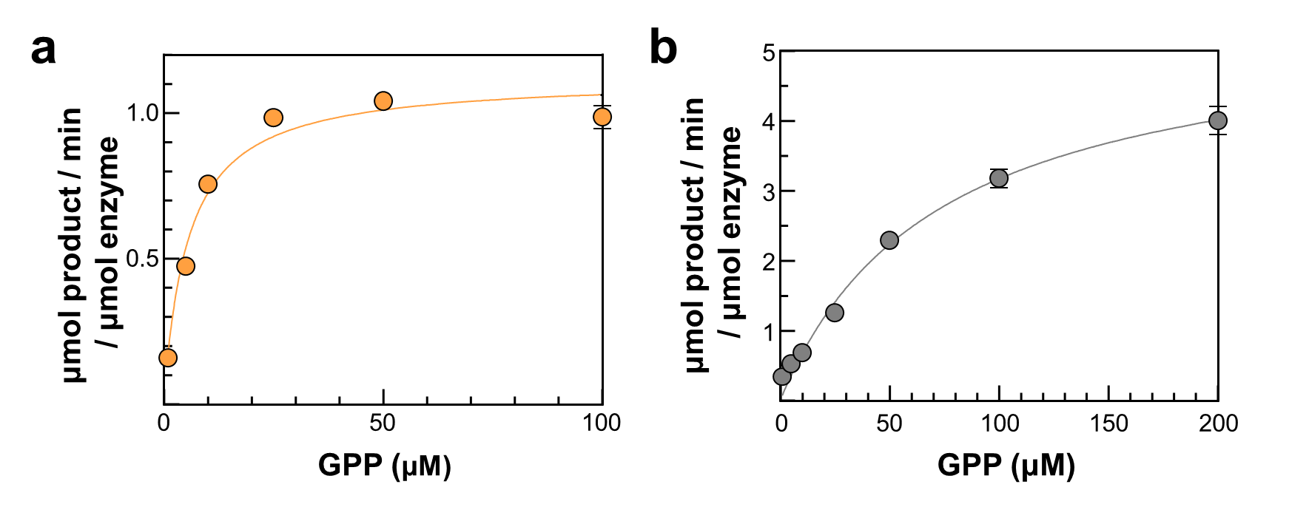
Figure S2. Michaelis–Menten plots comparing the kinetic parameters of MsLS and ArLS. (a) The ArLS reaction was performed containing 0.01 mg mL⁻¹ enzyme and 0.1 mM Mn²⁺ in 50 mM EPPS (pH 8.0) buffer, at 30 °C for 15 min. (b) The MsLS reaction was performed containing 0.005 mg mL⁻¹ enzyme and 1 mM Mn²⁺ in 50 mM PIPES (pH 6.7) buffer at 30 °C for 15 min. Data represent the means of two independent experiments, with error bars indicating the range.
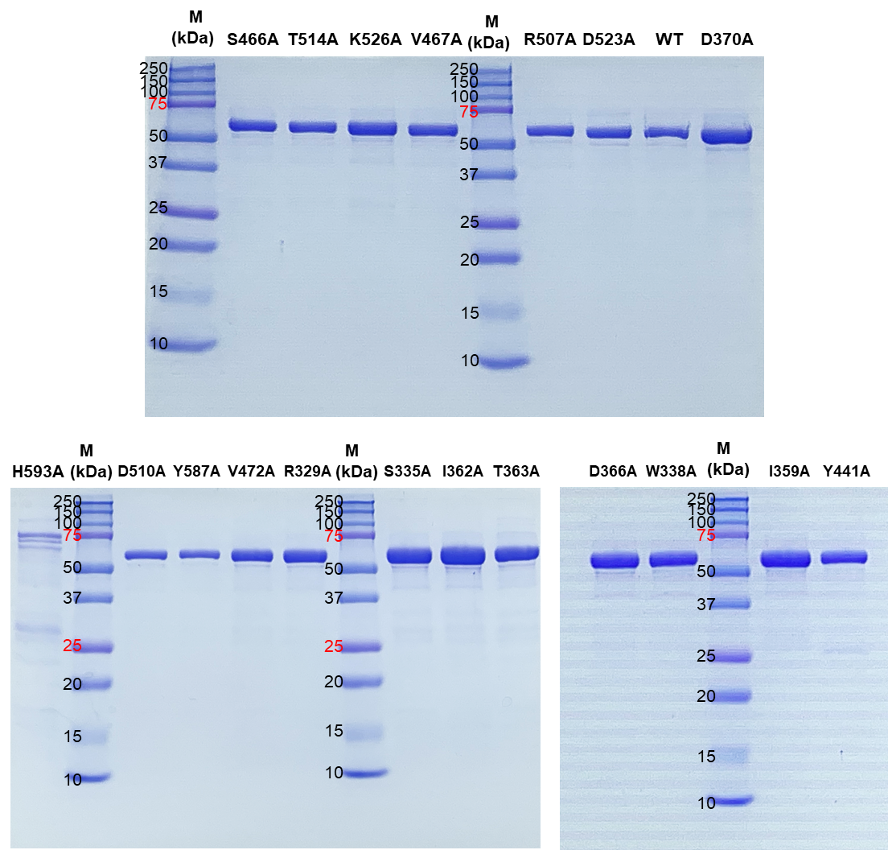
Figure S3. SDS–PAGE analysis of ArLS variants. Purified enzymes of ArLS variants were loaded. Protein markers (250, 150, 100, 75, 50, 37, 25, 20, 15, and 10 kDa) were also loaded. The protein size of ArLS was 66.1 kDa.

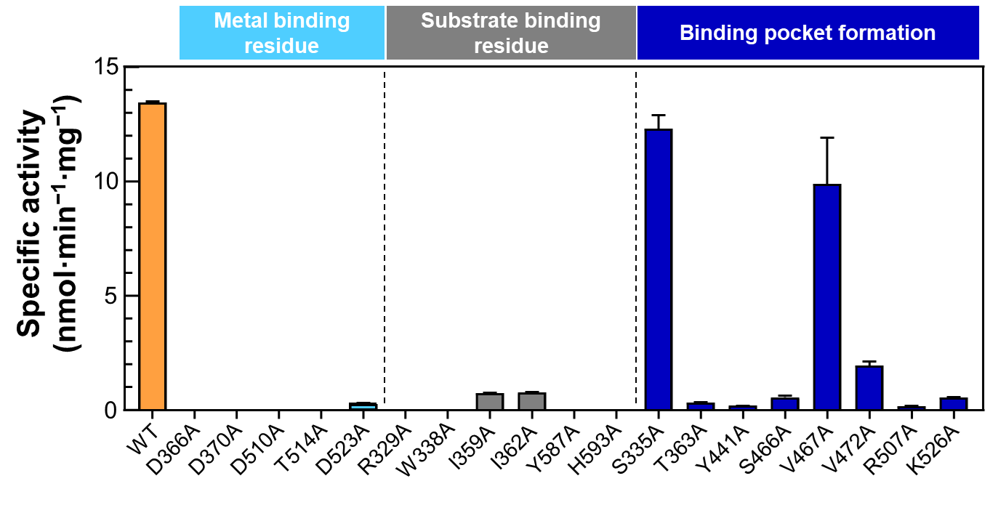
Figure S4. Comparative specific activities of ArLS and its engineered variants. All residues of the metal binding residues, substrate binding residues, and binding pocket formation residues were substituted to alanine. Concentration of ArLS and its variants was conducted in 50 mM EPPS (pH 8.0) buffer containing 0.1 mg mL⁻¹ enzyme, 0.1 mM Mn²⁺, and 50 μM GPP at 30 °C for 15 min. Data represent the means of two independent experiments, with error bars indicating the range.
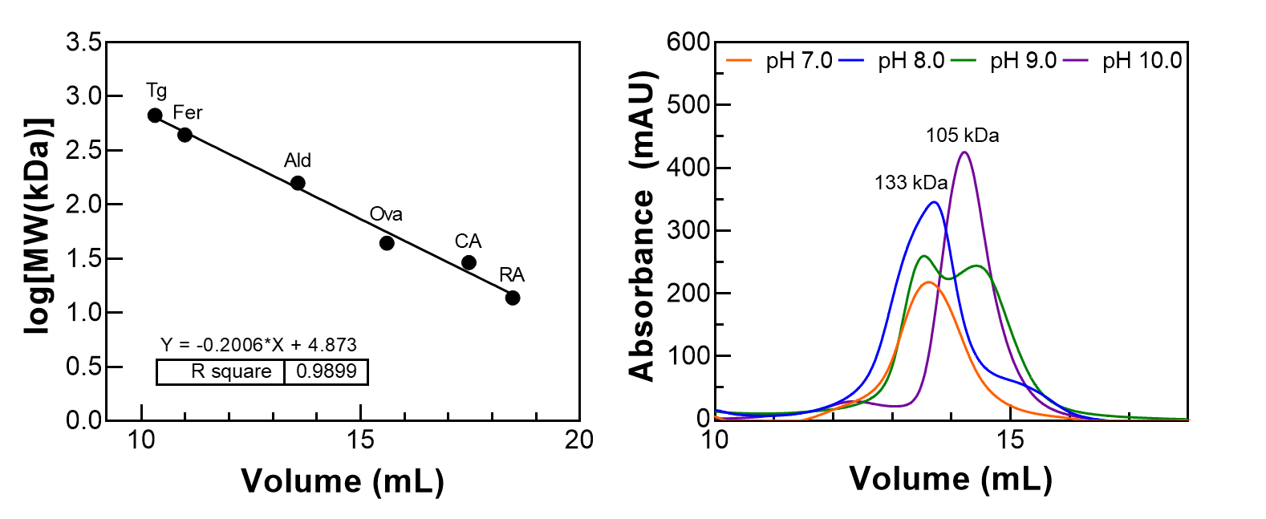
Figure S5. pH-dependent modulation in the oligomeric state of ArLS. (a) Calibration curve generated using molecular weight standards. Reference proteins (black circles) include ribonuclease A (R, 13.7 kDa), carbonic anhydrase (CA, 29 kDa), Ovalbumin (C, 44 kDa), aldolase (Ald, 158 kDa), ferritin (F, 440 kDa), and thyroglobulin (T, 669 kDa). (b) Molecular size-exclusion chromatography of ArLS under varying pH conditions. ArLS was analyzed in buffers at pH 7.0 (orange), 8.0 (blue), 9.0 (green), and 10.0 (purple) to assess pH-dependent modulation of its oligomeric state. Based on calibration with molecular weight standards, the peak at ~132 kDa corresponds to the dimeric form of ArLS, whereas the peak at ~105 kDa represents an additional species detected under alkaline conditions.
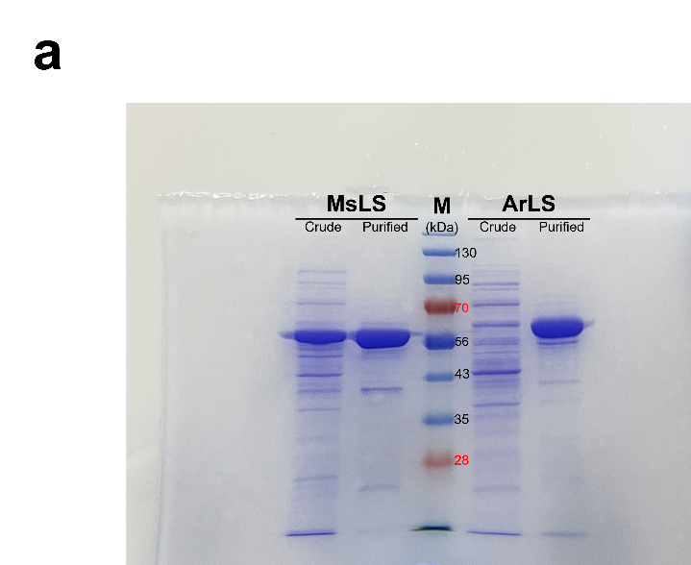

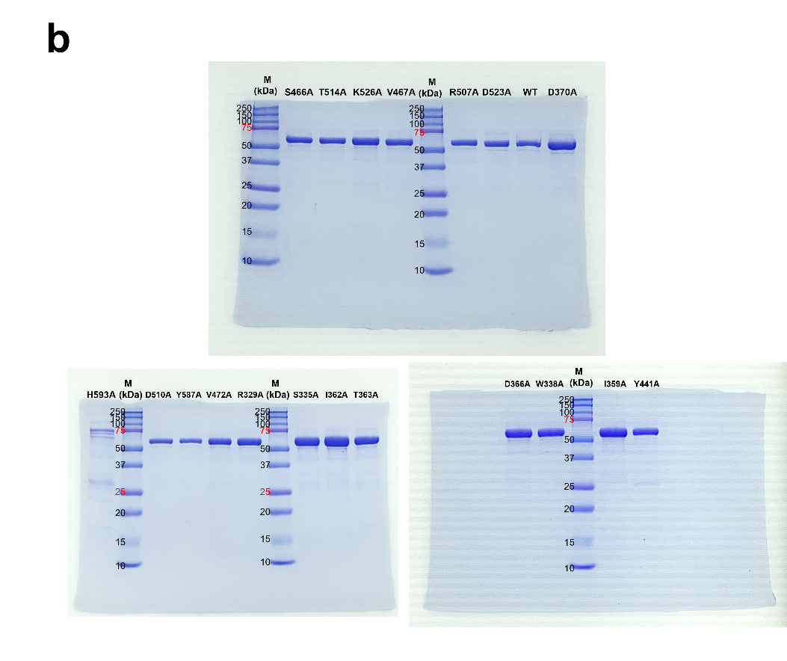

Figure S6. Original uncropped SDS-PAGE gel image corresponding to Figure 2 and Supplementary Figure S3. (a) Uncropped gel image corresponding to Figure 2. (b) Uncropped gel image corresponding to Supplementary Figure S3. The images are presented in their original, unprocessed form in accordance with the journal's editorial policy.

