Supplementary Information
Integrated phenotypic and genome-wide characterization of Ralstonia solanacearum strain R1 of tobacco
Yanmei He^{1 †}, Dongliang Yao^{2 †}, Shipei Zu³, Yi Liu⁵*, Junzhong Zhang^{1,4}*
Content:
Supplementary Figs1-2
Supplementary Table1-2
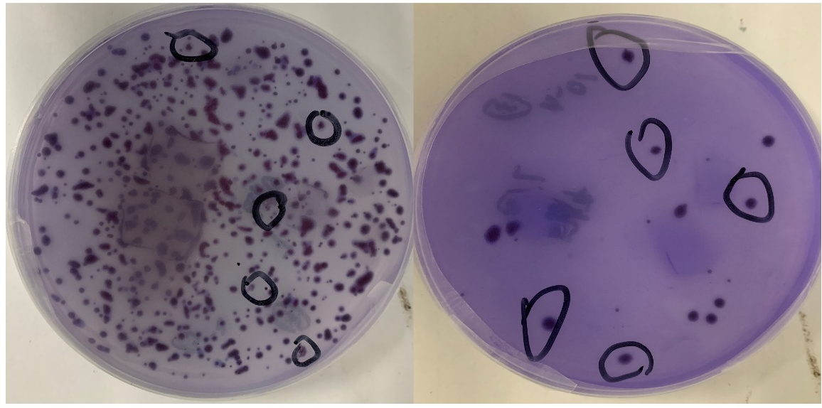
Supplementary Fig.1 Morphological characteristics of colonies on TTC medium. On the TTC identification medium, colonies of pathogenic bacteria exhibit an irregular shape, characterised by a flowing appearance. The centres of these colonies are red, while the peripheries are encircled by a relatively broad white zone.
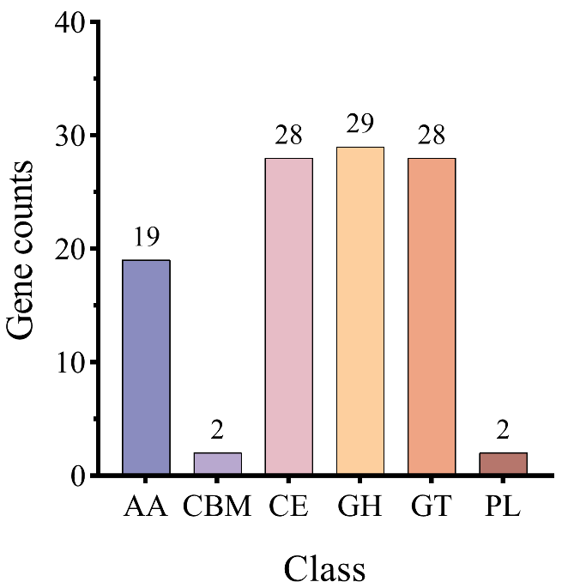
Supplementary Fig.2 Annotation results of the CAZy database of R1 strain. AA: Auxiliary Activities; CBM: Carbohydrate-Binding Modules; CE: Carbohydrate Esterases; GH: Glycoside Hydrolases; GT: Glycosyl Transferases; PL: Polysaccharide Lyases.
Supplementary Table 1. Determination of the R1 strain on the Biolog GenIII Identification Plate. The Biolog GENIII microplate is capable of conducting 94 phenotypic assays on microorganisms, comprising 71 tests for carbon source utilisation and 23 tests for chemical sensitivity. This functionality yields phenotypic profiles that facilitate the identification of a diverse array of Gram-positive and Gram-negative bacteria. The software integrated within the Biolog identification system identifies bacteria by analysing the phenotypic profiles presented on the Gen III microplate. In the accompanying table, a "+" denotes a positive result, while a "-" signifies a negative result.
Test item | Result | Test item | Result | Test item | Result | Test item | Result | Test item | Result
Negative control | ﹣ | Positive control | + | Gelatin | ﹣ | P-hydroxy-phenylacetic acid | ﹣ | N-acetyl Neuraminic acid | ﹣
Dextirn | ﹣ | D-mannose | ﹣ | Glycyl-L-prolin | ﹣ | Methyl pyruvate | ﹣ | 1% NaCl | ﹣
D-maltose | ﹣ | D-fructose | + | L-alanine | ﹣ | D-lactic acid Methyl ester | ﹣ | 4% NaCl | ﹣
D-trehalose | ﹣ | D-galactose | ﹣ | L-arginine | ﹣ | L-lactic acid | ﹣ | 8% NaCl | ﹣
D-cellobisoe | ﹣ | 3-methyl glucose | ﹣ | L-aspartic acid | + | Citric acid | + | D-serine | ﹣
Gentiobisoe | ﹣ | D-fucose | ﹣ | L-Gglutamic acid | + | α-keto-glutaric acid | ﹣ | Troleandomycin | ﹣
Sucrose | ﹣ | L-fucose | ﹣ | L-histidine | + | D-malic acid | ﹣ | Rifamycin SV | +
D-turanose | ﹣ | L-rhamnose | ﹣ | L-pyroglutamic acid | ﹣ | L-malic acid | + | Minocycline | ﹣
Stachyose | ﹣ | Inosine | ﹣ | L-serine | + | Bromo-succinic acid | ﹣ | D-aaccharic acid | ﹣
α-D-glucose | + | 1% sodium lactate | ﹣ | Lincomycin | + | Nalidixic acid | ﹣ | Vancomycin | +
pH6 | ﹣ | Fusidic acid | ﹣ | Guanidine HCI | ﹣ | Lithium chloride | ﹣ | Tetrazolium violet | +
pH5 | ﹣ | D-serine | ﹣ | Niaproof 4 | ﹣ | Potassium tellurite | + | Tetrazolium blue | +
D-raffinose | ﹣ | D-sorbitol | ﹣ | Pectin | + | Tween 40 | ﹣ | Acetic acid | ﹣
α-D-lactose | ﹣ | D-mannitol | ﹣ | D-galacturonic acid | + | γ-amino-butryric acid | ﹣ | Formic acid | ﹣
D-meliblon | ﹣ | D-arabitol | ﹣ | L-galactonic acid lactone | + | α-hydroxy-butyric acid | ﹣ | Sodium butyrate | ﹣
β-methyl-D-glucosilde | ﹣ | Myo-inositol | ﹣ | D-gluconic acid | ﹣ | β-hydroxy-D,L butyric acid | ﹣ | Sodium bromate | ﹣
D-salicin | ﹣ | Glycerol | ﹣ | D-glucuronic acid | + | α-keto-butyric acid | ﹣
N-acetyl-D-glucosamine | ﹣ | D-glucose-6-phosphate | ﹣ | Glucuronamide | + | Aztreonam | ﹣
N-acetyl-β-dmannosamine | ﹣ | D-fructose-6-phosphate | ﹣ | Mucic acid | ﹣ | Acetoacetic acid | ﹣
N-acatyl-D-galactosamine | ﹣ | D-aspartic acid | ﹣ | Quinic acid | + | Propionic acid | ﹣

Supplementary Table 2. Comparative genomic features of Ralstonia solanacearum strain R1 and representative RSSC strains. Genome sizes are total assembled length (including all replicons), reported in megabases (Mb) and rounded to two decimal places as per original sources; GC content values are as reported in the original publications. “N/A” indicates that the GC content was not reported in the original reference; CDS count refers to the total number of protein-coding sequences predicted in the complete genome (excluding tRNA and rRNA genes).

Strain | Total genome size (Mb) | GC content (%) | CDS count | Host | Reference
GMI1000 | 5.80 | 66.97 | 5129 | Tomato | Salanoubat et al, 2002.
FJ1003 | 5.90 | 67.00 | 5133 | Tobacco | Chen et al, 2022.
K60 | 5.77 | 66.40 | 4799 | Tomato | Remenant et al, 2017.
Po82 | 5.34 | 66.7 | 5018 | Potato | Xu et al, 2011.
Y45 | 5.82 | N/A | 5496 | Tobacco | Li et al., 2011.
R1 | 4.92 | 66.80 | 4285 | Tobacco | This study

Supplementary References:
- Salanoubat M, Genin S, Artiguenave F, et al. Genome sequence of the plant pathogen Ralstonia solanacearum. Nature. 2002;415(6871):497-502.
- Chen K, Zhuang Y, Wang L, et al. Comprehensive genome sequence analysis of the devastating tobacco bacterial phytopathogen Ralstonia solanacearum strain FJ1003. Front Genet. 2022;13:966092.
- Hayes MM, MacIntyre AM, Allen C. Complete Genome Sequences of the Plant Pathogens Ralstonia solanacearum Type Strain K60 and R. solanacearum Race 3 Biovar 2 Strain UW551. Genome Announc. 2017;5(40):e01088-17.
- Xu J, Zheng HJ, Liu L, et al. Complete genome sequence of the plant pathogen Ralstonia solanacearum strain Po82. Journal of Bacteriology, 2011, 193(16):4261-4262.
- Li Z, Wu S, Bai X, et al. Genome sequence of the tobacco bacterial wilt pathogen Ralstonia solanacearum. Journal of Bacteriology. 2011;193(21):6088-6089.

